**HYDRO VILLAGE PRIVATE LIMITED**

Subidhanagar-32, Kathmandu

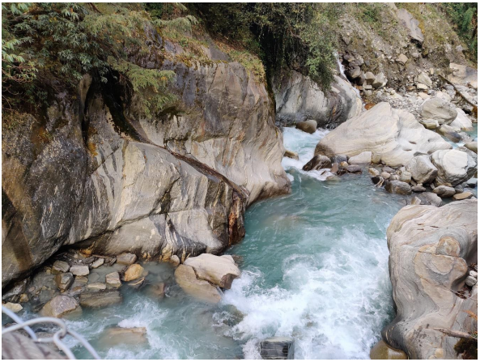

**Updated Feasibility Study of**

**MYAGDI KHOLA HYDROPOWER PROJECT (65 MW)**

**MYAGDI DISTRICT**

**UPDATED FEASIBILITY STUDY REPORT**

**Volume: I**

**Main Report**

**December 2022**

**Prepared by:**

|  |  |
| --- | --- |
| Description: logo-option-01-blackshadow_001.tif  **Address:**  **Gangadevi Marga, Buddhanagar, Kathmandu** |  |

MYAGDI KHOLA HYDROPOWER PROJECT (65 MW)

**UPDATED FEASIBILITY STUDY REPORT**

Final Report

|  |  |  |  |
| --- | --- | --- | --- |
| Quality Control | | Signature | Date |
| Prepared By: | Saphal Lamichhane  Surendra Shrestha  Jeevika Khadka  Ujwol Parajuli  Samikchya Sigdel  Bishal Koirala  Jyoti Jha  Sandeep Poudel  Shradye Shrestha |  |  |
| Checked By: | Shyam Bhusal  Subas Chandra Sunwar |  |  |
| Approved By: | Manohar Shrestha |  |  |

**June 2021**

|  |
| --- |
| logo-option-01-blackshadow_001.tif |

# LIST OF ACRONYMS

AMSL above Mean Sea Level

ASCE American Society of Civil Engineers

AR Access Road

B/C Benefit/Cost

BL Base Line

BM Bench Mark

BoQ Bill of Quantities

CBR California Bearing Ratio

DBM Design Base Memorandum

DC Direct Current

DCPT Dynamic Core Penetration Test

DDR Detailed Design Report

DEM Digital Elevation Model

DHM Department of Hydrology and Meteorology

DoED Department of Electricity Development

D/S Downstream

EDR Eastern Development Region

EIA Environmental Impact Assessment

EIRR Economic Internal Rate of Return

EPC Engineering, Procurement, Construction

ERMC Environment and Resource Management Consultant

ERT Electric Resistivity Tomography

FAT Factory Acceptance Tests

FDC Flow Duration Curve

FIDIC International Federation of Consulting Engineers

FSR Feasibility Study Report

GLOF Glacial Lake Outburst Floods

GoN Government of Nepal

GPS Global Positioning System

GWh Gigawatt Hour

HCE Hydro-Consult Engineering

HEC-RAS Hydrologic Engineering Centres River Analysis System

HP Hydropower Project

HFT Himalayan Frontal Thrust

HRT Head Race Tunnel

H/W Headworks

ICIMOD International Center for Integrated Mountain Development

lEC International Electrotechnical Commission

lEE Initial Environment Examination

IEO International Electro Technical Commission

INPS Integrated Nepal Power System

IPP Independent Power Producers

IRR Internal Rate of Return

ITP Inspection and Test Plan

KV Kilo Volt

MASL Meters Above Sea Level

MBT Main Boundary Thrust

MCT Main Central Thrust

MDE Maximum Design Earthquake

MHPP Ministry of Housing and Physical Planning

MKHPP Myagdi Khola Hydropower Project

MW Mega Watt

NBM New Bench Mark

NEA Nepal Electricity Authority

NPV Net Present Value

O&M Operations and Maintenance

OBE Operating Basis Earthquake

ODWFS Oil Directed Air Forced

OFWF Oil Forced Water Forced

ONAF Oil Natural Air Forced

ONAN Oil Natural Air Natural

PGA Peak Ground Acceleration

PH Powerhouse

PPMO Public Procurement Monitoring Office

PRoR Peaking Run of River

RM Rural Municipality

RoR Run of River

SEIA Supplementary Environmental Impact Assessment

SPT Standard Penetration Test

SRTM Shuttle Radar Topography Mission

S/S Substation

STDFS South Tibetan Detachment Fault System

ToR Terms of Reference

UFSR Updated Feasibility Study Report

UNCHS United Nations Commission on Human Settlements

U/S Upstream

V Volt

VDC Village Development Committee

WECS Water and Energy Commission Secretariat

TABLE OF CONTENT

[LIST OF ACRONYMS i](#_Toc121834189)

[LIST OF FIGURES xii](#_Toc121834190)

[LIST OF TABLES xiv](#_Toc121834191)

[1 INTRODUCTION 1](#_Toc121834192)

[1.1 Background 1](#_Toc121834193)

[1.2 Contents of the report 1](#_Toc121834194)

[1.3 Project location 2](#_Toc121834195)

[1.4 Project Access 2](#_Toc121834196)

[1.5 Project Layout 4](#_Toc121834197)

[1.6 Salient Features of the Project 7](#_Toc121834198)

[2 HYDROLOGY 14](#_Toc121834199)

[2.1 Introduction 14](#_Toc121834200)

[2.2 Catchment Characteristics 14](#_Toc121834202)

[2.3 Climate 18](#_Toc121834316)

[2.4 Available Data 18](#_Toc121834317)

[2.4.1 Hydrological Data 18](#_Toc121834318)

[2.4.2 Gauge Installation and data recording 19](#_Toc121834319)

[2.4.3 Meterological Data 22](#_Toc121834320)

[2.5 Basin Rainfall 25](#_Toc121834321)

[2.6 Long Term Mean Monthly Flow 26](#_Toc121834330)

[2.6.1 Catchment Correlation 26](#_Toc121834331)

[2.6.2 Regional Regression Analysis 31](#_Toc121834332)

[2.6.3 Adopted Long-term Mean Monthly Flow 35](#_Toc121834333)

[2.6.4 Riparian Release 39](#_Toc121834334)

[2.7 Flow Duration Curve (FDC) and Design Discharge 39](#_Toc121834335)

[2.7.1 Catchment Correlation 39](#_Toc121834336)

[2.7.2 Regional Regression Analysis 40](#_Toc121834337)

[2.7.3 Adopted Flow Duration Curve 43](#_Toc121834338)

[2.8 Flood Analysis 45](#_Toc121834339)

[2.8.1 Diversion during Construction Flood 46](#_Toc121834340)

[2.9 Low Flow 47](#_Toc121834341)

[2.10 Glacier Lake Outburst Flood (GLOF) 48](#_Toc121834342)

[2.11 Conclusions 48](#_Toc121834343)

[2.12 Recommendations 49](#_Toc121834344)

[3 SEDIMENT STUDY 50](#_Toc121834345)

[3.1 Sediment Study 50](#_Toc121834346)

[3.1.1 Suspended Sediment Concentration in LHKSHP 50](#_Toc121834347)

[3.1.2 Particle size distribution 51](#_Toc121834348)

[3.1.3 Sediment mineralogy 55](#_Toc121834349)

[3.1.4 Water Quality Test 57](#_Toc121834350)

[3.2 Conclusion and Recommendation 58](#_Toc121834351)

[4 GEOLOGY AND GEOTECHNICAL STUDY 59](#_Toc121834352)

[4.1 Regional Geology 59](#_Toc121834353)

[4.2 Project Geology 60](#_Toc121834354)

[4.2.1 Rock types 60](#_Toc121834355)

[4.2.2 Soil types 60](#_Toc121834356)

[4.3 Site Investigations 61](#_Toc121834357)

[4.4 Engineering Geological Conditions of Major Structures 63](#_Toc121834358)

[4.4.1 Headworks 63](#_Toc121834359)

[4.4.2 Headrace Tunnel (HRT) and Adits 66](#_Toc121834360)

[4.4.3 Surge tank 70](#_Toc121834361)

[4.4.4 Penstock 71](#_Toc121834362)

[4.4.5 Surface powerhouse and tailrace 72](#_Toc121834363)

[4.5 Construction material investigations 75](#_Toc121834364)

[4.5.1 Construction Material Testing 75](#_Toc121834365)

[4.6 Conclusion 76](#_Toc121834366)

[5 PROJECT DESCRIPTION AND DESIGN 77](#_Toc121834367)

[5.1 General Layout of Overall Project Components 77](#_Toc121834368)

[5.2 Headworks 77](#_Toc121834369)

[5.2.1 Diversion Weir and Stilling Basin in Myagdi Khola 77](#_Toc121834370)

[5.2.2 Undersluice in Myagdi Khola 79](#_Toc121834371)

[5.2.3 Intake at Myagdi Khola 81](#_Toc121834372)

[5.2.4 Gravel Trap at Myagdi Khola 83](#_Toc121834373)

[5.2.5 Connecting Canal 84](#_Toc121834374)

[5.2.6 Diversion Weir and Stilling Basin in Kunaban Khola 84](#_Toc121834375)

[5.2.7 Undersluice in Kunaban Khola 86](#_Toc121834376)

[5.2.8 Intake of Kunaban Khola 88](#_Toc121834377)

[5.2.9 Gravel Trap 90](#_Toc121834378)

[5.2.10 Approach Covered Canal 91](#_Toc121834379)

[5.2.11 Settling Basins 91](#_Toc121834380)

[5.3 Waterway 93](#_Toc121834381)

[5.3.1 General 93](#_Toc121834382)

[5.3.2 Inlet Portal 94](#_Toc121834383)

[5.3.3 Headrace Tunnel 94](#_Toc121834384)

[5.3.4 Rock trap 96](#_Toc121834385)

[5.3.5 Surge Shaft 96](#_Toc121834386)

[5.3.6 Butterfly Valve and Valve Chamber 98](#_Toc121834387)

[5.3.7 Drop Shaft, Pressure Tunnel / Penstock Pipe 98](#_Toc121834388)

[5.4 Powerhouse, Switchyard and Tailrace 103](#_Toc121834389)

[5.4.1 Powerhouse 103](#_Toc121834390)

[5.4.2 Tailrace 104](#_Toc121834391)

[5.4.3 Switchyard 104](#_Toc121834392)

[6 HYDROMECHANICAL WORKS 105](#_Toc121834393)

[6.1 Introduction 105](#_Toc121834394)

[6.2 Gates, Stoplogs and Trashracks 105](#_Toc121834395)

[6.2.1 Coarse Trashrack 105](#_Toc121834396)

[6.2.2 Undersluice gate (Radial) 105](#_Toc121834397)

[6.2.3 Undersluice stoplog 106](#_Toc121834398)

[6.2.4 Intake gate 106](#_Toc121834399)

[6.2.5 Trash passage Gate 106](#_Toc121834400)

[6.2.6 Gravel flushing gate 107](#_Toc121834401)

[6.2.7 Gravel flushing stoplog 107](#_Toc121834402)

[6.2.8 Coarse Trashrack 107](#_Toc121834403)

[6.2.9 Fine Trashrack 108](#_Toc121834404)

[6.2.10 Undersluice gate (Radial) 108](#_Toc121834405)

[6.2.11 Undersluice stoplog 108](#_Toc121834406)

[6.2.12 Intake gate 109](#_Toc121834407)

[6.2.13 Trash passage Gate 109](#_Toc121834408)

[6.2.14 Fish Ladder Gate 109](#_Toc121834409)

[6.2.15 Gravel flushing gate 110](#_Toc121834410)

[6.2.16 Gravel flushing stoplog 110](#_Toc121834411)

[6.2.17 Settling basin Inlet gate 110](#_Toc121834412)

[6.2.18 Settling basin outlet gate-I 111](#_Toc121834413)

[6.2.19 Settling basin outlet gate-II 111](#_Toc121834414)

[6.2.20 Settling basin flushing gate 111](#_Toc121834415)

[6.2.21 Settling basin flushing stoplog 111](#_Toc121834416)

[6.2.22 Settling basin flushing culvert gate 112](#_Toc121834417)

[6.2.23 Fine Trashrack 112](#_Toc121834418)

[6.2.24 Tailrace gate 112](#_Toc121834419)

[6.3 Steel Pipe and Accessories 113](#_Toc121834420)

[6.3.1 General 113](#_Toc121834421)

[6.3.2 Pipe diameter optimization 113](#_Toc121834422)

[6.3.3 Pipe thickness calculation 114](#_Toc121834423)

[6.3.4 Penstock Protection Valve 115](#_Toc121834424)

[6.4 Other HM special items 116](#_Toc121834425)

[7 ELECTRO-MECHANICAL EQUIPMENT 117](#_Toc121834426)

[7.1 General 117](#_Toc121834427)

[7.1.1 Design criteria 117](#_Toc121834428)

[7.1.2 Turbine selection and Mode of operation 117](#_Toc121834429)

[7.1.3 Turbine maintenance 118](#_Toc121834430)

[7.2 Valves 119](#_Toc121834431)

[7.2.1 Main Inlet Valve 119](#_Toc121834432)

[7.2.2 Penstock Shut-off Valve 120](#_Toc121834433)

[7.3 Overhead Crane 120](#_Toc121834434)

[7.4 Governor 120](#_Toc121834435)

[7.5 Powerhouse auxiliary 122](#_Toc121834436)

[7.5.1 Station drainage 122](#_Toc121834437)

[7.5.2 Upstream water conveyance dewatering system 122](#_Toc121834438)

[7.5.3 Cooling water system 122](#_Toc121834439)

[7.5.4 Compressed air system 123](#_Toc121834440)

[7.5.5 High pressure air system 123](#_Toc121834441)

[7.5.6 Low pressure air system 123](#_Toc121834442)

[7.5.7 Oil handling system 123](#_Toc121834443)

[7.5.8 Ventilation system 124](#_Toc121834444)

[7.5.9 Fire protection systems 124](#_Toc121834445)

[7.5.10 Water Deluge Systems 124](#_Toc121834446)

[7.5.11 Standpipe Water Protection System 125](#_Toc121834447)

[7.5.12 Carbon dioxide Deluge System 125](#_Toc121834448)

[7.5.13 Portable Firefighting Equipment 125](#_Toc121834449)

[7.5.14 Firewater Supply 125](#_Toc121834450)

[7.5.15 Workshop equipment 125](#_Toc121834451)

[8 ELECTRICAL EQUIPMENT 126](#_Toc121834452)

[8.1 Generator, excitation and ancillaries 126](#_Toc121834453)

[8.1.1 Excitation and Automatic Voltage Regulator 127](#_Toc121834454)

[8.1.2 Insulation class and temperature rise 128](#_Toc121834455)

[8.1.3 Generator Grounding 128](#_Toc121834456)

[8.1.4 Generator Protection and Relaying 129](#_Toc121834457)

[8.2 Main Unit Power Transformers 132](#_Toc121834458)

[8.2.1 Main Transformer Protection and Relaying 133](#_Toc121834459)

[8.3 Station Auxiliary Transformers 134](#_Toc121834460)

[8.3.1 DC powerhouse auxiliaries 135](#_Toc121834461)

[8.3.2 110 V DC system 135](#_Toc121834462)

[8.3.3 48V DC system 135](#_Toc121834463)

[8.3.4 24V DC system 135](#_Toc121834464)

[8.3.5 Emergency diesel generator 135](#_Toc121834465)

[8.4 Distribution transformers 136](#_Toc121834466)

[8.5 Bus Bar 136](#_Toc121834467)

[8.6 Current Transformer 136](#_Toc121834468)

[8.7 Voltage Transformer 136](#_Toc121834469)

[8.8 Lightning Arrestors 137](#_Toc121834470)

[8.9 Vacuum Circuit Breaker 137](#_Toc121834471)

[8.10 Control and protection 138](#_Toc121834472)

[8.10.1 Powerhouse group and unit control 138](#_Toc121834473)

[8.10.2 Switch-gear and transmission line protection 139](#_Toc121834474)

[8.10.3 Main and Backup Protection (Phase-Phase and Phase-Ground) 139](#_Toc121834475)

[8.10.4 Under Voltage/Over Voltage 139](#_Toc121834476)

[8.10.5 Out of Step Blocking (68) 140](#_Toc121834477)

[8.10.6 Auto Reclosing (79) 140](#_Toc121834478)

[8.10.7 Synchro-check (25) 140](#_Toc121834479)

[8.10.8 Breaker failure Protection (52BF) 140](#_Toc121834480)

[8.10.9 Control and indication at the tailrace and headworks 140](#_Toc121834481)

[8.10.10 Communication system 140](#_Toc121834482)

[8.11 Grounding 140](#_Toc121834483)

[8.12 HV switch yard 141](#_Toc121834484)

[8.12.1 132kV Measuring and Protection Equipment’s 141](#_Toc121834485)

[8.12.2 Metering Scheme 143](#_Toc121834486)

[9 TRANSMISSION LINE 147](#_Toc121834487)

[9.1 Transmission voltage level selection 147](#_Toc121834488)

[9.1.1 Quality of Supply 147](#_Toc121834489)

[9.2 Energy Meter and metering equipment 148](#_Toc121834490)

[9.3 Black Start/ Island Mode Operation 148](#_Toc121834491)

[10 POWER AND ENERGY COMPUTATION 149](#_Toc121834492)

[10.1 General 149](#_Toc121834493)

[10.2 Available discharge and power generating flow 149](#_Toc121834494)

[10.2.1 Long term average flow and design discharge 149](#_Toc121834495)

[10.2.2 Downstream release and available flow 149](#_Toc121834496)

[10.2.3 Design discharge and power generating flow 149](#_Toc121834497)

[10.3 System head loss 150](#_Toc121834498)

[10.3.1 Major loss 150](#_Toc121834499)

[10.3.2 Minor Loss 150](#_Toc121834500)

[10.4 Tail water level and net head 151](#_Toc121834501)

[10.4.1 Available head 151](#_Toc121834502)

[10.5 Efficiency and Typical Operation Plan 152](#_Toc121834503)

[10.6 Outages and Self consumption 153](#_Toc121834504)

[10.7 Plant capacity and Energy Computation as per PPA (57.3 MW) and upgraded capacity (65 MW) 153](#_Toc121834505)

[10.8 Conclusion 157](#_Toc121834639)

[11 CONSTRUCTION PLANNING AND SCHEDULING 158](#_Toc121834640)

[11.1 Introduction 158](#_Toc121834641)

[11.2 Accessibility 158](#_Toc121834642)

[11.3 Construction Activities 160](#_Toc121834643)

[11.3.1 Tendering, contract award and mobilization 160](#_Toc121834644)

[11.3.2 Civil Works activities 160](#_Toc121834645)

[11.3.3 Weir, stilling basin, undersluice, intake and associated structures and right bank flood walls in Myagdi Khola 161](#_Toc121834646)

[11.3.4 Connecting Canal 161](#_Toc121834647)

[11.3.5 Weir, stilling basin, undersluice, intake and associated structures and right bank flood walls in Kunaban Khola 162](#_Toc121834648)

[11.3.6 Settling basin and Approach Canal 163](#_Toc121834649)

[11.3.7 Headrace tunnel 163](#_Toc121834650)

[11.3.8 Surge shaft 165](#_Toc121834651)

[11.3.9 Pressure shaft 166](#_Toc121834652)

[11.3.10 Powerhouse civil work 166](#_Toc121834653)

[11.3.11 Tailrace culvert 166](#_Toc121834654)

[11.3.12 Switchyard 167](#_Toc121834655)

[11.3.13 Hydro-mechanical works 167](#_Toc121834656)

[11.3.14 Electromechanical equipment 167](#_Toc121834657)

[11.3.15 Transmission line 167](#_Toc121834658)

[11.4 Construction Schedule 167](#_Toc121834659)

[12 PROJECT COST ESTIMATION 174](#_Toc121834660)

[12.1 General 174](#_Toc121834661)

[12.2 Rate Analysis 174](#_Toc121834662)

[12.3 Cost estimation methodology 174](#_Toc121834663)

[12.4 Description of Cost Items 175](#_Toc121834664)

[12.4.1 Unit rate for Civil Works 175](#_Toc121834665)

[12.4.2 Civil Works 176](#_Toc121834666)

[12.4.3 Electromechanical Works 176](#_Toc121834667)

[12.4.4 Hydro-mechanical Works 176](#_Toc121834668)

[12.4.5 Transmission Line 176](#_Toc121834669)

[12.4.6 Infrastructure Works and Logistics 176](#_Toc121834670)

[12.4.7 EIA including mitigation and monitoring 177](#_Toc121834671)

[12.4.8 Land Acquisition, Compensation and Development 177](#_Toc121834672)

[12.4.9 Engineering Design and Supervision Cost 177](#_Toc121834673)

[12.4.10 Project Management Cost during Construction 177](#_Toc121834674)

[12.4.11 Construction Power 177](#_Toc121834675)

[12.4.12 Pre Project Development 177](#_Toc121834676)

[12.4.13 Insurance during Construction 178](#_Toc121834677)

[12.4.14 Contingencies 178](#_Toc121834678)

[12.4.15 VAT and Taxes 178](#_Toc121834679)

[12.5 Project cost estimate 179](#_Toc121834680)

[13 FINANCIAL ANALYSES 182](#_Toc121834681)

[13.1 Introduction 182](#_Toc121834682)

[13.2 Methodology 182](#_Toc121834683)

[13.2.1 Net Present Value (NPV) 182](#_Toc121834684)

[13.2.2 Internal Rate of Return (IRR) 182](#_Toc121834685)

[13.2.3 Benefit-Cost Ratio (BCR) 183](#_Toc121834686)

[13.3 Financial parameters 183](#_Toc121834687)

[13.3.1 Project cost 183](#_Toc121834688)

[13.3.2 Interest rate 183](#_Toc121834689)

[13.3.3 Discount rate 183](#_Toc121834690)

[13.3.4 Debt equity ratio 183](#_Toc121834691)

[13.3.5 Energy rate 183](#_Toc121834692)

[13.3.6 Escalation 184](#_Toc121834693)

[13.3.7 Currency exchange rate 184](#_Toc121834694)

[13.3.8 Loan repayment period 184](#_Toc121834695)

[13.3.9 Tax Rate 184](#_Toc121834696)

[13.3.10 Royalties 184](#_Toc121834697)

[13.3.11 Planning horizon 184](#_Toc121834698)

[13.3.12 Operation and maintenance cost 184](#_Toc121834699)

[13.3.13 Financing Charges 184](#_Toc121834700)

[13.3.14 Capital investment 185](#_Toc121834701)

[13.3.15 Depreciation 185](#_Toc121834702)

[13.3.16 Other parameters 185](#_Toc121834703)

[13.4 Project evaluation 185](#_Toc121834704)

[13.4.1 Financial analysis 185](#_Toc121834705)

[13.4.2 Sensitivity analysis 186](#_Toc121834781)

[13.5 Conclusion 186](#_Toc121834817)

[14 CONCLUSION AND RECOMMENDATIONS 187](#_Toc121834818)

[14.1 Conclusion 187](#_Toc121834819)

[14.2 Recommendations 190](#_Toc121834820)

[15 REFERENCES 191](#_Toc121834821)

[15.1 Previous study documents 191](#_Toc121834822)

[15.2 Civil Design References 191](#_Toc121834823)

[15.3 Mechanical 191](#_Toc121834824)

[15.4 Electro Mechanical 192](#_Toc121834825)

[15.5 Other References 192](#_Toc121834826)

[15.6 Geological Study references 194](#_Toc121834827)

# LIST OF FIGURES

[Figure 1‑1: Access to the Project Site 3](#_Toc121834065)

[Figure 1‑2: Project general layout 6](#_Toc121834066)

[Figure 2‑1: Myagdi Khola catchment at proposed weir site in satellite image 15](#_Toc121834067)

[Figure 2‑2: Elevation wise area distribution of MKHPP catchments at intake sites of Myagdi and Kunaban 17](#_Toc121834068)

[Figure 2‑3: Nearby river gauging stations considered for Myagdi Khola 19](#_Toc121834069)

[Figure 2‑4: Stage Discharge (Rating) curve for Myagdi Khola HPP developed from available data till date 21](#_Toc121834070)

[Figure 2‑5: Nearby meteorological stations considered for Myagdi Khola 22](#_Toc121834071)

[Figure 2‑6: DHM Meteorological stations near project catchment 25](#_Toc121834072)

[Figure 2‑7: Mean monthly hydrograph comparison at the intake of MKHPP 38](#_Toc121834073)

[Figure 2‑8: Adopted Mean monthly hydrograph at the intake of MKHPP 38](#_Toc121834074)

[Figure 3‑1: Result of particle size analysis of samples taken on 27-30 September, 01- 05 October and 06-10 October 2019 53](#_Toc121834075)

[Figure 3‑2: Result of particle size analysis of samples taken on 11-15 October and 16-21 October 2019 53](#_Toc121834076)

[Figure 3‑3: Result of particle size distribution analysis of samples taken on 25 July, 04 August & 15 August 2020 54](#_Toc121834077)

[Figure 3‑4: Result of particle size distribution analysis of samples taken on 25 August, 04 September & 15 September 2020 54](#_Toc121834078)

[Figure 3‑5: Result of particle size distribution analysis of samples taken on 21 September and 28 September 2020 55](#_Toc121834079)

[Figure 3‑6: Mineralogical composition of suspended sediment sample taken from Myagdi river at proposed intake site of MKHPP during the months of September and October of 2019 56](#_Toc121834080)

[Figure 3‑7: Mineralogical composition of suspended sediment sample taken from Myagdi river at proposed intake site of MKHPP during the monsoon of 2020 56](#_Toc121834081)

[Figure 4‑1: Regional Geological Map showing Project site (Compiled by Department of Mines & Geology, 1996). 59](#_Toc121834082)

[Figure 4‑2: Myagdi Diversion weir bedrock at both banks and piles of big boulders downstream 64](#_Toc121834083)

[Figure 4‑3: Kunaban diversion weir: bedrock at left bank and loose boulder mixed soil at right bank. 65](#_Toc121834084)

[Figure 4‑4: Inlet portal area with thick colluvium origin boulder mixed heterogeneous soil. 66](#_Toc121834085)

[Figure 4‑5: View of headrace tunnel, adit, surge tank and penstock layout with rock types and joints 67](#_Toc121834086)

[Figure 4‑6: Adit 1 portal area 68](#_Toc121834087)

[Figure 4‑7: View of outlet portal and surge tank area proposed in rock cliff at left bank of a stream. 71](#_Toc121834088)

[Figure 4‑8: Underground Penstock Alignment 72](#_Toc121834089)

[Figure 4‑9: Aerial view of proposed new surface powerhouse along with other alternatives and newely proposed powerhouse with bedrock at back slope. 73](#_Toc121834090)

[Figure 4‑10: Geological Map of the project area with additional ERT lines carried out during this study. 74](#_Toc121834091)

[Figure 5‑1: Weir and Stilling Basin Profile in Myagdi Khola 78](#_Toc121834092)

[Figure 5‑2: Proposed Undersluice Profile in Myagdi Khola 80](#_Toc121834093)

[Figure 5‑3: Proposed Intake Profile in Myagdi Khola 82](#_Toc121834094)

[Figure 5‑4: Rouse’s chart for fall velocity of particles 84](#_Toc121834095)

[Figure 5‑5: Boulder Weir Profile in Kunaban Khola 85](#_Toc121834096)

[Figure 5‑6: Proposed Undersluice Profile in Kunaban Khola 87](#_Toc121834097)

[Figure 5‑7: Proposed Intake Profile in Kunaban Khola 89](#_Toc121834098)

[Figure 5‑8: Rouse’s chart for fall velocity of particles 91](#_Toc121834099)

[Figure 5‑9: Settling Basin Plan 92](#_Toc121834100)

[Figure 5‑10: Optimization of headrace tunnel section 96](#_Toc121834101)

[Figure 5‑11: Schematic general arrangement of surge shaft and access tunnel 98](#_Toc121834102)

[Figure 5‑12: Penstock Pipe Optimization graph 102](#_Toc121834103)

[Figure 5‑13: Powerhouse Area Layout Plan 103](#_Toc121834104)

[Figure 5‑14 Profile of Powerhouse showing Tailrace 104](#_Toc121834105)

[Figure 6‑1: Optimization Curve for Penstock Pipe Diameter 114](#_Toc121834106)

[Figure 7‑1: Turbine Selection Chart 118](#_Toc121834107)

[Figure 8‑1: Single line diagram from Powerhouse to Switchyard 145](#_Toc121834108)

[Figure 8‑2: Grid interconnection at Dandakhet Sub-station 146](#_Toc121834109)

[Figure 11‑1: Construction Schedule for the project 168](#_Toc121834110)

# LIST OF TABLES

[Table 1‑1: Salient features of the project 7](#_Toc121834111)

[Table 2‑1: Hypsometric data of the catchment at intake of MKHPP 16](#_Toc121834112)

[Table 2‑2: Hypsometric data of the catchment at tailrace of MKHPP 16](#_Toc121834113)

[Table 2‑3: Hydrometric Stations located near the project catchment 19](#_Toc121834114)

[Table 2‑4: Location of Discharge measurement in Myagdi Khola 19](#_Toc121834115)

[Table 2‑5: Summary of Measured discharge at downstream of Confluence of Myagdi and Kunban (at Dovan) 20](#_Toc121834116)

[Table 2‑6: Summary of available stage and discharge data at downstream of confluence of Myagdi and Kunban (at Dovan) 20](#_Toc121834117)

[Table 2‑7: Metrological stations laying in the vicinity of the catchment 23](#_Toc121834118)

[Table 2‑8: DHM meteorological stations near project catchment 24](#_Toc121834119)

[Table 2‑9: Basin average annual rainfall 25](#_Toc121834120)

[Table 2‑10: Catchment parameters 28](#_Toc121834121)

[Table 2‑11: Long-term mean monthly flows by catchment correlation (CAR) at Myagdi Khola Intake 29](#_Toc121834122)

[Table 2‑12: Long-term mean monthly flows by catchment correlation (CAR) at Kunaban Khola Intake 30](#_Toc121834123)

[Table 2‑13: Long-term mean monthly flows by catchment correlation (CAR) for MKHPP intake (sum of Table 1‑9 and Table 1‑10) 31](#_Toc121834124)

[Table 2‑14: Details of stations considered for regional regression 32](#_Toc121834125)

[Table 2‑15: Long-term mean monthly flow of the reference gauging stations 32](#_Toc121834126)

[Table 2‑16: Long-term mean monthly flows at Myagdi Khola intake from regional regression analysis 34](#_Toc121834127)

[Table 2‑17: Long-term mean monthly flows of Kunaban Khola Intake from regional regression analysis 34](#_Toc121834128)

[Table 2‑18: Long-term mean monthly flows at MKHPP intake from regional regression analysis (sum of Table 1‑14 and Table 1‑15) 35](#_Toc121834129)

[Table 2‑19: Adopted long-term mean monthly flow at MKHPP intake in previous UFSR 36](#_Toc121834130)

[Table 2‑20: Comparison of long-term mean monthly flow at intake of MKHPP (Myagdi intake+ Kunaban intake) 37](#_Toc121834131)

[Table 2‑21: Flow duration curve of MKHPP from catchment correlation 39](#_Toc121834132)

[Table 2‑22: Flow duration curve of the reference gauging stations from regional regression 40](#_Toc121834133)

[Table 2‑23: Flow duration curve at the intake of MKHPP from regional regression analysis 41](#_Toc121834134)

[Table 2‑24: Adopted Flow duration curve at MKHPP intake in previous UFSR 43](#_Toc121834135)

[Table 2‑25: Comparison of developed flow duration curve at intake of MKHPP 44](#_Toc121834136)

[Table 2‑26: Estimated flood at intake and powerhouse site 45](#_Toc121834137)

[Table 2‑27: Estimated dry period diversion flood during construction 46](#_Toc121834138)

[Table 2‑28: Estimated low flow at intake site of Myagdi Khola 47](#_Toc121834139)

[Table 2‑29: Estimated low flow at Kunaban Khola Intake 47](#_Toc121834140)

[Table 2‑30: Estimated low flow at the intake site of MKHPP 47](#_Toc121834141)

[Table 3‑1: Statistical composition of monitored suspended sediment samples 50](#_Toc121834142)

[Table 3‑2: Peak and monthly average sediment concentrations 51](#_Toc121834143)

[Table 3‑3: Classification of sediment particles according to grain size 52](#_Toc121834144)

[Table 3‑4: Hardness of different minerals 57](#_Toc121834145)

[Table 3‑5: Corrosiveness characteristics of water based on LSI 57](#_Toc121834146)

[Table 4‑1: Summary of geophysical investigations carried out during previous studies 61](#_Toc121834147)

[Table 4‑2: Summary of ERT carried out during this study 62](#_Toc121834148)

[Table 4‑3: Summary of MASW and SRT carried out in different locations during this study 63](#_Toc121834149)

[Table 4‑4: Summary of rock support design of Headrace Tunnel 69](#_Toc121834150)

[Table 4‑5: Location of test pits for construction material survey 75](#_Toc121834151)

[Table 5‑1: The parameters considered in the optimization of HRT. 94](#_Toc121834152)

[Table 5‑2: Assumptions and Consideration in the optimization process: 99](#_Toc121834153)

[Table 5‑3: Result of Penstock optimization 102](#_Toc121834154)

[Table 6‑1 Length and Thickness of Pipe for Different Gross Heads 115](#_Toc121834155)

[Table 6‑2: Quantity of Some other special HM components 116](#_Toc121834156)

[Table 7‑1: Basic Features of Turbine 118](#_Toc121834157)

[Table 7‑2: Details of Powerhouse Crane 120](#_Toc121834158)

[Table 8‑1: Main preliminary parameters of generator 126](#_Toc121834159)

[Table 8‑2 Generator winding insulation and temperature rise 128](#_Toc121834160)

[Table 8‑3 Temperature rise limits 128](#_Toc121834161)

[Table 8‑4 Parameters of 3-phase power transformer 132](#_Toc121834162)

[Table 8‑5: Data for Auxiliary Transformer 134](#_Toc121834163)

[Table 8‑6: Data for Generator Circuit Breaker 137](#_Toc121834164)

[Table 8‑7: Data for 11 kV Disconnecting Switch 137](#_Toc121834165)

[Table 8‑8: Data For 11 kV CT 138](#_Toc121834166)

[Table 8‑9: Data for 11 kV PT 138](#_Toc121834167)

[Table 8‑10: Data for 11 kV LA 138](#_Toc121834168)

[Table 8‑11: Data for 11/132 kV Power Transformer 141](#_Toc121834169)

[Table 8‑12: Data For 132 kV Circuit Breaker 142](#_Toc121834170)

[Table 8‑13: Data for 132 kV Disconnecting Switch 142](#_Toc121834171)

[Table 8‑14: Data For 132 kV CT 142](#_Toc121834172)

[Table 8‑15: Data for 132 kV PT 143](#_Toc121834173)

[Table 8‑16: Data for 132 kV LA 143](#_Toc121834174)

[Table 10‑1 Power generating flow, m](#_Toc121834175)[3](#_Toc121834175)[/s 149](#_Toc121834175)

[Table 10‑2: Estimated head loss at each of the mean monthly flow 151](#_Toc121834176)

[Table 10‑3: Available net head for plant operation 151](#_Toc121834177)

[Table 10‑4: Typical plant operation plan and corresponding turbine efficiency 152](#_Toc121834178)

[Table 10‑5: Considerations of data to estimated energy as per PPA for 57.3 MW 153](#_Toc121834179)

[Table 10‑6: Considerations of data for energy estimation for 65 MW 153](#_Toc121834180)

[Table 10‑7: Estimated energy in Nepali calendar month as per Power Purchase Agreement (PPA) for 57.3 MW 155](#_Toc121834181)

[Table 10‑8 : Estimated energy in Nepali calendar month for the updgraded project capacity (65 MW) 156](#_Toc121834182)

[Table 11‑1: Alternative routes to project site 159](#_Toc121834183)

[Table 12‑1 Physical contingencies percentage 178](#_Toc121834184)

[Table 12‑2 VAT and Tax compliance percentage 179](#_Toc121834185)

[Table 12‑3: Summary of the project cost 179](#_Toc121834186)

[Table 13‑1 Considerations and results of the financial analysis 185](#_Toc121834187)

[Table 13‑2 Result of sensitivity analysis for the project capacity 65 MW 186](#_Toc121834188)

# INTRODUCTION

## Background

This report has been prepared as a part of agreement between Hydro Village Pvt. Ltd. and Hydro-Consult Engineering Ltd. for Updated Feasibility Study of Myagdi Khola Hydropower Project. This report describes the outcome of hydrological study, topographical survey, geological study, geotechnical study, recommended project layout and hydraulic design of each project components including hydro mechanical and electromechanical components. This report also provides description of plant capacity and energy estimate of the project, cost estimate and evaluation of the project.

## Contents of the report

This report has four volumes in total with Volume 1 as main report and the Annexes have been included in Volumes II and Volume III. The design drawings have been provided in Volume IV. The overall structure of the report is as follows:

**Volume 1: Main Report**

The Volume I describe the outcome of hydrological study, topographical survey, geological study, geotechnical study, Recommended Project layout and hydraulic design of each project components including hydro mechanical and electromechanical components. This report also provides description of plant capacity and energy estimate of the project, cost estimate and financial evaluation of the project.

**Volume II: Annex A- Hydrology Calculations**

The volume includes, the secondary data used in the hydrological analysis, rainfall data, flow measurement results and calculation sheets, recorded manual gauge water level data, calculations of the extreme flood, low flow analysis calculation, calculation of diversion during construction flood, sediment study report, etc.

**Annex B: Hydraulic Calculation**

This annex includes the calculation of weir hydraulic and design of stilling basin, calculation of undersluice design including fixing of operation platform level, design of trash passage, designs of intake and gravel trap including its flushing mechanism, design of approach culvert and settling basin, hydraulic calculation of tunnel sizing, design of surge shaft, penstock pipe hydraulic design, design of tailrace structure etc.

**Annex C: Cost Estimate, Energy and Project Evaluation**

This annex includes the quantity and cost estimate, rate analysis calculations and financial evaluation sheets of the proposed project option. This annex also includes calculation of energy generation of the proposed project option.

**Volume III: Annex D- Geophysical Investigation Report**

This volume includes the result and explanation report of ERT and SRT survey, MASW investigation carried out during this Updated Feasibility study of the project by the Client.

**Annex E: Construction Material Survey**

This annex includes the test report of construction materials from possible quarry sites in the project area.

**Volume IV: Drawings**

This volume includes general arrangement drawings, geological drawings and civil drawings.

## Project location

The project area is located Bagara, Dhaulagiri Rural Municipality of Myagdi District, Gandaki Province, Nepal. The headworks are located upstream of the confluence of Myagdi and Kunaban Khola, one on each river that meet at Dovan. The powerhouse is proposed on the right bank of Myagdi Khola at Jeltun Village, about 7500 m downstream from the Myagdi-Kunaban confluence at Mudi VDC.

The project boundary coordinates of Myagdi Khola HPP as specified in Generation License no. 326-076/077 and Updated Capacity Survey License no. 770-073/074 is 28˚37’49” N to 28˚34’18” N and 83˚25’00” E to 83˚21’50” E.

## Project Access

The project site can be accessed from Kathmandu following Tribhuvan Highway (Muglin), Prithivi Highway (Pokhara), Pokhara/Baglung highway (Baglung) and Maaldhunga-Beni Sadak till Myagdi district headquater - Beni. The road head from Kathmandu to Beni is blacktopped. From Beni, all weathered road leads till Darbang which is the nearest road head to the project site. As per the provided access road report, about 20 km road from Darbang to powerhouse site is under construction. The road passes along Lower Khara, Shivaratri Khola, Upper Khara, Khibang and Jugepani to reach the powerhouse site. A bailey bridge has also been proposed near Khibang. From the powerhouse site, approximately 8 km road has been designed to reach the headworks site.

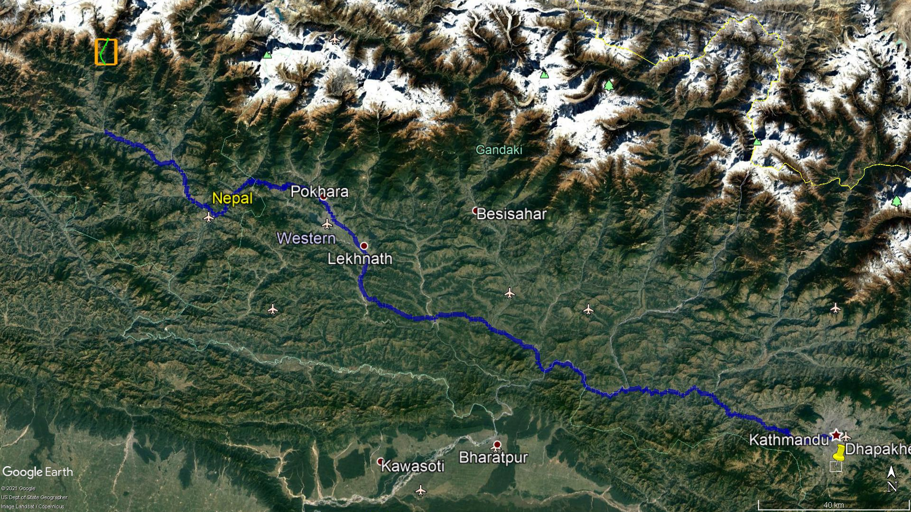

Project Area

Figure 1‑1: Access to the Project Site

## 

## Project Layout

Myagdi Khola Hydropower Project (MKHPP) is conceived as a run-of river type project. The project will have two headworks one at Myagdi River while another one at Kunaban River. The discharge from the Myagdi river will be diverted by constructing a sloping glacis type concrete gravity weir, which will be conveyed to the collection pond right after intake and gravel trap of Kunaban headworks area by a connecting canal of about 389mm length and Kunaban River crossing siphon of about 60m length. The design discharge from Kunaban river with combined discharge from Myagdi river is diverted by constructing boulder rip-rap weir and the flow is guided to the surface powerhouse through about 7,840m long waterway comprising approach canal, settling basin, headrace pipe, headrace tunnel, threevertical drop-shafts and horizontal shaft. The overall project layout has been presented in Figure 1‑2.

A 15 m long sloping glacis type uncontrolled overflow concrete gravity weir is provided to divert the flow towards intake. Also, two number of undersluices of different size are provided to pass the bed load during flood flow in the river. The intake structure is located at the right bank of Myagdi river adjacent to the undersluice. A Coarse trash rack is provided to prevent the trashes and large size floating debris from entering to the intake. The sediment, debris and boulders accumulated on the riverbed in front of the intake is flushed out from time to time through the undersluice. The intake side undersluice gate will remain open during the monsoon season when there will be enough water in the river. The gravel of size larger than 5mm passed through the trashrack will be trapped in the gravel trap structure provided just after the trash rack. A flushing conduit is provided to flush the trapped gravel from the gravel trap. The intake has been designed to draw the normal discharge of 15.625m3/s including 25% additional discharge for flushing of gravel trap and settling basin. This discharge is conveyed to the headworks in the Kunaban river via a conceret connecting canal of 2.8m (W) x 2.8m (H) and a siphon of size 2.4m (W) x 2.0m (H).

Another 20 m boulder rip-rap type uncontrolled overflow weir and one undersluice is provided to divert the flow from the Kunaban river. The intake structure is located at the right bank of Kunaban river adjacent to the undersluice. A Coarse trash rack is provided to prevent the trashes and large size floating debris from entering to the intake and a fine trashrack is provided at the start of the approach canal to prevent logs and other debris from entering the canal. The sediment, debris and boulders accumulated on the riverbed in front of the intake is flushed out from time to time through the undersluice. The undersluice gate will remain open during the monsoon season when there will be enough water in the river. The gravel of size larger than 5 mm passed through the trashrack will be trapped in the gravel trap structure provided just after the trash rack. A flushing conduit is provided to flush the trapped gravel from the gravel trap. The intake has been designed to draw the normal discharge of 15.625 m3/s which is including design discharge of 12.5 m3/s with 25% additional discharge for flushing of gravel trap and of settling basin. The design discharge is supplied to settling basin through two numbers of approach covered canals. Discharge to the settling basin is regulated through 2 numbers of vertical sliding gates of size 2.0 m wide and 2.2 m high provided at the beginning of the approach culvert.

Two chambered surface settling basin has been designed to settle the suspended sediments of size 0.15 mm with 90% efficiency given by Vetter’s equation. Flushing arrangements have been provided at the end of each bay to flush the deposited sediments back into the river through a flushing culvert. An emergency spillway has been provided at the end of the headpond to spill excess water which is collected by a spillway canal and discharged back into the river via a cascade structure.

The design discharge of 12.50 m3/s, from headpond located at downstream of the settling basin, will be conveyed to the headrace tunnel through a headrace pipe from a headpond provided at the outlet of settling basin. The length of headrace pipe is about 422m, and the length of headrace tunnel is 6170 m. A Surge Shaft 8 m dia circular section has been provided to subside the surge before reaching to the headrace tunnel. The invert level of the Surge Shaft is located at an elevation of 2450.95 masl and is located directly in top of the headrace tunnel. The length of penstock pipe upto the first bifurcation point is 1195.45 m including upstream penstock. The penstock will have three numbers of branch pipes, and feed the power generating water to three sets of vertical axis Pelton turbines inhoused in the surface powerhouse located at right bank of Myagdi Khola to produce 65 MW of power. The tail water coming out of the powerhouse will be discharged back to the Myagdi Khola through a tailrace culvert of length 78.5 m.

The project layout showing the general arrangement of the project components has been presented in Figure 1‑2.

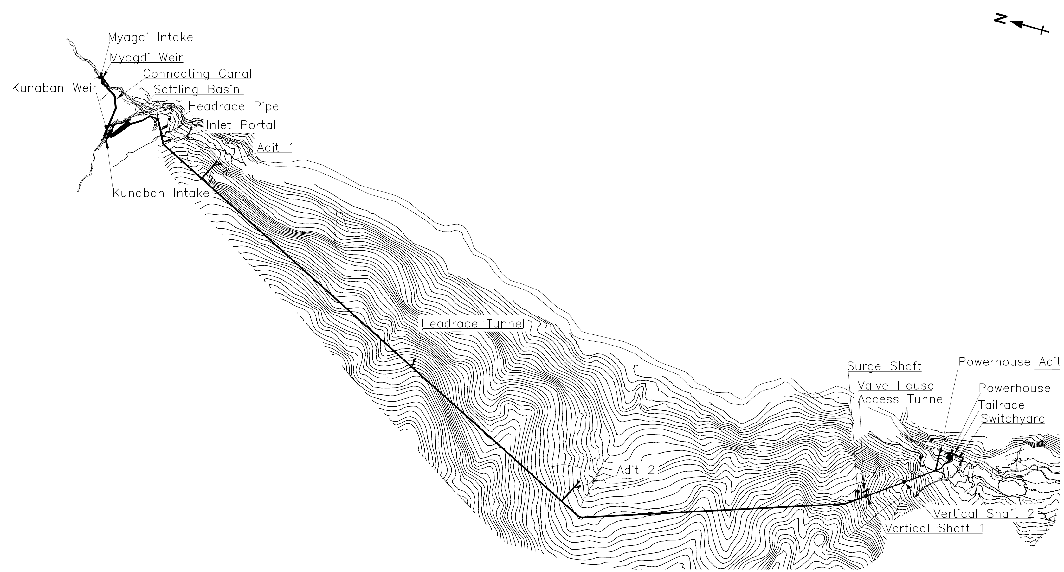

Figure 1‑2: Project general layout

## Salient Features of the Project

The Salient features of the project finalized from this updated feasibility study are as follows:

Table 1‑1: Salient features of the project

|  |  |  |  |  |
| --- | --- | --- | --- | --- |
|  | **Salient features of the Myagdi Khola Hydropower Project** | | | |
| **1** | **Project Location** | |  |  |
|  | Province No | | 4 |  |
|  | District | | Myagdi |  |
|  | Municipalities covered by project boundary | | Dhaulagiri Rural Municipalities |  |
|  | Project boundary | |  |  |
|  | Latitude | | 28º37’49” E to 28º34’18” N | |
|  | Longitude | | 83º25’00” E to 83º21’50” E | |
|  |  | |  |  |
| **2** | **General** | |  |  |
|  | Name of River | | Kunaban  Khola and Myagdi Khola |  |
|  | Nearest Town | | Beni Bazaar |  |
|  | Type of Scheme | | Run-of-river |  |
|  | Gross Head | | 629.00 | m |
|  | Rated Net Head | | 607.18 | m |
|  |  | |  |  |
| **3** | **Hydrology** | |  |  |
|  | Catchment Area of both rivers combined | | 305.10 | km2 |
|  | Design Discharge of Myagdi Khola and Kunaban Khola Combined | | 12.50 | m3/s |
|  | Design flood of Myagdi Khola at intake (1 in 100 Years) | | 497 | m3/s |
|  | Design flood of Kunaban Khola at intake (1 in 100 Years) | | 170.32 | m3/s |
|  | Design flood of Myagdi Khola at tailrace (1 in 100 Years) | | 691.70 | m3/s |
|  |  | |  |  |
| **4** | **Power and Energy** | |  |  |
|  | Design discharge | | 12.50 | m3/s |
|  | Rated net head | | 607.18 | m |
|  | Plant Capacity | | 57.3 | MW |
|  | Dry Energy | | 118.67 | GWh |
|  | Wet Energy | | 261.57 | GWh |
|  | Annual total Energy | | 380.24 | GWh |
| **5** | **Weir** | |  |  |
|  | **Myagdi Weir** | |  |  |
|  | Weir Type | | Sloping Glacis Weir |  |
|  | Weir Crest Length (excluding undersluice) | | 14 | m |
|  | Weir Height (from U/S Apron) | | 5.00 | m |
|  | Weir Crest Elevation | | 2483.00 | masl |
|  | Operation Platform Elevation | | 2491.50 | masl |
|  | **Stilling Basin** | |  |  |
|  | Type | | USBR Type II | |
|  | Stilling Basin Length | | 35.90 | m |
|  |  | |  |  |
|  | **Kunaban Weir** | |  |  |
|  | Weir Type | | Boulder Weir |  |
|  | Weir Crest Length (excluding undersluice) | | 20 | m |
|  | Weir Height (from U/S Apron) | | 3 | m |
|  | Weir Crest Elevation | | 2482.00 | masl |
|  | Operation Platform Elevation | | 2486.14 | masl |
|  |  | |  |  |
| **6** | **Undersluice** | |  |  |
|  | **Myagdi Undersluice** | |  |  |
|  | Size of Undersluice Opening (b x h) | |  |  |
|  | First Gate near intake (b x h) | | 2.50 x 2.50 | m |
|  | Second Gate away from Intake (b x h) | | 3.50 x 2.50 | m |
|  | No. of undersluice gates | | 2 | Nos. |
|  | Invert Level | | 2473.00 | masl |
|  |  | |  |  |
|  | **Kunaban Undersluice** | |  |  |
|  | Size of Undersluice Opening (b x h) | | 3.50 x 3.50 | m |
|  | No of undersluice gates | | 1 | nos. |
|  | Invert Level | | 2474.00 | masl |
|  |  | |  |  |
| **7** | **Intake** | |  |  |
|  | **Myagdi Intake** | |  |  |
|  | Type of Intake | | Side Intake |  |
|  | Size of Intake Opening (b x h) | | 3.60 x 2.50 | m |
|  | Number of Openings | | 2 | Nos. |
|  | Velocity of flow at intake trashrack | | 0.80 | m/s |
|  |  | |  |  |
|  | **Kunaban Intake** | |  |  |
|  | Type of Intake | | Side Intake |  |
|  | Size of Intake Opening (b x h) | | 4.80 x 2 | m |
|  | Number of Openings | | 2 | nos. |
|  | Velocity of flow at intake trashrack | | 0.80 | m/s |
|  |  | |  |  |
| **8** | **Gravel Trap and Flushing Culvert** | |  |  |
|  | **Gravel Trap of Myagdi Khola** | |  |  |
|  | No. of Hopper | | 1 | Nos. |
|  | Width of Hopper | | 8.20 | m |
|  | Length of Gravel Trap at base | | 4.10 | m |
|  | Total Length of Gravel Trap | | 6.10 | m |
|  | Total Width of Gravel Trap at Top | | 8.20 | m |
|  |  | |  |  |
|  | **Flushing Culvert of Myagdi Khola** | |  |  |
|  | Number of Openings | | 1 | Nos. |
|  | Size of Opening (b x h) | | 1.2 x 1.2 | m |
|  | Length of Flushing Culvert | | 27 | m |
|  |  | |  |  |
|  | **Gravel Trap of Kunaban Khola** | |  |  |
|  | No of Hopper | | 1 | Nos. |
|  | Width of Each Hopper | | 10.80 | m |
|  | Length of Gravel Trap at base | | 4.75 | m |
|  | Total Length of Gravel Trap | | 7.41 | m |
|  | Total Width of Gravel Trap at Top | | 10.80 | m |
|  |  | |  |  |
|  | **Flushing Culvert of Kunaban Khola** | |  |  |
|  | Number of Openings | | 2 |  |
|  | Size of Opening (Gravel Trap) (b x h) | | 1.2 x 1.2 | m |
|  | Size of Opening (Collection Pond) (b x h) | | 1 x 1 | m |
|  | Length of Flushing Culvert | | 73.33 | m |
|  |  | |  |  |
| **9** | **Connecting Tunnel** | |  |  |
|  | Width of Tunnel | | 2.80 | m |
|  | Height of Tunnel | | 2.80 | m |
|  | Bed Slope | | 1 in 500.0 |  |
|  | Length of Tunnel | | 389 | m |
|  | Invert level at the inlet | | 2481.15 | masl |
|  | Invert level at the outlet | | 2480.37 | masl |
|  |  | |  |  |
| **10** | **Connecting Tunnel Flushing at Outlet** | |  |  |
|  | Diameter of Flushing Pipe with Valve | | 0.75 | m |
|  |  | |  |  |
| **11** | **Syphon** | |  |  |
|  | Inlet Transition, Length | | 21.15 | m |
|  | Inlet Transition, Slope (H:V) | | 1:0.25 |  |
|  | Syphon Main Body, Length | | 25.05 | m |
|  | Outlet Transition, Length | | 12.93 | m |
|  | Outlet Transition, Slope (H:V) | | 1:0.25 |  |
|  |  | |  |  |
| **12** | **Settling basin** | |  |  |
|  | Location | | Near intake on the right bank of Kunaban River |  |
|  | Sediment size to be settled | | 0.15 | mm |
|  | Number of bays | | 2 | Nos. |
|  | Length of Settling Basin (Main Section) | | 85.00 | m |
|  | Width of Each Bay | | 11.00 | m |
|  | Efficiency | | 90% |  |
|  | Water Depth | | 8.5 | m |
|  | **Headrace Pipe** | |  |  |
|  | Length | | 422m | m |
|  | Diameter | | 2.20 | m |
|  |  | |  |  |
| **13** | **Headrace Tunnel and Rock Trap** | |  |  |
|  | **Headrace Tunnel** | |  |  |
|  | Shape | | D-Shaped |  |
|  | Total length (inlet portal to surge shaft offset point) | | 6,170.00 | m |
|  | Width of the finished line (Shotcrete lined) | | 3.20 | m |
|  | Height at the finished line (Shotcrete lined) | | 3.50 | m |
|  | **Rock Trap** | |  |  |
|  | Length | | 28.00 | m |
|  | Width | | 3.20 | m |
|  | Depth below tunnel invert level | | 2.20 | m |
|  |  | |  |  |
| **14** | **Surge Shaft** | |  |  |
|  | Type | | Simple surge shaft | |
|  | Finished Diameter | | 8.00 | m |
|  | Upsurge Level | | 2493.00 | masl |
|  | Downsurge level | | 2458.23 | masl |
|  | Top Level of Surge shaft including freeboard | | 2499.65 | masl |
|  | Bottom level of the Surge shaft | | 2450.95 | masl |
|  | Total height including freeboard and submergence | | 44.70 | m |
|  |  | |  |  |
| **15** | **Pressure shaft & Penstock Pipe** | |  |  |
|  | **Tunnel from surge shaft to vertical drop shaft** | |  |  |
|  | Shape | | D-shaped |  |
|  | Finished diameter (shotcrete lined) | | 3.20 | m |
|  | Finished height (shotcrete lined) | | 3.50 |  |
|  | Length up to the centre point | | 57.10 | m |
|  | **Vertical Drop shaft tunnel** | |  |  |
|  | Numbers of Vertical Drop | | 3 | nos. |
|  | Shape | | Circular |  |
|  | Excavation diameter | | 3.2 | m |
|  | Height of first drop shaft | | 196.38 | m |
|  | Length of mild slope penstock tunnel after first drop shaft | | 197.65 | m |
|  | Height of second drop shaft | | 246.95 | m |
|  | Length of mild slope penstock tunnel after second drop shaft | | 260.35 | m |
|  | Height of third drop shaft | | 98.02 | m |
|  | Length of mild slope penstock tunnel after third drop shaft before the first bifurcation point | | 119.84 | m |
|  |  | |  |  |
|  | **Mild Slope Penstock Tunnel Size** | |  |  |
|  | Shape | | D-shaped |  |
|  | Finished diameter | | 3.20 | m |
|  | Finished height | | 3.50 | m |
|  |  | |  |  |
|  | **Penstock Pipe** | |  |  |
|  | Diameter of main penstock pipe | | 2.0 | m |
|  | Length (From surge shaft to the first bifurcation) | | 1195.45 | m |
|  | Thickness | | 10mm to 45mm | mm |
|  | Penstock Steel Material specification | | IS 2062 E350 BO  EN 10025-4-S460M |  |
|  | Ultimate Tensile Stress steel | | 490/540 | N/mm2 |
|  | Yield Stress of steel | | 350/460 | N/mm2 |
|  |  | |  |  |
| **16** | **Powerhouse and Control Building** | |  |  |
|  | Type | | Surface Powerhouse | |
|  | Powerhouse Size (L x B), outer dimensions excluding control building | | 49.60 x 15.20 | m |
|  | Height from the Machine floor | | 20.00 | m |
|  | Control Building Size | | 41.75 x 9.0 | m |
|  | Design Tailwater Level | | 1850.47 | masl |
|  | No. of Units | | 3 |  |
|  | Turbine Centre Line Level | | 1853.00 | masl |
|  |  | |  |  |
| **17** | **Tailrace culvert** | |  |  |
|  | Rectangular Tailrace Box culvert length | | 78.5 | m |
|  | Size before merging (b x h) | | 2.2 x 2 | m |
|  | Size after merging of two culverts (b x h) | | 3.4 x 2 | m |
|  | Size after merging of three culverts (b x h) | | 4.6 x 2 | m |
|  | Slope | | 1 in 600 |  |
|  |  | |  |  |
| **18** | **Turbine** | |  |  |
|  | Type | | Vertical axis Pelton Turbine | |
|  | Number of units | | 3 |  |
|  | Efficiency | | 91.5% |  |
|  | Speed | | 750 | rpm |
|  | Rated output per unit | | 22.71 +10% COL | MW |
| **19** | **Generator** | |  |  |
|  | Number of Units | | 3 |  |
|  | Efficiency | | 97.0% |  |
|  | Voltage | | 11 | kV |
|  | Power Factor | | 0.85 |  |
|  | Rated output per unit | | 22.03 +10% COL | MW |
|  |  | |  |  |
| **20** | **Switchyard** | |  |  |
|  | Width (Including Access Road) | | 40 | m |
|  | Length | | 20 | m |
|  |  | |  |  |
| **21** | **Transmission Line** | |  |  |
|  | Length | | 17 | km |
|  | Voltage | | 132 | kV |
|  |  | |  |  |

# HYDROLOGY

## Introduction

This section of the report contains an overview of the project hydrology which is based on hydrological analysis by HCE and the review of hydrology of Updated Feasibility Study Report by Technoquarry Consults (P.) Ltd.

An accurate assessment of long-term hydrology is essential to any hydropower project. The longer the hydrological records, more reliable are the estimation of design parameters for the project. In the case of ungauged (i.e., either limited or no stream flow records) river, direct measurements of hydrological parameters are not available, so, it is necessary to look at catchments that have similar catchment characteristics and meteorological records for the estimation of the hydrological data.

The hydrological study of the project area comprises the desk study, field investigation, collection of hydrological and meteorological data from nearby project area, and various literature reviews. Briefly the hydrological study covers the following:

* Review of previous study report and other related literature review,
* Assessment of the best suitable nearby gauging stations,
* Catchment area delineation,
* Collection of updated hydro-meteorological data,
* Estimation and updating of flow hydrograph based on updated data,
* Estimation and update of flow duration curve,
* Estimation and update of extreme flood,

## Catchment Characteristics

Myagdi Khola is a perennial snow fed river originating from Dhaulagiri Himalayan Range. It is one of the major tributaries of Kali Gandaki River which is one of the major rivers of the Narayani Basin. The Myagdi Khola catchment is located in Myagdi district, Dhaulagiri Zone, Gandaki Province of Nepal.

Myagdi Khola originates from eastern side of the Dhaulagiri Himalayan Range. The river flows from north-east to south-west and joins with Kunaban Khola at Dovan. The Kunaban Khola also originates from western side of the Dhaulagiri Himalayan Range. Myagdi Khola, after its junction with Kunaban Khola, flows almost towards the south and again flows towards the south-west after its junction with Sinkos Khola located at about 1.25 km downstream from Jeltun Village. Then, the river joins with Mudi Khola (main tributary of Myagdi Khola) at near Khibang Village and Dar Khola near Solaban Village from which the river flows towards the south-east and joins with Kaligandaki Nadi at downstream of Beni Bazar.

The upper part of the catchment is covered with large glaciers which contribute to sustained flow during the dry season. The catchment has no any glacier lake. More than 90% of the catchment lies above 3000m, a favorable condition for higher degree of base flow throughout the year and less flood hazards. As per Physiographical Region, the catchment lies in between the High Mountain (2,000-2,500 m) and High Himalaya (2,500-8,848 m). The catchment area at the proposed intake sites of Myagdi Khola HPP (MKHPP) is shown in the satellite image below (Figure 2‑1).

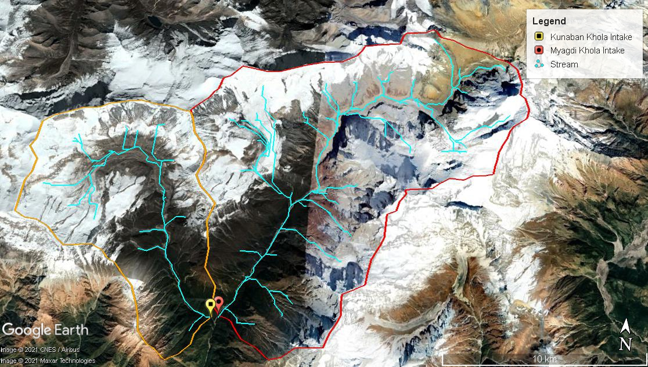

Myagdi Khola

Kunaban Khola

Figure 2‑1: Myagdi Khola catchment at proposed weir site in satellite image

Myagdi River is a gauged river, and it has a hydrometric station located near Mangalghat (404.7) with published stream flow records from 1976-2015. Since the data in the beginning years is sparse, 30 years of flow data from the year 1985-2015 have been used for the station 404.7. The catchment area plays vital role in all the methods used for the hydrological estimation. Hence, the catchment area needs to be calculated precisely.

Catchment area has been calculated by catchment delineation using GIS. The 90 m SRTM DEM data covering the Project area was taken from SRTM data source http://srtm.csi.cgiar.org/SELECTION/inputCoord.asp. Catchment area of Myagdi Khola at the proposed intakes of project, at Myagdi and Kunaban Khola have been recalculated by this method.

The recalculated catchment area at the intake of Myagdi Khola is 210.1 km2 and at the intake of Kunaban Khola is 95.0 km2.It means that total area contributing to the headworks of Myagdi Khola HPP is 305.1 km2. The catchment area calculated in the previous UFSR of Myagdi Khola HPP was 305 km2 and in previous UFSR of Myagdi khola (by Technoquarry) was 306 km2. As, the catchment area calculated in different phases of study is comparable, the catchment area of 305.1 km2 has been considered for the intake. Hence, the total catchment area considered for MKHPP at intake is 305.1 km2 and at tailrace is 346.5 km2.

The catchment area at the proposed intake and tailrace of MKHPP is shown in Table 2‑1 and Table 2‑2. The elevation wise catchment area at the proposed intake of MKHPP is shown in Figure 2‑2.

Table 2‑1: Hypsometric data of the catchment at intake of MKHPP

|  |  |  |  |  |  |  |
| --- | --- | --- | --- | --- | --- | --- |
| **Elevation (masl)** | **Myagdi Intake** | | **Kunaban Intake** | | **Total Area Contributing to Intake at MKHPP** | |
| **Area (km2)** | **%** | **Area (km2)** | **%** | **Area (km2)** | **%** |
| >5000 | 128.9 | 61.4% | 56.8 | 59.7% | 185.7 | 60.9% |
| 5000-3000 | 78.1 | 37.2% | 35.0 | 36.9% | 113.1 | 37.1% |
| <3000 | 2.98 | 1.4% | 3.24 | 3.4% | 6.22 | 2.0% |
| Total | 210.1 | 100.0% | 95.0 | 100.0% | **305.1** | 100.0% |

Table 2‑2: Hypsometric data of the catchment at tailrace of MKHPP

|  |  |  |
| --- | --- | --- |
| **Elevation (masl)** | **Tailrace of MKHPP** | |
| **Area (km2)** | **%** |
| >5000 | 186.8 | 53.9% |
| 5000m-3000 | 134.63 | 38.9% |
| <3000 | 25.03 | 7.2% |
| Total | **346.5** | 100.0% |

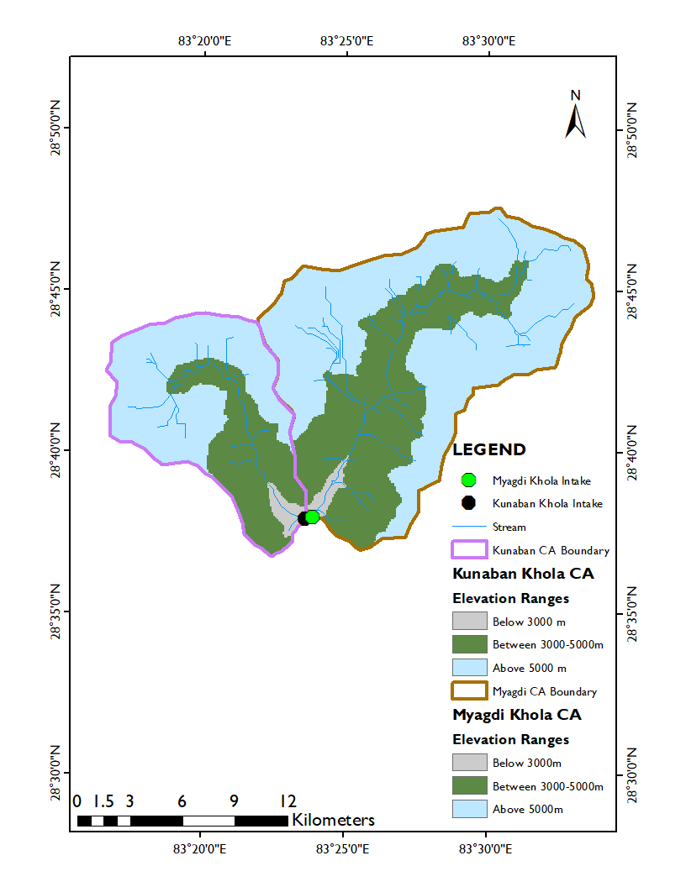

Figure 2‑2: Elevation wise area distribution of MKHPP catchments at intake sites of Myagdi and Kunaban

The hypsometric data of the catchment of Myagdi khola HPP shows that above 50% of the catchment at the intake lies above 5000 m elevation which means the catchment is highly influenced by snow contribution.







## Climate

Since catchment of the Myagdi Khola has wide variation in elevation, its climatic condition varies with altitude. As per climatic zone of Nepal, the catchment lies in between cool (2,000-3,000m) zone having mean annual air temperature of 10°to 15°C and arctic (4,500-5,000m) zone having mean annual air temperature of 0°to 2.5°C. The catchment at upper reach is surrounded by High Himalayan, thus having an arctic climate zone and the lower reach below the catchment has warm temperate climate zone having mean annual air temperature of 15° to 20°C.

The High Mountain Range in the north essentially forms a barrier forcing the monsoon brought about by orographic effects to pour down south of this range. Rainfall intensity varies throughout the catchment according to the degree of exposure with maximum intensities occurring on the south facing slopes. Rainfall intensity also varies in the catchment with elevation. In general, the amount of precipitation is highest in the south at the lower elevations and gradually decreases to the north with increase in elevation.

Winter precipitation in the region is sparse and falls as snow on the higher peaks. The period from October to November represents a general climatic transition to winter conditions. Rainfall is rare during this period. From the end of January until May, the region becomes progressively warmer. The permanent snow line is at El. 5000 m. From March onwards the snow line shifts upwards resulting in a gradual increase in river flows due to snowmelt.

## Available Data

### Hydrological Data

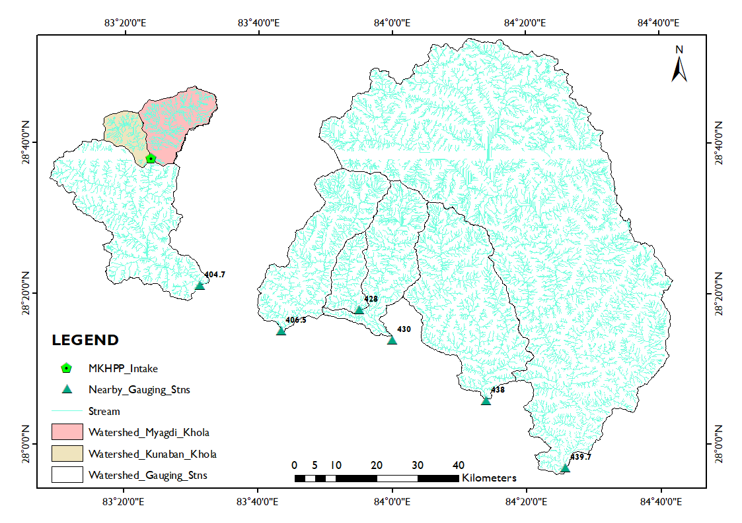

Figure 2‑3: Nearby river gauging stations considered for Myagdi Khola

Proposed intake sites of the Myagdi Khola does not have any long-term stream flows record. However, there is a gauging station no. 404.7 established by the department of Hydrology and Meteorology along the Myagdi Khola at Mangalaghat which is approximately 33km downstream from the proposed intake of Myagdi Khola HPP. Similarly, in the vicinity of the project area toward the east, there are also other five gauging stations (406.5, 428, 430, 438 and 439.7) having time series of data more than 20 years. These stations have been considered for the purpose of regional hydrological analysis. The western side of the catchment does not have any gauging stations having similar physiographic characteristics. The characteristics of these gauging stations are presented in Table 2‑3 and their locations in Figure 2‑3.

Table 2‑3: Hydrometric Stations located near the project catchment

| **S. N** | **Station** | **River** | **Location** | **Elevation (m)** | **Data Record** | | **Catchment Area**  **(km2)** |
| --- | --- | --- | --- | --- | --- | --- | --- |
|  |  | **Length** | **Period** |
| 1 | 404.7 | Myagdi Khola | Mangalaghat | 914 | 39 | 1976 - 2015 | 1067.71 |
| 2 | 406.5 | Modi Khola | Nayapul | 701 | 39 | 1976 - 2015 | 558.09 |
| 3 | 428 | Mardi Khola | Lahachowk | 915 | 41 | 1974 - 2015 | 139.50 |
| 4 | 430 | Seti Nadi | Phoolbari | 830 | 20 | 1964 - 1984 | 537.01 |
| 5 | 438 | Madi Nadi | Shisaghat | 457 | 45 | 1963 - 2008 | 847.12 |
| 6 | 439.7 | Marsyandi Nadi | Bimalnagar | 354 | 28 | 1987 - 2015 | 4055.12 |

Modi Khola, Seti Nadi and Madi Nadi originate from Annapurna Himalayan Range whereas, Myagdi Khola originates from Dhaulagiri Himalayan Range and Marsyandi Nadi originates from Annapurna Himalayan Range and Manaslu Himal. Mardi Khola is a tributary of Seti Nadi. Since Dhaulagiri Himalayan Range, Annapurna Himalayan Range and Manaslu Himal are nearest to each other; their physiographic characteristics can be considered to be similar. The daily flow data of adopted gauge stations have been included in Annex A of this report.

### Gauge Installation and data recording

Discharges have been measured in Myagdi Khola at four different locations by current meter. The locations are presented in Table 2‑4:

Table 2‑4: Location of Discharge measurement in Myagdi Khola

| **S.N.** | **Location** | **Longitude** | **Latitude** |
| --- | --- | --- | --- |
| 1 | Upstream of confluence at Myagdi Khola (Headworks at Myagdi Khola) | 83°23'39.96" | 28°37'52.58" |
| 2 | Upstream of confluence at Kunaban Khola (Headworks at Kunaban Khola) | 83°22'6.61" | 28°37'59.30" |
| 3 | Downstream of Confluence at Dovan | 83°23'40.67" | 28°37'40.55" |
| 4 | Jeltung, near PH location of MKHPP | 83°23'10.02" | 28°34'5.95" |

The measured discharge received till date, at the downstream of confluence at Dovan are used for the comparison with adopted flow for MKHPP. These measured flows are shown in Table 2‑5 below. Also, an Automatic Water Level Recorder (AWLR) has been installed in the confluence area, which is used to measure water depth. The available discharges and stages measured as shown in Table 2‑6 have been used to create a rating curve for Myagdi Khola as shown in Figure 2‑4.

Table 2‑5: Summary of Measured discharge at downstream of Confluence of Myagdi and Kunban (at Dovan)

| **Months** | **Measured Discharge(m3/s)** | | | |
| --- | --- | --- | --- | --- |
| **Daily** | **Average** | **Minimum** | **Maximum** |
| Baishakh | 7.157, 12.31, 7.25, 8.15 | **8.72** | **7.157** | **12.31** |
| Jestha | 17.08 | **17.08** | **17.08** | **17.08** |
| Asar |  |  |  |  |
| Shrawan | 32.54, 28.48 | **30.51** | **28.48** | **32.54** |
| Bhadra | 29.18, 30.57 | **29.88** | **29.18** | **30.57** |
| Asoj |  |  |  |  |
| Kartik |  |  |  |  |
| Mangsir | 5.325 | **5.33** | **5.325** | **5.325** |
| Paush | 4.652, 3.39, 4.612 | **4.22** | **3.39** | **4.652** |
| Magh | 3.465, 3.512, 4.206, 4.016, 3.928 | **3.83** | **3.465** | **4.206** |
| Falgun | 4.134, 4.292, 4.297, 4.897, 4.373, 4.249, 3.939, 3.11 | **4.31** | **3.11** | **4.897** |
| Chaitra | 5.965, 5.618, 5.665, 5.858, 9.03 | **6.43** | **5.618** | **9.03** |

Table 2‑6: Summary of available stage and discharge data at downstream of confluence of Myagdi and Kunban (at Dovan)

| **Date** | **Discharge (m3/s)** | **Stage (m)** |
| --- | --- | --- |
| 16 Poush 2076 | 3.39 | 0.46 |
| 1 Falgun 2076 | 3.11 | 0.45 |
| 16 Chaitra 2076 | 9.03 | 0.66 |
| 11 Baisakh 2077 | 12.31 | 0.85 |
| 1 Jestha 2077 | 17.08 | 1.24 |
| 10 Baisakh 2078 | 7.25 | 0.75 |
| 17 Baisakh 2078 | 8.15 | 0.78 |
| 16 Shrawan 2078 | 32.54 | 3.19 |
| 17 Shrawan 2078 | 28.48 | 2.92 |
| 15 Bhadra 2078 | 29.18 | 3.05 |
| 16 Bhadra 2078 | 30.57 | 3.1 |

Figure 2‑4: Stage Discharge (Rating) curve for Myagdi Khola HPP developed from available data till date

The equation of the rating curve is given by,



Where Q is discharge in river in m3/s, G is stage in m, α is stage in the river when there is no discharge, Cr and β are the calibration parameters.

The equation of the rating curve after calibration is found to be,



The rating curve has been prepared with very limited data so it is recommended to perform continuous measurements of discharge and stage in the desired project area. At least 2 years’ data is required to develop a reliable rating curve. Furthermore, the rating curve has been prepared from dry season flow only, hence two rating curves including wet season flow should be developed.

### Meterological Data

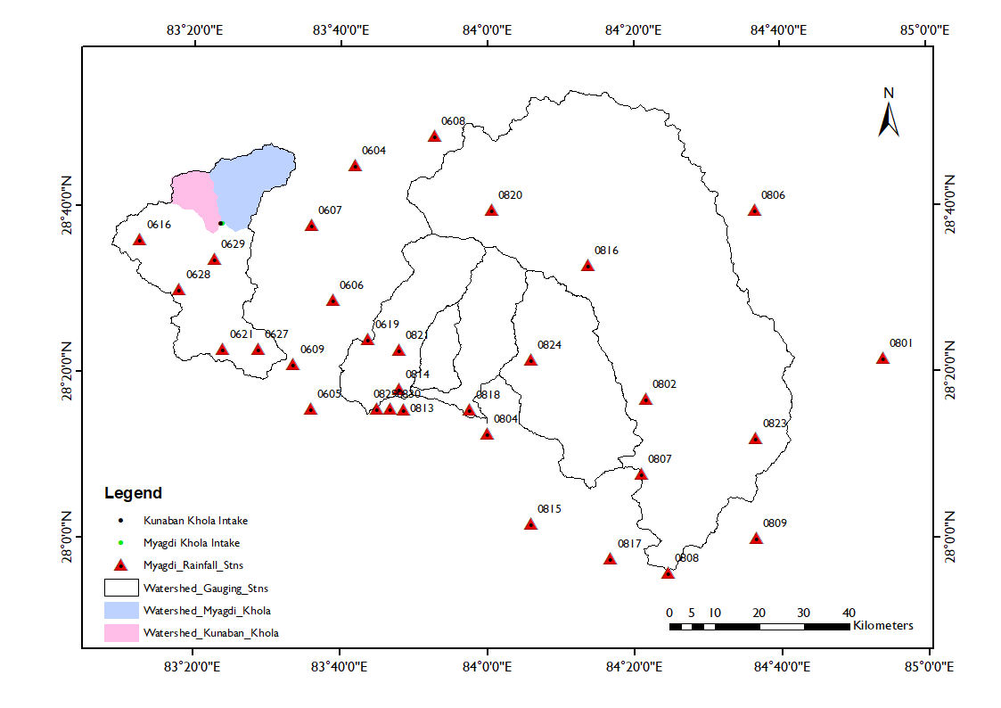

Figure 2‑5: Nearby meteorological stations considered for Myagdi Khola

Precipitations data are important to know the weather condition of the project site as well as to derive the hydrological parameters. There are no established rainfall stations within Myagdi Khola catchment. The rainfall data from the stations located in the vicinity of the Myagdi catchment have been collected from DHM. Also, the rainfall stations in the vicinity of the gauging stations considered for the hydrological analysis of Myagdi Khola have been collected from DHM. All the rainfall stations considered during the analysis are presented in Table 2‑7 and their locations are shown in Figure 2‑5. Although the span of data record available has been stated in the table below, there are many missing data. Also, some stations have years in between with no data. The mean monthly precipitation data have been included in Annex A of this report.

Table 2‑7: Metrological stations laying in the vicinity of the catchment

| **S. N** | **Stn No.** | **Stn. Name** | **Latitude** | **Longitude** | **Elevation (masl)** | **Data Record, available** | **Annual Precipitation, mm** |
| --- | --- | --- | --- | --- | --- | --- | --- |
| 1 | 604 | Thakmarpha | 28.75 | 83.7 | 2566 | 1967-2020 | 401 |
| 2 | 605 | Baglung | 28.26 | 83.6 | 984 | 1978-2014 | 1870 |
| 3 | 606 | Tatopani | 28.48 | 83.65 | 1243 | 1978-2008 | 1577 |
| 4 | 607 | Lete | 28.63 | 83.6 | 2384 | 1970-2021 | 1310 |
| 5 | 608 | Ranipauwa (M.Nath) | 28.81 | 83.88 | 3609 | 1978-2013 | 260 |
| 6 | 609 | Beni Bazar | 28.35 | 83.56 | 835 | 1979-2008 | 1544 |
| 7 | 616 | Gurja Khani | 28.6 | 83.21 | 2530 | 1979-2014 | 1887 |
| 8 | 619 | Ghorepani | 28.4 | 83.73 | 2742 | 1975-2010 | 2804 |
| 9 | 621 | Darbang | 28.38 | 83.4 | 1160 | 1989-2010 | 1979 |
| 10 | 627 | Kuhun | 28.38 | 83.48 | 1550 | 1992-2010 | 1539 |
| 11 | 628 | Muna | 28.5 | 83.3 | 1970 | 1992-2010 | 2479 |
| 12 | 629 | Baghara | 28.56 | 83.38 | 2330 | 1992-2020 | 2919 |
| 13 | 801 | Jagat (Setibas) | 28.36 | 84.9 | 1334 | 1979-2008 | 1202 |
| 14 | 802 | Khudi Bazar | 28.28 | 84.36 | 832 | 1979-2008 | 3381 |
| 15 | 804 | Pokhara Airport | 28.21 | 84 | 827 | 1979-2008 | 3921 |
| 16 | 806 | Larke Samdo | 28.66 | 84.61 | 3650 | 1978-2010 | 966 |
| 17 | 807 | Kunchha | 28.13 | 84.35 | 855 | 1979-2008 | 2589 |
| 18 | 808 | Bandipur | 27.93 | 84.41 | 965 | 1979-2008 | 1766 |
| 19 | 809 | Gorkha | 28 | 84.61 | 1097 | 1979-2008 | 1656 |
| 20 | 813 | Bhadaure Deurali | 28.26 | 83.81 | 1600 | 1985-2008 | 4051 |
| 21 | 814 | Lumle | 28.3 | 83.8 | 1740 | 1979-2008 | 5459 |
| 22 | 815 | Khairini Tar | 28.03 | 84.1 | 500 | 1979-2008 | 2348 |
| 23 | 816 | Chame | 28.55 | 84.23 | 2680 | 1979-2012 | 918 |
| 24 | 817 | Damauli | 27.96 | 84.28 | 358 | 1979-2008 | 1806 |
| 25 | 818 | Lamachaur | 28.26 | 83.96 | 1070 | 1979-2008 | 4191 |
| 26 | 820 | Manang Bhot | 28.66 | 84.01 | 3420 | 1979-2012 | 430 |
| 27 | 821 | Ghandruk | 28.38 | 83.8 | 1960 | 1976-2010 | 3254 |
| 28 | 823 | Gharedhunga | 28.2 | 84.61 | 1120 | 1979-2010 | 3019 |
| 29 | 824 | Siklesh | 28.36 | 84.1 | 1820 | 1979-2008 | 3773 |
| 30 | 829 | Sallyan | 28.26 | 83.75 | 100 | 1992-2010 | 3851 |
| 31 | 830 | Pamdur | 28.26 | 83.78 | 1160 | 1992-2010 | 5012 |

Precipitation in the project catchment was estimated based on the precipitation recorded in nearby DHM stations (Figure 2‑6). The meteorological stations 0601 (Jomsom), 0604 (Thakmarph), 0607 (Lete), 0616 (Gurja Khani), 0625 (Sanda), 0628 (Muna), 0629 (Baghara) established by Department of Hydrology and Meteorology (DHM) are used for estimating precipitation in the catchment (Table 2‑8).

The following stations are considered for rainfall analysis.

Table 2‑8: DHM meteorological stations near project catchment

|  |  |  |
| --- | --- | --- |
| **Station no.** | **Station name** | **Annual Average Precipitation mm** |
| 601 | JOMSOM | 259 |
| 604 | THAKMARPHA | 389 |
| 607 | LETE | 1285 |
| 616 | GURJA KHANI | 1857 |
| 625 | SANDA | 213 |
| 628 | MUNA | 2610 |
| 629 | BAGHARA | 2968 |

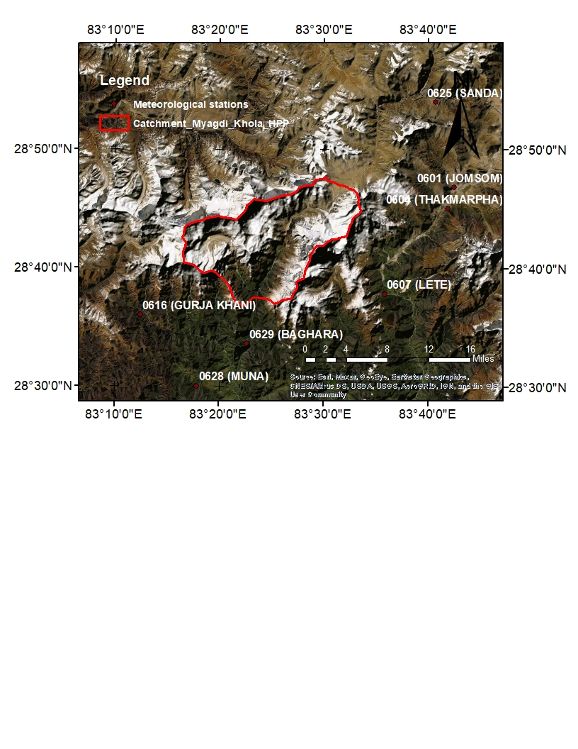

Figure 2‑6: DHM Meteorological stations near project catchment

The point rainfall recorded in the stations mentioned above have been used to estimate the areal rainfall in the catchment. The mean annual precipitation in the catchment have been estimated by Thiessen polygon method and Inverse Distance Weighted method.

## Basin Rainfall

Annual average basin rainfall of the catchments has been recalculated from the rainfall stations presented in Table 2‑8 using interpolation methods of IDW, Thiessen Polygon and creating Isohyets and from Natural neighbor method. Result of the analysis is presented hereunder in Table 2‑9.

Table 2‑9: Basin average annual rainfall

| **Catchment** | **Basin average Annual Precipitation (mm)** | | | | |
| --- | --- | --- | --- | --- | --- |
| **Annual Average of satellite data** | **IDW** | **Theissen Polygon** | **Isohyetal (Kriging)** | **Natural Neighbour** |
| Myagdi khola @ Mangalaghat (404.7) | 1757 | 2108 | 2245 | 2146 | 1878 |
| Modikhola @ Nayapul (406.5) | 3145 | 3058 | 2745 | 2609 | 2550 |
| Mardikhola @ Lahachowk (428.0) | 4302 | 3827 | 3791 | 3748 | 3403 |
| Seti khola @ Phoolbari (430.0) | 3250 | 3446 | 3300 | 3174 | 3022 |
| Madi Khola @ Shisaghat (438.0) | 2822 | 3180 | 3196 | 3086 | 3080 |
| Marshyandi khola @ Bimalnagar (439.7) | 1705 | 1870 | 1615 | 1685 | 1556 |
| Myagdi Intake | 1544 | 1792 | 2016 | 1835 | 1154 |
| Kunaban Intake | 2403 | 2112 | 2515 | 2190 | 1452 |
| Myagdi Khola HPP \_intake | 1629 | 1952 | 2171 | 2013 | 1303 |
| Myagdi Khola HPP \_tailrace | 1629 | 1958 | 2261 | 2001 | 1339 |
| **Remarks** |  |  |  | **Adopted** |  |

Due to less dense precipitation stations near catchment area, IDW cannot give the correct result as compared to isohyetal method. Theissen polygon does not consider the impact of all the stations in the proximity. Natural neighbour method is highly sensitive to the spatial pattern of the data locations. Hence, the result from isohyetal method is adopted as it also includes the effects of local features. The detailed calculation has been included in Annex A of this report.

## Long Term Mean Monthly Flow

The daily flow data and long term mean monthly flow is to be derived from indirect methods. Mean monthly flow adopted in the updated feasibility study of MKHPP by Technoquarry has been crosschecked with the flow estimated from current updated feasibility study by HCE. A minor difference has been noticed between the flow adopted in the previous UFSR and current UFSR study. In the previous report, the catchment area from DHM had been considered for the calculation, whereas in the current study, the catchment area has been recalculated using 90m SRTM DEM. The mean monthly flow has been recalculated from various methods in this updated feasibility study. In this review, updated data up to 2015 has been considered while in previous study, flow data up to 2006 was considered.

Flow measurement data available till date, at the downstream of confluence, at Dovan have also been used to validate the adopted mean monthly flow for MKHPP. The adopted mean monthly flow will be further validated with the measured flow data after getting more data as the flow measurement has been ongoing since April 2015.

The brief description of the methods adopted to calculate the mean monthly flow and comparison of the results from these methods are given in following sub-sections.

### Catchment Correlation

Since there is no availability of hydrological data of the project area, an attempt was made to correlate the flows using the area ratio from the flows with Myagdi Khola at Mangalaghat in previous Updated Feasibility Study. In this study, Catchment correlation has been performed with other six nearby gauging stations as well. The catchment parameters of intake at Myagdi, intake at kunaban and total of these two catchments are tabulated in Table 2‑10 for comparison of the catchment characteristics.

Table 2‑10: Catchment parameters

|  |  |  |  |  |  |  |
| --- | --- | --- | --- | --- | --- | --- |
| **Elevation (masl)** | **Myagdi Intake** | | **Kunaban Intake** | | **Total Catchment contributing to Intake of MKHPP** | |
| **Area (km2)** | **%** | **Area (km2)** | **Area (km2)** | **%** | **%** |
| >5000 | 128.9 | 61.4% | 56.8 | 59.7% | 185.7 | 60.9% |
| 5000-3000 | 78.1 | 37.2% | 35.0 | 36.9% | 113.1 | 37.1% |
| <3000 | 2.98 | 1.4% | 3.24 | 3.4% | 6.22 | 2.0% |
| Total | **210.1** | 100.0% | **95.0** | 100.0% | **305.1** | 100.0% |

|  |  |  |  |  |  |  |  |  |  |  |  |  |
| --- | --- | --- | --- | --- | --- | --- | --- | --- | --- | --- | --- | --- |
| **Elevation (masl)** | **Myagdi khola @ Mangalaghat (404.7)** | | **Modi khola @ Nayapul (406.5)** | | **Mardi khola @ Lahachowk (428.0)** | | **Seti khola @ Phoolbari (430.0)** | | **Madi Khola @ Shisaghat (438.0)** | | **Marshyandi khola @ Bimalnagar (439.7)** | |
|  | **Area (km2)** | **%** | **Area (km2)** | **%** | **Area (km2)** | **%** | **Area (km2)** | **%** | **Area (km2)** | **%** | **Area (km2)** | **%** |
| >5000 | 206.4 | 19.3% | 117.8 | 21.1% | 0.4 | 0.3% | 48.7 | 9.1% | 62.0 | 7.3% | 1157.6 | 28.5% |
| 5000-3000 | 338.9 | 31.7% | 174.4 | 31.2% | 26.0 | 18.6% | 181.5 | 33.8% | 164.5 | 19.4% | 1557.5 | 38.4% |
| <3000 | 522.4 | 48.9% | 265.9 | 47.6% | 113.1 | 81.1% | 306.7 | 57.1% | 620.6 | 73.3% | 1340.0 | 33.0% |
| Total | 1067.7 | 100.0% | 558.1 | 100.0% | 139.5 | 100.0% | 537.0 | 100.0% | 847.1 | 100.0% | 4055.1 | 100.0% |

The catchment of Myagdi Khola HPP at intake (Myagdi and Kunaban Khola) and nearby gauging stations considered for hydrological analysis has been shown in Figure 2‑3 above.

## 

The catchment of Myagdi Khola HPP which comprises of Myagdi Khola Intake and Kunaban Khola Intake has been correlated with the catchment of the DHM’s gauging station no. 404.7 along the Myagdi Khola at Mangalaghat to generate the mean daily flows at proposed intake site of Myagdi Khola HPP. The similar procedure has been followed to correlate with other five nearby catchments (mentioned in section 2.4.1). The calculated long-term mean daily flows in English Calendar has been converted into Nepali Calendar based on 2077 BS and finally, mean daily flows in the corresponding Nepali month were averaged to calculate the long-term mean monthly flow. The summary of mean monthly flow at the intake of Myagdi Khola, Kunaban Khola and intake of MKHPP (sum of Myagdi intake and Kunaban intake) from catchment correlation method with six gauging stations have been tabulated in Table 2‑11, Table 2‑12, and Table 2‑13 respectively.

Table 2‑11: Long-term mean monthly flows by catchment correlation (CAR) at Myagdi Khola Intake

|  |  |  |  |  |  |  |
| --- | --- | --- | --- | --- | --- | --- |
| **Month** | **Mean monthly flow at the intake of Myagdi Khola by CAR with** | | | | | |
| **Myagdi khola @ Mangalaghat (404.7)** | **Modi khola @ Nayapul (406.5)** | **Mardi khola @ Lahachowk (428.0)** | **Seti khola @ Phoolbari (430.0)** | **Madi Khola @ Shisaghat (438.0)** | **Marshyandi khola @ Bimalnagar (439.7)** |
| *CAR Coefficient* | **0.09** | **0.17** | **0.68** | **0.18** | **0.11** | **0.02** |
| Baisakh | 4.03 | 5.56 | 4.58 | 5.64 | 5.27 | 3.43 |
| Jestha | 8 | 10.67 | 8.84 | 9.75 | 10.31 | 7.18 |
| Ashar | 25.63 | 38.79 | 41.48 | 32.77 | 34.72 | 22.22 |
| Shrawan | 45.41 | 82.1 | 76.39 | 57.6 | 54.01 | 33.89 |
| Bhadra | 38.12 | 56.08 | 71.66 | 47.49 | 48.31 | 31.24 |
| Ashoj | 17.34 | 25.28 | 34.89 | 29.56 | 23.89 | 15.31 |
| Kartik | 7.94 | 10.18 | 13.71 | 12.6 | 10.68 | 6.74 |
| Mangsir | 4.75 | 6.57 | 7.43 | 7.65 | 6.54 | 4.05 |
| Poush | 3.45 | 4.84 | 5.54 | 5.47 | 4.82 | 3 |
| Magh | 2.79 | 3.89 | 4.62 | 4.56 | 4.04 | 2.48 |
| Falgun | 2.5 | 3.43 | 4.25 | 4.2 | 3.7 | 2.34 |
| Chaitra | 2.86 | 3.79 | 4.09 | 4.37 | 3.91 | 2.45 |
| **Average** | **13.6** | **20.9** | **23.1** | **18.5** | **17.5** | **11.2** |

Table 2‑12: Long-term mean monthly flows by catchment correlation (CAR) at Kunaban Khola Intake

|  |  |  |  |  |  |  |
| --- | --- | --- | --- | --- | --- | --- |
| **Month** | **Mean monthly flow at the intake of Kunaban Khola by CAR with** | | | | | |
| **Myagdi khola @ Mangalaghat (404.7)** | **Modi khola @ Nayapul (406.5)** | **Mardi khola @ Lahachowk (428.0)** | **Seti khola @ Phoolbari (430.0)** | **Madi Khola @ Shisaghat (438.0)** | **Marshyandi khola @ Bimalnagar (439.7)** |
| *CAR Coefficient* | **0.29** | **0.55** | **2.19** | **0.57** | **0.36** | **0.08** |
| Baisakh | 1.82 | 2.51 | 2.07 | 2.55 | 2.38 | 1.55 |
| Jestha | 3.62 | 4.83 | 4 | 4.41 | 4.67 | 3.25 |
| Ashar | 11.6 | 17.55 | 18.77 | 14.83 | 15.71 | 10.05 |
| Shrawan | 20.55 | 37.15 | 34.57 | 26.06 | 24.44 | 15.34 |
| Bhadra | 17.25 | 25.38 | 32.42 | 21.49 | 21.86 | 14.13 |
| Ashoj | 7.84 | 11.44 | 15.79 | 13.38 | 10.81 | 6.93 |
| Kartik | 3.59 | 4.61 | 6.21 | 5.7 | 4.83 | 3.05 |
| Mangsir | 2.15 | 2.97 | 3.36 | 3.46 | 2.96 | 1.83 |
| Poush | 1.56 | 2.19 | 2.51 | 2.48 | 2.18 | 1.36 |
| Magh | 1.26 | 1.76 | 2.09 | 2.06 | 1.83 | 1.12 |
| Falgun | 1.13 | 1.55 | 1.92 | 1.9 | 1.68 | 1.06 |
| Chaitra | 1.29 | 1.71 | 1.85 | 1.98 | 1.77 | 1.11 |
| **Average** | **0.29** | **0.55** | **2.19** | **0.57** | **0.36** | **0.08** |

Table 2‑13: Long-term mean monthly flows by catchment correlation (CAR) for MKHPP intake (sum of Table 1‑9 and Table 1‑10)

|  |  |  |  |  |  |  |
| --- | --- | --- | --- | --- | --- | --- |
| **Month** | **Mean monthly flow at the MKHPP Intake by CAR with** | | | | | |
| **Myagdi khola @ Mangalaghat (404.7)** | **Modi khola @ Nayapul (406.5)** | **Mardi khola @ Lahachowk (428.0)** | **Seti khola @ Phoolbari (430.0)** | **Madi Khola @ Shisaghat (438.0)** | **Marshyandi khola @ Bimalnagar (439.7)** |
| *CAR Coefficient* | **0.2** | **0.38** | **1.51** | **0.39** | **0.25** | **0.05** |
| Baisakh | 5.85 | 8.07 | 6.65 | 8.19 | 7.65 | 4.98 |
| Jestha | 11.62 | 15.5 | 12.84 | 14.16 | 14.98 | 10.43 |
| Ashar | 37.22 | 56.34 | 60.24 | 47.6 | 50.43 | 32.28 |
| Shrawan | 65.96 | 119.24 | 110.96 | 83.67 | 78.45 | 49.23 |
| Bhadra | 55.37 | 81.46 | 104.08 | 68.98 | 70.17 | 45.37 |
| Ashoj | 25.18 | 36.72 | 50.68 | 42.94 | 34.7 | 22.24 |
| Kartik | 11.53 | 14.79 | 19.92 | 18.31 | 15.51 | 9.79 |
| Mangsir | 6.90 | 9.55 | 10.8 | 11.11 | 9.49 | 5.88 |
| Poush | 5.00 | 7.03 | 8.04 | 7.95 | 7.00 | 4.35 |
| Magh | 4.06 | 5.65 | 6.72 | 6.62 | 5.86 | 3.6 |
| Falgun | 3.63 | 4.98 | 6.17 | 6.11 | 5.38 | 3.39 |
| Chaitra | 4.15 | 5.5 | 5.94 | 6.35 | 5.68 | 3.55 |
| **Average** | **19.71** | **30.4** | **33.59** | **26.83** | **25.44** | **16.26** |

### Regional Regression Analysis

The regional analysis method has been used to estimate mean flow series at the proposed intake site. In this method, the long term mean monthly flow has been estimated from the relationship obtained between the monthly flow of each month of the known stations and their respective catchment area.

The regression analysis is carried out between the monthly flow of the known stations for each month and their respective catchment area and the equation obtained is as follows:

Y=aX^b

Where

Y=Mean monthly flow for each month at the proposed intake site

X=Catchment area at the intake site, Km2

a and b= constants generated from the graph

The gauging stations considered for the development of regional regression equation between mean monthly flow and the catchment area are presented in Table 2‑14.

Table 2‑14: Details of stations considered for regional regression

|  |  |  |  |  |  |
| --- | --- | --- | --- | --- | --- |
| **SN.** | **Station** | **River** | **Location** | **Data Record** | **Catchment Area (Km2)** |
| 1 | 404.7 | Myagdi | Mangalaghat | 1976-2015 | 1067.71 |
| 2 | 406.5 | Modi | Nayapul | 1976-2015 | 558.09 |
| 3 | 428.0 | Mardi | Lahachowk | 1974-2015 | 139.50 |
| 4 | 430.0 | Seti | Phoolbari | 1964-1984 | 537.01 |
| 5 | 438.0 | Madi | Shisaghat | 1963 - 2008 | 847.12 |
| 6 | 439.7 | Marshyandi | Bimalnagar | 1987 - 2015 | 4055.12 |

For all reference six gauging stations in the vicinity of the project area, available daily flows of the corresponding day in the corresponding year were averaged to calculate the long-term mean daily flow. The calculated long-term mean daily flows in English Calendar were converted into Nepali Calendar based on 2077 BS and then, mean daily flows in the corresponding Nepali month were averaged to calculate the long-term mean monthly flow as tabulated in Table 2‑15.

Table 2‑15: Long-term mean monthly flow of the reference gauging stations

|  |  |  |  |  |  |  |
| --- | --- | --- | --- | --- | --- | --- |
| **Month** | **Myagdi Khola (404.7)** | **Modi Khola (406.5)** | **Mardi Khola (428)** | **Seti Nadi (430)** | **Madi Nadi (438)** | **Marsyandi Nadi (439.7)** |
| C.A, km2 | 1067.71 | 558.09 | 139.50 | 537.01 | 847.12 | 4055.12 |
| Baishakh | 20.49 | 14.76 | 3.04 | 14.42 | 21.25 | 66.14 |
| Jesth | 40.68 | 28.35 | 5.87 | 24.93 | 41.60 | 138.64 |
| Ashar | 130.27 | 103.07 | 27.55 | 83.79 | 140.05 | 429.03 |
| Shrawan | 230.85 | 218.14 | 50.74 | 147.28 | 217.84 | 654.34 |
| Bhadra | 193.80 | 149.02 | 47.59 | 121.42 | 194.84 | 603.12 |
| Ashoj | 88.13 | 67.17 | 23.18 | 75.59 | 96.35 | 295.69 |
| Kartik | 40.37 | 27.05 | 9.11 | 32.22 | 43.06 | 130.19 |
| Mangsir | 24.16 | 17.46 | 4.94 | 19.56 | 26.36 | 78.19 |
| Poush | 17.51 | 12.86 | 3.68 | 11.65 | 19.45 | 57.84 |
| Magh | 14.21 | 10.34 | 3.07 | 14.00 | 16.28 | 47.86 |
| Falgun | 12.69 | 9.12 | 2.82 | 10.75 | 14.94 | 45.09 |
| Chaitra | 14.54 | 10.06 | 2.72 | 11.18 | 15.76 | 47.23 |
| **Average** | **20.49** | **14.76** | **3.04** | **14.42** | **21.25** | **66.14** |

The calculated long-term mean monthly flows against total catchment area of the corresponding reference gauging stations were plotted on a log scale for each month of the year (Baishakh to Chaitra). The regression equations along with the corresponding coefficient of correlation R2, thus obtained, for each month were used to estimate the long-term mean monthly flow at the proposed intake site of Myagdi Khola, Kunaban Khola and intake of MKHPP as presented in Table 2‑16, Table 2‑17, and Table 2‑18 respectively.

Table 2‑16: Long-term mean monthly flows at Myagdi Khola intake from regional regression analysis

|  |  |  |  |
| --- | --- | --- | --- |
| **Month** | **Regression Equation** | **Value of R2** | **Discharge (m3/s)** |
| Baishakh | Y=0.045X^0.8935 | 0.9736 | 5.34 |
| Jestha | Y=0.0707X^0.9249 | 0.9837 | 9.93 |
| Ashar | Y=0.5568X^0.8028 | 0.9848 | 40.73 |
| Shrawan | Y=1.488X^0.7387 | 0.9618 | 77.25 |
| Bhadra | Y=1.1954X^0.7465 | 0.99 | 64.7 |
| Ashoj | Y=0.6394X^0.7353 | 0.9792 | 32.6 |
| Kartik | Y=0.2101X^0.7752 | 0.9831 | 13.25 |
| Mangsir | Y=0.1072X^0.7998 | 0.9775 | 7.71 |
| Poush | Y=0.0723X^0.8079 | 0.9869 | 5.43 |
| Magh | Y=0.0729X^0.7866 | 0.9544 | 4.89 |
| Falgun | Y=0.0579X^0.8031 | 0.9745 | 4.24 |
| Chaitra | Y=0.0512X^0.8301 | 0.9793 | 4.33 |

Note: Y=long-term mean monthly flow in m3/s and X=drainage area in km2.

In above table, the values of R2 are more than 0.90 for each month. Thus, it shows a good fit between the data and the generated regression equations for each month can give reliable results.

Table 2‑17: Long-term mean monthly flows of Kunaban Khola Intake from regional regression analysis

|  |  |  |  |
| --- | --- | --- | --- |
| **Month** | **Regression Equation** | **Value of R2** | **Discharge (m3/s)** |
| Baishakh | Y=0.045X^0.8935 | 0.9736 | 2.63 |
| Jestha | Y=0.0707X^0.9249 | 0.9837 | 4.77 |
| Ashar | Y=0.5568X^0.8028 | 0.9848 | 21.55 |
| Shrawan | Y=1.488X^0.7387 | 0.9618 | 43.01 |
| Bhadra | Y=1.1954X^0.7465 | 0.99 | 35.79 |
| Ashoj | Y=0.6394X^0.7353 | 0.9792 | 18.20 |
| Kartik | Y=0.2101X^0.7752 | 0.9831 | 7.17 |
| Mangsir | Y=0.1072X^0.7998 | 0.9775 | 4.09 |
| Poush | Y=0.0723X^0.8079 | 0.9869 | 2.86 |
| Magh | Y=0.0729X^0.7866 | 0.9544 | 2.62 |
| Falgun | Y=0.0579X^0.8031 | 0.9745 | 2.24 |
| Chaitra | Y=0.0512X^0.8301 | 0.9793 | 2.24 |

Note: Y=long-term mean monthly flow in m3/s and X=drainage area in km2.

In above table, the values of R2 are more than 0.90 for each month. Thus, it shows a good fit between the data and the generated regression equations for each month can give reliable results.

Table 2‑18: Long-term mean monthly flows at MKHPP intake from regional regression analysis (sum of Table 1‑14 and Table 1‑15)

|  |  |
| --- | --- |
| **Month** | **Discharge (m3/s)** |
| Baishakh | 7.45 |
| Jestha | 14.02 |
| Ashar | 54.96 |
| Shrawan | 101.78 |
| Bhadra | 85.48 |
| Ashoj | 42.90 |
| Kartik | 17.70 |
| Mangsir | 10.40 |
| Poush | 7.34 |
| Magh | 6.55 |
| Falgun | 5.72 |
| Chaitra | 5.91 |

### Adopted Long-term Mean Monthly Flow

*In Previous Updated Feasibility Study (by Technoquarry)*

In the previous updated feasibility study (by Techno-quarry), the mean monthly flow was calculated using CAR with Mangalaghat and from regional regression analysis using the long term mean monthly flow of nearby stations: 404.7, 406.5, 428, 430, 438, and 439.7. The long-term mean monthly flows calculated from the catchment correlation with Myagdi Khola (404.7) were on lower side whereas the same flows calculated using regional regression analysis of reference six gauging stations were on higher side.

The reasons for lower value from the catchment correlation with Myagdi Khola (404.7) were due to:

* location (42Km downstream from proposed intake site) and
* large catchment area of the DHM’s gauging station 404.7 (3.5 times the catchment of the proposed intake site).

98% of the catchment at proposed intake site of Myagdi Khola HPP lies above 3000m which means the catchment is highly influenced by snow contribution. Regional regression analysis is one of the commonly précised method for estimating mean monthly flow which gives reasonable acceptable result and can be adopted where there are no other better alternatives or direct data is not available from the concerned river. Therefore, to be in conservative side, average of these two methods was recommended to calculate the long-term mean monthly flow at proposed intake site of the MKHPP as presented in Table 2‑19.

Table 2‑19: Adopted long-term mean monthly flow at MKHPP intake in previous UFSR

|  |  |  |  |
| --- | --- | --- | --- |
| **Month** | **CAR with Myagdi Khola (404.7)** | **Regional regression analysis** | **Adopted Discharge (Average)** |
| Baishakh | 5.18 | 6.82 | 6.00 |
| Jestha | 9.17 | 12.42 | 10.80 |
| Ashar | 32.8 | 52.44 | 42.62 |
| Shrawan | 62.34 | 100.53 | 81.44 |
| Bhadra | 52.39 | 83.75 | 68.07 |
| Asoj | 23.27 | 43 | 33.14 |
| Kartik | 10.33 | 17.23 | 13.78 |
| Mangsir | 5.91 | 9.81 | 7.86 |
| Poush | 4.36 | 7.09 | 5.73 |
| Magh | 3.55 | 5.78 | 4.67 |
| Falgun | 3.2 | 5.14 | 4.17 |
| Chaitra | 3.61 | 5.3 | 4.46 |
| **Average** | **18.01** | **29.11** | **23.56** |

*In Present Updated Feasibility Study (by HCE)*

PPA agreement has already been done for Myagdi Khola HPP based on previous UFSR. The flow adopted in PPA agreement for MKHPP has been tabulated in Table 2‑20 below. In this updated feasibility study, long term mean monthly flow for MKHPP has been estimated using CAR, PCAR and regional regression method referring nearby gauging stations as tabulated in Table 2‑14. As out of six-gauge stations considered, station 404.7 is located at Myagdi Khola, the long term mean monthly flow estimated from CAR and PCAR using this station has been tabulated below for comparison. Also, regression analysis using the reference six gauging stations considered are presented in Table 2‑20 below. The available daily measured data at Dovan (confluence of Myagdi and Kunaban), tabulated in Table 2‑5 above have also been presented in the table below for comparison. Along with the comparison table, these long term monthly average flow data have been plotted in a graph with the measured flow data as shown in Figure 2‑7 below.

Table 2‑20: Comparison of long-term mean monthly flow at intake of MKHPP (Myagdi intake+ Kunaban intake)

| **Month** | **PPA** | **Present Updated Feasibility Study** | | | **Measured Discharge @ Dovan** | | **Adopted Flow (PPA flow)** | **Remarks** |
| --- | --- | --- | --- | --- | --- | --- | --- | --- |
| **CAR** | **PCAR** | **Regional analysis** | **Daily** | **Avg.** |
| Baisakh | 6.09 | 5.85 | 5.49 | 7.45 | 7.157, 12.31, 7.25, 8.15 | 8.72 | 6.09 | Measured discharges are on higher side compared to adopted flow. |
| Jestha | 11.8 | 11.62 | 10.90 | 14.02 | 17.08 | 17.08 | 11.8 | Measured discharge is on higher side compared to adopted flow. Also, the adopted flow is comparable to the flow calculated from CAR. |
| Ashar | 45.42 | 37.22 | 34.91 | 54.96 |  |  | 45.42 |  |
| Shrawan | 73.28 | 65.96 | 61.87 | 101.78 | 32.54, 28.48 | 30.51 | 73.28 |  |
| Bhadra | 65.41 | 55.37 | 51.94 | 85.48 | 29.18, 30.57 | 29.88 | 65.41 |  |
| Ashoj | 36.1 | 25.18 | 23.62 | 42.90 |  |  | 36.1 |  |
| Kartik | 13.49 | 11.53 | 10.82 | 17.70 |  |  | 13.49 |  |
| Mangsir | 7.11 | 6.90 | 6.48 | 10.40 | 5.325 | 5.325 | 7.11 | The adopted flow is comparable to the flow calculated from CAR and on the higher side by 32%-34% in comparison to the average of available measured flow. More measured data are needed for validation. |
| Poush | 5.56 | 5.00 | 4.69 | 7.34 | 4.652, 3.39, 4.612 | 4.218 | 5.56 |
| Magh | 4.54 | 4.06 | 3.81 | 6.55 | 3.465, 3.512, 4.206, 4.016, 3.928 | 3.8254 | 4.54 | The adopted flow is comparable to the flow calculated from CAR and on the higher side by 19% in comparison to the average of available measured flow. More measured data are needed for validation. |
| Falgun | 4.36 | 3.63 | 3.40 | 5.72 | 4.134, 4.292, 4.297, 4.897, 4.373, 4.249, 3.939, 3.11 | 4.31 | 4.36 | Adopted flow is comparable to the measured flow. |
| Chaitra | 4.41 | 4.15 | 3.90 | 5.91 | 5.965, 5.618, 5.665, 5.858, 9.03 | 6.43 | 4.41 | Adopted flow is comparable to the flow calculated from CAR and on the lower side compared to the measured flow. |
| **Avg.** | **23.13** | **19.71** | **18.49** | **30.02** |  |  | **23.13** |  |

|  |
| --- |
| Figure 2‑7: Mean monthly hydrograph comparison at the intake of MKHPP |
| Figure 2‑8: Adopted Mean monthly hydrograph at the intake of MKHPP |

The long term mean monthly flow at the intake of MKHPP has been compared in Table 2‑13 and also graphically represented in Figure 2‑7 above. The adopted mean monthly flow for dry months is mostly comparable to the available measured data. Also, they are comparable with the mean monthly flow calculated using CAR with Stn. 404.7 in this Updated Feasibility Study. Hence, the mean monthly flow as considered in PPA and previous feasibility study shall be continued in this updated feasibility study as well.

### Riparian Release

For growing socioeconomic activities around the project area and also from environmental point of view, the project has to release minimum downstream flow to maintain the natural ecosystem. The downstream release is critical especially in those months when the river flow is less than the design flow. As the downstream release has more impact on the energy production of the project, the trade-off between the river ecosystem and energy cost is very important.

Myagdi Khola Hydropower Project (MKHPP) is conceived as a run-of river type project. The long-term mean monthly flow for driest month, Falgun at the intake of MKHPP is 4.36 m3/s. As per prevailing environment act of Nepal, the downstream release should be 10% of minimum long-term mean monthly flow, i.e., 0.436m3/s will be released downstream as the riparian release for aquatic life.

## Flow Duration Curve (FDC) and Design Discharge

The FDC is a probability discharge curve that shows the percentage of time; a particular flow is equaled or exceeded. In a run-off-the-river hydropower project, it is useful to know the variation of flow over the year to make ease to select the most appropriate turbine configuration as well as for project optimization.

In this updated feasibility study, FDC has been derived from catchment correlation and regional regression method.

### Catchment Correlation

The generated mean daily flows at the proposed intake site of MKHPP from catchment correlation with the DHM’s gauging stations considered (as mentioned in Table 2‑3 above) have been used to calculate the long-term mean daily flows. And based on the generated mean daily flows, flow duration curve has been developed whose values are tabulated in Table 2‑21 below:

Table 2‑21: Flow duration curve of MKHPP from catchment correlation

| **% Exceedence** | **Derived from daily data generated at Myagdi HPP using CAR with stations** | | | | | |
| --- | --- | --- | --- | --- | --- | --- |
| **404.7** | **406.5** | **428** | **430** | **438** | **439.7** |
| 1% | 120.56 | 185.38 | 218.69 | 128.58 | 145.69 | 75.98 |
| 5% | 79.15 | 108.23 | 131.13 | 86.92 | 91.47 | 55.37 |
| 10% | 55.72 | 82.00 | 99.50 | 73.85 | 67.34 | 45.44 |
| 15% | 43.71 | 67.21 | 78.29 | 65.90 | 55.10 | 38.74 |
| 20% | 34.29 | 53.73 | 59.26 | 53.68 | 46.46 | 31.36 |
| 25% | 25.83 | 40.34 | 43.74 | 38.52 | 37.09 | 24.77 |
| 30% | 18.23 | 27.11 | 29.96 | 26.30 | 27.16 | 18.13 |
| 35% | 13.46 | 19.02 | 21.19 | 20.74 | 19.19 | 13.09 |
| **40%** | **10.86** | **14.87** | **15.51** | **16.87** | **14.91** | **10.31** |
| 45% | 8.97 | 12.08 | 12.15 | 13.52 | 12.10 | 8.35 |
| 50% | 7.63 | 10.22 | 10.52 | 11.19 | 10.34 | 6.85 |
| 55% | 6.66 | 9.07 | 9.29 | 10.11 | 9.07 | 5.89 |
| 60% | 5.81 | 8.20 | 8.49 | 8.98 | 8.10 | 5.19 |
| 65% | 5.09 | 7.54 | 7.74 | 8.35 | 7.38 | 4.71 |
| 70% | 4.63 | 6.89 | 7.11 | 7.84 | 6.81 | 4.33 |
| 75% | 4.26 | 6.29 | 6.67 | 7.10 | 6.37 | 3.96 |
| 80% | 3.89 | 5.79 | 6.10 | 6.65 | 5.94 | 3.68 |
| 85% | 3.60 | 5.46 | 5.60 | 6.14 | 5.47 | 3.43 |
| 90% | 3.34 | 5.02 | 4.81 | 5.61 | 5.04 | 3.26 |
| 95% | 3.03 | 4.41 | 3.90 | 4.85 | 4.43 | 3.05 |
| 100% | 1.32 | 2.90 | 0.06 | 0.97 | 2.28 | 1.67 |

### Regional Regression Analysis

The flow duration curves of the reference six gauging stations have been developed based on available mean daily flows and tabulated in Table 2‑22 below.

Table 2‑22: Flow duration curve of the reference gauging stations from regional regression

| **Probability of Exceedence (%)** | **Myagdi Khola (404.7)** | **Modi Khola (406.5)** | **Mardi Khola (428)** | **Seti Nadi (430)** | **Madi Nadi (438)** | **Marsyangdi Nadi (439.7)** |
| --- | --- | --- | --- | --- | --- | --- |
| 5% | 277.00 | 198.00 | 59.96 | 153.00 | 254.00 | 736.00 |
| 10% | 195.00 | 150.00 | 45.50 | 130.00 | 187.00 | 604.00 |
| 15% | 152.99 | 122.95 | 35.80 | 116.00 | 153.00 | 515.00 |
| 20% | 120.00 | 98.30 | 27.10 | 94.50 | 129.00 | 416.80 |
| 25% | 90.40 | 73.80 | 20.00 | 67.80 | 103.00 | 329.25 |
| 30% | 63.80 | 49.59 | 13.70 | 46.30 | 75.41 | 240.94 |
| 35% | 47.10 | 34.80 | 9.69 | 36.50 | 53.30 | 174.00 |
| **40%** | **38.01** | **27.20** | **7.09** | **29.70** | **41.40** | **137.00** |
| 45% | 31.40 | 22.10 | 5.55 | 23.80 | 33.60 | 111.00 |
| 50% | 26.70 | 18.70 | 4.81 | 19.70 | 28.70 | 91.10 |
| 55% | 23.32 | 16.60 | 4.25 | 17.80 | 25.18 | 78.30 |
| 60% | 20.35 | 15.00 | 3.88 | 15.80 | 22.50 | 69.01 |
| 65% | 17.80 | 13.80 | 3.54 | 14.70 | 20.50 | 62.60 |
| 70% | 16.20 | 12.60 | 3.25 | 13.80 | 18.90 | 57.50 |
| 75% | 14.90 | 11.50 | 3.05 | 12.50 | 17.70 | 52.60 |
| 80% | 13.60 | 10.60 | 2.79 | 11.70 | 16.50 | 48.90 |
| 85% | 12.60 | 9.99 | 2.56 | 10.80 | 15.20 | 45.60 |
| 90% | 11.70 | 9.18 | 2.20 | 9.88 | 14.00 | 43.30 |
| 95% | 10.60 | 8.06 | 1.78 | 8.54 | 12.30 | 40.50 |

For each values of the probability of exceedence (5% to 95%), the discharges against total catchment area of the corresponding reference gauging stations were plotted on a log scale. The regression equations along with the corresponding coefficient of correlation R2, thus obtained, for each values of the probability of exceedence were used to develop the flow duration curve at the proposed intake site of MKHPP as presented in Table 2‑23.

Table 2‑23: Flow duration curve at the intake of MKHPP from regional regression analysis

| **Probability of Exceedence (%)** | **Regression Equation** | **Value of R2** | **Discharge (m3/s)** |
| --- | --- | --- | --- |
| 5% | Y=1.5804X^0.7437 | 0.9899 | 111.27 |
| 10% | Y=1.1303X^0.7549 | 0.9921 | 84.81 |
| 15% | Y=0.8426X^0.7702 | 0.9858 | 69.02 |
| 20% | Y=0.6006X^0.7879 | 0.9808 | 54.43 |
| 25% | Y=0.3903X^0.8111 | 0.9810 | 40.40 |
| 30% | Y=0.2346X^0.8345 | 0.9819 | 27.75 |
| 35% | Y=0.1668X^0.8379 | 0.9823 | 20.11 |
| **40%** | **Y=0.1144X^0.8579** | **0.9809** | **15.47** |
| 45% | Y=0.0859X^0.8689 | 0.9818 | 12.37 |
| 50% | Y=0.0792X^0.8555 | 0.9830 | 10.56 |
| 55% | Y=0.0746X^0.6863 | 0.9798 | 3.78 |
| 60% | Y=0.0718X^0.7437 | 0.9786 | 5.05 |
| 65% | Y=0.0677X^0.7549 | 0.9728 | 5.08 |
| 70% | Y=0.0628X^0.7702 | 0.9700 | 5.14 |
| 75% | Y=0.06X^0.7879 | 0.9711 | 5.44 |
| 80% | Y=0.0543X^0.8111 | 0.9680 | 5.61 |
| 85% | Y=0.0491X^0.8345 | 0.9680 | 5.80 |
| 90% | Y=0.0372X^0.8379 | 0.9679 | 4.48 |
| 95% | Y=0.0247X^0.8579 | 0.9714 | 3.33 |

Note: Y=Discharge in m3/s and X=drainage area in km2.

In above table, the values of R2 are more than 0.90 for each value of the probability of exceedence. Thus, it shows a good fit between the data and the generated regression equations for each value of the probability of exceedence can give reliable results.

### Adopted Flow Duration Curve

*In Previous Updated Feasibility Study (by Technoquarry)*

In the previous updated feasibility study (by Techno-quarry), the flow duration curve at proposed intake site of the Myagdi Khola HPP was developed from catchment correlation with Myadi Khola (404.7) and regression analysis of the reference six gauging stations. The flow duration curve developed from catchment correlation with Myagdi Khola (404.7) were found to be on lower side whereas, the same curve developed from regional regression analysis of the reference six gauging stations were found to be on higher side. The reasons for lower value from the catchment correlation with Myagdi Khola (404.7) are the same as explained in Section 2.6.3. Therefore, to be in safe side, average of these two methods was recommended for use at proposed intake site and tailrace site of the project as tabulated in Table 2‑24.

Table 2‑24: Adopted Flow duration curve at MKHPP intake in previous UFSR

| **Probability of exceedence** | **CAR with Myagdi Khola (404.7)**  **(I)** | **Regional regression analysis   (II)** | **Adopted  (Average of I & II)** |
| --- | --- | --- | --- |
| 5% | 75.67 | 107.66 | 91.67 |
| 10% | 52.56 | 82.65 | 67.61 |
| 15% | 40.84 | 66.93 | 53.89 |
| 20% | 31.92 | 54.00 | 42.96 |
| 25% | 24.46 | 40.89 | 32.68 |
| 30% | 17.34 | 27.80 | 22.57 |
| 35% | 12.93 | 19.64 | 16.29 |
| **40%** | **10.29** | **14.73** | **12.50** |
| 45% | 8.37 | 11.58 | 9.98 |
| 50% | 7.04 | 9.90 | 8.47 |
| 55% | 6.16 | 8.62 | 7.39 |
| 60% | 5.23 | 7.69 | 6.46 |
| 65% | 4.62 | 7.07 | 5.85 |
| 70% | 4.18 | 6.57 | 5.38 |
| 75% | 3.85 | 6.06 | 4.96 |
| 80% | 3.58 | 5.59 | 4.59 |
| 85% | 3.33 | 5.10 | 4.22 |
| 90% | 3.08 | 4.60 | 3.84 |
| 95% | 2.83 | 3.91 | 3.37 |

*Present Updated Feasibility Study (by HCE)*

In this UFSR, two methods namely catchment correlation and regional regression analysis of the reference gauging stations (as mentioned in Table 2‑3 above) have been used for developing flow duration curve of MKHPP in order to find the 40% dependable flow.

The flow duration curve at proposed intake site of the Myagdi Khola developed from catchment correlation with Myagdi Khola (404.7) and regression analysis of the reference six gauging stations are presented in Table 2‑25. Also, the FDC adopted in previous UFSR for intake at MKHPP have been tabulated in the same table for comparison.

Table 2‑25: Comparison of developed flow duration curve at intake of MKHPP

| **Probability of exceedence** | **Adopted FDC in previous UFSR** | **FDC calculated in present UFSR** | |
| --- | --- | --- | --- |
| **CAR with Myagdi Khola (404.7)** | **Regional regression analysis** |
| 5% | 91.67 | 79.15 | 111.27 |
| 10% | 67.61 | 55.72 | 84.81 |
| 15% | 53.89 | 43.71 | 69.02 |
| 20% | 42.96 | 34.29 | 54.43 |
| 25% | 32.68 | 25.83 | 40.40 |
| 30% | 22.57 | 18.23 | 27.75 |
| 35% | 16.29 | 13.46 | 20.11 |
| 40% | **12.50** | **10.86** | **15.47** |
| 45% | 9.98 | 8.97 | 12.37 |
| 50% | 8.47 | 7.63 | 10.56 |
| 55% | 7.39 | 6.66 | 3.78 |
| 60% | 6.46 | 5.81 | 5.05 |
| 65% | 5.85 | 5.09 | 5.08 |
| 70% | 5.38 | 4.63 | 5.14 |
| 75% | 4.96 | 4.26 | 5.44 |
| 80% | 4.59 | 3.89 | 5.61 |
| 85% | 4.22 | 3.60 | 5.80 |
| 90% | 3.84 | 3.34 | 4.48 |
| 95% | 3.37 | 3.03 | 3.33 |

Above table shows that the flow duration curve developed from catchment correlation with Myagdi Khola (404.7) are found to be on lower side whereas, the same curve developed from regional regression analysis of the reference six gauging stations are found to be on higher side. The reasons for lower value from the catchment correlation with Myagdi Khola (404.7) are the same as explained in comparison of the long-term mean monthly flows.

Regional regression analysis is one of the commonly practiced method for developing flow duration curve which gives reasonable acceptable result and can be adopted where there are no other better alternatives or direct data is not available from the concerned river. The 40% exceedence flow adopted in previous UFSR was 12.50 m3/s. In this UFSR, the 40 % exceedence flow calculated from CAR with station 404.7 is 10.86 m3/s and from regional regression method is 15.47 m3/s. The adopted design flow in previous UFSR i.e. 12.50 m3/s is obtained at 36.6 % exceedence flow from CAR with Stn. 404.7 and at 44.7% exceedence flow from regional regression method based on present UFS. The average of these two methods gives the 40% exceedence flow as 13.135 m3/s which is higher than that adopted in previous UFSR (12.50 m3/s). Hence, the FDC in previous UFSR has been adopted at the proposed intake site of MKHPP in this updated feasibility study where the design discharge at 40 % exceedence flow at the intake of MKHPP is 12.50 m3/s.

## Flood Analysis

In the previous updated feasibility study (by Techno-quarry), the flood discharges at the proposed intake considering both Myagdi and Kunaban catchment combined and the tailrace site of the Myagdi Khola HPP was developed from catchment correlation with Myagdi Khola (404.7) and regression analysis of the reference six gauging stations.

In the present updated feasibility study (by HCE) catchment correlation and regional regression analysis of the reference gauging stations have been used for estimating flood discharge at the intake of Myagdi sub-catchments and the flood discharge in the intake of Kunaban sub-catchment have been derived by catchment correlation method. In the flood discharge estimation, using the Gumbel method, the catchment area ratio has been used with the large catchment area of the DHM’s gauging station, 404.7 (~3.5 times the catchment of the proposed intake site). This gives the flood discharge on the lower side. While estimating flood discharge using regional regression analysis, six nearby gauging stations have been used to generate a regression equation. As the catchments considered are very large compared to the catchment of Intake and tailrace, the regional coefficient calculated is also high. Hence, the flood discharge is calculated on the higher side by regional regression. To be on the safe side, the average from catchment correlation and regional regression has been adopted as the design flood at the intake of the Myagdi sub-catchment and tailrace. The flood discharge estimated at both the intakes and the tailrace of MKHPP has been tabulated below in Table 2‑26.

Table 2‑26: Estimated flood at intake and powerhouse site

| **Return period (yrs.)** | **Adopted design flood (m3/s)** | | |
| --- | --- | --- | --- |
| **Headworks at Myagdi** | **Headworks at Kunaban** | **Tailrace** |
| 2 | 167 | 66.28 | 248.12 |
| 5 | 255 | 92.33 | 367.15 |
| 10 | 313.5 | 110.77 | 445.78 |
| 20 | 369.5 | 128.84 | 521.15 |
| 50 | 442.5 | 152.50 | 618.66 |
| **100** | **497** | **170.32** | **691.70** |
| 200 | 551.5 | 188.11 | 764.47 |
| 500 | 623.5 | 211.60 | 860.45 |
| 1000 | 678 | 229.36 | 932.99 |

Considering the capacity of the project, the design flood at the intake of Myagdi sub-catchment, Kunaban sub-catchment and tailrace site of MKHPP has been taken for 100 years of return period which is **497** m3/s, **170.32** m3/sand **691.70** m3/s respectively.

### Diversion during Construction Flood

The annual period of November – May is considered in the estimation of the flood for the diversion during construction since the cost of diversion (i.e. coffer dams) becomes very high if it is constructed to stand during the monsoon. In order to prevent maximum flows during this period from entering the construction area, the diversion work has to be designed to withstand dry season floods. It is the usual practice and recommendation of the standards to consider a dry period, 1 in 20 years return period flood for the diversion during the construction. Dry seasonal flood analysis has been carried out by two methods namely catchment correlation using the Gumbel method with Myagdi Khola (404.7) and regional flood frequency analysis. In the updated feasibility study (by HCE), the average of CAR and regional regression has been adopted as the dry period flood/ construction flood at the intake of Myagdi and Kunaban Sub-catchments separately which is tabulated in Table 2‑27.

Table 2‑27: Estimated dry period diversion flood during construction

| **Return period** | **Dry period diversion flood @ Myagdi (m3/s)** | **Dry period diversion flood @ Kunaban (m3/s)** |
| --- | --- | --- |
| 2 | 16.34 | 8.76 |
| 5 | 23.74 | 12.55 |
| 10 | 28.55 | 15.00 |
| **20** | **33.13** | **17.36** |
| 50 | 39.03 | 20.39 |

The adopted 20-year return period flood for the construction period at the intake of the Myagdi sub-catchment is 33.13 m3/s and for the Kunaban sub-catchment is 17.356 m3/s.

## Low Flow

Low flow analysis has been carried out using the derived daily inflow series (1976-2015) of Myagdi Khola at the proposed intake site of Myagdi Khola and Kunaban Khola. The low flow at the intake site of MKHPP has been calculated by adding the low flow of Intake of Myagdi Khola and Kunaban Khola.

Using the daily flow series data, 1-day, 7-day, 15-day and 30-day average flow series has been developed to extract the corresponding duration minimum flows. Then using the minimum flow series data of 40 years (from 1976 to 2015), Weibull’s probability distribution functions were fitted to each minimum flow series. This is one of the recommended methods for calculating Low Flow Analysis which is widely used due to its reliability. The result has been presented in Table 2‑28, Table 2‑29, and Table 2‑30. The detail calculation is available inAnnex A.

Table 2‑28: Estimated low flow at intake site of Myagdi Khola

| **Return period (T-year)** | **Minimum Daily flows, m3/s** | | | | **Remarks** |
| --- | --- | --- | --- | --- | --- |
| **1-day** | **7-day** | **15-day** | **30-day** |
| 2 | 2.01 | 2.08 | 2.16 | 2.30 | Adopted |
| 5 | 1.63 | 1.69 | 1.79 | 1.85 |  |
| 10 | 1.42 | 1.48 | 1.57 | 1.61 |  |
| 20 | 1.24 | 1.30 | 1.39 | 1.40 |  |
| 50 | 1.04 | 1.10 | 1.19 | 1.18 |  |
| 100 | 0.92 | 0.97 | 1.06 | 1.03 |  |

Table 2‑29: Estimated low flow at Kunaban Khola Intake

| **Return period (T-year)** | **Minimum Daily flows, m3/s** | | | | **Remarks** |
| --- | --- | --- | --- | --- | --- |
| **1-day** | **7-day** | **15-day** | **30-day** |
| 2 | 0.91 | 0.94 | 0.98 | 1.04 | Adopted |
| 5 | 0.74 | 0.77 | 0.81 | 0.84 |  |
| 10 | 0.64 | 0.67 | 0.71 | 0.73 |  |
| 20 | 0.56 | 0.59 | 0.63 | 0.64 |  |
| 50 | 0.47 | 0.50 | 0.54 | 0.53 |  |
| 100 | 0.41 | 0.44 | 0.48 | 0.47 |  |

Table 2‑30: Estimated low flow at the intake site of MKHPP

| **Return period (T-year)** | **Minimum Daily flows, m3/s** | | | | **Remarks** |
| --- | --- | --- | --- | --- | --- |
| **1-day** | **7-day** | **15-day** | **30-day** |
| 2 | 2.92 | 3.02 | 3.14 | 3.34 | Adopted |
| 5 | 2.36 | 2.46 | 2.59 | 2.69 |  |
| 10 | 2.06 | 2.15 | 2.29 | 2.34 |  |
| 20 | 1.80 | 1.89 | 2.03 | 2.04 |  |
| 50 | 1.51 | 1.60 | 1.73 | 1.71 |  |
| 100 | 1.33 | 1.41 | 1.54 | 1.50 |  |

According to the aforementioned calculation approach, the adopted low flows at the MKHPP intake for the 1-day, 7-day, 15-day, and 30-day periods are 2.92 m3/s, 3.02 m3/s, 3.14 m3/s, and 3.34 m3/s, respectively as shown in Table 1-42.

This information of low flow has been used to know whether the plant will go beyond the lowest operating capacity of the plant’s single unit, thus by helping in the design of the turbine units. However, it will be costly to design the plant units considering the higher return period low flow as one of the criteria of turbine design. However, it is recommended to design the turbine units in such way that it will operate at minimum flow as 40% of the single unit design discharge with considerable decrease in efficiency. The detail calculation is available in Annex A.

## Glacier Lake Outburst Flood (GLOF)

Glacier lake outburst flood (GLOF) is a type of outburst flood that occurs when the dam containing a glacier lake fails. It causes loss of life and properties, considerable damages of downstream huge structures, destruction of cultivation land and change of natural ecosystem. Therefore, GLOF has to be considered for the design of river engineering structures located at downstream of hazardous glacier lakes.

Final report on Glacier Lakes and Glacial Lake Outburst Floods in Nepal prepared by ICIMOD (2011) shows that a total of 1,466 glacial lakes with a total area of 64.78 km2 lies in Nepal. Out of 1,466 glacier lakes, 116 glacier lakes with a total area of 9.538 km2 lie in the Gandaki basin. But it does not show the presence of any glacier lake in catchment of the project.

Similarly, Nepal has experienced at least 24 GLOF events in the past. Among them, 14 are believed to have occurred in Nepal itself and 10 were the result of flood surge overspills across the China-Nepal border. Out of 24 GLOF events, 5 GLOF events had occurred in the Gandaki basin. But it does not show the occurrence of any GLOF event in catchment of the project.

Moreover, 21 glacier lakes were identified as potentially critical glacier lakes in Nepal by ICIMOD (2011). Out of 21 lakes, 5 lakes lie in the Gandaki basin. But it does not show the identification of any potentially critical lakes in catchment of the project.

Topographic map of Nepal having index no. 2883 06 in 1:50,000 Scale also does not show the presence of any glacial lake in catchment of the project. Thus, the project is considered to be out of GLOF risk. However, monitoring of large glaciers in upper part of the catchment has to be recommended in the future for considering the formation of glacier lakes.

## Conclusions

Based on the above studies on hydrology, followings conclusions can be drawn for the design of hydropower project components.

* The design discharge has been adopted to be 12.50 m3/s.
* 100 years return period flood at the proposed intake of Myagdi river is 497m3/s, at intake of Kunaban river is 170.32 m3/s and tailrace site of the project is 691.70 m3/s respectively.
* The construction flood of 1 in 20 years return period at the proposed headworks sites of the project is 33.13 m3/s and 17.35 m3/s for Myagdi Intake and Kunban Intake.
* Similarly, based on the final report on Glacier Lakes and Glacial Lake Outburst Floods in Nepal prepared by ICIMOD (2011) the project does not have any glacier lake and hence, it is considered out of GLOF risk.

## Recommendations

For reliability of the adopted monthly flow at proposed intake site of the project, it is recommended for further work prior to the detail design as;

* Continuous measurement of the flows at intake site of the Myagdi Khola to obtain long-term time series of the flow data.

Similarly, for improvement of the rating curve developed at weir axis and tailrace of the Myagdi Khola,

* the rating curve has to be developed based on the measured flow data in the future.

Moreover, based on the final report on Glacier Lakes and Glacial Lake Outburst Floods in Nepal prepared by ICIMOD (2011), the project area is out of GLOF risk. However;

* Monitoring of large glaciers in upper part of the catchment has to be recommended in the future for considering the formation of glacier lakes.

# SEDIMENT STUDY

## Sediment Study

Sediment transport in most Himalayan Rivers is a natural phenomenon and is complex too. Particle size may range from fine sand to big boulders. The secondary data of the sediment in Nepalese rivers are not available. The data on suspended sediment load of Myagdi Khola was first collected in November 2019 and then the sediment sampling has been carried out again from July 2020 to September 2020.

Sediment load in the river may vary from year to year. Therefore, for design purposes, a long-term database is required. Fluctuations in the annual sediment load are usually much larger than flow variations. Larger seasonal variations are usually seen in the sediment load. Most of the sediment transport takes place during the monsoon season (usually assumed to be 80% to 90%). High sediment concentrations must, however, is expected during relatively small pre-monsoon floods.

Sediment concentration and particle size distribution of the suspended sediment are essential parameters for the design of settling basin. Similarly, the mineralogical composition of the sediment particles is useful to assess the eroding effect of sediment particles in turbine and other water exposed structures.

### Suspended Sediment Concentration in LHKSHP

In connection to the updated feasibility study of Myagdi Khola HPP, sediment sampling was carried out at headwork site of the project from September 2019 to October 2019 and from July 2020 to September 2020, one sample a day. It is recommended to continue the sediment sampling till the construction of the project. A total of 25 samples were taken during the period September to October 2019 and 75 samples during the period of July to September 2020. In total, these 100 samples have been considered for the suspended sediment concentration analysis.

Out of 100 samples analyzed, about 52% samples have concentration less than 1000 ppm, 44% samples have concentration between 1000 ppm to 5000 ppm and only 4% samples have concentration higher than 5000 ppm. The statistical composition of the observed 100 samples taken for the year of 2019 & 2020 is presented in the table below.

Table 3‑1: Statistical composition of monitored suspended sediment samples

|  |  |  |  |  |  |  |  |
| --- | --- | --- | --- | --- | --- | --- | --- |
| **No of Samples** | **Concentration** | | | | | | |
| **Samples <= 50 ppm** | **Samples 50-100 ppm** | **Samples 100-500 ppm** | **Samples 500-1000 ppm** | **Samples 1000-5000 ppm** | **Samples > 5000 ppm** | **Total no of samples** |
| No. | 24 | 1 | 14 | 13 | 44 | 4 | 100 |
| % | 24% | 1% | 14% | 13% | 44% | 4% | 100% |

The peak and monthly average concentrations presented in Table 3‑2 show that the maximum monthly average concentration occurs in August which means that the monsoon floods carry large amount of eroded soil particles. The maximum concentration event of 6201 ppm was observed on 12 August 2020. The list of suspended sediment concentration data analyzed during this study has been included in ANNEX A.

Table 3‑2: Peak and monthly average sediment concentrations

|  |  |  |
| --- | --- | --- |
| **Month** | **Monthly average concentration (ppm)** | **Maximum daily average concentration (ppm)** |
| Sep-19 | 19.50 | 32.00 |
| Oct-19 | 21.62 | 64.00 |
| Jul-20 | 2393.73 | 5139.00 |
| Aug-20 | 2063.23 | 6201.00 |
| Sep-20 | 742.90 | 1882.00 |

The sediment data of September 2019 was collected from 27 to 30 September i.e., 4 days only, which is not enough to interpret the average concentration and maximum daily average concentration for the month. Concentration during October is very nominal as compared to that during monsoon months July, August and September. It is not wise to make concrete decision on sediment concentration based on few monsoon data; however, this can be used to figure out monthly variation of sediment concentration and to estimate the possible annual sediment load at intake site and at settling basin.

Also, it is not logical to compare the minimum concentration, since the samples were taken only during the monsoon period at the time of feasibility study. However, the concentration value of 3 to 26 ppm observed on several days of September 2019 indicates that the river is almost clean sometimes even during monsoon months when there is less or no rain.

### Particle size distribution

River sediment is usually a mixture of grains of different particle sizes. A common way to describe is a mixture in terms of percentage finer by weight of particles with increasing grain sizes, which is known as Particle Size Distribution (PSD). Mixtures with a wide spread of sizes are termed as ‘well graded’, while mixtures with narrow range of grain sizes are termed as “poorly graded”.

Mineral particles are classified according to their size as shown in Table 3‑3. For particles coarser than silt (above 63 micron), the grain size is usually determined by sieving in standard sieve sets. However, this requires a sample of several kilograms to be accurate and representative. Other methods such as based on Laser Diffraction principles are more practical and accurate when a few grams of sample are available for analysis. Particle size distribution (PSD) analysis was carried out by employing a Beckman Coulter Particle Size Analyzer of capacity 0.4 micron to 2000 microns. This equipment analyzes the particle sizes using Laser Diffraction method. In this method, when particles of different sizes are exposed to a beam of light, the pattern of scattered light is observed. The analyzer, then, analyzes the particle sizes by using those patterns of scattered light. A standard procedure specified by the equipment manufacturer was used to analyze the particle sizes. PSD gives the percentage composition of sediment with respect to size, which is further used to estimate the trap efficiency of settling basin as well as flushing interval of deposited sediment and sediment particles transmitted to powerhouse.

Table 3‑3: Classification of sediment particles according to grain size

| Primary Classification  (size in mm) | | Secondary Classification | | |
| --- | --- | --- | --- | --- |
| Coarse | Medium | Fines |
| Boulders | Larger than 250 |  |  |  |
| Cobbles | 250– 60 |  |  |  |
| Gravels | 60 – 2 | 60-20 | 20-6 | 6-2 |
| Sand | 2– 0.06 | 2– 0.6 | 0.6– 0.2 | 0.2 – 0.06 |
| Silt | 0.06– 0.002 | 0.06– 0.02 | 0.02 – 0.006 | 0.006 – 0.002 |
| Clay | Less than 0.002 |  |  |  |

Particle size distribution (PSD) analysis was carried out for mixed samples from 27-30 September 2019, 01- 05 October 2019, 06- 10 October 2019, 11-15 October 2019 and 16- 21 October 2019. PSD analysis was also conducted for the samples taken during the monsoon of 2020, i.e samples taken on 25 July, 4 August, 15 August, 25 August ,4 September, 15 September, 21 September and 28 September. In total, PSD analysis was conducted on 5 mixed samples on the year 2019 and 8 samples on the year 2020. The result of samples taken during the monsoon of the year 2020 has been presented in Figure 3‑1 to Figure 3‑3. Detailed report of PSD analysis of the samples taken during the year of 2019 and 2020 has been included in ANNEX A.

The result PSD analysis shows that particles finer than 0.2 mm size vary as per the followings:

* In July: about 80%
* In August: about 70– 90%
* In September: about 48 – 88%
* In October: about 57 – 87%

The result of PSD analysis of 5 mixed samples in 2019 and 8 samples taken during the monsoon of 2020 shows in average about 75% particles are finer than 0.2 mm size which indicates the dominance of the fine particles in Myagdi Khola.

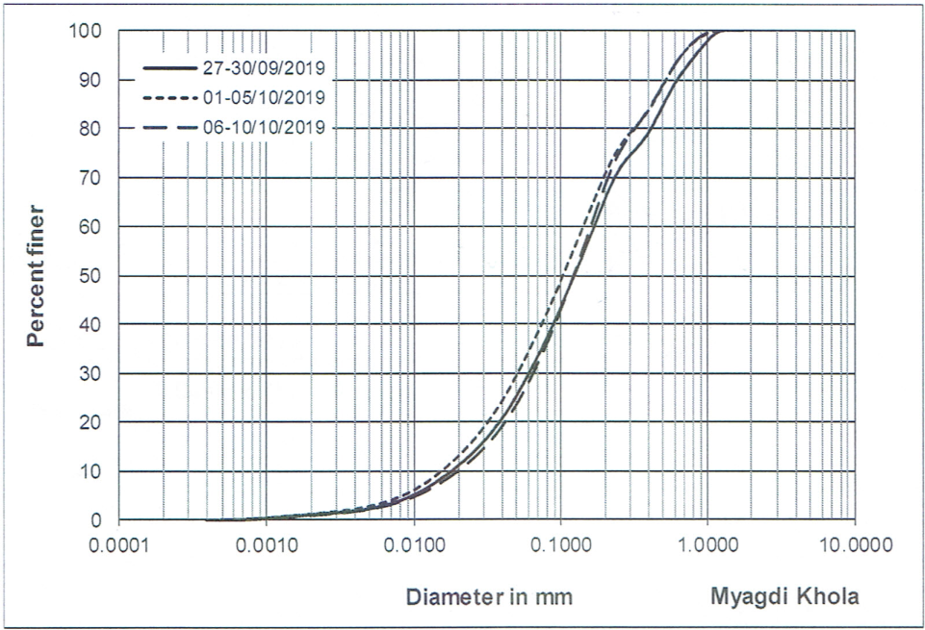

Figure 3‑1: Result of particle size analysis of samples taken on 27-30 September, 01- 05 October and 06-10 October 2019

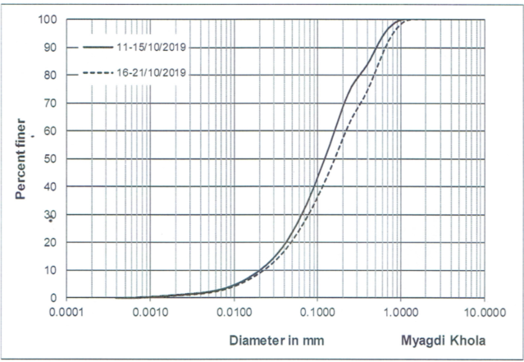

Figure 3‑2: Result of particle size analysis of samples taken on 11-15 October and 16-21 October 2019

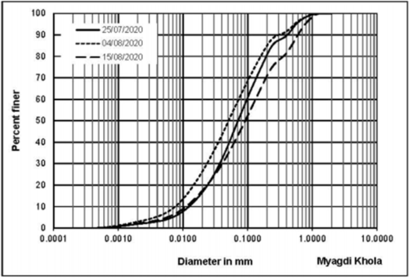

Figure 3‑3: Result of particle size distribution analysis of samples taken on 25 July, 04 August & 15 August 2020

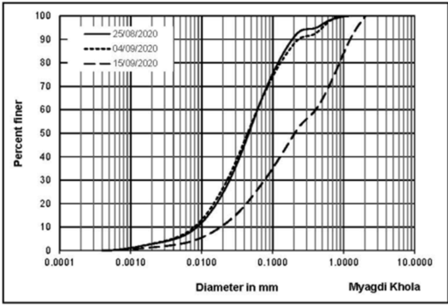

Figure 3‑4: Result of particle size distribution analysis of samples taken on 25 August, 04 September & 15 September 2020

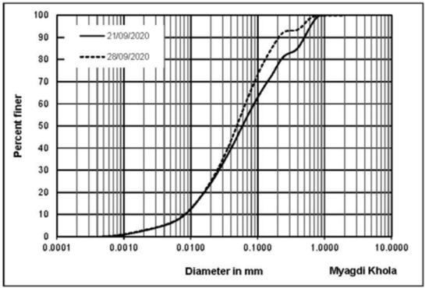

Figure 3‑5: Result of particle size distribution analysis of samples taken on 21 September and 28 September 2020

### Sediment mineralogy

The results from microscopic analysis of suspended sediments of the samples taken from the Myagdi khola, near proposed intake, during the end of September 2019 and the month of October 2019, have been analyzed. Also, the mineralogy of suspended sediment collected during the monsoon of 2020 have been analyzed. The assessment shows that Quartz (49-55%) and Mica (15-18%) are the dominant minerals in Myagdi Khola. The content of Feldspar is 3-9%. Tourmaline, Garnet, Hornblende, Kyanite are grouped under ‘Others (A)’ and clay, chlorite and other unidentified fine sediments have been included under ‘Others (B)’. The average percentage content of minerals of the suspended sediment samples of 2019 and 2020 have been illustrated in Figure 3‑6 and Figure 3‑7 below. The hardness of different minerals is presented in Table 3‑4.

For mineralogical composition of each samples Refer ANNEX A.

Figure 3‑6: Mineralogical composition of suspended sediment sample taken from Myagdi river at proposed intake site of MKHPP during the months of September and October of 2019

Figure 3‑7: Mineralogical composition of suspended sediment sample taken from Myagdi river at proposed intake site of MKHPP during the monsoon of 2020

About 60 percent of the mineral grains in the sediment contains minerals with hardness greater than 5 in Mohs hardness scale which are Quartz, Feldspar, Tourmaline (0.7%), Hornblende (~0.2%) and other hard minerals/rock fragments (~1.1%). Hence, they can abrade the turbine material. Remaining 40 percent of material comprises Mica (15%), calcite (21.4%), highly weathered rock fragments, organic debris, etc. which possess hardness lower than 5 in Mohs’ scale.

Table 3‑4: Hardness of different minerals

|  |  |  |  |  |  |
| --- | --- | --- | --- | --- | --- |
| **Minerals** | **Quartz** | **Feldspar** | **Mica** | **Others (A)** | **Others (B)** |
| Hardness (Mohr’s scale) | 7 | 6 | 2 - 3 | ≥5 | <5 |

The mineralogical study of the samples taken during the monsoon of 2020 shows very high concentration of quartz content (49%) in Myagdi River Suspended Sediment (refer Figure 3‑7). Though the concentration of finer particles (particles finer than 0.2mm) is high in the samples taken, the high concentration of quartz content indicates the inevitability of the settling basin as the quartz particles has high erosive nature due to their higher hardness.

### Water Quality Test

Representative samples have been collected from site for water quality test at Soil Water and Air Testing (SWAT) Laboratory Pvt. Ltd. The test has covered PH, Electrical Conductivity, Turbidity, Total Hardness, Chloride, Nitrate and Iron content tests. The test report has been included in the ANNEX A.

It is important to know whether the water is corrosive or not. Two common tests can determine if water is likely to be corrosive: the Langelier Saturation Index (LSI) and the Ryzner Stability Index (RSI). To use the LSI, a laboratory must measure pH, electrical conductivity, total dissolved solids, alkalinity, and total hardness. Hence, Alkalinity test need also be carried out for Langelier Index (LSI) to assess the corrosiveness of the water. Water is classified in following way based on the LSI:

LSI<0: Water is undersaturated with respect to calcium carbonate. Undersaturated water has a tendency to remove existing calcium carbonate protective coatings in pipelines and equipment.

LSI=0: Water is considered to be neutral. Neither scale-forming nor scale removing

LSI>0: Water is supersaturated with respect to calcium carbonate (CaCO3) and scale forming may occur

The corrosiveness of water can be further classified as given in Table 3‑5 based on LSI.

Table 3‑5: Corrosiveness characteristics of water based on LSI

|  |  |
| --- | --- |
| **LSI value** | **Indication** |
| -2.0<-0.5 | Serious corrosion |
| -0.5<0 | Slightly corrosion but non-scale forming |
| LSI = 0.0 | Balanced but pitting corrosion possible |
| 0.0<0.5 | Slightly scale forming and corrosive |
| 0.5<2 | Scale forming but noncorrosive |

If the water is found corrosive in nature, corrosion protection measures, such as proper painting of penstock pipe, gates etc. needs to be applied during the construction works.

## Conclusion and Recommendation

During the study, suspended sediment samples of Myagdi Khola were taken from the proposed intake site of the project. The collected samples were analyzed for the sediment concentration, particle size distribution (PSD) and mineralogical study of the project. From the studied carried out during this updated feasibility, following conclusion and recommendations have been made on the sediment study of the project:

* The observed maximum concentration of the suspended sediment as observed from the analysis of the samples taken during 2019 and 2020, found to be 6201 ppm observed during the month of 12 August 2020. The maximum concentration that the river caries cannot be concluded from the concentration study of the samples taken for the period of two years, though the observed result is very much useful information for the design of the project. Hence, it is recommended to give the continuity to the sediment study works of the project.
* The Particle Size Distribution (PSD) analysis of the suspended samples, taken from the intake site, conducted during the feasibility study indicates that there is dominance of finer suspended particles (i.e., finer than 0.2mm) in Myagdi River. It is recommended to give the continuity to the sediment study works of the project for further confirmation of PSD of the suspended sediment that the Myagdi River carries.
* The mineralogical study of the samples taken from the Myagdi River near proposed intake site of the project during the end of monsoon of 2019 and monsoon of 2020 shows very high concentration of quartz content (i.e., in average, more than 50%) in the suspended sediment of the Myagdi river. Though the concentration of finer particles (particles finer than 0.2mm) is high in the samples taken both during the feasibility study, the high concentration of quartz (hard mineral) content indicates the inevitability of the settling basin as the quartz particles has high erosive nature due to their higher hardness.

# GEOLOGY AND GEOTECHNICAL STUDY

## Regional Geology

Myagdi Khola Hydropower Project project lies in both Lesser and Higher Himalaya zone of Western Nepal separated by Main Central Thrust (MCT) based on the Nepal Geological Map Compiled by Department of Mines & Geology (1996). Myagdi Khola Hydropower Project consists of medium to high grade metamorphic rocks such as slate, limestone, quartzite, gneiss and schist of Lesser and Higher Himalaya. Graphitic slate with limestone bands and white quartzite with schist/slate bands rocks of the Lesser Himalaya belong to Benighat Slate and Fagfog Quartzite Formations respectively (Figure 4‑1). Similarly, gneiss with schist bands rocks belong to Higher Himalaya. Gneiss and quartzite rocks are fresh to slightly weathered, fine to coarse-grained, widely foliated to massive, strong to very strong, jointed whereas slate is very closely foliated, medium strong to strong, platy to blocky, fissile and some sections crenulated and deformed.

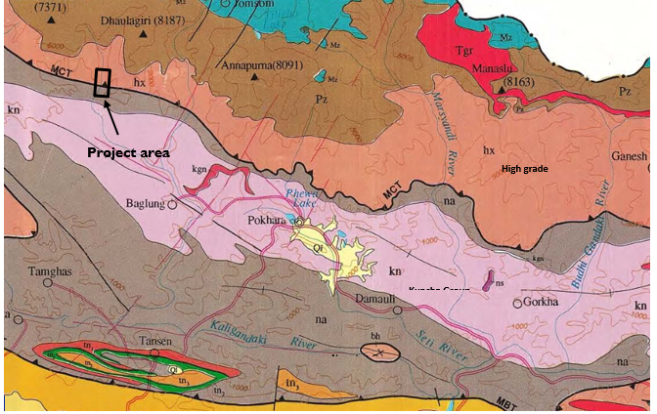

Figure 4‑1: Regional Geological Map showing Project site (Compiled by Department of Mines & Geology, 1996).

Rocks of Lesser Himalaya and Higher are separated by the Main Central Thrust (MCT) which passes through around 4,400m of the headrace tunnel near intermediate adit valley. The MCT was active during the early phases of Himalayan orogeny but now it is no longer active. From engineering point of view, the MCT is a thick zone of low to high grade metamorphic rocks without weak shear zones and hence this will not create any risks for construction of any structures. Apart from the MCT there are several few centimeters to few meters thick shear/weak zones mostly along the foliation plane which may require adequate treatment as per established engineering practices during tunnel construction.

In general, out of three major joints the foliation joint is dominant and critical joint in the Project area. It strikes almost E - W with steeply dipping (30 - 60°) towards north.

## Project Geology

### Rock types

Gneiss, quartzite and slate are the main rock types of the project area and briefly described below:

#### Gneiss

Gneiss with schist bands is fresh to slightly weathered, grey, medium to coarse-grained, thickly foliated to massive, medium strong to very strong with kyanite, sillimanite and garnet. Gneisses are mainly banded type and partly augen gneiss. Banded gneiss is dominant than schist and augen gneiss. Quartzite bands are also intercalated in gneiss. This gneiss rock unit is very good for tunnel construction due to strong and massive nature.

#### Quartzite

Quartzite is fresh to slightly weathered, grey to white, fine to coarse-grained, closely to widely foliated, strong to very strong, jointed, blocky with mica partings and bands of schist/slate. Quartzite is also folded in some sections. Three sets of joints were present in quartzite rock mass. Overbreak and wedge failure in presence of water are common georisks in shear zone, heavily jointed with phyllite parting and blocky nature of quartzite.

#### Graphitic slate with limestone bands

Graphitic slate is slightly weathered, fine to medium grained, grey to dark grey, thinly to closely foliated, weak (weathered) to strong (fresh), fissile with limestone intercalation and bands. At some sections slate was deformed and weak in nature whereas in limestone intercalation and limestone bands dominant sections, slate was medium strong to strong in nature due to calcareous binding. Overbreak and rock squeezing in presence of water are common georisks in this thinly foliated, weak, fissile and crenulated nature of slate.

### Soil types

The project area consists of mainly Quaternary alluvial and colluvium origins loose to dense coarse-grained heterogeneous soils. The soils product of landslides in the area is briefly described below:

#### Alluvial soil

The alluvial origin heterogeneous soil is distributed along the riverbanks and elevated terrace in some areas. This soil deposited by the Myagdi Khola comprises majority of sub-rounded to well-rounded boulders (< 3 m in diameter), cobbles, pebbles and gravels with minority of sandy matrix. The fine material is non-cohesive and mostly sand. This alluvial soil is classified as clean sandy GRAVEL/BOULDER. These deposits form gentle topography in the area mostly along the banks.

#### Colluvial soil

The heterogeneous Colluvial soil, the product of landslides, is found along the foothills and banks of the Myagdi. The soil along foothills comprises mostly of angular big boulders (1-3 m dia.) and gravels with minor portion clayey sandy silt matrix. The fine material contains low plastic sandy silt.

Colluvium soils are classified as loose Silty sandy GRAVEL/BOULDER. Voids are present and hence there is high risk of settlement during seismic event and hence proper compaction will be necessary.

## Site Investigations

The following geophysical investigations had been carried out during the by the Client during previous studies which are:

* three ERT profiles in old headworks and one MASW,
* two ERT profiles in adit 2,
* two ERT profiles in surge shaft,
* two ERT profiles in surface penstock,
* three ERT profiles and three MASW in powerhouse.

Total investigation length of 2D ERT was 3,480m, which are summarized below in Table 4‑1.

Table 4‑1: Summary of geophysical investigations carried out during previous studies

| **Profile’s name** | **Location** | **Name of investigation** | **Length (m)** |
| --- | --- | --- | --- |
| ERT-1 | Headworks Old location below the confluence | 2D ERT | 350 |
| ERT-2 | 210 |
| ERT-3 | 350 |
| MASW-1 | MASW & HVSR | 23 |
| ERT-4 | Adit 2 | 2D ERT | 300 |
| ERT-5 | 300 |
| ERT-6 | Surge tank | 2D ERT | 230 |
| ERT-7 | 230 |
| ERT-8 | Surface penstock | 2D ERT | 350 |
| ERT-9 | 230 |
| ERT-10 | Surface powerhouse | 2D ERT | 230 |
| ERT-11 | 350 |
| ERT-12 | 350 |
| MASW-2 | MASW & HVSR | 23 |
| MASW-3 | 23 |
| MASW-4 | 23 |
|  |  | Total length of ERT = | 3,480m |

As the location the of headworks has shifted to upstream side of the confluence, the previous investigation carried out in this area did not seemed applicable for the new headworks arrangement. Also, further investigations were required to study for other options for placement of different components, therefore additional ERT investigation were carried out in locations as listed in Table 4‑2 below.

Table 4‑2: Summary of ERT carried out during this study

| **Profile No.** | **Location** | **Length (m)** |
| --- | --- | --- |
| ERT-1 | Left Bank of Myagdi Khola (Intake area) | 170 |
| ERT-2 | Left Bank of Myagdi Khola (Intake area) | 225 |
| ERT-4 | Hillslope covering right bank of Myagdi Khola (Intake area) | 210 |
| ERT-5 | Confluence of Kunaban and Myagdi Khola to the Hillslope (Intake area) | 300 |
| ERT-6 | Right bank of Kunaban Khola (Intake area) | 300 |
| ERT-7 | Hillslope at right bank of Kunaban Khola (Intake area) | 200 |
| ERT-8 | Hillslope at right bank of Kunaban Khola (Intake area) | 150 |
| ERT-9 | Left bank of Kunaban Khola (Intake area) | 150 |
| ERT-10 | Hillslope at proposed Intake of Kunaban Khola (Intake area) | 200 |
| ERT-11 | Right bank of Kunaban Khola (Intake area) | 150 |
| ERTALT-1 | Left bank of Kunaban Khola to the hillslope (Intake area) | 150 |
| ERTALT-2 | Right bank of Kunaban Khola to hillslope (Intake area) | 150 |
| ERT-12 | Hillslope at Proposed Inlet portal | 300 |
| ERT-13 | Hillslope at Proposed Inlet portal | 300 |
| ERT-14 | Hillslope at Proposed Inlet portal | 300 |
| ERTALT-3 | Hillslope at Proposed Inlet portal | 150 |
| ERTALT-4 | Hillslope at Proposed Inlet portal | 300 |
| ERTALT-5 | Hillslope at Proposed Inlet portal | 150 |
| ERT-15-1 | Hillslope at Proposed Audit | 300 |
| ERT-15-2 | Hillslope at Proposed Audit | 300 |
| ERT-16 | Hillslope at Proposed Audit | 300 |
| ERT-17 | Hillslope at Proposed Audit | 300 |
| ERT-18 | Hillslope at Proposed Audit | 300 |
| ERT-19 | Hillslope at Proposed Powerhouse Area | 250 |
| ERT-20 | Hillslope at Proposed Powerhouse Area | 300 |
| ERT-21 | Hillslope at Proposed Powerouse Area | 300 |
| ERT-22 | Hillslope at Proposed Powerhouse Area | 300 |
|  | **Total** | **6805** |

Similarly additional MASW and SRT investigations were carried out in the locations as shown in Table 4‑3 below.

Table 4‑3: Summary of MASW and SRT carried out in different locations during this study

|  |  |  |
| --- | --- | --- |
| **Profile No.** | **Location** | **Length** |
| MASW 1 | Right Bank of Weir at Myagdi Khola | 35 |
| MASW 2 | Left Bank of Weir at Kunaban Khola | 35 |
| MASW 3 | Settling Basin | 35 |
| MASW 4 | Edge of Settling Basin | 35 |
| MASW 5 | Powerhouse Area | 39.3 |
| MASW 6 | Powerhouse Area | 69.8 |
| MASW 7 | Powerhouse Area | 36.1 |
| MASW 8 | Powerhouse Area | 17.5 |
| SRT 1 | Settling Basin | 120 |
| SRT 2 | Settling Basin | 72.2 |
| SRT 3 | Powerhouse | 120.8 |

## Engineering Geological Conditions of Major Structures

Major proposed structures of the project along the right bank are two diversion weirs in Myagdi and Kunaban Khola, single surface desander, headrace tunnel, surge shaft, underground plus surface penstock and surface powerhouse.

Engineering Geological conditions of structures are described below:

### Headworks

Headworks is designed to divert water from Myagdi Khola to Kunaban Khola then to surface desander to headrace tunnel. Diversion weirs, intake structures and approach canal can be constructible without major issues considering proper cut slope protection, foundation, cut off wall and flood control structures design in upstream and downstream of weirs and connecting canal from Myagdi to Kunaban and approach canal to desander.

There are two diversion weirs in Myagdi Khola and Kunaban Khola.

#### Myagdi Diversion Weir and Canal

The proposed Myagdi diversion weir at about 20m wide narrow gorge with bedrock. The area consists of bedrock on both banks and along weir axis followed by wider bank in downstream and narrow and wider bank upstream (Figure 4‑2). Exposed bedrock is massive about 50m in length along the river and about 15m high on both banks. Bedrock is fresh, grey, coarse grained, very strong, massive gneiss with few joint and very good rock mass quality.

Diversion weir is proposed in bedrock without major issue, but rock excavation will be necessary (Figure 4‑2). However, boulders rip rap weir will be suitable for debris flow and high flood events. There are plenty of boulders available for construction of boulders rip rap weir in the area.

Boulders rip rap barriers upstream before narrow gorge should be better to construct to protect headworks from debris flow events which will reduce velocity and deposit big boulders at upstream area.

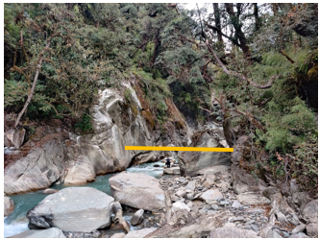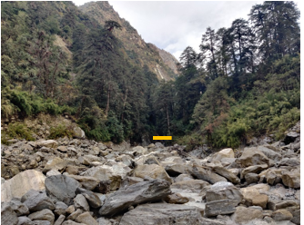

**Weir axis**

Figure 4‑2: Myagdi Diversion weir bedrock at both banks and piles of big boulders downstream

About 426 m long Concrete canal from Myagdi weir to Kunaban weir is proposed majorly along gentle terrace of boulder mixed soil and partly along base of rock cliff.

#### Kunaban Diversion Weir

The location of proposed diversion weir is more than 20m wide and consists of bedrock cliff at left bank and alluvial origin heterogeneous boulder-gravel mixed loose soil followed by steep slope at right bank (Figure 4‑3). Bedrock is fresh, grey, coarse grained, very strong, massive gneiss with few joint and very good rock mass quality. Additinoal geophysical investigations were carried out in the area to identify the subsurface condition. The additional geophysical investigations in the area are namely ERT-6, ERT-7, ERT-8, ERT-10, ERT-11and ERTALT-2 on the right bank where major structures of the project are located which show that the colluvial deposit thickness is about 5-10m in top and is comprised of weathered rock below this stratum and having gneiss in the bed. Similary ERT-9, ERTALT-1 and MASW - 2 has been done in the left bank of Kunaban river which shows small layer of colluvial deposit with strong massive gneiss in the bed.

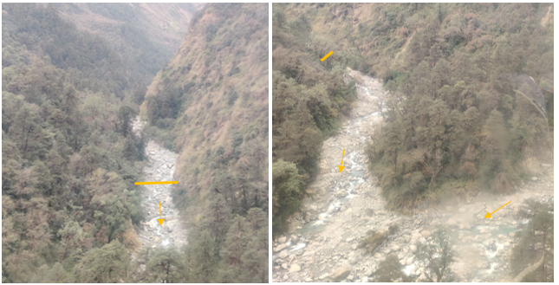

**Myagdi Khola**

**Kunaban Weir**

**Kunaban Khola**

Figure 4‑3: Kunaban diversion weir: bedrock at left bank and loose boulder mixed soil at right bank.

The weir will be constructed in boulder mixed heterogeneous loose soil foundation and hence proper compaction will be necessary. Soil slope cutting in loose boulder mixed heterogeneous soil at the right bank will be necessary for construction of intake and canal structures to desander. Similarly flood control structures upstream and downstream are proposed as necessary.

About 38.7 m long approach canal to desander is proposed along gentle slope of boulder mixed heterogeneous soil.

#### Desander

For option-1 of desander the right bank of Kunaban river is chosen which lies in gentl sloping terrace of boulder mixed heterogenous soil deposit. The ERT investigation carried out in the area namely ERT-7, ERT-8, ERT-10, ERT-11and ERTALT-2 shows that the colluvium deposit is 5-10m in top and is comprised of weathered rock below this stratum and having gneiss in the bed.

Surface desander is proposed in gentle upstream sloping terrace of boulder mixed heterogeneous soil deposited by the river. The layout of the Desander is designed in such a way to reduce excavation. Proper compaction for foundation will be necessary due to presence of boulders. Additional ERT were carried out in the area for both the desander and the tunnel inlet portal which are namely ERT 12, ERT 13, ERT 14, ERTALT 3, ERTALT 4 and ERTALT -5 which shows the bedrock is encounterd in the depth 5-20m from the ground surface.

#### Inlet portal

The Inlet portal is proposed in thick colluvium origin heterogeneous boulder mixed soil covered by thick vegetation (Figure 4‑4). Since, the inlet portal in the FSR layout was below the confluence of Myagdi and Kunaban Khola, previous site investigations were carried out in those locations only. Therefore, additional ERT 12, ERT 13, ERT 14, ERTALT 3, ERTALT 4 and ERTALT -5 are carried out around the inlet portal area which shows the bedrock is encounterd in the depth 5-20m from the ground surface. Thus, the portal location has been proposed according to the result of these ERT profile.

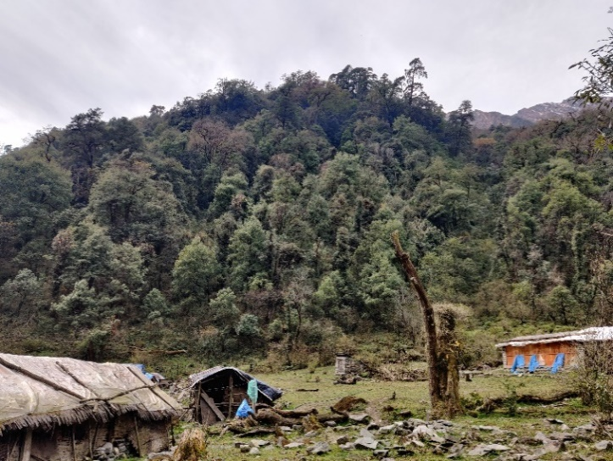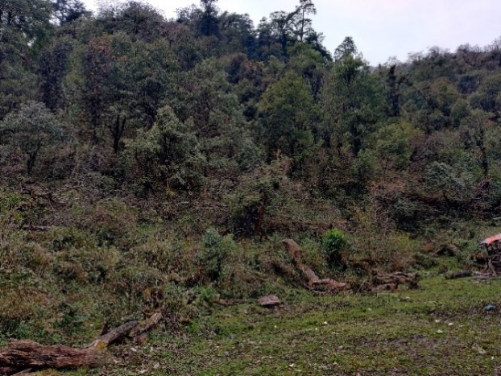

Figure 4‑4: Inlet portal area with thick colluvium origin boulder mixed heterogeneous soil.

### Headrace Tunnel (HRT) and Adits

Total length of 6127m HRT will pass through gneiss (±60%), quartzite (±28%) and slate (±12%) estimated based on the site based geological profile (Figure 4‑5).

Gneiss is fresh, grey, medium to coarse-grained, thickly foliated to massive, strong to very strong with schist bands. This gneiss rock unit is very good for tunnel construction due to strong and massive nature and very less georisks are expected except water ingress mainly in gullies crossing sections. Gneiss is expected to be encountered more than 60% length of the tunnel.

Quartzite is fresh to slightly weathered, grey to white, fine to coarse-grained, closely to widely foliated, strong to very strong, jointed, and blocky with mica partings and bands of schist/slate. Quartzite is also very good for tunneling with less problems except in schist/slate dominant intercalation and jointed rock mass. However, overbreak and wedge failure in presence of water are some of the georisks in shear zone, heavily jointed with phyllite parting and blocky nature of quartzite which has been considered during the design.

Graphitic slate is slightly weathered, grey to dark grey, fine to medium grained, thinly to closely foliated, medium strong to strong, fissile with limestone intercalation and bands. At some sections slate was deformed and weak in nature whereas in limestone intercalation and limestone bands dominant sections, slate was medium strong to strong in nature due to calcareous cementing. Overbreak and rock squeezing in presence of water are georisks anticipated in this thinly foliated, weak, fissile and crenulated nature of slate and has been considered in the design.

Generally, there are three sets of joints. Amongst the joints, foliation joint (30°- 60°/000°-030°) is persistence, planer smooth, closely spaced, filled by sericite/clay, steeply dipping, dominant and critical joint which will control stability of tunnel (Figure 4‑5). There is set of steep joint/fault (60°- 80°/180°-200°) almost perpendicular to the foliation through which ground water ingress/leakage is expected. In addition to this, few centimeters to few meters thick shear/weak zones along the foliation plane are also expected where water ingress, overbreak and rock squeezing are pronounced.

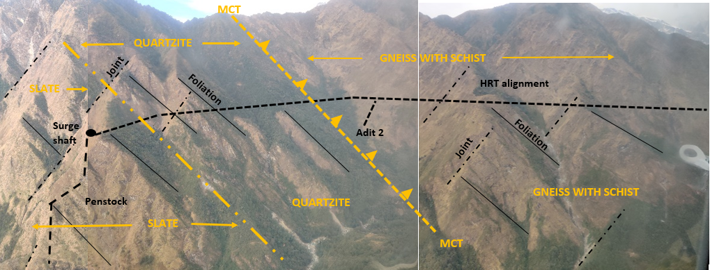

Figure 4‑5: View of headrace tunnel, adit, surge tank and penstock layout with rock types and joints

The headrace tunnel will cross the MCT (Figure 4‑5) and it is a thick zone of low to high grade metamorphic rocks without weak shear zones. Therefore, the MCT will not create any risks for construction of any structures.

#### Tunnel Design and layout

The proposed 3.20m wide and 3.50m high inverted D shaped HRT is about 6,127 m long with two intermediate adits (Adit 1 and Adit 2). There will be five faces for tunnel excavation and excavation distance from one face varies from minimum 349m and maximum 1,761m which is constructible with experienced manpower efficient equipment and proper ventilation system. Tunnel length, through widely foliated to massive, strong to very strong Gneiss, from Inlet portal to Adit 1 is about 1,260m with rock cover of 100 to 400m and side cover of minimum 100m. Excavation distance from one face is about 630m. Likewise longer excavation distance, through widely foliated to massive, strong to very strong Gneiss, is about 2,700m from Adit 1 and Adit 2 with maximum rock cover of 800m and minimum side cover of 400m. Tunnel excavation length from Adit 2 to surge shaft is around 2,200m with rock cover of 150m to 360m and side cover more than 150m which passes through strong to very strong quartzite and medium strong to strong slate. Around Adit 2 there is a gully crossing and based on the information of ERT 15 there are few shear zones and inorder to avoid the risk of leakage of water from the tunnel 150m side cover is provided in this part which is maintained with a bend in the headrace tunnel. Apart from this consolidation grouting after concrete lining might also be required based on the geological condition encountered during the construction.

The tunnel is designed as monoclonal slope from Inlet portal to surge shaft and requires pumping in downward tunnel faces during construction if seepage water discharge is high which will hamper excavation. However, self draining tunnel profile is recommended to be studied during detailed design phase.

Tunnel excavation condition will be very favorable based on the joint orientation due to the tunnel driving almost perpendicular to the foliation plane with steeply dipping (30°-60°) bedrock. In addition, this perpendicular tunnel driving direction with steep dipping will improve tunnel stability, can excavate good tunnel shape and give shortest crossing length in shear/weak zones. However, this joint orientation tunnel excavation direction will not dominantly improve stability in thick shear/weak zones and heavily jointed rock mass.

#### Rock mass Conditions

The rock mass condition along the HRT has been roughly estimated to be Class III 34.80%, Class IV 37.30% Class V 20.50 % and Class VI 7.40%. It will be totally based on the surface geological mapping without any sub-surface investigations. Therefore, it will be difficult to quantify rock mass condition accurately. However, very poor to fair/good rock mass quality (Q value = 0.5-10: Class I, II, III) are expected to be dominant and minor amount of extremely poor to exceptionally poor rock mass may be expected.

Tunneling condition through strong to very strong, widely foliated to massive Gneiss with schist bands is anticipated to be fair to good rock (Q = 1-20) except in heavily jointed, water ingress and shear zone sections. Similarly, rock mass condition in widely foliated, strong to very strong Quartzite is likely to be very poor to fair rock (Q =0.5-4) mass condition except in schist/slate dominant intercalation, shear zone and heavily jointed rock mass. Rock mass condition of thinly to closely foliated, medium strong to strong, fissile graphitic Slate is expected to be extremely poor to poor rock mass (Q = 0.02-4) except in sections where quartzite and limestone intercalation and bands are dominant.

Rock mass condition of shear/weak zones, weathered rock and heavily jointed rock mass with seepage are extremely poor to exceptionally poor rock (Q<0.1). In such extremely poor to exceptionally poor rock mass overbreak, rock squeezing and water ingress tunneling georisks are anticipated. Effort has not been made to identify shear/weak zones which are sources of georisks.

#### Adit portals

Two intermediate adits are proposed at base of rock cliff with sloping colluvium origin heterogeneous soil. Adit 1 Portal is proposed near rock cliff having challenge for constructing access platform (Figure 4‑6). Portal can start with less slope cutting and 5-8cm thick shotcrete and pattern of rock bolt support at 1.5-2m spacing. There is no suitable space for tunnel muck disposal.

Similarly, Adit 2 Portal is suitable at the left bank in bedrock exposure. The area is steep slope and excavation will be necessary to construct the portal with less slope cutting and 5-8cm thick shotcrete and pattern of rock bolt support at 1.5-2m spacing. There is small space to manage tunnel muck in the stream area by erecting gabion walls.

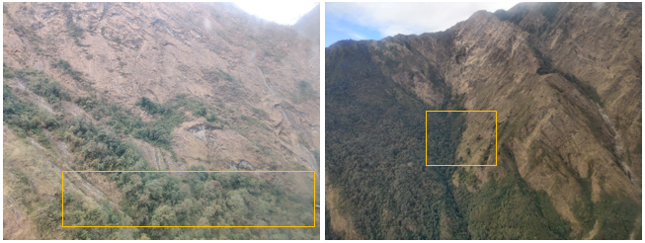

|  |  |
| --- | --- |
| Figure 4‑6: Adit 1 portal area | **Adit 2 portal location** |

Likewise, outlet portal around surge shaft area is proposed in rock cliff by cutting 46m high bedrock to make platform to work. It is necessasry to shift either towards the stream or the ridge to make working platform with less cutting. There is small space to manage tunnel muck either in the stream area by erecting gabion walls or bring down to safe place.

#### Rock Support Design

According to the rock mass properties and size of the headrace tunnel, the rock support design is divided into six different rock classes. A combination of grouted rock bolts in different spacing and fibre reinforced shotcrete with various thicknesses are the primary rock support from class I to VI. Shotcrete is considered as temporary and part of permanent support. Combination of steel sets with pattern of rock bolts and fibre reinforced shotcrete are considered in VI rock class. A 2.0m to 2.5m long 20 mm diameter grouted rock bolts are included as typical for classes I to VI. Isolated wedge failures can be controlled by spot bolting using quick action resin capsule combined with shotcrete.

Table 4‑4: Summary of rock support design of Headrace Tunnel

| Rock Support Class | Q-value | Support amount and type | Rock mass condition/ recommendations |
| --- | --- | --- | --- |
| **I**  FAIR TO GOOD ROCK | >1 | Spot bolting in unstable wedges.  Apply 5cm fibre shotcrete at mica bands, fractured area and slaking rock. | Thickly foliated to massive (> 20cm) competent stable rock with greater than 1m spaced joints. |
| **II**  POOR ROCK | 0.4 – 1 | 2m long rock bolt in 1.5 m pattern.  Apply 5cm fibre shotcrete at crown and mica bands, slaking rock, fractured/ jointed area. | Medium foliated (10 - 60cm spaced) strong stable rock mass with widely spaced few joints. |
| **III**  VERY POOR ROCK | 0.1– 0.4 | 2m long rock bolt in 1.3m pattern.  10cm fibre shotcrete at crown and walls. | Thinly foliated (10-20cm spaced) and jointed with thin few clay bands, weak to medium strong rock. |
| **IV**  VERY POOR ROCK | 0.04–0.1 | 2m long rock bolt in 1.2m pattern.  12cm fibre shotcrete at crown and walls. | Very thinly foliated (<10cm) and jointed with thin several intersection of clay gouge, small blocky, medium strong to weak rock. |
| **V**  EXTREMELY POOR ROCK | 0.01-0.04 | 2.5m long rock bolt in 1.1m pattern.  20cm fibre shotcrete at crown and walls  Spiling c/c = 40cm in crown, L = 6m.Spiling shall be inclined at 10º to 15º. L = 6m or pull +1.5m. End of spiling to be fixed with straps/re-bars and bolts. | Very heavily jointed sugar cube like, disintegrated, highly weathered or decomposed, sheared and weak rock mass with multiple clay gouge bands.  Support to be applied immediately.  Reduced blast pull to be utilized. |
| **VI**  EXCEPTIONAL-LY POOR ROCK | <0.01 | **A. In dry section:**  Spiling c/c = 40cm in crown, L = 6m.. 15cm thick fibre reinforced shotcrete and 2.5m pattern of rock bolt in 1m spacing.  **Steel sets (ISMB 75x150mm**) with 250mm thick concrete lining in walls and crown and 200mm thick lining in invert.  **B. In heavy squeezing area:**  20cmFibre reinforcedshotcrete with steel strut and 20cm lining at invert.  Spiling c/c = 20-40cm in crown, L = 6m. Spiling shall be inclined at 10º to 15º. L = 6m or pull +1.5m. End of spiling to be fixed with straps/re-bars and bolts. | Sheared and crushed rock with thick multiple bands of clay gouge containing >60% clay. Easily peeled with knife. No self-supporting capacity and zero stand up time. Expect rock squeezing.  Support to be applied immediately.  Reduce pull to be utilized.  Heading and benching excavation method may be necessary in heavy seepage and high overburden sections. |

### Surge tank

Surge tank is proposed inside the rock cliff and designed to connect by aeration tunnel at crown to release air (Figure 4‑7). Rock cliff is made up of thinly to closely foliated, medium strong to strong slate with limestone intercalation and bands where 8m diameter surge tank is constructible. Level of Outlet portal will be near a stream and can be constructible. Major challenge in such steep terrain is access road and tunnel muck disposal.

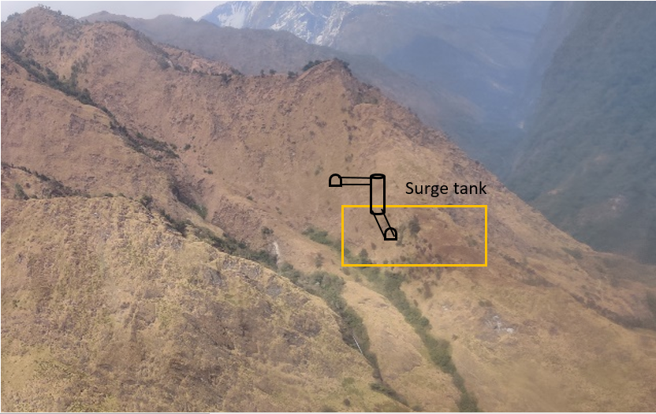

Figure 4‑7: View of outlet portal and surge tank area proposed in rock cliff at left bank of a stream.

The surge shaft area was investigated by two ERT profiles (ERT-6 and ERT-7).

### Penstock

Combination of two drop shaft with penstock tunnels in upper part and surface penstock at the lower end is considered for design. The proposed circular 3.0m diameter upper and lower penstock shafts are 173.73m and 245.60m and 72.25m high respectively. Similarly, 4.0 m wide with 10% gradient upper penstock tunnel and lower penstock tunnel are 233.23m and 250m long. Underground penstock arrangement, vertical and horizontal, in steep rock hill of thinly to closely foliated, medium strong to strong slate with limestone intercalation and bands is reasonable based on the topography and risk point of view. Geologically underground penstock in the medium strong to strong slate is constructible with risk of slabbing stress induced problem in lower penstock tunnel due to > 500m rock cover with anisotropic stress developed by steep rock hill and orientation parallel to the foliation plane.

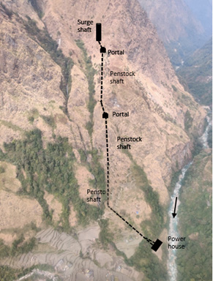

Figure 4‑8: Underground Penstock Alignment

### Surface powerhouse and tailrace

The surface powerhouse is proposed during the feasibility study in flat alluvial origin heterogeneous boulder mixed soil along straight course of the permanent stream and hence there will be high risk of damage by debris flow or landslide event in heavy and continuous rain (Figure 4‑9). Therefore, the powerhouse location has been shifted by about 20m further upstream where bedrock is exposed at back slope and suitable for penstock outlet. Different layout options have been considered during the design as shown in Figure 4‑9.

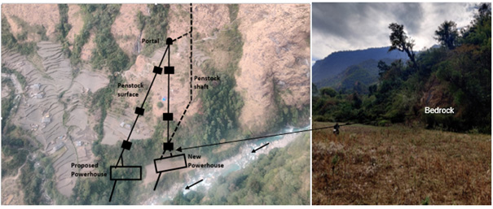

Figure 4‑9: Aerial view of proposed new surface powerhouse along with other alternatives and newely proposed powerhouse with bedrock at back slope.

Site investigations (ERT-10, -11, -12 and MASW-2, -3, -4) indicated thick alluvial origin heterogeneous boulder mixed fine dominated loose soil without indication of bedrock. Therefore, foundation of powerhouse will be in this fine dominated alluvial origin loose soil. Shear wave velocity at 4m depth varies from 100 to 300m/s and estimated bearing capacity will be less than 250 kN/m2 which is low. In addition, ground water table is at 5-10m depth measured in November which could rise up in monsoon.

Additional ERT-19, ERT-20, ERT-21 and ERT-22 in 2021 is carried out in powerhouse area showing bedrock is found in the depth 2-5m in ERT-19, 5m in ERT 20, 5-7m in ERT 21 and 5-10m in ERT-21 from the ground level showing the found will be on the bedrock for newely proposed powerhouse.

Tailrace will be short box culvert along the alluvial origin heterogeneous boulder mixed soil.

The geological map of the project area with additional ERT lines carried out during this study is shown in Figure 4‑10 below.

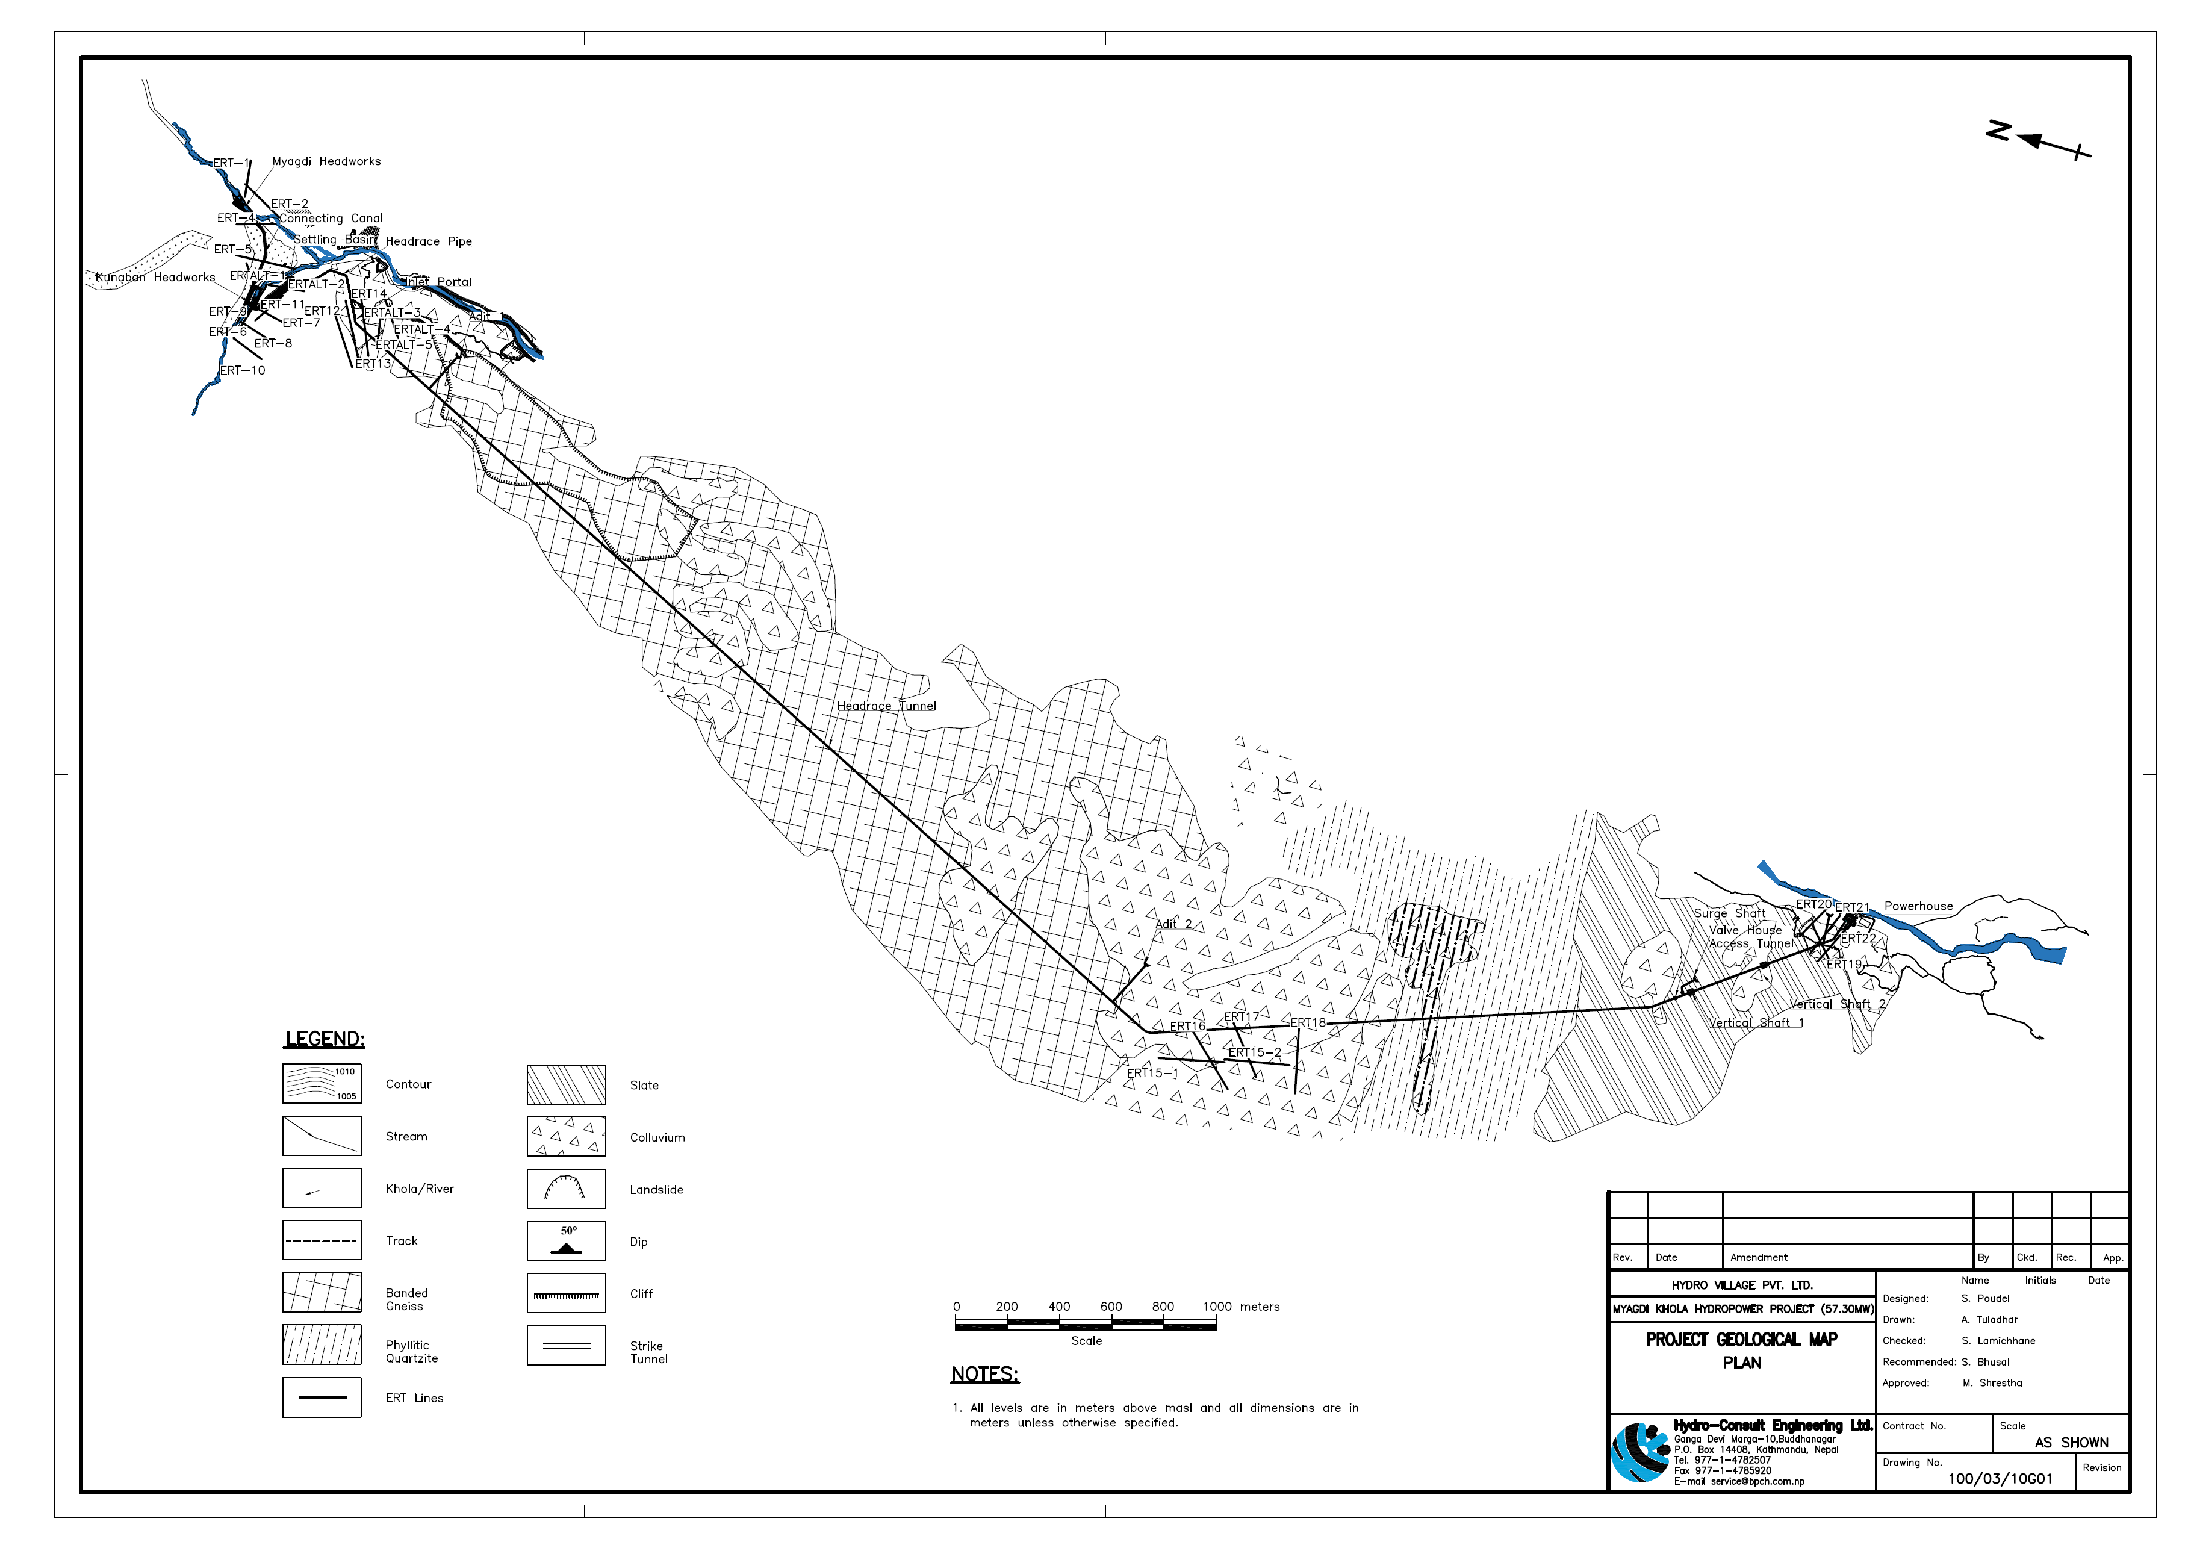

Figure 4‑10: Geological Map of the project area with additional ERT lines carried out during this study.

## Construction material investigations

The construction materials, fine and coarse aggregates are available mostly from Myagdi River at headworks, nearby Dovan and powerhouse site. Material samples from possible location for such quarry materials at the headworks nearby Dovan and powerhouse area are collected with four pits in the both the areas. The locations of the test pits are shown as below:

Table 4‑5: Location of test pits for construction material survey

| **S.N.** | **Test pit No.** | **Easting** | **Northing** | **Elevation (m)** | **Location** |
| --- | --- | --- | --- | --- | --- |
| 1 | Pit-1 | 440836 | 3167989 | 2460 | Headworks area: Flood plain deposit on Kunaban Khola on right bank upstream of Myagdi and Kunaban Khola confluence |
| 2 | Pit-2 | 440945 | 3167887 | 2445 | Headworks area: Flood plain deposit on left bank of Kunaban Khola just upstream of Myagdi and Kunaban Khola confluence. |
| 3 | Pit-3 | 441035 | 3167860 | 2445 | Headworks area: River bar deposit left bank of Myagdi Khola just upstream of Myagdi and Kunaban Khola confluence. |
| 4 | Pit-4 | 440992 | 3167888 | 2445 | Headworks area: Flood plain deposit on left bank of Myagdi Khola upstream of confluence point of Myagdi and Kunaban Khola. |
| 5 | Pit-5 | 440131 | 3161413 | 1850 | Powerhouse area: Just downstream of the PH area beside a Kholsi at right bank of Myagdi Khola |
| 6 | Pit-6 | 440120 | 3160984 | 1820 | Powerhouse area: Right bank of Myagdi Khola just downstream of suspension bridge |
| 7 | Pit-7 | 440179 | 3161015 | 1820 | Powerhouse area: Left bank of Myagdi Khola just upstream of suspension bridge |
| 8 | Pit-8 | 440188 | 3161050 | 1825 | Powerhouse area: Left bank of Myagdi Khola upstream of Suspension bridge. |

### Construction Material Testing

The construction materials taken from the sites mentioned above have been tested for their suitability for the construction purpose. The tests carried out to check for the appropriateness of the materials are:

1. Grain Size Analysis
2. Specific Gravity and Water Absorption Test
3. Aggregate Curshing Value
4. Agreegate Impact Value
5. Sodium Sulphate Soundness
6. Flakiness Index
7. Elongation Index
8. Los Angeles Abarasion Test
9. Mica Content
10. Alkali reactivity Test

The results of these tests are provided in Volume III: Annex E.

## Conclusion

Myagdi Khola Hydropower Project consists of Graphitic Slate, Quartzite and Gneiss. Graphitic Slate with limestone bands and Quartzite with schist/slate bands rock units belong to the Lesser Himalaya whereas Gneiss with schist bands rock unit belong to Higher Himalaya. Gneiss and quartzite rocks are fresh to slightly weathered, fine to coarse-grained, widely foliated to massive, strong to very strong, jointed and good rocks for tunneling. Similarly Graphitic slate is very closely to widely foliated, medium strong to strong, platy to blocky, fissile and some sections crenulated and deformed.

Rocks of Lesser Himalaya and Higher are separated by the Main Central Thrust (MCT) which passes through around chainage 4,400m of the headrace tunnel upstream of intermediate adit 2. The MCT was active during the early phases of Himalayan orogeny but now it is no longer active. From engineering point of view, the MCT is a thick zone of low to high grade metamorphic rocks without weak shear zones and hence this will not create any risks for construction of any structures.

The Myagdi valley upstream of the confluence headworks area is full of mass wasting events in past and still there are several active landslides and avalanches. There might be a risk of damaging diversion weir and intake structures by landslide damming and landslide dammed outburst flood with debris flow in extreme mega event in future. Constant surveillance has to be ensured to identify such damming and removing the debris and necessary protection measures have to be taken to prevent rock fall / slope failures to prevent such events.

Further, it is recommended that drilling with testing of core samples at different locations be carried out verify the subsurface information especially in the regions of settling basin area, inlet portal location, the kholsi crossing location of the headrace tunnel, the adit portal locations and the powerhouse.

# PROJECT DESCRIPTION AND DESIGN

## General Layout of Overall Project Components

Myagdi Khola Hydropower Project is a run-of-river type hydropower project located in Bagara, Dhaulagiri Rural Municipality of Myagdi District and Gandaki Province of Nepal. The project has the design discharge of 12.50 m3/s and gross head of 629.0m to produce annual average energy of 380.24 GWh with the installed capacity of 65.00 MW.

The project components constitute of 2 headworks i.e in Myagdi khola and Kunaban khola. Myagdi headworks comprises of a 15m long sloping glacis concrete weir, a side intake with two openings and a gravel trap, two undersluice with radial gates and a trash passage. The water from Myagdi Khola is transferred to Kunaban headworks via a connecting canal. The Kunaban headworks comprises of 18 m long boulder weir, side intake with two openings, a gravel trap, 85m long two bay desander with each bay of 11 m width. The waterways consist of a 6127 m long inverted D-shaped headrace tunnel with a finished size of 3.20m X 3.50m and penstock with two vertical shafts and two horizontal D-shaped tunnel. A surface powerhouse housing three units of vertical axis pelton turbines has been proposed in the right bank of Myagdi Khola.

For general layout and arrangement of the project components, refer Figure 1‑2 of this report and Volume IV.

## Headworks

The project consists of two headworks, one in Myagdi Khola and another one in Kunaban Khola. The Myagdi Khola headworks consists of a sloping glacis weir with stilling basin for energy dissipation, two gated undersluice structure for bedload flushing, side intake with two openings to draw design discharge and additional discharge for flushing of settling basin. The design discharge from Myagdi Khola is conveyed to Kunaban Headworks via a connecting canal. The Kunaban headworks consists of a boulder weir with a stilling basin for energy dissipation, a gated undersluice structure for bed load flushing, side intake with two openings to draw the design discharge and additional discharge required for flushing of gravel trap and settling basin, gravel trap and gravel flushing structure, approach canal, two bay settling basin and flushing structure and a head pond at the outlet of settling basin and a headrace pipe conveying the discharge into the headrace tunnel. The layout of the project components at Headworks is presented in Volume IV.

### Diversion Weir and Stilling Basin in Myagdi Khola

#### General Description

A sloping glacis type concrete gravity weir with horizontal floor stilling basin has been designed. Considering the available space and the magnitude of flood that the project has to be designed for, weir axis of crest length 15m excluding the sluiceway has been taken in the design. The weir axis lenth is governed by the river width. The wier axis length has to be limited to 14m due to the narrow river width at weir axis area, With this weir axis width, the head over the crest will be high which increase the level of intake operation platform, however, it will not have significant impact on the project cost as there is exposed bed rock on both the banks at weir axis, its upstream and downstream which eliminates the need of upstream and downstream flood walls. The weir crest elevation has been fixed to the elevation of 2483 masl with 5 m high weir above the upstream apron. The water elevation at 100 years return period design flood over the weir crest shall be 2489.58 masl. Due to high concentration of boulders, gravels and silt in the river, a sloping glacis type weir profile is provided for the ease of releasing it to the downstream. Upstream floor level is at 2478 masl whereas the downstream floor level at stilling basin has been fixed to 2469 masl as required by the calculation of depressed depth of stilling basin.

The additional energy created from the construction of weir of 5m height will be dissipated by a stilling basin of length 35.9m with its depressed floor level at elevation of 2469 masl designed for the energy dissipation purpose. Since the Froude number at jump lies between 4.5 and 9.0, the jump is steady jump. Considering the Froude number (between 4.5 and 9.0), U.S.B.R stilling basin type II has been designed (refer Design of Small Dams, USBR). The Chute blocks have not been considered in the design as it gets damaged by the boulders and gravel carried by the river during monsoon. The stilling basin has been designed as concrete structure with boulder rip rap binded by concrete infill. Since the foundation of the headworks lies in rock bed therefore significant seepage and uplift forces are not considered in the design of stilling basin.

The weir axis is located about 380m u/s from the confluence of Myagdi Khola and Kunaban Khola. The left bank of the weir body flushes with the exposed bed rock while the intake structure needs rock excavation on the right bank. The sizing of the free overflow weir and fixation of crest level are very much influenced by physical constraints related to the ability to pass flood flows, river gradient at the weir site and stability of the section which are explained below in hydraulic criteria. The proposed weir and stilling basin profile is presented in Figure 5‑1. For detail drawings of the weir and stilling basin plan, profile and sections refer Volume IV.

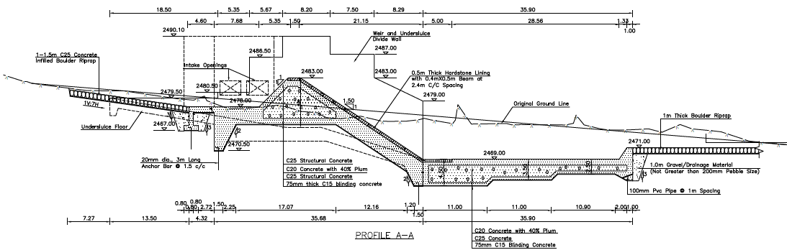

Figure 5‑1: Weir and Stilling Basin Profile in Myagdi Khola

#### Hydraulic Criteria and Design

As discussed earlier in the preceding section, the weir and stilling basin has been designed considering following criteria:

* Sediment and bed load transport in this river is high during monsoon season with the particle size ranging from sand particles to big boulders due to which the diversion structure should be designed in such a way so that the sediment and bed load safely passes to the downstream of the structure. Considering this nature of the river, an uncontrolled overflow sloping glacis type concrete gravity weir has been selected instead of gated spillway to protect the structure during high flood.
* Also, the landslides at u/s of intake may cause a sudden flood at the intake site. So, to prevent large damages during hazard flood, a free overflow weir is considered suitable.
* For fixation of weir crest level, the required level difference between invert level of the undersluice and intake has been considered so that the floating debris/gravel and small boulders will not enter the intake. Furthermore, the settling basin flushing head requirement, has also been considered while fixing the elevation of the crest level of free overflow weir.
* The free overflow weir and the guide wall crest level has been designed for the 1:100 year flood, equal to 496.54 m3/s.
* For the fixation of operation platform maximum flood corresponding to 1:1000 years has been considered so as to provide safe access to the platform during the high flood.
* For the energy dissipation, the provision of stilling basin is included in design. Headloss due the friction in the floor has been neglected.

The upstream apron of 15m has been further added to the weir to increase the length of seepage barrier supporting to the stability of the wier. For detail hydraulic calculations refer: **Volume II – Annex B: Hydraulic Calculation.**

**Results**

From the above mentioned hydraulic criteria and site conditions, following results has been obtained which are presented below.

|  |  |  |  |  |  |
| --- | --- | --- | --- | --- | --- |
| Weir Crest Length |  |  |  | **15.00** | m |
| Weir Height above US riverbed | |  |  | **5.00** | m |
| Weir Crest Elevation |  |  |  | **2,483.00** | masl |
| Q100 Design Flood |  |  |  | **496.54** | m³/s |
| Guide Wall Top Elevation | |  |  | **2490.10** | masl |
| Q1000 Design Flood |  |  |  | **694.41** | m³/s |
| Operation Platform Elevation | |  |  | **2,490.10** | masl |

### Undersluice in Myagdi Khola

#### General description

The undersluice has been proposed at right bank of Myagdi Khola, parallel to the weir axis. The purpose of provisioning the undersluice is primarily to reduce the deposition of large amount of bed material in front of intake as the gates are operated to allow the bed material to safely pass downstream of the sluiceway gates during the monsoon period when there is excess discharge in the river. Secondly, the sluiceway gates are operated to flush out the sediment deposited in front of Intake during the time of availability of sufficient excess flow for flushing purpose. Depending on the size of boulders that the river caries, as observed in the site during the project site visit and design flood available for the design of undersluice, two sluiceway gates; one of opening size 2.5m x 2.5m (W x H) and other of opening size 3.5m x 2.5m (W xH) has been designed. Considering the size of boulders available at headworks site, it is assumed that the river will carry the boulders of size above 2 m rarely. Hence, the provided sluiceway opening size shall be sufficient to safely pass the boulders carried out by the river during high flood to the downstream of the undersluice.

Undersluice gates have to be operated time to time during the monsoon depending on the flow in the river and the bedload carried by it. Moreover, the vertical sliding gates get choked by deposited bed materials in front of it and creates problem of operation. Hence, considering the smooth operational benefit of the radial gates over vertical sliding gates, radial gates have been provisioned though the cost of radial gate is significantly high as compared to that of vertical sliding gates. In the long run the provision of radial gate comes to be cheaper as the loss of energy generation due to mal operation of vertical sliding gates and its repair and maintenance. Stop logs of same opening size have been provisioned in front of the sluiceway gates for the purpose of repair and maintenance of the sluiceway gates.

The gate regulation of undersluice will guide the design discharge flow through intake during the low flow season. Since the floor and the walls of the undersluice are highly susceptible to abrasion, the walls will be steel lined and the floor will be lined with 40cm thick hard stone between high strength concrete cross beams of grade C60. The proposed undersluice profile is shown in Figure 5‑2. For detail civil drawing of the undersluice refer Volume IV.

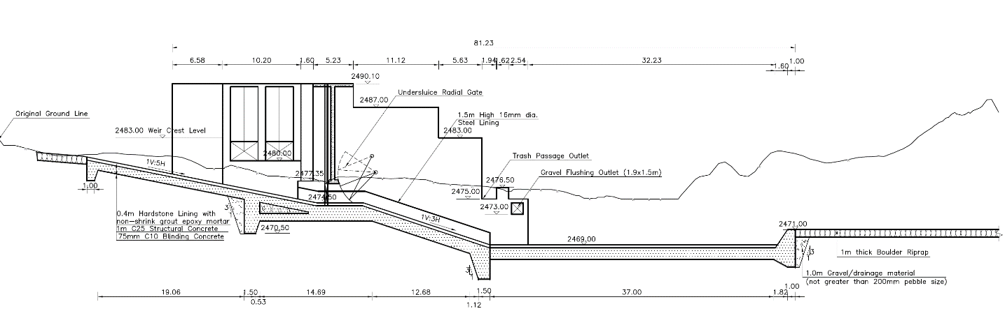

Figure 5‑2: Proposed Undersluice Profile in Myagdi Khola

#### Hydraulic Design

The major assumptions and considerations that has been used for the hydraulic design of undersluice is discussed below.

* The undersluice will pass at least 14% of the design flood.
* The size of the undersluice gates has been fixed considering the maximum size of the boulder that the river normally carries during monsoon and the design flood.
* Free flow occurs downstream of the undersluice during normal operating condition and submerged flow occurs during flood.
* To minimize the eroding effect of bed load, hard stone lining has been provided at invert and steel lining has been provided in the walls of sluiceway channel.
* The upstream apron slope of the sluiceway channel has been provided 1 in 5 to ease the flushing of the deposited bed load at the in front of the intake.
* The downstream slope of sluiceway channel has been 1 in 3 so that the flow velocity in the channel will be sufficient to avoid the deposition of flushed bed load in the channel.
* The sluiceway channel ends at the starting point of stilling basin at same level of stilling basin.
* The Sheild's critical diameter has also been checked for various flood years.
* The further design parameters and considerations have been provided here under.

**Design Parameters for Undersluice**

Design discharge (100 years) =496.54 m3/s

Contraction coefficient = 0.61

Discharge coefficient = 0.60

Invert Level of gate: 2473 masl

Manning’s coefficient: 0.015

**Results**

From design as well site conditions, an undersluice of following dimension has been designed;

* Number of openings : 2
* Size of opening : 2.5 x 2.5 meters & 3.5 x 2.5 meters
* Width of undersluice channel : 6.5 meters
* Floor thickness : Varying thickness provided depending on requirement
* Upstream floor slope before gate : 1 in 5
* Longitudinal slope of undersluice : 1 in 3
* Invert level : 2474.50 2473.00 masl
* Gate type : Radial gate

The details of calculation have been provided in Volume II-Annex B: Hydraulic Calculations.

### Intake at Myagdi Khola

#### Hydraulic design

A submerged orifice type side intake with two numbers of equal size of gate openings of 3.6 m wide and 2.5 high have been designed to draw the discharge of 11.5 m3/s including 15% additional discharge, required for flushing of gravel trap at the normal operation level 2483 masl (river water level at infront of intake at weir crest level). The flow velocity through the intake orifice at normal water level have been limited to 0.8 m/s, the exact figure as designed is 0.747m/s at normal operation discharge, as higher velocity at intake opening increases the intake loss as well as it creates problem in removal of trash from the trash rack. A coarse trash rack consisting of 20 mm thick bars spaced at 100mm center to center has been provided at an inclination of 80o with the horizontal direction. The invert level of intake orifice has been kept at a level of 2480 masl, which is 3.7 m above the invert level of undersluice, to prevent the entry of floating debris/bed load into the intake chamber from the river. Then water will enter a small culvert of the intake area and then flow to the gravel trap. Top level of the intake gate has been fixed at 0.5 m below the weir crest level to prevent the entry of floating trashes into the intake even during the normal operation level. The upper part of the intake above the trash racks will have a breast wall to control the entrance of flood water into the water conveyance system. The intake gate is operated to control the entry of excessive discharge into the intake during high flow in the river. The plant will be operated only up to the 10 years flood and above 10 years return period flood, the plant will be shut down. A trash passage structure is provided at the right side of the intake which allows the floating trashes to pass the downstream of the weir. A profile of the intake structure has been provided in Figure 5‑3.

The major criteria considered in the hydraulic design of the intake have been summarized as follows:

* The intake is designed as submerged orifice type as it has benefit of minimizing the entry of trashes inside the intake.
* Intake orifices will be capable to withdrawing the design discharge and additional 15% discharge for flushing purpose.
* The top level of orifice shall be at least 0.5 m below NWL in order to provide minimum submergence required for orifice flow as well as to minimize the clogging of trashrack by passing floating debris.
* The orifice will be substantially higher than riverbed so as to minimize the entry of bed load inside the intake.
* Velocity at intake will be limited to 0.5m/s to 1.1m/s during normal flow conditions for the exclusion of bed load and floating load to remain at the trash rack (Ref: Emile Mosony 2/A) and also for the easeness of removal of trashes.
* A coarse trash rack consisting of 20 mm thick bars spaced at 100mm center to center is provided at an inclination of 80o with the horizontal direction to minimize the entry of floating debris and trashes inside the intake.
* Intake gates will be operated to control the flow through intake during flood time.

The size of the intake orifice is calculated using following relation.

Q= AC

Where,

Q= design discharge through the orifice in m3/s

V= velocity through orifice, the recommended velocity through orifice during normal flow is 0.6m/s -1.1 m/s

g=9.81m/s

Hr-hh = head loss through the orifice to pass the Q amount of discharge through it

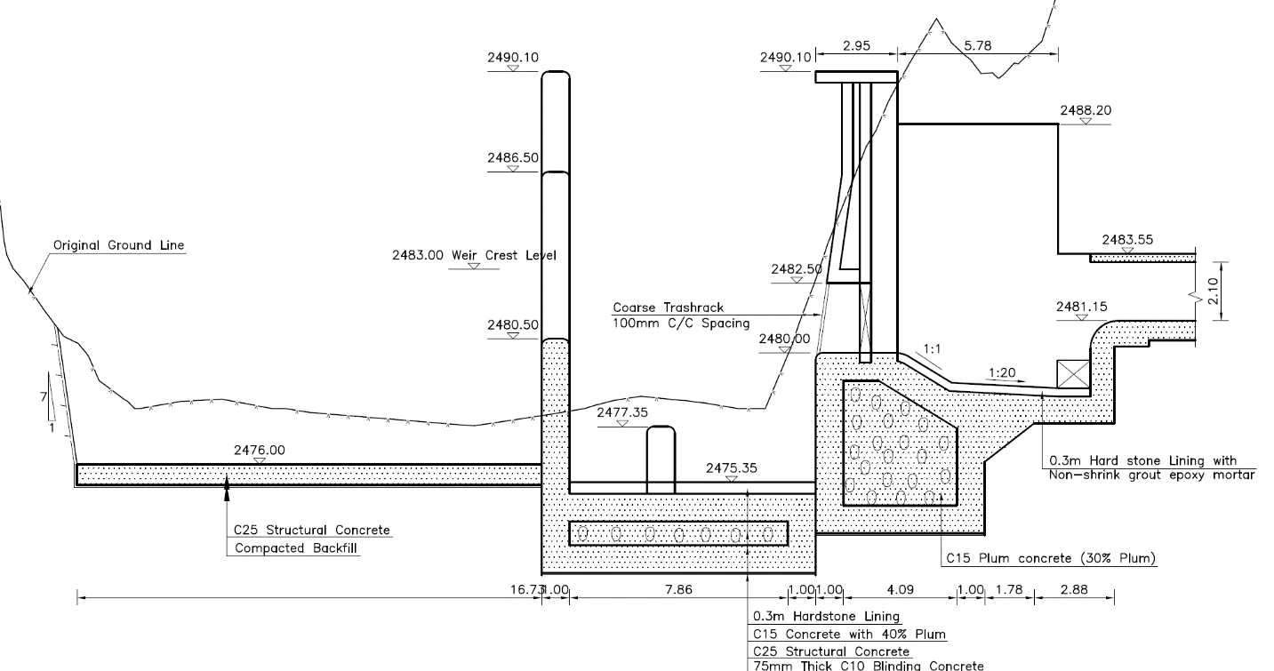

Figure 5‑3: Proposed Intake Profile in Myagdi Khola

The major results obtained from the hydraulic design of the intake habe been summarized in following table.

|  |  |  |
| --- | --- | --- |
| Design Discharge at normal operation including 15% additional discharge for flushing of gravel trap | 11.50 | m³/s |
| Number of Orifice | 2 | No. |
| Width of Orifice | 3.60 | m |
| Height of Orifice | 2.50 | m |
| Thickness of trashrack bars | 20.00 | mm |
| Spacing of trashrack bars | 100.00 | mm |
| Submergence of intake orifice | 0.50 | m |
| Invert level of intake gate | 2,480.00 | masl |
| Sill level of intake gate | 2,482.50 | masl |

Further details of hydraulic calculation of intake structure and calculation sheets has been provided in Volume II-Annex B: Hydraulic Calculations.

### Gravel Trap at Myagdi Khola

#### Hydraulic design

During the monsoon gravels can enter inside the intake through trash racks. Hence, a gravel trap structure is provided immediately after the intake to settle and flush the settled gravel back to the river at the downstream through a flushing conduit. Considering the size of intake and the discharge to be withdrawn through it, a single hopper (8.20m width) gravel trap structure has been designed with conventional hydraulic flushing system. The gravel trap will be continuously flushed when there is sufficient water in the river. The entrance of gravel trap is kept at 2480.00 masl with a slope of 1 in 1 for a length of 2m whereas, the start of hopper is fixed at 2478.73 masl with the longitudinal slope of 1 in 20 with a length of 3.8m to ease the flushing of settled particles. Flow through velocity in gravel trap is calculated as 0.75 m/s. At the downstream end of the gravel trap, a gravel flushing culvert is provided to flush the trapped particles. Flushing gates are also provided to control the flushing discharge. In consideration with 100 years high flood level, the external side walls of gravel trap is maintained at 2488.20 masl.

A flushing culvert of 1.2m width and 1.2m height with bed slope of 1 in 30 has been provided to flush out particles of size up to 100 mm mean diameter. The full flushing of the gravel trap will be carried out during monsoon withdrawing additional discharge through the intake orifice. The flushing culvert of 27 m length will flush out the gravels settled at gravel trap to the river flow at downstream of the sluiceway channel.

As discussed in the above paragraphs, some of the parameters considered in the hydraulic design of the gravel trap are summarized here under.

* Minimum Size of particle to be settled at gravel trap: 5 mm
* Maximum size of particle to be flushed: 100 mm
* Design discharge: 11.50 m3/s
* Flushing discharge: 1.50 m3/s
* Concentration of particles above 5 mm has been considered as 800 ppm
* Fall velocity is calculated from Rouse’s chart

**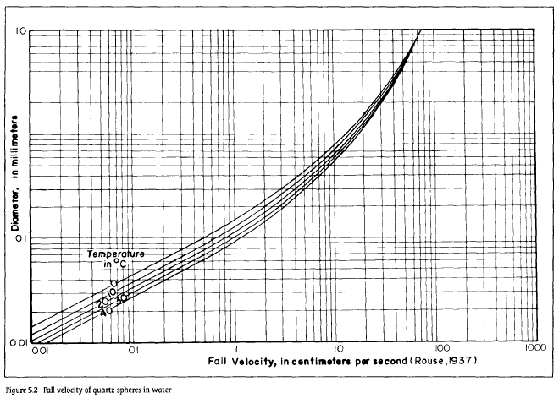**

Figure 5‑4: Rouse’s chart for fall velocity of particles

### Connecting Canal

#### Hydraulic Design

Immediately after gravel trap, connecting tunnel has been provided to convey the total of 10 m3/s of discharge to the headworks area of Kunaban at normal operating level at the intake. The tunnel draws the water from the pond at gravel trap. As the uphill slope of the tunnel alignment consists of weathered rock and alluvial deposits, the tunnel has been designed by stabilizing the inlet portal area. Considering the hydraulic design, the tunnel section has been fixed at 2.8 m wide and 2.8 m high with the slope of 1 in500. The invert level at the inlet is 2481.15 masl. The length of the connecting tunnel is 389 m. The invert level of connecting tunnel at the outlet is 2480.37 masl.

The flow in the approach canal has been designed as free flow during normal operation. The Intake gates should be operated during monsoon in such a way that only required discharge for power generation and flushing of gravel trap shall pass through the intake gate. The canal sections have designed with the longitudinal slope of 1:700 so that the condition of silting and scouring can be prevented.

### Diversion Weir and Stilling Basin in Kunaban Khola

#### General Description

A boulder rip-rap weir with horizontal floor stilling basin has been designed. The boulder weir is chosen to ease the passage of boulders downstream of the weir. It is easier and cheaper in construction than other type of weirs. Considering the available space and the magnitude of flood that the project has to be designed for, weir axis of crest length 20m excluding the sluiceway and creast width of 3.0m has been taken in the design. The weir crest elevation has been fixed to the elevation of 2482.00 masl which is 3.0 m high weir above the upstream apron. The water elevation at 100 years return period design flood over the weir crest shall be 2485.36 masl. A slope of 1 in 4 is kept at upstream and 1 in 5.4 slope is kept at the downstream of the weir considering the bed load carrying nature of the river and stability requirement of the weir body. Upstream floor level is at 2479.0 masl whereas the downstream floor level at the end of the slope is fixed at2466.58 masl.

The weir axis is located about 350m u/s from the confluence of Myagdi Khola and Kunaban Khola. The left bank of the weir body flushes with the exposed bed rock while there is no exposed bed rock on the right bank. The sizing of the free overflow weir and fixation of crest level are very much influenced by physical constraints related to the ability to pass flood flows, river gradient at the weir site and stability of the section which are explained below in hydraulic criteria. The proposed weir and stilling basin profile is presented in Figure 5‑5. For detail drawings of the weir and stilling basin plan, profile and sections refer Volume IV.

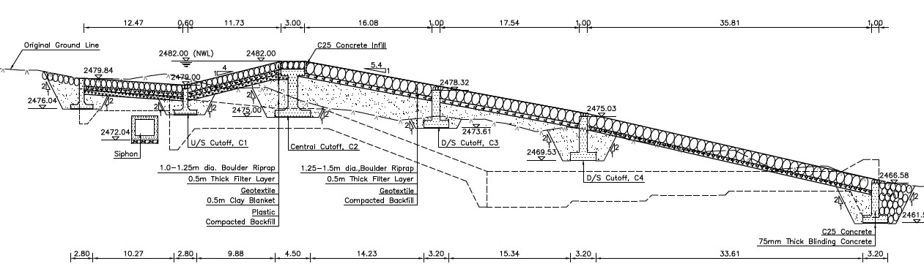

Figure 5‑5: Boulder Weir Profile in Kunaban Khola

#### Hydraulic Criteria and Design

As discussed earlier in the preceding section, the weir and stilling basin has been designed considering following criteria:

* Sediment and bed load transport in this river is high during monsoon season with the particle size ranging from sand particles to big boulders due to which the diversion structure should be designed in such a way so that the sediment and bed load safely passes to the downstream of the structure. Considering this nature of the river, an uncontrolled boulder riprap weir has been selected over other type of weirs to secure the structure during high flood.
* Also, the landslides and GLOFs u/s of intake may cause a sudden flood at the intake site. So, to prevent large damages during hazard flood, a free overflow weir is considered suitable.
* For fixation of weir crest level, the required level difference between invert level of the undersluice and intake has been considered so that the floating debris/gravel and small boulders will not enter the intake. Furthermore, the settling basin flushing head requirement, has also been considered while fixing the elevation of the crest level of free overflow weir.
* The free overflow weir and the guide wall crest level has been designed for the 1:100 year flood, equivalent to 170.30 m3/s.
* For the fixation of operation platform maximum flood corresponding to 1:1000 years has been considered so as to provide safe access to the platform.
* Since the riverbed material is permeable, seepage under the structure and uplift due to seepage is considered in the design of the weir.
* The upstream and downstream glacis slope of the proposed weir has been taken 1in 4 and 1 in 5.4 respectively to ease the passage of boulders to the downstream of the weir and as required by the stability criteria of the weir.

For detail hydraulic calculations refer: **Volume II – Annex B: Hydraulic Calculation.**

**Results**

From the above mentioned hydraulic criteria and site conditions, following results has been obtained which are presented below.

|  |  |  |
| --- | --- | --- |
| Weir Crest Length | **20.00** | m |
| Weir Height above US riverbed | **3.00** | m |
| Weir Crest Elevation | **2482.00** | masl |
| Q100 Design Flood | **170.30** | m³/s |
| Guide Wall Top Elevation | **2,482.80** | masl |
| Q1000 Design Flood | **229.36** | m³/s |
| Operation Platform Elevation | **2,486.14** | masl |

### Undersluice in Kunaban Khola

#### General description

The undersluice has been proposed at right bank of Kunaban Khola, parallel to the weir axis. The purpose of provisioning the undersluice is primarily to reduce the deposition of large amount of bed material in front of intake as the gates are operated to allow the bed material to safely pass downstream of the sluiceway gates during the monsoon period when there is excess discharge in the river. Secondly, the sluiceway gates are operated to flush out the sediment deposited in front of Intake during the time of availability of sufficient excess flow for flushing purpose. Depending on the size of boulders that the river caries, as observed in the site during the project site visit and design flood available for the design of undersluice, one sluiceway gate having opening of size 3.5m x 3.5m (W x H) has been designed. Considering the size of boulders available at headworks site, it is assumed that the river will carry the boulders of size above 2 m rarely. Hence, the provided sluiceway opening size shall be sufficient to safely pass the boulders carried out by the river during high flood to the downstream of the undersluice. A trash passage structure is provided at the right side of the undersluice which allows the floating trashes to pass the downstream of the weir.

Undersluice gates have to be operated time to time during the monsoon depending on the flow in the river and the bedload carried by it. Moreover, the vertical sliding gates get choked by deposited bed materials in front of it and creates problem of operation. Hence, considering the smooth operational benefit of the radial gates over vertical sliding gates, radial gates have been provisioned though the cost of radial gate is significantly high as compared to that of vertical sliding gates. In the long run the provision of radial gate comes to be cheaper as the loss of energy generation due to mal operation of vertical sliding gates and its repair and maintenance. Stop logs of same opening size have been provisioned in front of the sluiceway gates for the purpose of repair and maintenance of the sluiceway gates.

The gate regulation of undersluice will guide the design discharge flow through intake during the low flow season. Since the floor and the walls of the undersluice are highly susceptible to abrasion, the walls will be steel lined and the floor will be lined with 40cm thick hard stone between high strength concrete cross beams of grade C60. The proposed undersluice profile is shown in Figure 5‑6.

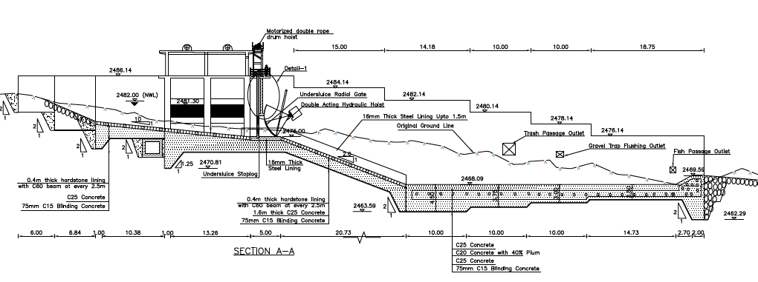

Figure 5‑6: Proposed Undersluice Profile in Kunaban Khola

#### Hydraulic Design

The major assumptions and considerations that has been used for the hydraulic design of undersluice is discussed below.

* The undersluice will pass at least 14% of the design flood.
* The size of the undersluice gates has been fixed considering the maximum size of the boulder that the river normally carries during monsoon and the design flood.
* Free flow occurs downstream of the undersluice during normal operating condition and submerged flow occurs during flood.
* To minimize the eroding effect of bed load, hard stone lining has been provided at invert and steel lining has been provided in the walls of sluiceway channel.
* The upstream apron slope of the sluiceway channel has been provided 1 in 10 to ease the flushing the deposited bed load at the in front of the intake.
* The downstream slope of sluiceway channel has been 1 in 2.6 so that the flow velocity in the channel will be sufficient to avoid the deposition of flushed bed load in the channel.
* The sluiceway channel ends at the starting point of stilling basin at same level of stilling basin.
* The Sheild's critical diameter has also been checked for various flood years.
* The further design parameters and considerations have been provided here under.

**Design Parameters for Undersluice**

Design discharge (100 years) =170.32 m3/s

Contraction coefficient = 0.61

Discharge coefficient = 0.60

Invert Level of gate: 2476.0 masl

Manning’s coefficient: 0.015

**Results**

From design as well site conditions, an undersluice of following dimension has been designed;

* Number of openings : 1
* Size of opening : 3.5 x 3.5 meters
* Width of undersluice channel : 3.6 meters
* Floor thickness : Varying thickness provided depending on requirement
* Upstream floor slope before gate : 1 in 10
* Longitudinal slope of undersluice : 1 in 2.6
* Invert level : 2476.0 masl
* Gate type : Radial gate

The details of calculation has been provided in Volume II-Annex B: Hydraulic Calculations.

### Intake of Kunaban Khola

#### Hydraulic design

A submerged orifice type side intake with two numbers of equal size of gate openings of 4.8m wide and 2.0m high have been designed to draw the discharge of 15.64 m3/s including 25% additional discharge, required for flushing of gravel trap and settling basin at the normal operation level 2482.00 masl (river water level at infront of intake at weir crest level).The flow velocity through the intake orifice at normal water level have been limited to 0.8 m/s, the exact figure as designed is 0.763 m/s at normal operation discharge, as higher velocity at intake opening increases the intake loss as well as it creates problem in removal of trash from the trash rack. A coarse trash rack consisting of 20 mm thick bars spaced at 100mm center to center has been provided at an inclination of 80o with the horizontal direction. The invert level of intake orifice has been kept at a level of 2479.30 masl, which is 3.30 m above the invert level of undersluice gate, to prevent the entry of floating debris/bed load into the intake chamber from the river. Then water will enter a small culvert of the intake area and then flow to the gravel trap. Top level of the intake gate has been fixed at 0.7m below the weir crest level to prevent the entry of floating debris into the intake even during the normal operation level. The upper part of the intake above the trash racks will have a breast wall to control the entrance of flood water into the water conveyance system. The intake gate is operated to control the entry of excessive discharge into the intake during high flow in the river. The plant will be operated only up to the 10 years flood and above 10 years return period flood, the powerplant will be shut down. A profile of the intake structure has been provided in Figure 5‑7. For detail Civil drawings of intake structure, please refer Volume IV.

The major criteria considered in the hydraulic design of the intake have been summarized as follows:

* The intake is designed as submerged orifice type as it has benefit of minimizing the entry of trashes inside the intake.
* Intake orifices will be capable of withdrawing the design discharge and additional 25% discharge for flushing purpose.
* The top level of orifice shall be at least 0.7 m below NWL in order to provide minimum submergence required for orifice flow as well as to minimize the clogging of trashrack by floating debris.
* The orifice will be substantially higher than riverbed so as to minimize the entry of bed load inside the intake.
* Velocity at intake will be limited to 0.5m/s to 1.1m/s during normal flow conditions for the exclusion of bed load and floating load to remain at the trash rack (Ref: Emile Mosony 2/A) and also for the easeness of removal of trashes
* A coarse trash rack consisting of 20 mm thick bars spaced at 100mm center to center is provided at an inclination of 80o with the horizontal direction to minimize the entry of floating debris and trashes inside the intake.
* Intake gates will be operated to control the flow through intake during flood time.

The size of the intake orifice is calculated using following relation.

Q= AC

Where,

Q= design discharge through the orifice in m3/s

V= velocity through orifice, the recommended velocity through orifice during normal flow is 0.6m/s -1.1 m/s

g=9.81m/s

Hr-hh = head loss through the orifice to pass the Q amount of discharge through it

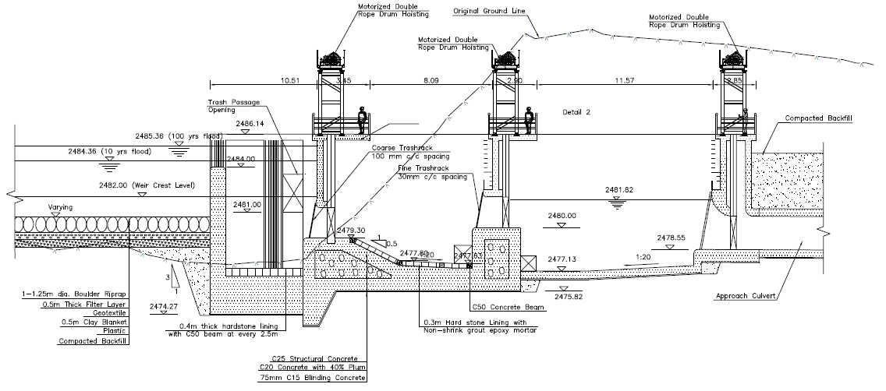

Figure 5‑7: Proposed Intake Profile in Kunaban Khola

The major results obtained from the hydraulic design of the intake habe been summarized in following table.

|  |  |  |
| --- | --- | --- |
| Design Discharge including 25% additional discharge for flushing | 15.64 | m³/s |
| Number of Orifice | 2 | No. |
| Width of Orifice | 4.80 | m |
| Height of Orifice | 2.50 | m |
| Thickness of trashrack bars | 20.00 | mm |
| Spacing of trashrack bars | 100.00 | mm |
| Submergence of intake orifice | 0.70 | m |
| Invert level of intake gate | 2,479.30 | masl |
| Sill level of intake gate | 2,481.30 | masl |
| Intake orifice submergence | 0.700 | m |

Further details of hydraulic calculation of intake structure and calculation sheets has been provided in Volume II-Annex B: Hydraulic Calculations.

### Gravel Trap

#### Hydraulic design

During the monsoon gravels can enter inside the intake through trash racks. Hence, a gravel trap structure is provided immediately after the intake to settle and flush the settled gravel back to the river at the downstream through a flushing conduit. Considering the size of intake and the discharge to be withdrawn through it, a single hopper (10.8m width) gravel trap structure has been designed with conventional hydraulic flushing system. The gravel trap will be continuously flushed when there is sufficient water in the river. The entrance of gravel trap is kept at 2479.30 masl with a slope of 1 in 0.5 for a length of 2.66m whereas, the start of hopper is fixed at 2477.80 masl with the longitudinal slope of 1 in 20 with a length of 4.75m to ease the flushing of settled particles. At the downstream end of the gravel trap, a gravel flushing culvert is provided to flush the trapped particles. Flushing gates are also provided to control the flushing discharge. In consideration with 100 years high flood level, the external side walls of gravel trap are maintained at 2486.14 masl. At the end of the gravel trap, a fine trash rack of bar thickness of 16mm with center to center spacing of 30 mm has been also provided to prevent trashes and gravels of larger size from entering the Approach canal.

A flushing culvert of 1.2 m width and 1.2m height with bed slope of 1 in 40 has been provided to flush out particles of size up to 100 mm mean diameter. The paired flushing culverts get merged into a single culvert of size 1.2 wide and 1.2 height after the flushing gates. The full flushing of the gravel trap will be carried out during monsoon withdrawing additional discharge through the intake orifice. The flushing culvert of 73.33m length will flushes out the gravels settled at gravel trap to the river flow at downstream of the sluiceway channel.

As discussed in the above paragraphs, some of the parameters considered in the hydraulic design of the gravel trap are summarized here under.

* Minimum Size of particle to be settled at gravel trap: 5 mm
* Maximum size of particle to be flushed: 100 mm
* Design discharge: 15.64 m3/s
* Flushing discharge: 1.25 m3/s
* Concentration of particles above 5 mm has been considered as 800 ppm
* Fall velocity is calculated from Rouse’s chart

****

Figure 5‑8: Rouse’s chart for fall velocity of particles

### Approach Covered Canal

#### Hydraulic Design

Immediately after gravel trap, two numbers of covered canals have been provided to convey the total of 14.39 m3/s of discharge to settling basin including discharge required for flushing (15% of design discharge) at normal operating level at the intake. Each canal draws the water from the pond at gravel trap and supply it to the corresponding side bay settling basin. As the uphill slope of the canal alignment consists of weathered rock and alluvial deposits, the approach canals has been design as buried covered canal with backfill cover of 2m. Since it is retained by backfill from all the sides, stability of both the Approach canals has been considered safe. Considering the hydraulic design, both approach canal section has been fixed at 2.0 m wide and 2 m high which includes 0.32 m of freeboard. The length of each approach canal is 38.7 m.

The flow in the approach canal has been designed as free flow during normal operation, however the covered canal will be pressurized during monsoon if the intake gates are not operated properly. Hence, Intake gates are operated during monsoon in such a way that only required discharge for power generation and flushing of gravel trap shall pass through the intake gate.

The canal sections have designed with the longitudinal slope of 1:600 so that the condition of silting and scouring can be prevented.

### Settling Basins

#### Hydraulic Design

The rivers carry sediment during monsoon. From mineralogical studies carried out during the feasibility studya, it is found that the quartz content is dominant with average concentration of more than 47%. Though the concentration of finer particles (particles finer than 0.15mm) is high in the samples taken, the high concentration of quartz content indicates the inevitability of the settling basin as the quartz particles has high erosive nature due to their higher hardness. Two options of settling basin location has been studied in this study, i.e. the Option I is just downstream of the intake on the right bank of the Kunaban river and the Option II is at about 400 m downstream of the intake near to the tunnel inlet portal. Huge excavation is required at Option II and also the there will be the risk of sediment depotion at approach culvert. Hence for now, Option I have been considered for the cost estimation and description of the project layout structures. However, it is recommended to carryout the drilling at both the settling basin locations for the assessment of necessary geotechnical information of the soil strata to make the final decision on settling basin location.

Settling basin has two bays with the dimension of 11m wide, 85 m long and 8.5m deep including hopper. Each bay consists of two hoppers with the top width of 5 m and height of 4.2m. The hopper side slope of 40º, i.e., higher than the angle of repose of the soil, and longitudinal bed slope of 1 in 40 has been provided to ease the scouring the deposited sediment particles during its flushing. At the bottom of main settling zone, a flushing channel of 1m width and 1m height is provided for the ease of sediment sluicing toward its end. The size of the basin has been designed from Vetters’s theory for trap efficiency.

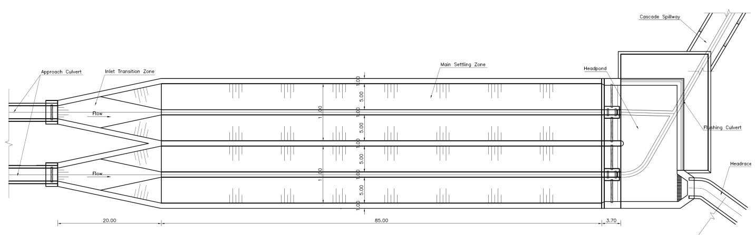

Figure 5‑9: Settling Basin Plan

In consideration with high head plant and concentration of sediment at river, settling basin has been designed with 90% trap efficiency for the particle size of 0.15 mm from the Vetters’s theory. The inlet transition is provisioned with expansion angle of 120 to insure the laminar flow in the transition. Flow to each of the basins will be regulated through the gates provided at the end of the approach canal. The sediment storage capacity and flushing capacity of the basin will be sufficient to take care of a situation with an actual suspended sediment concentration of 8000 ppm over a period of 8 hours.

The proposed settling basin is designed as an intermittent type with a mechanized flushing system. At the bottom of the main settling zone a slope of 1 in 40 is provided for the sediment flushing channel.

The leftside wall of the settling basin is provided at the height of 2480.60 masl which has freeboard of more than 1m with the normal operating water level, whereas the rightside wall will have minimum height same as that of the leftside wall and will be stepped incase the topography demands so in order to retain the left side slope.

A catch drain will be provided on rightside of the basin to trap and safely pass the surface runoff to the river. A perforated drainpipe will be provisioned at the level of hopper bottom along the rightside basin to drain out the percolated water so as to reduce the uplift pressure. Backfilling at the right side of the bay will be done only up to the level of 1.5 m below from the top of the basin wall and will be inclined at 30° with the horizontal to meet the hill slope.

Outlet transition of the settling basin will be used as headpond to maintain tranquil water level at the start of the tunnel inlet. Water will flow to the headpond through the four gated outlet orifices with the dimension of 4.35m width by 1.5 m height and a bellmouth 2.2m dia. steel pipe will be provided at the end of the settling basin. The headpond will be of height 9.20m and 11m of length spanning through the width of settling basin. The end walls of the headpond are fixed at level of 2479.70 masl which acts as emergency spillway incase of flash floods when sufficient time is not available for the intake gates to be operated. This spill water is trapped in a spillway canal which conveys the excess water back into the river downstream. A cascade structure flowed by a chute ending at riverbed has been provided for the safe passage of spilled water back to the river stone riprap with concrete infill has been provided in the riverbed where the spilled water hits the bed.

**Settling Basins Flushing**

Considering the, high head of the project and eroding nature of sediment particles having dominant quartz content (i.e. about 50% quartz from the sample studied), mechanized flushing system is recommended. Two flushing pipes of 1m dia. will be provided at the starting whereas after merging of two steel pipes, which will then be provided as a steel lined flushing culvert of 1.5m x 1.5m. The invert level of the flushing culvert outlet will be above the 2 years return period flood.

Two sets of vertical lift gate of size 1.0 m x 1.0 m are provisioned for the operation of the sediment flushing.

## Waterway

### General

The waterway of this project comprises of 6127m long inverted D-shaped headrace tunnel, 8m dia surge shaft with its top ventilated by means of Aeration tunnel of 45m length, 66.2 m long penstock tunnel, followed by two drop shafts of 221and 300.60m connected by mild slope penstock tunnels of 298.2m followed by 327.3m mild slope tunnel after second drop shaftwill convey water before finally branching off for three units. The right bank of Myagdi Khola has been selected for the waterway alignment based on the topography, space available to locate the structures and favourable geological conditions.

The buried headrace pipe of 400m length guides the water from the settling basin outlet to the tunnel inlet portal. The tunnel inlet portal has been proposed on the right bank of Myagdi Khola downstream of the confluence of Myagdi Khola and Kunaban Khola.

The headrace tunnel is aligned with a single bend to maintain sufficient side and vertical cover. The total length of penstock of starting from the surge shaft to the first bifurcation point is about 1213 m. An underground valve chamber has been proposed at the downstream from the junction of surge shaft. The penstock length upstream of this junction along the HRT has been provided with full concrete cashing so that it works as anchor block. Total six number of thrust blocks have been provided at each start and end of vertical shafts. The vertical shaft penstock has been designed as full concrete casing through its length to clamp the penstock and hold it in position. The horizontal portion of the penstock have been provided with support piers as there is no need of full concrete casing in this portion. Anchor blocks known as bifurcation blocks have been provided at each of the bifurcation points. The penstock pipe length beyond the bifurcation points have been provided with full concrete casing to hold the pipe.

### Inlet Portal

The inlet portal has been proposed 400m downstream of the settling basin on the right bank of the Myagdi and Kunaban river confluence. As per the geophysical investigation the proposed location has bed rock of Quanrtize with about 15m of colluvium deposit. Certain quantity of excavation in deposit and clearing of weathered rock as well as clearing of over hanged fractured rock pieces has to be done as preparatory work of the inlet portal. The support structures such as rock bolt and shotcrete shall be provided as shown in the drawings. For the confirmation of the depth of the deposit material and nature of the rock strata at inlet portal, drilling is recommended.

### Headrace Tunnel

The headrace tunnel of this project is headed by the inlet portal located on the right bank of Myagdi Khola at 2464.85 masl. An inverted D-shaped tunnel of length 6170 m long tunnel section, from inlet portal to the meeting point of HRT and surge shaft offset tunnel, with 3.2m width x 3.5m height finished section with shotcrete lined has been proposed to convey the design discharge of 12.50 m3/s into the penstock pipe. The D-shaped tunnel has been selected since the clear space required for the mechanization of tunnel excavation is not available with horseshoe shape tunnel for this size of tunnel.

The tunnel gradient depends most on the inlet invert level and the invert level of the surge shaft. The invert level of tunnel at inlet point has been fixed to the level of 2464.85 masl considering the minimum submergence criteria required at the outlet of headpond. The invert level of the surge shaft is fixed considering the required submergence at the outlet of the surge shaft at the time of lowest level of downsurge (i.e. at maximum down-surge condition). Such fixed invert level of the surge shaft is at 2450.95 masl. This level difference of the tunnel gives the gradient of the tunnel. The headrace tunnel has been provided at the downward slope of 1 in 450 to reach to the HRT invert level of 2450.95 masl at the surge shaft point. However, the possibility of providing self draining slopes will be studied during the further phase of study together with the detailed water hammering so as to avoid the risk of negative pressure in the waterway.

The design of headrace is based on following criteria:

* The maximum design discharge is 12.50 m3/s
* The flow is assumed to be low pressure flow.
* Alignment has been fixed based on the shortest route for water passage as well as based on the geological condition of the site.
* While selecting the alignment, minimum required lateral cover, minimum required overburden, probable overstressing due to excessively high overburden etc. has been considered.
* Velocity of the flow shall not exceed 1.6m/s to reduce scouring.

The tunnel section has been optimized with respect to energy loss verses increase in cost of construction of tunnel per unit increase in diameter. The assumption and considerations used for the tunnel optimization has been presented in Table below.

Table 5‑1: The parameters considered in the optimization of HRT.

|  |  |
| --- | --- |
| Length of the tunnel | 6170 m |
| Manning’s coefficient | 0.025 |
| Design discharge | 12.50 m3/s |
| Turbine efficiency | 91% |
| Generator efficiency | 97% |
| Transformer efficiency | 99% |
| Overall efficiency of the system | 88.39% |
| Project life | 30 years |
| Dry season outage | 4% |
| Wet season outage | 4% |
| Discount rate | 10.5% |
| Dry season rate | NRs. 8.4 |
| Wet season rate | NRs. 4.8 |

Following equation has been used to determine the loss in capacity (kW) i.e., energy loss in system for proposed D-shaped tunnel and discharge.



Where,

C= Loss in capacity due to head loss

L = Length of tunnel, m

M = Inverse of Manning’s roughness coefficient (n)

A = Sectional area of tunnel, m2

R = Hydraulic radius, m

Q = Discharge, m3/s

Figure 5‑10: Optimization of headrace tunnel section

The optimum size of the headrace tunnel for design discharge of 12.50 m3/s has been calculated as 2.9m wide and 2.9m heigh. However, considering the construction time of such length of headrace tunnel, semi-mechanization has to be adopted. Hence, considering the size of equipment and space requirement for ventilation purpose, the finished size of the headrace tunnel has been adopted as 3.2m wide and 3.5m heigh. Optimization calculation details have been included in **Annex B** of this report. The estimated length of the various rock class of HRT and corresponding recommended rock support has been given in section 4.4.2.4 of this report.

### Rock trap

Since most of the stretches of the tunnel is shotcrete lined, the shotcrete aggregates and rock fragments may get eroded by the flow in the tunnel during the plant operation which may flow along with the water and finally reach to the turbine damages to the parts in contact with the water. Hence, to trap such rock particles, a depressed structure has been provisioned in the tunnel about 35 m upstream of the surge shaft to trap and store such rock particles. The dimension of rock trap is 28mx3.2m (L x W). The depth of rock trap has been kept 2.2m below from the tunnel invert level and length has been designed to settle down the particle size of 5 mm.

### Surge Shaft

#### Hydraulic Design

A surge shaft is necessary to mitigate the impact of hydraulic transients and to guarantee the stability of the overall waterway system during the oscillations (water hammering effect) caused by load acceptance and rejection during operation. The surge shaft provides space for the water volume raised due to upsurge created by the sudden rejection of load and also provide the space for the reserve water for the sudden acceptance of the load thus by avoiding the risk of developing the negative pressure in the penstock pipe during the sudden acceptance of the load.

The simple surge shaft and restricted orifice type surge shaft are the very common type of surge shaft used in the hydropower projects. The orifice type surge shaft is smaller in size as compared to Simple Surge shaft; but it sends more surge to the headrace tunnel than that in case of simple surge shaft which ultimately increases the support structure particularly in poor rock sections of the waterway. Hence, considering the estimated rock mass quality along the HRT, the simple surge shaft has been selected. The surge release structure could be provided in flowing ways:

1. Surge tank place at top of surface
2. Surge shaft with top exposed to surface
3. Surge shaft with ventilation tunnel

The choice from these types depends on the available topography. Further, the first and third type increase the cost as compared to second one as the first type, surge tank placed on surface, has to be designed completely as water tank requiring more cost from stability and structural points of view and the third type, surge shaft with ventilation tunnel, requires extra structure know as ventilation tunnel for the purpose of ventilating the surge structure. However, due to the limitation of the topography the top exposed to surface type of Surge Shaft could not be provided therefore surge shaft with ventilation tunnel of 30m length has been proposed.

The location of the surge shaft has been selected considering the height of surge shaft required and its invert level and top-level elevations considering minimum downsurge and maximum upsurge elevation, lateral cover required for the stability during construction, lateral cover and overburden required for the headrace tunnel as well as the geological condition. Thus, selected surge shaft is located at uphill side just above the upstream kholsi near Bagara village. While selecting the location of surge shaft, access road provision and conveniency for workability has been also considered. Clear exposed bed rock is seen at the kholsi. Another very important criterion for the selection of location for the surge shaft is that it should be placed as closer as possible to the powerhouse to minimize the water hammering pressure in the penstock pipe which ultimately economizes the cost of waterway.

The cylindrical shaped surge shaft with its top ventilated has been designed to be located jist above the headrace tunnel alignment. The cylindrical shape was preferred considering the benefit of circular shape in stability of the structure.

The minimum diameter of the surge shaft was calculated from Thoma Criteria and then, the optimum diameter of 8 m was taken considering the surge volume to avoid very long shaft. The invert level of surge shaft was fixed by considering the required downsurge height and submergence required during the sudden acceptance of load to avoid the risk of developing of negative pressure in the penstock pipe. Thus, calculated invert level of surge shaft is found to be 2450.95 masl. The invert level of the penstock pipe at inlet is proposed on the floor level of the surge shaft. The arrangements of the Surge shaft, Ventilation tunnel with respect to headrace tunnel is shown in Figure 5‑11.

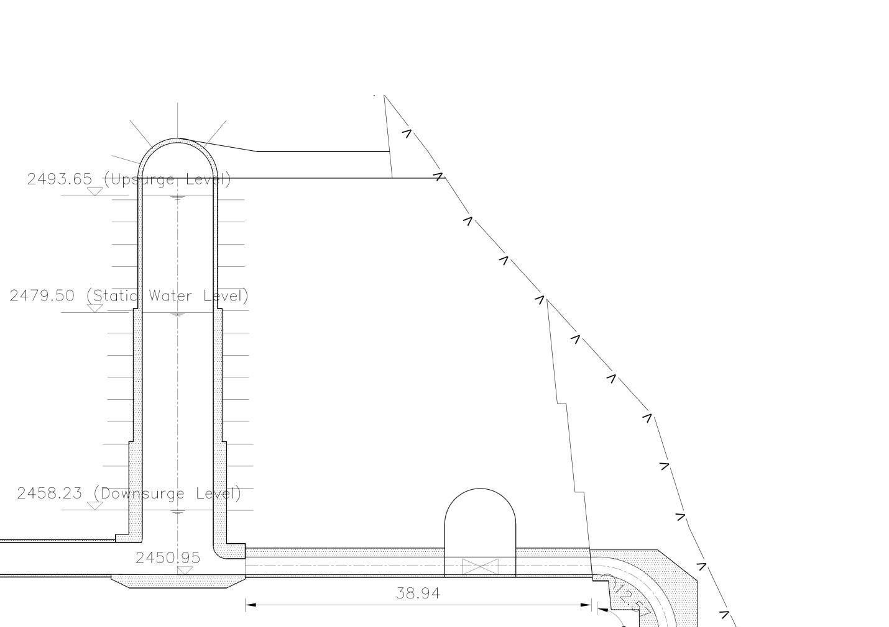

Figure 5‑11: Schematic general arrangement of surge shaft and access tunnel

### Butterfly Valve and Valve Chamber

A butterfly valve of size 2.0 m dia has been provided at 25 m downstream along the HRT from the meeting point of surgeshaft offset tunnel with HRT for the maintenance purpose of penstock pipe at its downstream. A valve chamber has been provided with wider section excavation to house the valve and to provide the space for its operation. The penstock upstream of this valve chamber has been provided with full concrete casing. The detail dimension of the valve chamber has been provided in the drawings included in Volume IV of this report.

### Drop Shaft, Pressure Tunnel / Penstock Pipe

#### General

Due to topography and the space constraint on the surface powerhouse location, the penstock pipe has to be also designed as underground pressure shaft to convey the flow from the HRT to the powerhouse. The pressure shaft starts from the surge shaft and ends at main inlet valve (MIV) of the powerhouse. The total length of the penstock pipe from surge shaft to the first bifurcation point is about 1213 m.

The initial portion of the penstock is horizontally laid on concrete casing up-to the vertical shaft drop point. After the bend, it is positioned vertically, clamped to the walls of concrete casing in vertical shaft. The penstock is then aligned in a mildly sloped tunnel section resting on support piers. The penstock will go through three drop shafts followed by mild slope horizontal tunnel. At the end it gets trifurcated and runs straight into three individual units in the powerhouse. After the branching, the penstock pipe is completely surrounded with concrete casing. By considering probable geological risks during construction and available rock cover, underground penstock shaft is considered as vertical drop shaft and 10% gradient for horizontal shaft. The detail drawing of the pressure tunnel / penstock pipe is presented in Volume IV.

#### Penstock tunnel

The length of penstock starting from the junction of offset tunnel with HRT to the first bifurcation point of penstock is about 1195.45 m. The first stretch of about 66.20 m has been provided with shotcrete lined finished D-shaped section of 3.2m (width) x 3.5 m (height) which is followed by vertical drop shaft of 3.2 m excavation diameter circular section. There are three drop shafts having height of 196.38 m (first drop shaft), 246.95m (second drop shaft) and 98.02 m (third drop shaft). The drop shafts are connected by mild slope tunnel of length about 197.65 m and 260.35 m respectively. The length of mild slope penstock tunnel from bottom of third drop shaft to first bifurcation point is sbout 119.84m. After the last mild slope penstock tunnel the branching of the penstock will take place in the underground part as well.

#### Penstock Optimization

Various diameter of penstock pipe ranging from 2.0m to 3.8m has been considered for the optimization process keeping other hydraulic and material constraints same for all considered diameter pipes. The optimization of the penstock pipe has been carried considering the energy loss verses the cost of penstock pipe. During this optimization study, the pipe thickness has been varied in 8 stretches from 10mm to 28mm which is summarized in Table 5‑3. For detail calculations refer Annex: B of this report.

Table 5‑2: Assumptions and Consideration in the optimization process:

|  |  |
| --- | --- |
| Length of Penstock Pipe (Including the branch pipes) | 1213 m |
| Design discharge | 12.50 m3/s |
| Young’s modulus of steel | 200,000 N/mm2 |
| Ultimate Tensile Stress | 570 N/mm2 |
| Yield Stress of steel | 450 N/mm2 |
| Material Specifications | As per IS 2062, 2011 |
| Allowable Stress | One third of Ultimate Tensile Stress (Refer IS Code; IS 11639 Part 2 : 1995) |
| Adopted Factor of Safety | 3.0 |
| Maximum Static Head | 629.00 m |
| Surge Head (water hammering head) | 20 % of Static Head at each of the sections |
| Welding efficiency | 90% |
| Overall efficiency of system | 88.39% |
| Project life period | 30 years |
| Discount rate | 10.5 % |
| Dry and Wet season outage | 4% |
| Dry season energy rate | NRs. 8.4 |
| Wet season energy rate | NRs. 4.8 |
| Roughness Value (k) | 0.12 |

**Pipe material and Allowable stress**

The raw material for the penstock pipe shall be in-accordance to the Indian Standards IS 2062: 2011 or equivalent national or international standards having minimum yield strength of 450 MPa and ultimate tensile strength 570 MPa. The thickness of the pipe has been calculated to withstand surge head of 20% of static head, corrosion allowance and the hydrostatic head keeping in view of material specification and its availability. The wall thickness of pipe varies from 10 mm at the top portion to 45 mm at the bottom portion. The thickness of pipe has been designed in such a way that it is able to withstand the surge pressures and the hydrostatic pressure. Extra thickness 3 mm has been considered as corrosion allowance. While selecting the minimum pipe thickness, buckling and handling thickness requirement criteria as mentioned in ASCE steel penstock design manual has also been considered.

The allowable stress and the factor of safety adopted for design depends upon the yield point stress and maximum ultimate tensile strength. Following are the allowable stress adopted for the design of Penstock pipe:

* In normal operation, the design stress will not exceed one-third of minimum ultimate tensile strength or 60 % of minimum yield point stress, whichever is less.
* In the emergency condition, the design stress will not exceed two-third of minimum ultimate tensile strength or 90 % of minimum yield point stress, whichever is less.

The factor of safety for the structural design of penstock pipe is calculated by following formula:

F.O.S= $\frac{Yiled Stress}{Allowable Stress}$

The adopted factor of safety for design is 3.0.

**Head loss**

Head loss is the one of the major parameters in penstock optimization. The headloss decreases with the increase of penstock diameter but the material cost increases. Darcy- Waishbach equation as given hereunder has been used for calculation of head loss due to pipe friction.

$hf=\frac{fLv^2}{2gD}$

The value of loss coefficient “f” was taken from the Moody Diagram for friction in pipe referring IS 11625:1986.

**Thickness of Steel Penstock Pipe**

The thickness of the pipe has been calculated to withstand surge head, corrosion and the hydrostatic head keeping in view of material specification and its availability. The wall thickness of pipe varies from 10 mm at the top portion to 45 mm at the bottom portion. While estimating the pipe thickness for various segments extra thickness 3 mm is considered as corrosion allowance as reflected in following equation. While selecting the minimum thickness, the criterion of buckling and handling thickness requirement as mentioned in ASCE steel penstock design manual.

The pipe thickness has been calculated as per the IS code:



#### Minimum thickness for Shipping and Handling:

The minimum thickness of Penstock pipe for shipping and handling has been calculated using the formulas of PG&E and Bureau of Reclamation formula as mentioned in ASCE Steel Penstocks which are as follows:

* (PG&E formula) tmin= D/288
* (Bureau of Reclamation formula) tmin= (D+20)/400

Where, D=proposed penstock diameter

**Result of Penstock Optimization**

The optimization of penstock resulted in the optimized diameter of 2.0m with thickness of pipe varying from 10mm at top segment to 45 mm at lowest segment. The calculation of penstock optimization has been included in **Annex B: Hydraulic Calculations**. The optimization graph has been presented in Figure 5‑12.

Figure 5‑12: Penstock Pipe Optimization graph

The penstock pipe thickness and diameter for different section of the pipe as obtained from the penstock optimization has been presented in Table 5‑3. The thickness of penstock pipe has been designed considering 20% of water hammer surge head in addition to static head and it should be confirmed by the electromechanical contractor that the water hammer pressure rise in the pipe won’t exceed 20% of the static head.

Table 5‑3: Result of Penstock optimization

| Section | Seg 1 | Seg 2 | Seg 3 | Seg 4 | Seg 5 | Seg 6 | Seg 7 | Seg 8 | Seg 9 | Seg 10 | Branch Pipe (1.8 m/1.2 m) |
| --- | --- | --- | --- | --- | --- | --- | --- | --- | --- | --- | --- |
| Length of penstock of section, m | 152.39 | 60 | 67.05 | 257.27 | 60 | 60 | 65 | 164.65 | 274.97 | 81.51 | 85.07 |
| Static Head, m | 123.50 | 183.50 | 247.50 | 279.50 | 339.50 | 399.50 | 464.50 | 524.50 | 589.50 | 636.50 | 626.50 |
| Wall thickness of penstock pipe, mm | 10 | 14 | 18 | 20 | 25 | 28 | 32 | 36 | 40 | 45 | 40/32 |

#### Thrust Block

Six thrust blocks will be positioned at both bend of the vertical shaft. Thrust blocks are designed to stabilize the hydraulic forces at the pipe bends. The thrust block is considered safe in sliding, overturning and bearing capacity since it is confined and anchored with rock bolts into the surrounding rock.

## Powerhouse, Switchyard and Tailrace

### Powerhouse

#### General

A surface powerhouse has been proposed on the right bank of Myagdi Khola in the vicinity of Jeltun Village of Myagdi District. The powerhouse houses three units of vertical axis Pelton turbines and generators with generation capacity of 19.1 MW each. The dimension of proposed powerhouse is 49.60 x 15.2 x 25.00m (LxBxH). Flood protection wall in the boundary of the powerhouse premises and covering the switchyard area and is extended into the hill side of the switchyard thus protecting the nearby Kholsi from entering the switchyard and powerhouse premises as well.

The general arrangement of the powerhouse is shown in Figure 5‑13.

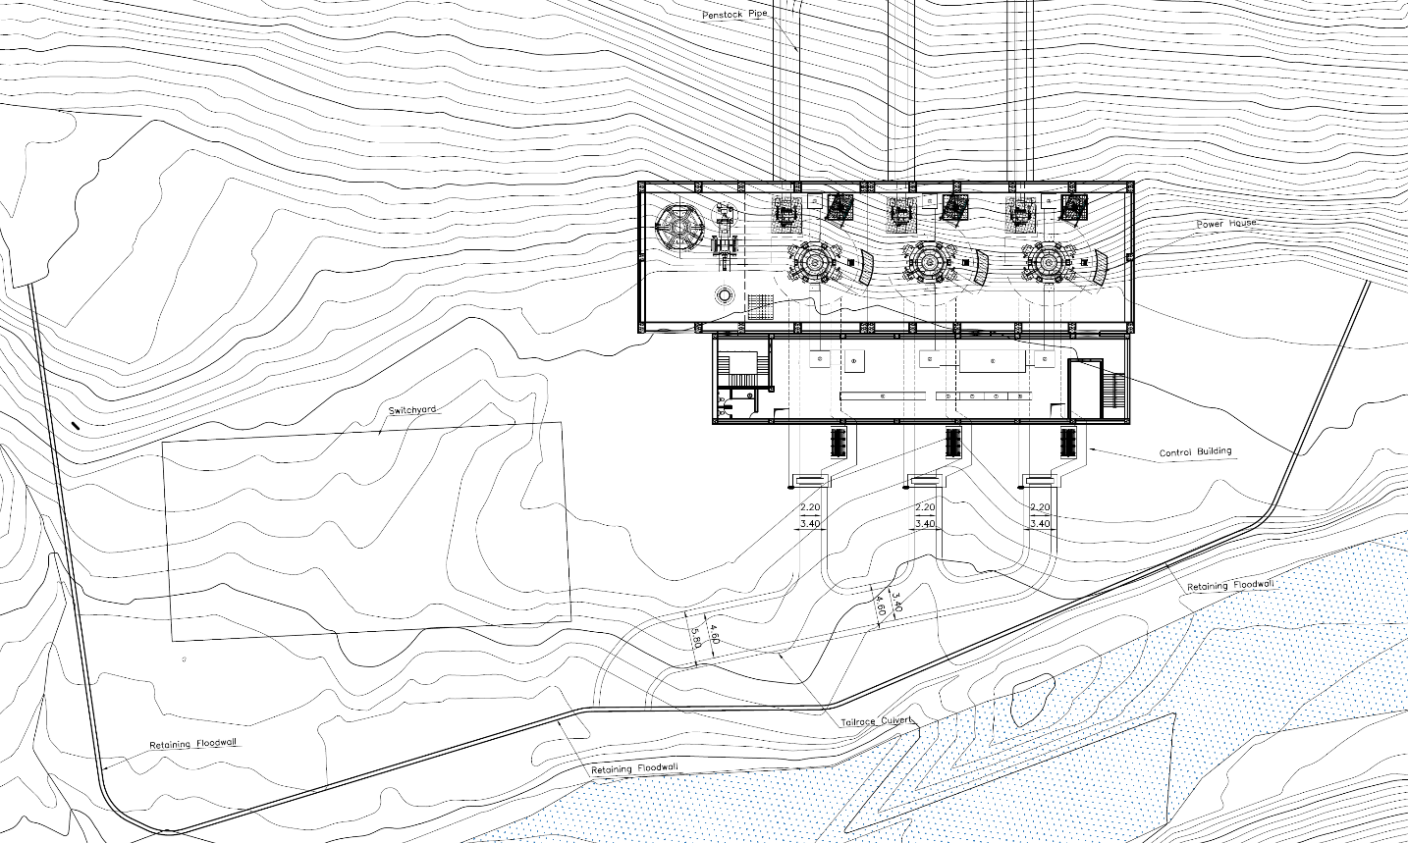

Figure 5‑13: Powerhouse Area Layout Plan

The proposed powerhouse of the project lays over a flat terrain, and well above the flood level of the Myagdi Khola. Considering the head and discharge of the project, Pelton turbine with vertical axis alignment has been selected. The turbine center level has bee fixed at an elevation of 1853 masl. Also, the outlet of tailrace culvert has been placed just above the HFL.

Retaining structures is provided at the east and south side of the powerhouse for providing access and flood protection.

The general arrangement, profile and sections of the powerhouse are shown in **Volume IV.**

Arrangement of powerhouse with the longitudinal profile of tailrace with flood level has shown in Figure 5‑14.

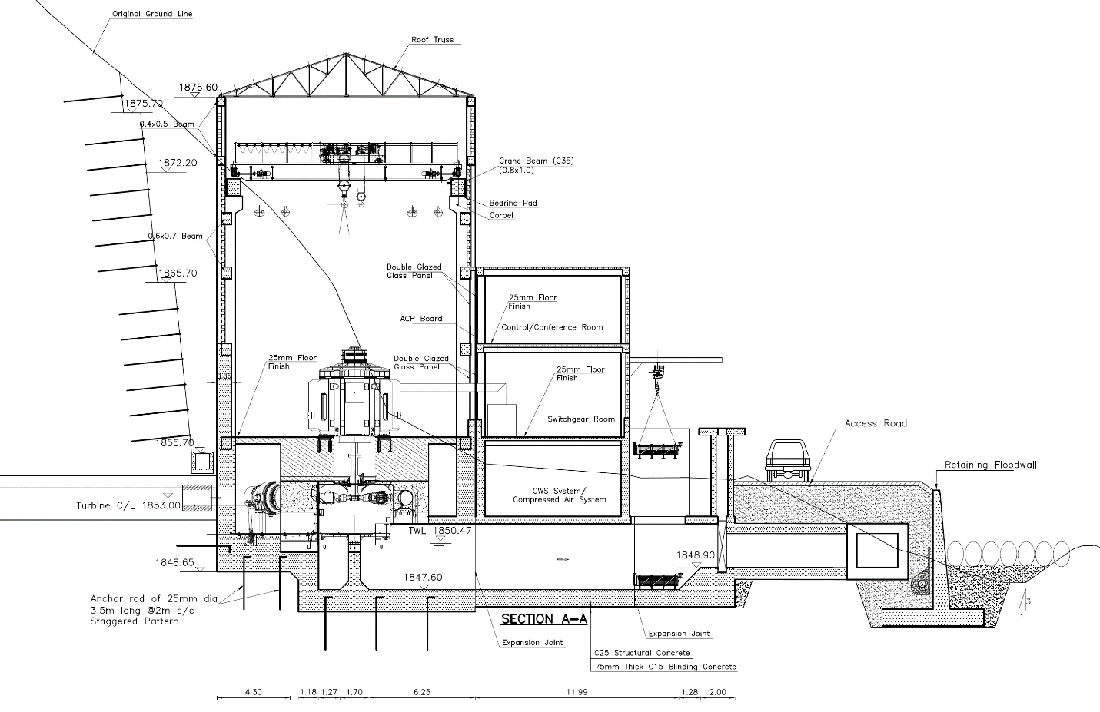

Figure 5‑14 Profile of Powerhouse showing Tailrace

### Tailrace

A tailrace culvert of size 2.40m x 2.00m (B x H) has been designed at a slope of 1 in 800. Rectangular box culvert at the end discharges the water back into the Myagdi Khola. The rectangular shaped concrete conduit will be ‘cut and cover’ type. The key is provided at the outlet with two layers of 1.5m to 2m boulder riprap with concrete infill to protect from scouring at the outlet. An access to the pit during maintenance is also incorporated. Further, the outlet of tailrace has been kept at 1848.82 masl which is above 100 years return period flood. However, in case of high floods than considered, a stop log is provided at the end of the tailrace to prevent the backflow. Similarly, this arrangement also helps to avoid the sediment deposition into the tailrace during high flood.

### Switchyard

The switchyard location has been proposed in the periphery of the powerhouse. The switchyard area is located on right bank of Myagdi Khola. The platform of switchyard covering 40x20 meter area has been proposed to be placed at an elevation of 1851.5 masl, on toe of hill at Right Bank of the river.

# HYDROMECHANICAL WORKS

## Introduction

This chapter intends to provide information on Hydro-mechanical components according to the project requirements. It describes various type of gates, stoplogs, trashracks, pipes, etc including all the accessories to be used in this project.

## Gates, Stoplogs and Trashracks

Different types of gate, stoplog and trashrack are necessary to be provided on intake, gravel trap and Settling basin area to control the flow and remove the debris/ silt from the water way and its accessories. The size of each hydro mechanical component is determined from the hydraulic design calculation. Each gate is necessary to be provided with the sealing arrangement, hoisting, steel supports, dogging device, position indicator, lifting beam, and appurtenant parts and guide frame including track, seal beam, lintel, etc., as required. Different types of gate, stoplog and trashrack are necessary to be provided on intake, gravel trap etc.

1. **Myagdi Headworks**

### Coarse Trashrack

Two sets of inclined coarse trashrack are proposed at intake side to exclude large floating debris, logs and boulders from the intake. The clearance between the two bars will be maintained at 100 mm.

Technical data:

Clear width : 3.6 m

Clear height : 2.5 m

Design head : 8.95 m

Bar Opening : 100 mm

Quantity : 2 Sets

### Undersluice gate (Radial)

Two sets of hydraulic hoist operated radial gate is proposed at undersluice area. This gate helps to control sedimentation in front of the intake and water flow control for the power plant.

Technical data:

Clear width : 2.50 m

Clear height : 2.50 m

Design head : 14.45 m

Sealing : Four-way upstream with auxiliary top sealing

Hoisting : Two sets of hydraulic hoist for each unit.

Quantity : 2 sets

### Undersluice stoplog

One set fixed wheel/sliding stoplog is proposed at the upstream of the radial gate. It shall be operated using electric rope drum hoist. This stoplog helps the maintenance of the undersluice channel and the radial gate.

Technical data:

Clear width : 2.5 m

Clear height : 2.5 m

Design head : 8.27 m

Sealing : Four-way downstream

Hoisting : One set of electric rope drum hoist

Quantity : 1 sets

### Intake gate

Two sets of fixed wheel gate are proposed at intake behind the Intake coarse trashrack. These gates help to control the water flow along the approach.

Technical data:

Clear width : 3.6 m

Clear height : 2.5 m

Design head : 8.95 m

Sealing : Four-way upstream

Hoisting : Two sets of motorized Rope Drum

Quantity : 2 Sets

### Trash passage Gate

One set trash passage gate operated by electric screw spindle is proposed at intake area. This gate help to remove the trash collected at intake.

Technical data:

Clear width : 1.50 m

Clear height : 1.5 m

Design head : 6.95 m

Sealing : Four-way upstream

Hoisting : One set of electric operated screw spindle hoisting with manual

facility

Quantity : 1 Set

### Gravel flushing gate

One set of motor operated gravel flushing gate is proposed at gravel trap area. This gate help to remove the gravel and silt collected before the main intake.

Technical data:

Clear width : 1.2 m

Clear height : 1 m

Design head : 6.5 m

Sealing : Four-way downstream

Hoisting : One set of motor operated screw spindle hoisting with manual

operation facility

Quantity : 1 Set

### Gravel flushing stoplog

One set of electrically operated flushing stoplog is proposed at upstream of gravel flushing gate. This stoplog helps for repair and maintenance purpose of the gravel flushing gate.

Technical data:

Clear width : 1.2 m

Clear height : 1 m

Design head : 6.5 m

Sealing : Four-way upstream

Hoisting : One set of motor operated screw spindle hoisting with manual

operation facility

Quantity : 1 Set

1. **Kunaban Headworks**

### Coarse Trashrack

Two sets of inclined coarse trashrack are proposed at intake side to exclude large floating debris, logs and boulders from the intake. The clearance between the two bars will be maintained at 100 mm.

Technical data:

Clear width : 4.8 m

Clear height : 2.5 m

Inclined length : 4.67 m

Design head : 6.42 m

Bar Opening : 100 mm

Quantity : 2 Sets

### Fine Trashrack

Two sets of inclined fine trashrack are proposed at upstream of intake gate to exclude small floating debris, trashes etc. The clearance between the two bars will be maintained at 50 mm.

Technical data:

Clear width : 5.25 m

Clear height : 4.26 m

Inclined length : 4.85 m

Design head : 1.97 m

Bar Opening : 50 mm

Quantity : 2 Sets

### Undersluice gate (Radial)

One set of hydraulic hoist operated radial gate is proposed at undersluice area. This gate helps to control sedimentation in front of the intake and water flow control for the power plant.

Technical data:

Clear width : 2.50 m

Clear height : 2.50 m

Design head : 11.32 m

Sealing : Four-way upstream with auxiliary top sealing

Hoisting : Two sets of hydraulic hoist

Quantity : 1 sets

### Undersluice stoplog

One set fixed wheel/sliding stoplog is proposed at the upstream of the radial gate. It shall be operated using electric rope drum hoist. This stoplog helps the maintenance of the undersluice channel and the radial gate.

Technical data:

Clear width : 2.5 m

Clear height : 3.10 m

Design head : 8.0 m

Sealing : Four-way downstream

Hoisting : One set of electric rope drum hoist

Quantity : 1 sets

### Intake gate

Two sets of fixed wheel gate are proposed at intake behind the Intake coarse trashrack. These gates help to control the water flow along the approach.

Technical data:

Clear width : 4.8 m

Clear height : 2.5 m

Design head : 6.42 m

Sealing : Four-way upstream

Hoisting : Two sets of motorized Rope Drum

Quantity : 2 Sets

### Trash passage Gate

One set trash passage gate operated by electric screw spindle is proposed at intake area. This gate help to remove the trash collected at intake.

Technical data:

Clear width : 1.50 m

Clear height : 2.0 m

Design head : 4.07 m

Sealing : Four-way upstream

Hoisting : One set of electric operated screw spindle hoisting with manual

facility

Quantity : 1 Set

### Fish Ladder Gate

One set fish ladder gate operated by electric screw spindle is proposed at intake area. This gate help move fish to more upstream and downstream in the river.

Technical data:

Clear width : 0.60 m

Clear height : 0.60 m

Design head : 4.07 m

Sealing : Four-way upstream

Hoisting : One set of electric operated screw spindle hoisting with manual

facility

Quantity : 1 Set

### Gravel flushing gate

One set of motor operated gravel flushing gate is proposed at gravel trap area. This gate help to remove the gravel and silt collected before the main intake.

Technical data:

Clear width : 1.2 m

Clear height : 1 m

Design head : 4.92 m

Sealing : Four-way downstream

Hoisting : One set of motor operated screw spindle hoisting with manual

operation facility

Quantity : 1 Set

### Gravel flushing stoplog

One set of electrically operated flushing stoplog is proposed at upstream of gravel flushing gate. This stoplog helps for repair and maintenance purpose of the gravel flushing gate.

Technical data:

Clear width : 1.2 m

Clear height : 1 m

Design head : 4.92 m

Sealing : Four-way upstream

Hoisting : One set of electrically operated screw spindle hoisting with manual facility

Quantity : 1 Set

### Settling basin Inlet gate

Two sets of motorized rope drum operated gates are proposed at settling basin outlet area. These gates help to control the water flow to the pipe.

Technical data:

Clear width : 2.5 m

Clear height : 2 m

Design head : 2.03 m

Sealing : Four-way upstream sealing arrangement

Hoisting : Two sets of motorized rope drum hoisting

Quantity : Two Sets

### Settling basin outlet gate-I

Two sets of motorized screw spindle operated gates are proposed at settling basin outlet area. These gates help to control the water flow to the pipe.

Technical data:

Clear width : 4.5 m

Clear height : 1.5 m

Design head : 3.26 m

Sealing : Four-way double sealing arrangement

Hoisting : Two sets of screw spindle hoisting

Quantity : Two Sets

### Settling basin outlet gate-II

Two sets of motorized screw spindle operated gates are proposed at settling basin outlet area. These gates help to control the water flow to the pipe.

Technical data:

Clear width : 4.05 m

Clear height : 1.5 m

Design head : 3.26 m

Sealing : Four-way double sealing arrangement

Hoisting : Two sets of screw spindle hoisting

Quantity : Two Sets

### Settling basin flushing gate

Two sets of electric motor operated gates are proposed at settling basin flushing area. This gates are used during cleaning the silt collected at settling basin chambers.

Technical data:

Clear width : 1.0 m

Clear height : 1.0 m

Design head : 10.96 m

Sealing : Four-way downstream

Hoisting : Two sets of motor operated screw spindle hoisting with manual

facility

Quantity : 2 Sets

### Settling basin flushing stoplog

Two sets of electric motor operated gates are proposed at settling basin flushing area. This gates are used during cleaning the silt collected at settling basin chambers.

Technical data:

Clear width : 1.0 m

Clear height : 1.0 m

Design head : 10.96 m

Sealing : Four-way upwnstream

Hoisting : Two sets of motor operated screw spindle hoisting with manual

facility

Quantity : 2 Sets

### Settling basin flushing culvert gate

One set of electrically operated gate is proposed at the settling basin flushing culvert area. This gate is used during cleaning the silt collected at settling basin chambers.

Technical data:

Clear width : 2.0 m

Clear height : 1.8 m

Design head : 8.4 m

Sealing : Four-way downstream

Hoisting : One set of electrically operated screw spindle hoisting with manual facility

Quantity : 1 Set

### Fine Trashrack

One set of inclined fine trashrack are proposed at headpond to exclude small floating debris, trashes etc. The clearance between the two bars will be maintained at 50 mm.

Technical data:

Clear width : 5.34 m

Inclined length : 4.58 m

Design head : 9.0 m

Bar Opening : 50 mm

Quantity : 2 Sets

### Tailrace gate

Three sets of motorized rope drum operated gates has been proposed at tailrace area. This gates help to block the backflow from the tailrace and maintenance of the turbine section.

Technical data:

Clear width : 2.4 m

Clear height : 2.0 m

Design head : 2.0 m

Sealing : Four-way sealing (To prevent flow from river basin as well as

tailrace canal)

Hoisting : Three sets of motorized rope drum hoisting

Quantity : 3 sets

## Steel Pipe and Accessories

### General

The inside diameter of penstock pipe derived from the optimization calculation is 2 m. The wall thickness of pipe varies from 10 mm to 45 mm. The thickness is calculated by taking the effect of water hammer with 2 mm corrosion allowance. The material has been proposed of minimum Yield Strength (YS) is 450 MPa and Ultimate Tensile Strength (UTS) is 570 MPa.

The design flow velocity in the main penstock pipe is 3.98 m/sec.

The penstock pipe is surface at some section and buried at some section. Anchor blocks are provided at each change of direction of the penstock pipe to provide necessary weight to counter act the resultant of all the forces and to transmit them safely to the ground.

Corrosion prevention measure for steel penstock will be coatings of Epoxy Coal tar on both outer and inner surface. The coating thickness will be 400 microns in case of buried pipe and 330 microns if the pipe is exposed.

Manhole will be required along the entire penstock pipe. It will provide access to the pipe, outlet portal and a main inlet valve for maintenance and the penstock pipe. The number and location of manhole shall be decided during detailed design stage.

1 set of bifurcation having inlet diameter of 2000 mm and outlet diameter of 1600 mm and 1200 mm and another bifurcation having inlet diameter of 1600 mm and outlet diameter of 1200 mm is provided to divide the flow of water coming from penstock to three units of turbines equally.

Expansion joint are provided at each exposed section of penstock between anchor blocks to permit the longitudinal expansion or contraction at different atmospheric temperature. The number and location of expansion joints shall be decided during detailed design stage.

### Pipe diameter optimization

The penstock was optimized for the most cost-effective combination of the penstock diameter and thickness. Increase in penstock diameter raises the capital cost, but the energy output also increases because of the reduction in the head losses. This initial cost of the penstock with different diameters is compared with the changes in the revenue generated by the project during its operating life to obtain an optimum net present value of the project.

Optimum diameter and thickness of the penstock pipes are determined from an economic analysis considering cost of different diameter pipes, head loss through the pipe and consequent loss of energy, construction cost of vertical shaft. Net present value (NPV) is calculated to find the optimum diameter of the penstock.

Effect of varying the diameter size on energy output and consequent scheme cost is shown in Figure 6‑1 . The chart shows the optimum penstock pipe diameter is 2.0 m.

Figure 6‑1: Optimization Curve for Penstock Pipe Diameter

### Pipe thickness calculation

The pipe thickness design is based on the following data and assumptions:

Design flow 12.5 m3/s

Discount Rate 10%

Unit weight of steel 7850 kg/m3

Yield stress of steel 450 N/mm2

Ultimate Tensile Strength 570 N/mm2

Material Specification SAILMA 450 HI or Equivalent

Young’s modulus of steel 200,000 N/mm2

Corrosion allowance 2 mm

Welding efficiency 90 %

Gross head 626.5

Surge head different at different section

Factor of safety 2.2 (with respect to YS)

Analysis Period 30 yrs

Length and thickness of pipe for different gross heads are given in Table below.

Table 6‑1 Length and Thickness of Pipe for Different Gross Heads

|  |  |  |  |  |
| --- | --- | --- | --- | --- |
|  | **Description** | **Thickness, mm** | **Length, m** | **Static head, m** |
| **Material: YS 450Mpa, TS 570 MPa** | Internal Dia. 2.0 m | 10 | 152.39 | 123.50 |
| 14 | 60 | 183.50 |
| 18 | 67.05 | 247.50 |
| 20 | 245.35 | 267.58 |
| 25 | 71.92 | 339.50 |
| 28 | 60.0 | 299.50 |
| 32 | 65 | 464.50 |
| 36 | 164.65 | 524.50 |
| 40 | 274.97 | 589.50 |
| 45 | 81.51 | 626.50 |
| Branch pipe Internal dia.1600 mm and 1200 mm | 32 | 92 | 626.50 |
| **Grand total** | |  | **1334.84** |  |

### Penstock Protection Valve

One set of Penstock Protection (Butterfly) valve with By-pass valve and Air release valve shall be installed between the headrace tunnel and the penstock. The valve helps during repair and maintenance at downstream side of the penstock as well as store the water up to this valve. It also acts as shut off valve in case of turbine breakdown, penstock rupture. The valve shall be operated during normal starting and stopping of the unit.

The valve shall have flanges for upstream connection to the penstock inlet pipe and downstream connection to an expansion/dismantling pipe and operating mechanism with servomotor and counterweight for closing. The design of valve shall minimize the hydraulic losses through the valve. The valve shall have sufficient capacity to allow maximum flow of turbine discharge.

Technical data:

Internal diameter : 2.0 m

Design head : 30m

Quantity : 1 Set

## Other HM special items

Other Hydro-mechanical items are given in table below:

Table 6‑2: Quantity of Some other special HM components

| S.N. | Description | Quantity | Units |
| --- | --- | --- | --- |
|  | Bifurcation from Dia. 2.0 m to 1.6 m & 1.2 m | 1 | Set |
|  | Bifurcation from Dia. 1.6 m to 1.2 m | 1 | Set |
|  | Bulkhead Door at Adit | 1 | Set |
|  | Manholes (to be decided during detail design) | 6 (Approx.) | Sets |
|  | Bellmouth | 2 | No. |
|  | Saddle, wear and stiffener plate (Thk=8mm) | 43.24 | Ton |
|  | Expansion Joint (to be decided during detail design) | 3(Approx.) | Nos. |
|  | Penstock Protection Valve, Internal Dia. 2.0 m, (Butterfly valve with By-pass valve and Air release valve) | 1 | Set |
|  | Miscellaneous Items (Monkey ladder, Steel Staircase, Railings & other Steel Works) | 1 | Lot |

# ELECTRO-MECHANICAL EQUIPMENT

## General

Hydroelectric power generation involves conversion of hydraulic energy into mechanical energy by the hydraulic turbine, and conversion of mechanical energy of rotating turbine into electrical energy by an electric generator. The generating equipment housed in powerhouse is divided into mechanical generating equipment, comprising of inlet valves, turbines, governor, cooling water supply etc. and electrical equipment comprising of generator, excitation system, circuit breakers, metering, protection & control equipment, etc. The generating units with high efficiency build from modern state of the art & technology and the best one that can be economically realized in practice are considered for use in Myagdi Khola Hydropower Project (MKHPP). The succeeding sections provide the study and design of all the major generating equipment, in detail.

The project area is located in Bagara, Dhaulagiri Rural Municipality of Myagdi District, Gandaki Province, Nepal. The headworks are located upstream of the confluence of Myagdi and Kunaban Khola, one on each river that meet at Dovan. The powerhouse is proposed on the right bank of Myagdi Khola at Jeltun Village, about 7500 m downstream from the Myagdi-Kunaban confluence at Mudi VDC.

Powerhouse building contains turbine main inlet valves, turbines, governors, generators and electromechanical accessories. The powerhouse consists of the machine floor, assembly/erection bay, general workshop, control room and all the hydro-mechanical and electromechanical equipment.

### Design criteria

The design and the selection of the turbines and governors are based on the following criteria;

* The output shaft power of individual turbine unit will be 19965 kW at rated head and flow.
* The optimum rated specific and synchronous speed will be selected referring to the standard guidelines available viz. IEC; Indian Standard; IHE Delft.
* The governors will be of the electro-hydraulic digital type of proven design and be equipped with

electronic controls for fast response and stable load control.

### Turbine selection and Mode of operation

Three equal capacity units of Vertical Shaft, Pelton Type Turbine have been selected for this project. The number and rating of turbine generator units have been determined on the basis of head and discharge, operational flexibility, part load operation, turbine-generator footprint and subsequent excavation requirement inside powerhouse, transportation constraints of electromechanical equipment to the site, weighted average efficiency and overall economy of the plant.

Pelton type turbine has been found suitable to the given head and discharge condition. Vertical shaft alignment of turbine and generator has been selected due to site conditions, space availability, and excavation requirement. Pelton turbine offers lower specific speed, greater weighted average efficiency within the discharge and head variation limit, and weight of the unit rotor that can easily transportable to the site. Number of units is chosen such that the turbine will always operate above 40% of the design discharge of each unit even in the low flow period and optimum reliability, availability and maintainability is achieved.

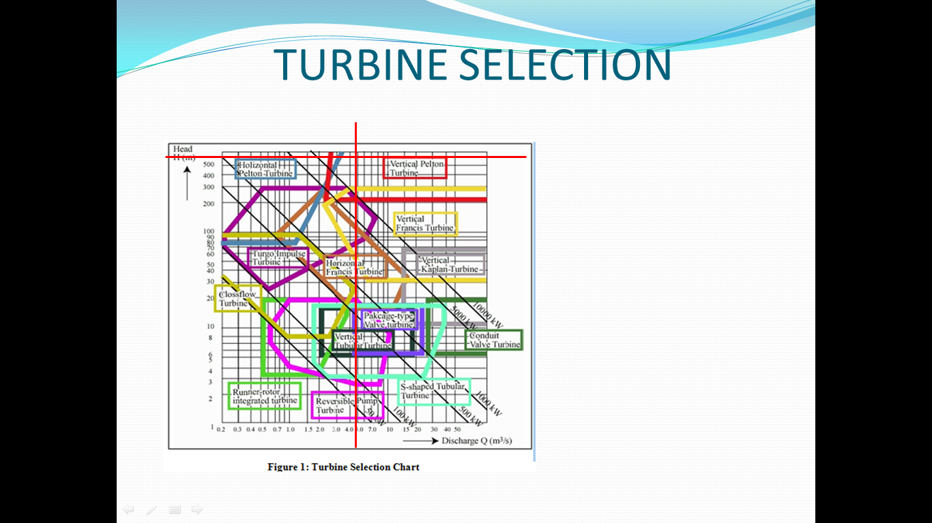

Figure 7‑1: Turbine Selection Chart

Each of the three (3) Pelton Turbine units selected shall be operated at full capacity during full discharge period, especially during wet months, including 10% overloading condition also have been envisaged as per normal practice. During the dry months especially in Magh and Falgun, economic operation of plant has been considered and expected to operate not lower than 50% of design discharge.

Table 7‑1: Basic Features of Turbine

| Description | Parameters |
| --- | --- |
| Turbine rated output, P | 19965 kW |
| No of Units | 3 |
| Shaft Arrangement | Vertical |
| Gross head, Hg | 626.50 m |
| Rated net head, Hnet | 604.68 m |
| Rated water flow, Q | 4.17 m3/s per unit |
| Rated speed, n | 750 rpm |
| Specific Speed | 23.6 |
| Runway Speed | 1350 rpm |
| Rated Efficiency, η | 0.91 |

### Turbine maintenance

Although the desander will remove a large portion of the sediment from the power flow water during the monsoon flood, some sediment will inevitably remain in the flow and pass through the turbines. This remaining sediment will be abrasive thus exposing the turbine runner’s buckets, nozzle tips and rings and possibly the head cover and bottom ring wearing and tearing plates to erosion damages.

It is envisaged that both units will require annual minor maintenance and a major overhaul at an interval of two to three years. Machine overhauling schedule will be so arranged that every year major overhauling is carried out on only one unit. In order to shorten the overhauling period, there shall be a provision for one set of spare runner and nozzle’s parts.

In many old powerhouses, there is a traditional approach of the turbine runner removal, a general practice of removing the generator rotor. This approach is time consuming and normally requires decommissioning of equipment. There is also a risk of damage to the equipment. In Nepal, due to presence of silt, the frequency of repair and maintenance of turbine parts is very high in comparison to the generator parts. It is, therefore, proposed that the runner will be removed without removing the generator rotor.

Runner removal is initiated first by opening access frame. Then, the runner is lifted directly by Electric Overhead Travelling (EOT) Crane. The runner is then carried through the machine floor hatch and finally transferred to the service/erection bay where the repair will be carried out.

## Valves

### Main Inlet Valve

Spherical type main turbine inlet valve will be used for each turbine unit. Spherical valve with "double seal system," consisting of both maintenance and service stainless steel seals will be employed. This sealing system enables the penstock to remain pressurized when maintenance operations are being undertaken on the downstream side of the valve.

The valves will be operated by oil pressurized servomotor supplied from the pressure oil system of the governor. The valve will be closed by counterweight. Each inlet valve will be provided with an automatic as well as manual operated by-pass valve. The by-pass valve will be of needle valve type and operated by pressure oil to be supplied from the governor system.

Flow is distributed to the turbines through individual branch pipes after main penstock from a single headrace tunnel via a manifold. Therefore, in order to isolate any unit for inspection and maintenance without disrupting flow to the remaining units, it is necessary to provide a main inlet valve (MIV) for each unit. For the gross head above 200 m, a spherical valve will be appropriate.

Depending on the concentration of sediment passing into the power waterway, the spherical valve surface may suffer erosion damage, which could affect sealing. Providing all seals are removable, adjustable and made of high performance rubber, this should not be a major problem. The inlet valve is located inside the powerhouse immediately upstream of the distribution pipe, thus facilitating its installation and maintenance handling using the powerhouse overhead crane.

The spherical valve inside diameter will be identical to that of the distribution pipe. The opening of MIV shall be affected by its independent pressure oil system or by pressure oil system common to governor and MIV. For reliable and positive closing, closing operation of MIV shall be affected through counter weight. For pressure equalization before opening, MIV shall be provided with Bypass valve.

An expansion joint will be provided between the spherical valve and distribution pipe in order to cope with the thermal expansion of penstock, distribution pipe and spherical valve. Besides, the presence of such joint enables convenient dismantling of the valve during maintenance period.

### Penstock Shut-off Valve

One set of Butterfly Valve completes with all Control & Monitoring Panel, Hydraulic power pack Servomotor, Anti-vacuum Air Valve, Bypass Valve, Handling HOT Crane and necessary networking for operation. It shall be installed just downstream of Surge Tank and at start of penstock pipe in Valve house. It shall closed when the penstock pipe rupture. It shall act as isolating devices for inspection of penstock pipe without dewatering entire headrace tunnel and surge tank. The valve by virtue of their design and robust construction, close down automatically and instantaneously in the event of the downstream water ways penstock pipe to turbine rapture.

The operation of valve normally through a Servomotor operated by a hydraulic power pack which house a hydraulic pumps, directional control valves, necessary pipe networking. The opening of valve is by this servo system but closing shall be by counter weight.

The valve shall be supplied along with a fully wired and compact electrical control panel with necessary instruments, sensors, contactors etc., which in turn shall also be hooked up to Central Control Room of the power plant for remote operation and monitoring.

## Overhead Crane

A double girder Electric Overhead Travelling (EOT) crane of sufficient capacity is provided to meet the lifting requirements of the heaviest piece of equipment in powerhouse, which is anticipated to be the generator rotor with shaft. The crane will be equipped with one main and one auxiliary hoist. It should be noted that additional lifting devices such as monorails, chain blocks, wheeled platform/trolleys etc. are also required for lifting and moving equipment in areas which are out of reach of the overhead crane and should be duly considered.

Preliminary assessment of lifting requirement provides the following lifting capacity of the electrical overhead crane.

Table 7‑2: Details of Powerhouse Crane

|  |  |  |
| --- | --- | --- |
| Description | Unit | Quantity |
| Main Hook capacity | Tons | 50 |
| Auxiliary Hook capacity | Tons | 10 |
| Heaviest part to be lifted (Generator Rotor) | Tons | 38 |
| Voltage | 3 Phase, 400V, 50Hz | |

## Governor

Each turbine unit will be provided with an efficient automatic governing system with adequate capacity to control the turbine under all conditions. Control and operation of the turbines will be possible either from the station control room or from the local unit control panel for the purpose of commissioning and testing.

Control of the turbine will be accomplished by controlling the opening/closing of the needles, with minimum loss of water so that pressure in the penstock never exceed given limit. The governors will be designed and equipped for taking the unit automatically to the rated speed at no-load operation. When the generator is connected to the grid, the regulating parameters of governor will be changed and load setting will be possible. The governors will allow proper sharing of load between all the units under any condition of load and speed without hunting. When the power house is interconnected with the existing power system, the units will be capable of synchronizing with the other power stations in the system.

Each unit will consists of a Digital Electronic Governor with Proportional Integral Derivative (PID) action while running on isolated as well as on Load Sharing Module.

The governor will control the speed of the turbine via modulation of the deflector. The governing system should be highly accurate and rugged.

The range of adjustment shall at least be as follows:

1. Speed setting -5% to +5%
2. Permanent speed drop 0 - 10%
3. Integral Time constant, TD 0.1 - 20 s
4. Derivative gain, TN 0 - 2 s
5. Temporary Speed drop 0-100%
6. Dead Time 0.2 s
7. Dead Band <= 0.02%
8. Momentary pressure rise 15% of static head

The turbine governor system will include following control functions:

1. Manual Start-up by sequences of linked control actions,
2. Semi-automatic start up by sequences of linked control actions,
3. Full automatic start-up,
4. Operation with automatic power limitations, with power feedback,
5. Control of turbine output when the both units are operating in parallel,
6. Frequency control/Load control,
7. Load sharing between the units,
8. Rated speed no-load control,
9. Normal shut down
10. Emergency shutdown, and
11. Provide oil pressure to control the main inlet valve, spear (needle) and jet deflector.

The governor system will consist of the following main units:

1. Electronic digital control CPU,
2. Speed monitoring system,
3. Oil pressure system,
4. Oil pressure accumulator system,
5. Hydraulic actuator control unit,
6. Mechanical hydraulic over-speed device,
7. Servomotor feed-back system,
8. Instrumentation, alarm and safety devices and
9. Speed signal generator

Each turbine is controlled by an electro-hydraulic digital type governor having a hydraulic system to operate the nozzles for regulation of the water jet. The main features of the governor include:

1. Programming capabilities for automatic control of nozzle openings to regulate and maintain maximum output of turbine, if required.
2. Interconnection with the station alarm and protection circuits for emergency shutdown of the unit.

The pressure system of the governor includes a sump tank from which hydraulic oil is pressurized by pumps for storage in an accumulation pressure tank. For pressuring the governor oil pressure system, there should be a provision of high pressure compressed air system. A jockey is supplied to maintain oil pressure in the system when regulating demands on the governor are low. The oil pressure system includes essential controls and piping interconnections to the governor relay valve and the turbine guide servomotors. It is also common practice to have a common pressure oil system for Turbine and Main inlet valve. The final choice on it shall be made during detail design process.

## Powerhouse auxiliary

### Station drainage

Drainage water from different parts of the powerhouse is collected in a deep drainage sump tank located in the drainage floor. At least two submersible type drainage pumps; one on duty and one on standby, removes water collected in the sump tank and pump it through embedded piping to the tail water downstream from the tailrace gates.

Two oil interceptors are located adjacent to the drainage sump in order to prevent any spillage of oil into the tailrace. All drainage water must pass through one of the interceptors before entering the sump tank.

### Upstream water conveyance dewatering system

For the repair and maintenance of the penstock portion and to achieve complete dewatering of the water conveyance system, one set of Penstock protection valve will be provided downstream of surge shaft so that the valve can be closed and the repair & maintenance of the penstock and the inlet valve can be performed without dewatering the tunnel, surge shaft, settling basin and approach canal. During maintenance, gate valve will be closed and each branching unit will be equipped with draining provisions which will be located at the lowest point of the penstock in each branch, from where dewatering by gravity will be possible down to tailwater level. Below this level, complete dewatering will require the utilization of the drainage system as outlined above. For this purpose, drain lines to the tailrace are closed and drain lines to the drainage sump are opened. For the dewatering of water conveyance system upstream of the Bonneted gate, the intake gate will be closed and the water conveyance system will be dewatered from normal dewatering system.

### Cooling water system

Cooling water (CW) from tailrace has been proposed taking into account of the risk of high content of suspended sediment and debrise in the “raw” water during the monsoon period and importance of reliability of cooling water system.

The system will pump water to the CW supply headers by base mounted pumps installed in the powerhouse interior in an Open Circuit System. After cooling hot oil and air, the water will be drained back to tailrace.

Under this system, the pumped water first passes through a coarse mesh filter (one on-duty and one standby) and then through a rotary strainer (one on-duty and one standby). Rotary strainer is a fine filter. The filtered water from separate tapping is passed through a common pipeline after some pressure reduction. This cooling water is then supplied to different cooling components. However, the cooling water for shaft sealing is further passed through micro filters before passing through shaft seal cooler. Finally, water from cooling components (except the shaft seal) is discharged directly into the tailrace. The water from the shaft seal is initially discharged into drainage trench which leads water to the drainage sump. From drainage sump, water is pumped out to tailrace. Two or more pumps are required, one on duty and the other, standby.

As a backup provision, a pipeline system shall be installed which interconnects all the Cooling Water (CW) supply headers and pumps to an overhead de-silting tank behind the powerhouse at ground level (the distance shall remain minimum and within the powerhouse proximity). This shall serve as a Complete Cooling System in case the problem arises in the primary CW supply system.

The cooling water (CW) supply system shall be applied for the following usage;

1. Cooling water supply for the generator thrust bearing and guide bearings.
2. Cooling water supply for the sealing box of turbine.
3. Cooling water supply for oil sump tank cooler.
4. Cooling water supply for compressed air supply system.
5. Water coolers of the generator, if required.
6. Any other item of plant requiring supply of cooling water.

Generally, filters are cleaned once a week but it all depends on concentration of sediment in power flow. If silt/sediment concentration is high, frequency of cleaning will be high. For instance, in monsoon season, filters may need daily cleaning.

### Compressed air system

The compressed air system includes the supply and distribution piping and equipment for the high pressure and low-pressure systems.

### High pressure air system

High pressure compressed air system shall be required for pressure oil system of Governor as well as main Inlet Valve. This system is common to all units and comprises two air-cooled compressors; one "on-duty" and one "standby" which feed the main air receiver tank. This air tank contains sufficient quantity of compressed air to supply the total air required for all units without any contribution from the air compressors. The compressed air system will be located at turbine floor level.

### Low pressure air system

The low-pressure air system provides compressed air for the generator brakes, maintenance tools and instrumentation. It is supplied at the required pressure from the main air receiver via a pressure reducing valve set. Hose stations with quick connect couplings are located on the service air header at each unit, in the erection bay, service area, drainage gallery and at other strategic locations in the powerhouse. Air is dried and filtered to improve the reliability and prolong the life of the equipment.

### Oil handling system

From this system, the oil is supplied to the Governor System and bearing lubricating system. It may be common to both the governor and bearing. The oil handling systems include oil purification and treatment equipment, separate oil storage tanks, one for untreated and one for treated oil, and separate supply and return piping headers to the units. The oil treatment room is separately located at turbine floor level and will be provided with fire protection system.

The oil handling and purification equipment for the oil handling systems includes:

1. A fixed oil purifier designed to remove all traces of water, gases, solids and sludge from the bearing and governor oil.
2. Two (2) number of positive displacement oil pumps with filters; one for clean (treated) oil and the other for dirty (untreated) oil.
3. Two sets of flexible hoses.
4. A mobile oil storage tank to flush the clean oil supply header and to supply makeup oil as required.
5. Laboratory equipment for testing of oil handling systems.

Transformer oil also needs treatment. This is done with a mobile type oil purifier. The capacity of mobile filter will be 2000 liter/hour and that of fixed type filter will be approximately 800 liter/hour.

### Ventilation system

The machine / generator floor in Hydropower needs special ventilation system. The outlet and entrance should be designed in such a way that there is always free circulation of natural fresh air.

The ventilation plant room consisting of three fans, two "on-duty" and one "standby" and associated filters, shall be located at required places. The air from fan room is distributed to machine floor and via air duct. The air distribution duct is equipped with air regulating valve and fire damper at each outlet. The top or the sides of unloading / machines floor are provided with air exhaust fans which expel the used air outside the power house. In control room, a split type air conditioning system may also be installed for air cooling if required.

### Fire protection systems

For fire protection system particularly for high pressure deluge system, a hydro-pneumatic tank of adequate capacity may be provided in conjunction with pumped water supply system so that water is instantly available from hydro-pneumatic tank on occurrence of fire. The capacity of tank should be adequate to supply water requirements for fire protection till pumps are able to start and build up required pressure. There are four distinct types of firefighting equipment provided in the powerhouse complex namely;

1. High pressure water deluge and sprinkle system.
2. Low pressure water hose station.
3. Carbon dioxide deluge system.
4. Portable firefighting equipment.
5. Firewater supply.
6. Workshop Equipment.

### Water Deluge Systems

Dry type (i.e. dry from the deluge valve to the sprinkler nozzles) water deluge sprinkler ring systems with solenoid-operated deluge valves are provided to protect the Step-up Power Transformers and oil storage room. These individual systems are activated and annunciated by heat detectors to operate the specific deluge valve.

### Standpipe Water Protection System

In addition to the high pressure deluge and sprinkler systems, a low pressure firewater system is provided in the powerhouse. Hose stations are provided at suitable places and are each equipped with fire hose with an adjustable spray nozzle.

### Carbon dioxide Deluge System

A Mixed Type, hybrid of compress gas with water or only water sprinkles deluges system can adopt to protect the generators from fire as generators are in open spaces. The automatic firefighting system is activated by heat and smoke detectors and simultaneous operation of the general differential relays to operate the specific deluge valve.

### Portable Firefighting Equipment

Portable firefighting equipment like portable CO2 (4.5 kg each) and dry chemical extinguishers (4.5 kg each) at various locations will be provided in sufficient quantity arranged at the inflammable places to protect the control room.

### Firewater Supply

Fire water supplies share the same tapping as that for the cooling water supply and also share the same strainers for water filtration. After filtration, the fire water line is separated from cooling water line and then the fire water passes through a common fire water pipe. This fire water line is the source of both high and low pressure firewater.

### Workshop equipment

The mechanical and electrical workshop will be equipped with a number of machines and tools for pneumatic and electric appliances for the maintenance of the mechanical, electrical equipment and hydraulic steel structure at the site. A separate room is allocated for the same in machine floor level adjacent to control room.

# ELECTRICAL EQUIPMENT

The powerhouse will include turbine/generator floor, machine hall, and control room/service bay that accommodates most of the electrical devices and equipment. The powerhouse will house Three (3) units of generators each rated at 19766 kW and coupled to Pelton turbine & equipment with spherical valve to each unit. The design net head will be 604.68 m.

The succeeding sections will describe on vital electrical equipment.

## Generator, excitation and ancillaries

The installed capacity of MKHPP is 57300 kW, with two equal capacity units. The rated output of each generating unit will be 19766 kW, three phase, AC synchronous, horizontal shaft type coupled to Pelton turbine having brushless excitation. The exciter voltage can be controlled both manually and automatically.

Each of the generators in the powerhouse are rated at 19766 kW, 0.85 power factor, which will meet the turbine output at 19965 kW each, under rated head conditions and speed of 750 rpm. The generator sets will be easily controlled to varying demands of power system and will be arranged to start and stop very rapidly.

The generator will be Totally Enclosed Water Air Cooled (TEWAC) type having air to water heat exchangers located in the generator pit. The generator fire protection system will be incorporated through a fire protection system. The Mixed Type, hybrid system will be activated only with the simultaneous operation of heat or smoke detectors in the pit and the operation of the generator differential protection take place. The alarm will be initiated when the joint signal from the fire detectors and generator differential relays are received.

The generator will be equipped with a set of combined pneumatic or hydraulic operated mechanical brakes with jacks for ease of stopping operation whenever required.

Considering fast response necessary for the stability of the system during disturbances, the proposed generator will be equipped with a brushless excitation system with high response time and power system stabilizer. Besides, for the field flashing, DC will be used through 110V DC supply system.

In view of the geographic location and existing transportation constraints, the stator and rotor parts of the generators will be delivered to the site in sections which will be assembled in the powerhouse service bay. A 50 ton capacity overhead traveling crane will be provided for lifting the complete rotor during assembly or disassembly of the generators. The estimated weight of the single piece generator rotor is about 38 tones. This will however, be confirmed later through the supplier of the turbine generator sets.

The main preliminary parameters of the generators in a nut-shell are presented on Table 8‑1.

Table 8‑1: Main preliminary parameters of generator

| **Parameters** | **Value** |
| --- | --- |
| Number of units | 3 |
| Rated output per unit | 23.25 MVA @ 0.85 PF (19.766 MW) |
| Power Factor | 0.85 |
| Cooling | TEWAC (Totally Enclosed Water to Air Cooling) |
| Synchronous Speed | 750 rpm |
| Number of poles | 8 |
| Rated Efficiency | 97% |
| Frequency | 50 Hz |
| Rated Voltage | 11 kV |
| Neutral Grounding | Resistive grounding through neutral grounding transformer |
| Excitation | Brushless |

The generator will at least have following major protection system:

1. Reverse power Relay
2. Loss of field relay
3. High speed trip relay
4. Voltage controlled over current relay
5. Generator differential protection
6. Under and over frequency
7. Loss of synchronization relay
8. Generator ground backup relay
9. Negative phase sequence relay
10. Over and Under voltage relay and
11. 100% Stator earth fault relay.
12. Field ground detect relay

### Excitation and Automatic Voltage Regulator

Each generator will be equipped with brushless excitation system consisting of a 3-phase AC exciter and silicon diode type rotating rectifier bridge mounted on the generator shaft extension. The system shall be complete along with surge suppressor, automatic voltage regulator of solid-state type with thyristor bridge and field suppression equipment etc.

The number of Rectifier Bridge shall be so chosen such that one bridge is always available as spare. The protection against voltage spikes shall be provided. The AVR shall have fast response and antihunting features. The AVR shall be provided with cross compensating devices for parallel operation of generators.

The excitation transformer shall be 5-7kVA, with 11kV on primary side. The Transformer shall be of dry type.

The excitation shall be suitable for maintaining the voltage for a grid voltage variation of ± 5% & for a frequency variation of ± 3%. The AVR shall be sensitive enough to track and respond the changes upto +/- 0.5% of normal voltage (average of 3 phases) of the Generator when operating under steady load conditions (for any load) or excitation within operating range and shall initiate corrective action without hunting. The response time of excitation system shall be less than 20ms.

After the initial maximum voltage following any load rejection up to 100% of rated load, the AVR shall restore the terminal voltage to a value not more than 5% above or below the voltage being held before load rejection and shall maintain the voltage within these limits throughout the period of generator over speed.

The AVR shall have the following features:

a) Two auto channel with one manual mode for voltage control

b) Voltage / frequency during accelerating and decelerating of machine

c) Power factor / KVAR control mode

d) Reactive power shedding

e) KVAR limit

g) Short circuit maintenance

h) Diode failure indication

Besides these, equipment for limiting and regulating (both automatic/manual mode) on generator rotor current shall be included. Voltage setting devices and necessary control switches shall be included. These equipments shall be of a tropical design and shall work satisfactorily at a temperature of maximum 40oC

### Insulation class and temperature rise

Table 8‑2 Generator winding insulation and temperature rise

|  |  |
| --- | --- |
| **Item** | **Type of insulation** |
| For rotor and stator winding | Class F insulation |
| Temperature rises over ambient | Class B insulation |

The following limits of temperature rise over ambient temperature (40˚C) shall be applied to the windings of generator, when the generator delivering the rated output continuously at the rated voltage, power factor and frequency.

Table 8‑3 Temperature rise limits

|  |  |  |  |
| --- | --- | --- | --- |
| **Item** | **Method of Measurement** | **Max. Temperature Rise** | |
| AC Winding | Resistance | Stator  80 0C | Rotor  90 0C |
| AC Winding | Build-in sensing device | 80 0C | 90 0C |

### Generator Grounding

The generator neutral grounding will be high resistance grounding type, achieved by installing a grounding transformer with a dry type low resistance connected to its secondary. The grounding transformer will be of 50 Hz, enclosed dry type, natural air cooled.

The primary of the transformer will be connected solidly between Neutral of the generator and the ground as shown in the single line diagram.

The ground fault current will be limited to the range of 5-15 A when the single phase to ground fault occurs in the generator terminal. Primary voltage rating of distribution transformer will be 11.0 kV and the secondary will be 240 V.

Grounding transformer, loading resistor, neutral isolating switches and other necessary accessories will be mounted on a separate panel named as Neutral Grounding Transformer (NGT) panel located near each generator.

### Generator Protection and Relaying

The following relay schemes shall be applied for the protection of generator:

#### Stator Phase Fault Protection (Main and Backup Protection)

High speed variable slope percentage differential relay (87G) shall be selected as primary protection for stator phase fault protection. Mho type distance relay (21) shall be used for generator zone phase fault back up as well as system phase fault backup protection. Both primary and backup protection shall energize separate hand-reset multi-contact auxiliary relays. These auxiliary relays shall simultaneously initiate the following:

i. Trip the main generator circuit breaker

ii. Trip the field breaker

iii. Trip the prime mover

iv. Turn on Firefighting as internal generator fire protection (for main protection only)

v. Operate necessary alarms and annunciation

In conjunction with distance relay (21), voltage dependent over current relay (51V) shall be used for the system backup protection. Its purpose is to trip the generator breaker, as the fault has not been cleared by main and other protections after certain period of time.

#### Generator Ground Fault Protection (Main and Backup Protection)

Primary ground fault protection shall be provided by voltage relay (59I) tuned to fundamental frequency connected across the resistance connected to secondary of the distribution transformer. This relay however only provides protection for 95% of the generator stator earth fault. Hence, to cover 100% of the stator winding, third harmonic tuned under voltage relay (27) shall be used to provide tripping of the generator during earth fault in the stator winding near generator terminal. The 27 relay shall be self-protecting against the sustained overvoltages. The 27 and 591 relays must be filtered to prevent fundamental or third harmonic voltages respectively from affecting operation. The setting of 27 and 591 relays should be analyzed to assure overlapping for all fault locations. 59S shall be provided to care for the protection during starting and stopping sequence of the unit.

A third harmonic voltage relay shall be Placed across the grounding impedance. The relay shall operate on the decrease in third harmonic voltage at the neutral which will occur during a stator phase to ground fault. The 27 relay shall be supervised by a voltage relay 59C to prevent the relay from operation when excitation is removed from the generator.

For system ground fault backup protection, single ground backup relay (51GN) from a separate CT as per Scheme 10 of IEEE Std. C.37.101-2006 installed in the Generator neutral/earth connection shall be used.

Separate lockout relays shall be provided to distinguish phase fault from ground faults and primary from backup relay operation. Both main and backup protection for ground fault protection shall initiate the following:

i. Trip the main generator circuit breaker

ii. Trip the field breaker

iii. Trip the prime mover

iv. Operate necessary alarms and annunciation

#### Stator Thermal Protection

Stator thermal protection (49) is selected to protect the over-heating, over loading and high continuous over load current of the stator winding of generator through the use of embedded RTDs with the stator windings. The stator thermal protection (49) shall sound an alarm in case the stator temperature exceeds the predefined limits.

In addition, protection against failure of cooling system shall also be provided. The protection system shall monitor the cooling water temperature through RTDs. It shall also monitor flow and pressure of cooling water. The protection system shall initiate an alarm and automatically reduce loads to safe levels in case of failure of cooling systems. If the problem persists for some predefined time, then it shall trip the generator.

#### Negative Phase Sequence Protection

Negative phase sequence relay (46) shall be selected to protect against unbalanced or asymmetrical current. The generator shall be capable of withstanding, without injury, the effects of a continuous current unbalance corresponding to a negative sequence current, provided the rated MVA capacity is not exceeded and the maximum current does not exceed 105% of rated current in any phase. The relay shall be sensitive and capable of detecting and tripping for negative sequence currents down to the continuous capability of a generator. The relay shall be provided with sensitive alarm units that shall be used to forewarn an operator when machine continuous capability is exceeded. The negative sequence relay shall be connected to trip the main generator breaker.

#### Protection against Loss of Field

Loss of excitation relay (40) is selected to prevent the damage due to loss of synchronism resulting from the under excitation. Severe loss of excitation caused by field failure can cause a high value of reactive current to be drawn from the power system which is dangerous to generator. Adequate time delay shall be provided in order to prevent possible incorrect operations on stable swings. The protection relay shall trip the main generator circuit breaker and the field breaker.

#### Rotor Earth Fault Protection

The rotor field winding protection (64R) shall protect the rotor winding from occasional earth fault. In the case of the detection of the earth fault the generator must be immediately tripped. The scheme of protection shall consist of a DC voltage relay connected between neutral terminal of the exciter field and the ground with DC supply connected to the neutral and the relay. Adequate time delay shall be provided to prevent unnecessary operating the relay during transitory unbalance of the filed circuit with respect to the ground.

#### Reverse Power Protection

Reverse power relay (32P) shall be provided for anti-motoring protection. It shall be provided with a time delay to prevent operation during power swings caused by system disturbances or when synchronizing the machine into the system. The time delay shall be coordinated with allowable turbine motoring times. A manual trip bypass shall be provided to allow operator intervention in the event of the lack of operation of the primary anti-motoring protection.

#### Loss of Synchronism Protection

Out-of-step relay (78) shall be provided to protect the generator against loss of synchronism. The relay shall detect the loss of synchronism condition by analyzing the variation in the apparent impedance viewed at the generator terminals. The relay shall use single-blinder scheme to protect the generator against loss of synchronism condition. The blinder units shall be supervised by a Mho unit that is set to permit tripping for impedance swings that appear in the generator and a limited portion of the system but shall prevent operation of the scheme on stable swings.

#### Abnormal Frequency Protection

Over frequency - Under frequency relay (81) shall be provided to protect the generator against abnormal frequency. The relay should have provision to set the upper and lower frequency range of permissible operation. For nominal over frequency, the relay shall give the alarm in the control room. However, for high over frequency and under frequency, the relay shall trip the generator. The under frequency relay shall be coordinated with under frequency relay installed for line protection and the time setting shall be longer then the time setting of the line under frequency relay.

#### Overvoltage Protection

Protection of the generators for the overvoltage shall be carried out with a frequency-compensate (or frequency insensitive) overvoltage relay (59). The relay shall have both an adjustable instantaneous unit and another adjustable time delay unit with an inverse time characteristics. The instantaneous unit shall be set to pick up at 130-150% voltage while the inverse time unit shall be set to pick up at about 110% of normal voltage. It shall trip the generator circuit breaker and the field circuit breaker.

#### Volts/Hz Protection

Volt/Hz (24) relay is selected for the detection of an impermissible high induction in generator, which leads to a thermal over loading. In generator, over excitation (V/F) may occur when starting up, shutting down under full load with weak system or under isolated operation.

#### Voltage Balance Relay

Voltage balance relay (60) is selected to detect the VT fuse failure. It compares the secondary voltages of two set of VT's and can be used to block possible incorrect tripping of those protection functions whose performance may be affected by the apparent loss of voltage such as when a VT fuse ruptures.

#### Protection against Inadvertent Energizing

Protective scheme shall be provided to protect the generator from being damaged or completely destroyed due to inadvertent energizing. Frequency supervised instantaneous overcurrent relay (50) shall be used for protection against inadvertent energizing. The scheme shall use frequency relays with pick-up and drop-out time delays to supervise instantaneous overcurrent tripping relays.

## Main Unit Power Transformers

The generated voltage of each generating unit will be stepped up to transmission voltage via step-up power transformer. Altogether, 3 (Three) 3-phase outdoor type, power transformers will be installed in the switchyard with adequate protection facilities.

Each transformer will be of three phase type with YNd11 vector group. The low voltage side of the transformer will have flange for receiving XLPE on LV side and HV bushings will be provided for 132 kV connections on HV side.

Two three-phase power transformers of rated capacity 25000 kVA, 50 Hz, oil immersed, double wound with copper winding will step-up the 11 kV generation voltages to 132 kV for transmission to Dadakhet S/S. The LV side i.e., 11 kV of the transformer will have a delta connection whereas HV side will have star phase configuration with neutral brought out. This neutral terminal will be connected to the grounding grid through a neutral CT. This transformer neutral will be solidly grounded.

The rating of individual transformer is consistent with the generator rating. The variation in voltage can be accomplished by the automatic voltage adjustment of the generator. It is recommended that an off-load tap-changer be provided to compensate for any changes in the system operating characteristics throughout the life of the plant. The recommended tap range is ± 2x2.5%. The cooling will be Oil Natural Air Natural (ONAN) on rated capacity and Oil Natural Air Forced (ONAF) for additional overloading. So, fans and their control will also be provided.

Hence, 3-phase power transformers as specified in the Table 8‑4 below are suggested.

Table 8‑4 Parameters of 3-phase power transformer

| **Parameter** | **Value** |
| --- | --- |
| Rating | 25 MVA |
| Cooling | ONAN/ONAF |
| Primary Voltage | 11 kV |
| Secondary Voltage | 132 kV |
| Rated Voltage (kVrms) | Primary side – 12.0 kV and Secondary Side -145 kV |
| Nominal Voltage (Line to Line) | Primary side – 11.0 kV and Secondary Side -132 kV |
| Rated Lightning Impulse withstand Voltage (kVrms) | Primary side - 75kV and Secondary Side -650 kV |
| Power Frequency Induced Over Voltage (kVrms) | Primary side - 28kV and Secondary Side -275 kV |
| Vector Group | YNd11 (solidly grounded neutral) |
| Frequency | 50Hz |
| Taps | ±5% in steps of 2.5% each on the 132 kV windings |
| Impedance | less than 8% |

Each transformer will have its own catchment basin connected to the drainage system, feeding a common oil-water separation pit. A partition wall will be provided to separate each transformer bank, and a fire detection & sprinkler system will be installed for adequate fire protection.

### Main Transformer Protection and Relaying

Following minimum protections are proposed to be implemented in power transformers;

#### Transformer Phase Fault Protection (Main and Backup Protection)

High speed differential relay (87T) shall be selected as primary protection for transformer phase fault protection. The relays shall be provided with self-compensating facilities for the mismatch of the current transformer ratio between the current transformers installed in high voltage and low voltage windings and also mismatch of current ratios because of tap changing operation of the transformer.

The differential relay shall be provided with harmonic restrained type features to block the protection during magnetizing inrush condition of the transformer due to switching or during external fault condition.

Over-current relay (50/51) shall be used for transformer phase fault back up as well as system phase fault backup protection.

For over-current relay application, the pickup value shall permit the transformer to carry its rated load plus margin for overload. The settings shall be above the transformer inrush current to prevent nuisance tripping. Both primary and backup protection shall energize separate hand-reset multi-contact auxiliary relays. These auxiliary relays shall simultaneously initiate the following:

Trip the transformer low voltage side and high voltage side circuit breakers.

Operate necessary alarms and annunciations

#### Ground Fault Protection (Main and Backup Protection)

The residual relay (50/51N) shall be used to detect the ground faults within the delta winding of the transformer. Restricted earth fault protection (64REF) shall be used to detect and protect the grounded Y-winding of the transformer. For system ground fault backup protection, ground backup relays (51NT1, 51NT2) from the neutral CT shall be selected. Separate lockout relays shall be proved to distinguish phase faults from ground faults and primary from backup relay operation. Both main and backup protection for ground fault protection shall initiate the following:

Trip the transformer low voltage side and high voltage side circuit breakers.

Operate necessary alarms and annunciation

#### Transformer Thermal Protection

For transformer thermal/overcurrent protection, Transformer Thermal Relay (49) and Apparatus Thermal Relay (26) shall be used. Transformer Thermal Relay (49) shall be used to detect the Transformer winding hot spots while the Apparatus Thermal Relay (26) shall be implemented in detecting Transformer Oil temperature. The hot spot temperature shall be simulated by both top oil temperature and direct heating effect of load current. The thermostatic element of the relay shall be immersed in the transformer top oil. The relay shall have two contacts which close at successively higher temperature. The lower level shall initiate an alarm and the higher level shall trip the breakers and isolate the transformer.

#### Mechanical Detection of Faults

For the detection of accumulation of gases due to slow decomposition of the transformer insulation or oil, Gas Accumulator relay (Buchholz relay) shall be provided. The relay shall be provided with alarm and trip contacts for slow gas accumulation and high velocity oil flow through the relay respectively.

#### Sudden Gas/Pressure Relay Protection

Internal faults in an oil-filled power transformer can instantly vaporize surrounding oil, generating gas pressures that can cause catastrophic failure, rupture the tank, and spread flaming oil over a large area. The sudden pressure relay (63) is designed to detect a sudden pressure increase caused by arcing. It is set to operate before the pressure relief device. The control circuit should de-energize the transformer by tripping the breakers at both ends and provide an alarm.

#### Over-fluxing protection

Over-fluxing relay shall be provided to block tripping of differential relay during over-fluxing condition of the transformer if such condition is not within the harmful limits of the transformer (V/f≤1.1). However, inverse definite minimum time (IDMT) type tripping shall be provided to protect the transformer in the event of exceeding the blocking limits of over-fluxing.

#### Low Oil Level Protection

Oil level protection (71) shall be provided to protection the transformer from conditions where the mineral oil level drops below acceptable limit, which may be detrimental for the transformer. This protection shall sound an alarm in case the oil level drops to a certain predefined low level and trip the transformer in case the level drops further to lower limit.

## Station Auxiliary Transformers

Auxiliary transformer or station supply transformers provide electrical supply to the powerhouse electrical equipment’s. The auxiliary transformer, used for station power supply, shall be three phase, indoor, oil immersed, and ONAN type of 150 kV

Table 8‑5: Data for Auxiliary Transformer

|  |  |  |
| --- | --- | --- |
| **S.No.** | **Description** | **Parameters** |
| 1 | Number of Transformers | 1x3 Phase |
| 2 | Type | Outdoor |
| 3 | Cooling | ONAN |
| 4 | Rating | 150kVA |
| 5 | Maximum Voltage | Primary side – 11 kV and Secondary Side – 0.4kV |
| 6 | Type of Tap changing | Off Load |
| 7 | Tap Changing Range | ±5% in Steps of 2.5 |
| 8 | Principal tapping | 11 kV |
| 9 | Vector Group reference | Dyn11 |

### DC powerhouse auxiliaries

For the desired high degree reliability, the control, protection, alarm, and telemetering equipment will be fed from a DC supply. The DC supply will be provided by two battery bank, one bank 110 V and another will be 24 V both supplied with double battery chargers for 100% redundancy. The concept will be that failure of a single charger, DC supply system should not disable the operation of the control and protection relay system in the powerhouse. There will be an emergency lighting arrangement through DC or by Uninterruptable Power Supply (UPS) systems. DC panels will be located in the adjoined battery charger room in the machine floor. The battery capacity and adequately rated charger will be worked out during the detailed design stage of electrical components.

### 110 V DC system

Used for switchgear operations, emergency lighting, generator field flashing, relay panels, inverter supply, continuously energized coils, solenoids, annunciations, control and other purposes.

For emergency lighting, a set of DC/AC static inverter (UPS) will be used.

### 48V DC system

48V DC System is used for the communication system. Although important, the number of consumers using 48V DC is limited and hence dedicating a separate battery bank for 48V DC system may not be cost economical.

For the communication with Substation, Dam site, Office etc. from powerhouse, the communication equipment shall be selected which operates with 48V DC supply. For 48V DC system, a DC/DC converter will be used to supply 48V from 110V battery system.

### 24V DC system

The rated 24V DC system is being used in electronic equipment which functions as control units. It is extensively used in microprocessor-based control units as its power requirement and voltage level is low. It is also used in LED indicators, SCADA equipment, solenoids control circuits etc.

A separate 24V battery bank and battery chargers are required for reliable 24V DC supply.

All the batteries will be of vented type Lead Acid battery.

### Emergency diesel generator

One emergency diesel generator set will be installed in the separate building to provide an emergency source of power during a system failure or power outage at powerhouse. The diesel generator building will be located outside next to the termination switchyard.

The set would be of adequate rating for supplying sufficient power to enable the black starting of one unit, and the operation of drainage pumps, a governor oil pump, a bearing oil pump, an air compressor for governor system, and to feed the battery chargers. The preliminary estimated capacity of the standby generator is about 200 kVA at 0.8 power factor, 50 Hz for the terminal voltage of 400/230V as shown in single line diagram.

Similarly, one number of 100 kVA, 0.8 p.f., 50 Hz, with the terminal voltage of 400/230V diesel generator shall be installed in Headworks site for emergency operation of headworks gates and lighting purpose during power outage.

The scheme shown is designed to provide maximum flexibility in maintaining a secure and reliable auxiliary supply system.

The main distribution system for auxiliary electrical supplies will be as follows:

1. 400/230V AC, 3 phases, 4 wire, 50 Hz with earthed neutral for station lighting and power auxiliaries;
2. 110V DC, unearthed, for unit control, protection, metering and emergency lighting;
3. 230V AC, 50Hz (derived from 110V DC supplied static inverters) for equipment which requires a reliable AC supply;

## Distribution transformers

Two numbers of Distribution Transformers each of 250 and 100 kVA, three phase, ONAN type, 11kV/400V will be used as power supply for Staff Quarters and Headworks area respectively. The Distribution transformers will be of Dyn11 type with offload tap changing of ±5%. The distribution transformers receive the overhead 11kV line incomer, supplied from isolation transformer. The power for housing complex and headworks will be supplied from the MCCB/ LV switch-gear located in the feeder pillar near the transformer pole. The distribution transformer for staff quarter shall be installed appropriately inside the quarter and the distribution transformer for headworks area shall be installed appropriately in the headworks area.

## Bus Bar

Air insulated three phase bus-bar system, extensible to make connection with the bus-bars of the fuse switch provided below

## Current Transformer

The current transformers will be of dry, synthetic resin insulated type. All secondary connections will be connected to a terminal block which will be located in a dust-proof and watertight terminal box and will be clearly labelled. An earth connection to the housing will be provided.

The current transformers will be designed to carry continuously a current of 120% of the rated current. The rated current of the secondary windings will be 1 A.

The core for measuring purposes will have the following characteristics:

Accuracy class - 0.2

Cores for protection purposes will have the following characteristics:

Accuracy class - 5 P10

The rating, burden and location of current transformer shall be as specified in Single Line Diagram (SLD).

## Voltage Transformer

Indoor voltage transformers will be of the single-phase dry synthetic resin type. All primary and secondary connections will be clearly marked. An earth connection to the housing will be provided. Windings for measuring purposes will be designed for accuracy according to class 0.2.

Voltage transformers will have an additional secondary winding for earth fault protection, connected in open delta with a resistive burden. The accuracy class will be 3P. Secondary will be provided with miniature circuit breakers with alarm contacts and primary will be protected with a fuse.

Burdens of all windings will not be less than 125% of the overall computed (design) burden of the connected apparatus including cables

## Lightning Arrestors

The lightning arresters will be of the gapless metal oxide (MOA) type.

The generator will be protected against incoming voltage surges by means of lightning arresters connected between phases and earth.

The outdoor lightning arresters will be mounted on steel structures and will be fitted with a pressure relief device. Surge counters shall be supplied. The earth conductor from the arrester to the counter, as well as the terminal of the counter, will be suitably insulated or screen protected against accidental touching.

The Lightning Arrestors for the protection of generator will be of rated voltage 12 kV.

## Vacuum Circuit Breaker

Metal Enclosed, Cubicle Indoor type, 3 phase vacuum circuit breakers are used in the 11 kV side of Powerhouse equipment. This includes, Generator Circuit Breaker (2Nos), Delta side of Station Auxiliary Transformer (1 Nos) and circuit breaker on Delta side of Power Transformer (1 No)

Table 8‑6: Data for Generator Circuit Breaker

| **S.No.** | **Description** | **Parameters** |
| --- | --- | --- |
| 1 | Type | Vacuum, Metal Enclosed, Cubicle Indoor Type |
| 2 | Rated Continuous Current | 4000 A |
| 3 | Rated Voltage | 12 kV |
| 4 | Rated Short Circuit Breaking Current | 40 kArms |
| 5 | Number of Circuit Breakers | 3 |
| 6 | Operating Sequence | O-0.3S-CO-3min-CO |

Table 8‑7: Data for 11 kV Disconnecting Switch

|  |  |  |
| --- | --- | --- |
| **S.No.** | **Particular** | **Specifications** |
| 1 | Type | Outdoor |
| 2 | Voltage Rating | 12 kV |
| 3 | Frequency | 50Hz |
| 4 | Insulation level | 28kV/75kVpk |
| 5 | Nominal Discharge Current | 40 kA |

Table 8‑8: Data For 11 kV CT

|  |  |  |
| --- | --- | --- |
| **S.No.** | **Particular** | **Specifications** |
| 1 | Type | Outdoor |
| 2 | CT Ratio | 4000/1-1-1A,  4000/1-1 A |
| 3 | Frequency | 50Hz |
| 4 | Insulation level | 28 kV/75kVpk |
| 5 | Burden | 30 VA |
| 6 | Accuracy | CL-PS for protection  CL-0.5 for metering |

Table 8‑9: Data for 11 kV PT

| **S.No.** | **Particular** | **Specifications** |
| --- | --- | --- |
| 1 | Type | Outdoor |
| 2 | Primary Voltage | 11/√3 kV |
| 3 | Secondary Voltage | 0.11 kV |
| 4 | Frequency | 50Hz |
| 5 | Insulation level | 28kV/75kVpk |
| 6 | Burden | 30 VA |
| 7 | Accuracy | 3P for protection  0.5 for metering |

Table 8‑10: Data for 11 kV LA

|  |  |  |
| --- | --- | --- |
| **S.No.** | **Particular** | **Specifications** |
| 1 | Type | Outdoor |
| 2 | Voltage Rating | 12 kV |
| 3 | Frequency | 50Hz |
| 4 | Insulation level | 28kV/75kVpk |
| 5 | Nominal Discharge Current | 10kA |

## Control and protection

A control room for the powerhouse, the MV switch-gear and the associated works, will be located within the powerhouse near to machine hall floor. The remote indication of the weir and desander gates at the headworks will be in the powerhouse control room from which it will be possible to control the units and the auxiliary systems.

### Powerhouse group and unit control

The powerhouse will be attended by shift duty staffs round the clock. Full automatic control of the units will be made possible from the powerhouse control room.

The unit control panels and the excitation panels will be located on the machine floor adjacent to each other. Both manual and automatic control will be provided. For the testing of the units during commissioning and maintenance, it will be possible to control a unit in either automatic or manual mode from these panels. When the unit is ready for synchronizing, the automatic or manual synchronization will be possible from unit cubicle and only automatic control shall be possible from the centrally located control room.

The powerhouse and switching equipment will be controlled from the control desk located in the control room. The station control console with its own control and monitoring instruments, the synchronizer, the joint controller, the station annunciator, the metering panels, the protective relay panels, the temperature recorders, water level recorders, spillway and desander gate position indicators; etc. will be all located in the powerhouse control room. The unit protection panels, located in the control room will accommodate the turbine-generator and the step-up power transformers protection relays. The unit protection will include the relay functions, such as generator differential, stator earth fault, over-voltage, under-voltage, voltage restrained over-current, under/over-frequency, loss of excitation, negative sequence, stator over-temperature, Volt/Hz protection, bearing failure, governor accumulator tank pressure, over-speed, trash-rack differential level, pin failure detection, unit differential, over-current, transformer gas pressure, transformer gas pressure, transformer winding temperature. The auxiliary service transformer over-current, auxiliary service switch-gear over-current and earth fault protection without undue disturbance to the system will also be incorporated.

### Switch-gear and transmission line protection

The basic concept of protective relay schemes on a high voltage system is to minimize damage of system equipment, to minimize the effects of the system disturbances, and to ensure that no single contingency will disable the protection on any element of the system. Thus protective relays must be capable of reliable operation on any element of the system. They must also possess a high degree of security against unwanted operations. For maximum reliability, all circuits of the system should be protected by two protective schemes i.e. main and backup, each of which is capable of independent detection and isolation of all faults without undue disturbance to the system.

The following relay schemes for line protection are proposed:

### Main and Backup Protection (Phase-Phase and Phase-Ground)

The main protection of 132kV Transmission line shall consist of a high speed distance relay (21) with in-built single pole and three pole auto-reclosing for phase-to-phase faults and for phase to ground faults. The distance relay measuring elements shall consist of separate measuring elements for all three phase to phase faults and separate measuring elements for three phases to ground faults. The measuring zone shall consist of three forward zones and two reverse zones.

The protection system shall incorporate a high speed fault detection and direction decision function for both phase to phase and phase to ground faults.

For Back up protection, directional over-current and directional earth fault element shall be included to detect all three phase to phase and phase to ground faults. The directional relays shall be both adjustable time over-current and instantaneous type.

### Under Voltage/Over Voltage

27/59 relays shall be used for protection against under / over voltage conditions in the transmission line.

### Out of Step Blocking (68)

The relays shall perform power swinging blocking of the protection during power swing.

### Auto Reclosing (79)

The relays shall be capable of providing single pole and three pole single shot auto reclosing function

### Synchro-check (25)

A fast automatic synchro-check relay element shall be incorporated in the protection system

### Breaker failure Protection (52BF)

Breaker failure protection shall be incorporated to provide for breaker failure condition.

### Control and indication at the tailrace and headworks

All the headworks structures, including the headrace tunnel intake, will always be attended for security reasons. Direct control of the settling basin operation and of the spillway-gates from the powerhouse is not envisaged as being necessary. A separate simple control room with SCADA system will be established at the headworks to online monitor the water level at headworks and control the gates accordingly. Besides, equipment failure alarms at essential gates, gate position indication, water levels, trash-rack differential indications will be transmitted to the powerhouse control room from headworks.

However, in order to protect the powerhouse from damage during a high flood or Glacial Lake Outburst Flood (GLOF) event, a provision for automatic closure of the tailrace gate will be provided. When the water level at the headworks exceeds the normal flood level, a signal activated by a float relay will be transmitted to the powerhouse control room, where it will cause the units to shut down and the tailrace gate to close automatically. This will prevent debris from entering the tailrace, which can cause detrimental effect to the installation.

### Communication system

For communications between Myagdi Khola HPP powerhouse, other power houses / substations together with the Load Dispatch Center (LDC) of NEA, Optical Ground Wire Communication (OPGW) and trunk dialing telephone system is suggested.

OPGW communications will be arranged for speech as well as data exchange, normally from the powerhouse to Hangpang substation and to the LDC in Kathmandu.

In the control room one more telephone service will also be installed for trunk dialing communications with the LDC and other substations.

An automatic telephone alarm system is envisaged for the powerhouse, its offices and the emergency Diesel generator building, the residence of operational staffs, guard house etc.

## Grounding

Adequate grounding is provided inside the powerhouse and switchyard. The grounding grid shall be designed such that the touch and step potentials will be within the safety margin. The overall grid earth resistance will not exceed 0.5 ohm. The diesel generator area will also be properly grounded. The main objectives of grounding are:

* to provide low resistance grounding
* to limit the step and touch potentials within the acceptable limits as indicated in IEEE 80 standard to limit the ground potential rise during ground fault occurrence and to limit over-voltages
* to assure the proper operation of the protective relay system

The low grounding resistance will be achieved by interconnecting the powerhouse ground system to the switchyard ground system together with the tailrace pond. The ground resistivity measurements will be required which shall be performed during the detail design of grounding grid.

## HV switch yard

132kV outdoor type switchyard shall be constructed near the powerhouse to evacuate the generated power. The switchyard components shall be suitable for hot, humid and moderately polluted environment. The switchgear system for this switchyard shall be equipped with Circuit breakers, Current transformers, potential transformers, disconnecting switches with/without earthing and Lightning Arrestors and synchronous check relay etc. for 132kV incoming and outgoing circuits. The switchgear system here will work in coordination with the associated control panels accommodated in the control room and shall ensure the overall protection of the switchyard.

### 132kV Measuring and Protection Equipment’s

Measuring and protection equipment’s shall be installed for 132 kV side protection of the outgoing line as well as the interconnection substation. The technical details of measuring and protection equipment is shown below.

Table 8‑11: Data for 11/132 kV Power Transformer

|  |  |  |
| --- | --- | --- |
| **S. No** | **Description** | **Parameters** |
| 1 | No. of Power Transformer | One (1) |
| 2 | No. of Phases | Three (3) |
| 3 | Type | Outdoor, oil immersed |
| 4 | Cooling | ONAN |
| 5 | Rating | 25 MVA |
| 6 | Rated Voltage (Line to Line) | Primary side – 11 kV and Secondary Side -132 kV |
| 7. | Transformer Current | 3539.22 A on LV side & 294.85 A on HV side |
| 8 | Insulation Level on LV Side | 28 kV/75 kVpk |
| 9 | Insulation level On HV Side | 275 kV/ 650kVpk |
| 10 | Type of Tap changing | Off Load on High Voltage side |
| 6.6 | Tap Changing Range | ±10% in Steps of 2.5 |
| 12 | Principal tapping | 132 kV |
| 13 | Vector Group reference | YNd11 |

Table 8‑12: Data For 132 kV Circuit Breaker

| **S. No** | **Description** | **Parameters** |
| --- | --- | --- |
| 1 | Type | SF6, Outdoor Type, 3 Phase, Single Throw, Spring Charged, Motor Operated |
| 2 | Rated Continuous Current | 1250 A |
| 3 | Rated voltage | 145kV |
| 4 | Rated Short Circuit Breaking Current | 31.5 kA |
| 5 | Number of Circuit Breakers | One (1) |
| 6 | Operating Sequence | O-0.3sec-CO-3min-CO |
| 7 | Insulation Level | 275KV/650kVpk |
| 8 | Closing Coil & Opening Coil Supply Voltage | 110 VDC |
| 9 | Motor Supply Voltage | 230 VAC |

Table 8‑13: Data for 132 kV Disconnecting Switch

|  |  |  |
| --- | --- | --- |
| **S.No.** | **Particular** | **Specifications** |
| 1 | Type | Outdoor |
| 2 | Voltage Rating | 145 kV |
| 3 | Frequency | 50Hz |
| 4 | Insulation level | 275kV/650kVpk |
| 5 | Nominal Discharge Current | 31.5 kA |

Table 8‑14: Data For 132 kV CT

| **S.No.** | **Particular** | **Specifications** |
| --- | --- | --- |
| 1 | Type | Outdoor |
| 2 | CT Ratio | 400/1-1-1A,  400/1-1 A |
| 3 | Frequency | 50Hz |
| 4 | Insulation level | 275 kV/650kVpk |
| 5 | Burden | 30 VA |
| 6 | Accuracy | CL-5P20 for protection  CL-0.5 for metering |
|  | **Tariff Metering CT (For Main and Check Meter)** |  |
| 7 | Core-1, Main Meter  Core-2, Backup Meter | 400/1 A  400/1 A |
| 8 | Accuracy class | 0.1, 0.1 |
| 9 | Rated VA burden for each core | 15, 15 VA |

Table 8‑15: Data for 132 kV PT

| **S.No.** | **Particular** | **Specifications** |
| --- | --- | --- |
| 1 | Type | Outdoor |
| 2 | Primary Voltage | 132/√3 kV |
| 3 | Secondary Voltage | 0.11 kV |
| 4 | Frequency | 50Hz |
| 5 | Insulation level | 275kV/650kVpk |
| 6 | Burden | 30 VA |
| 7 | Accuracy | 3P for protection  0.5 for metering |
|  | **Metering PT (For Main and Check Meter)** |  |
| 8 | Voltage ratio | 132/√3:0.11/√3: 0.11/√3 kV |
| 9 | Rated burden | 15, 15 VA |
| 10 | Accuracy class | 0.1, 0.1 |

Table 8‑16: Data for 132 kV LA

|  |  |  |
| --- | --- | --- |
| **S.No.** | **Particular** | **Specifications** |
| 1 | Type | Outdoor |
| 2 | Voltage Rating | 120 kV |
| 3 | Frequency | 50Hz |
| 4 | Insulation level | 275kV/650kVpk |
| 5 | Nominal Discharge Current | 40kA |

### Metering Scheme

To measure import and export of energy between User and Owner’s system, Bi- directional Energy Meters (Main and Check Meters) shall be installed at proposed Substation as shown in SLD. The Main and Check Meters shall be able to record the followings:

* Voltage (KV)
* Current (A)
* Power Factor (Lead and Lag)
* Frequency (Hz)
* MW or KW
* MWh or KWh(import and export)
* MVAr or KVAr (import and export)

1. In addition, KW meter, KVAr meter, PF meter, Ammeter and Voltmeter shall be installed at control panel inside control building of substation for both 11 /132 KV system to measure respective quantities minimum discharge current of 10 kA.

The Single Line Diagram (SLD) of the project from Powerhouse to Switchyard is given in Figure 8‑1 and the Single Line Diagram (SLD) for the grid connection point in Dandakhet is given in Figure 8‑2 below.

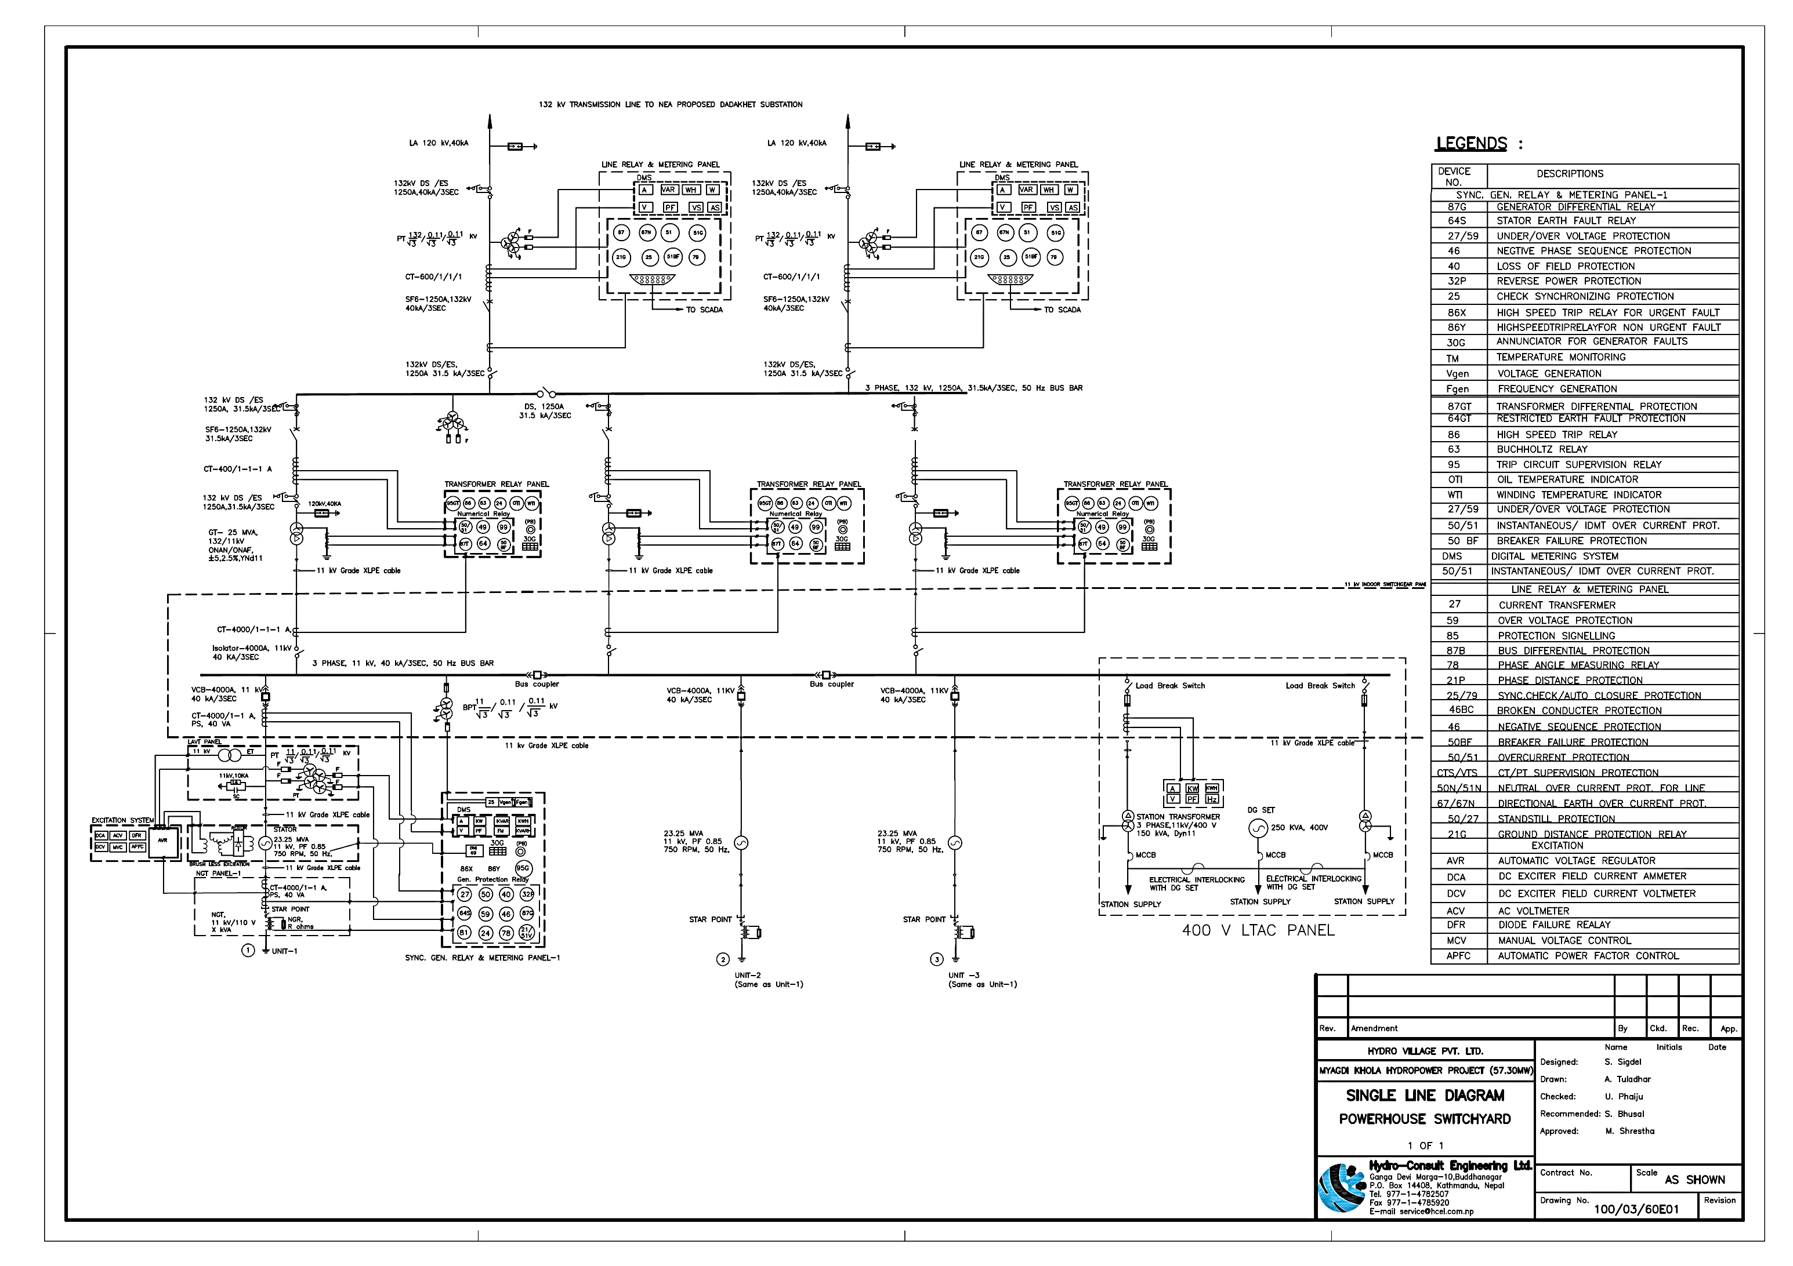

Figure 8‑1: Single line diagram from Powerhouse to Switchyard

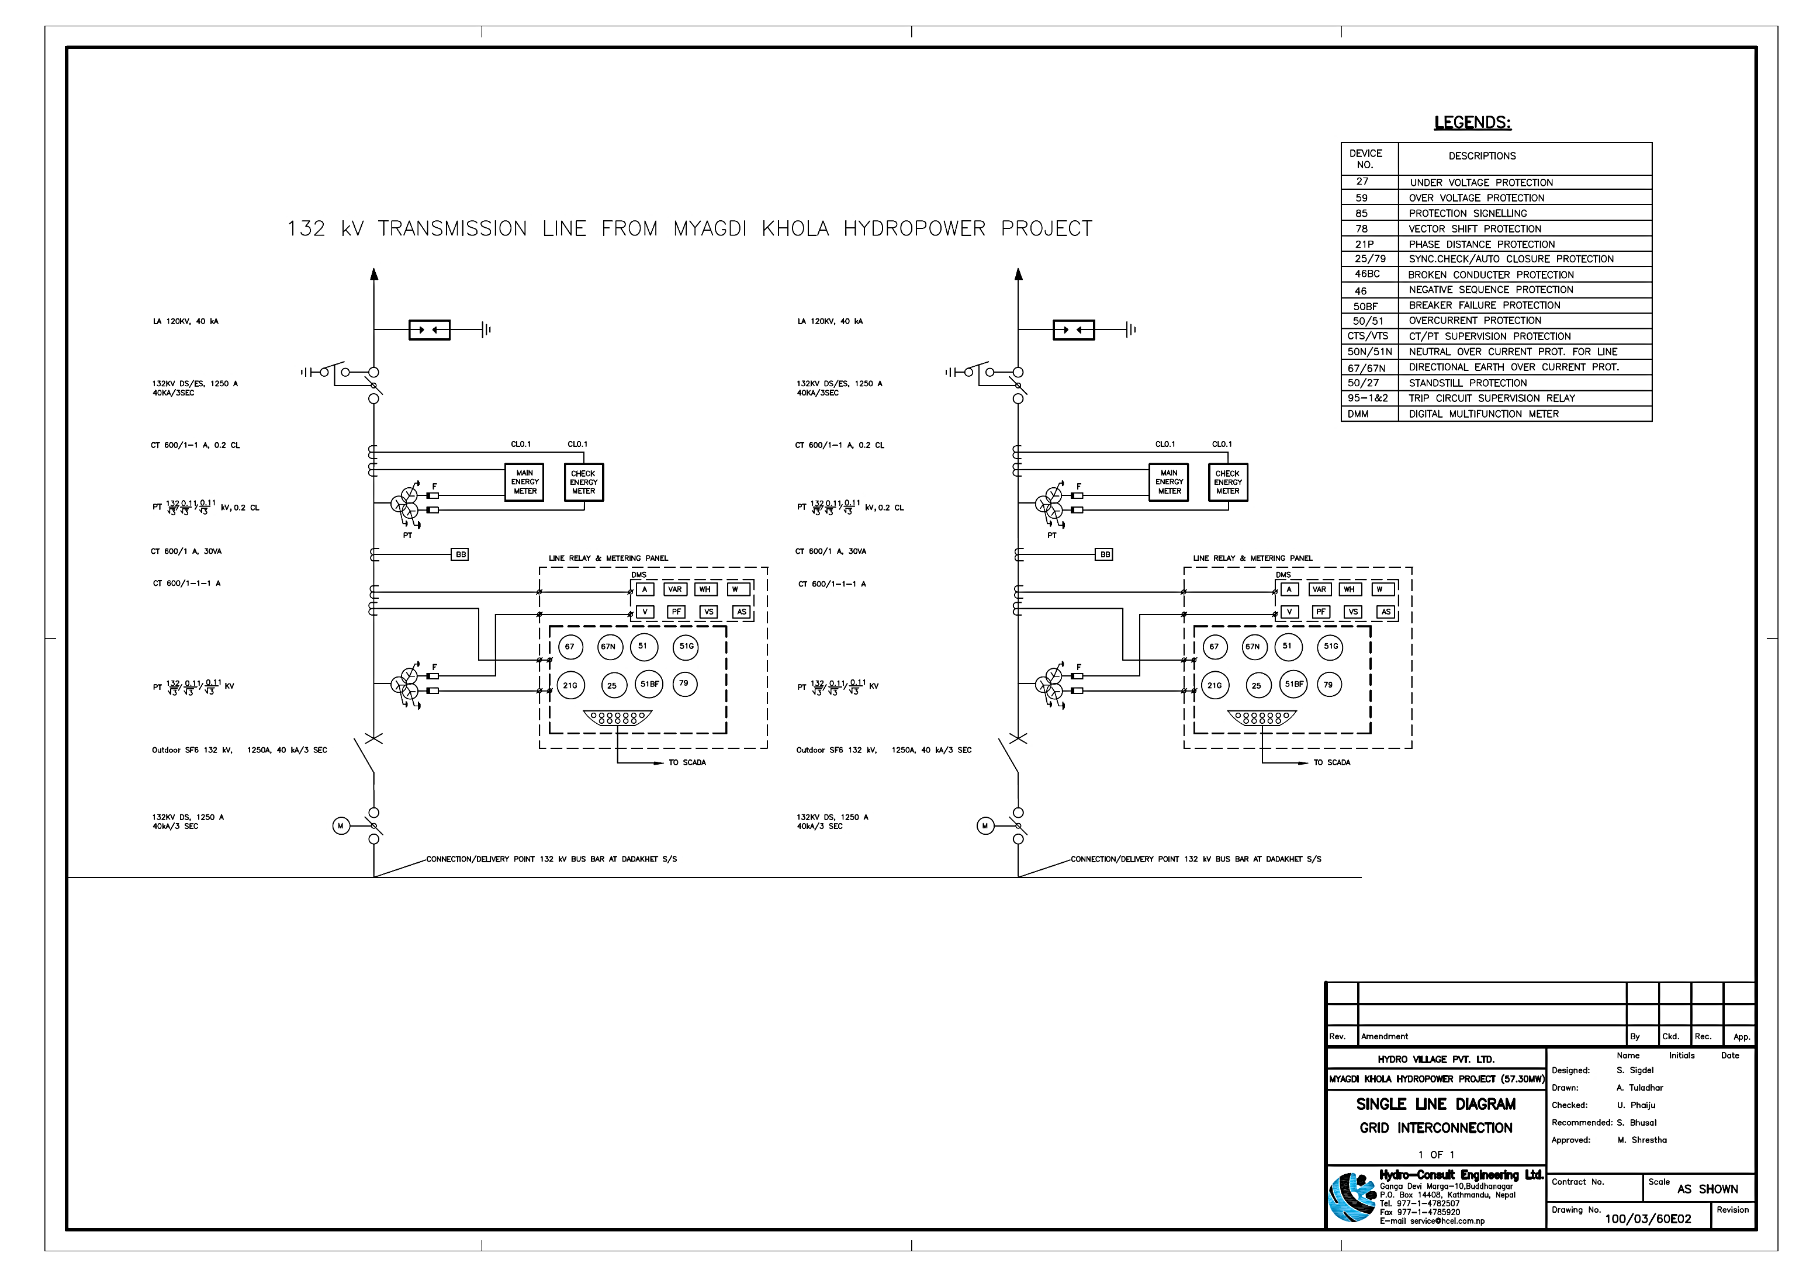

Figure 8‑2: Grid interconnection at Dandakhet Sub-station

# TRANSMISSION LINE

## Transmission voltage level selection

The standard transmission voltage levels in Nepal are 66 kV, 132 kV and 220 kV. The 66kV level is phasing out lately due to lack of use and availability of equipment in the international market. The most economical transmission voltage level is selected from among the standard voltage levels. The voltage level in use at the nearest substation is also a factor to be considered while making the choice.

To evacuate power from the project, the project will construct double circuit 132 kV transmission line with ACSR 'Bear' conductor from powerhouse to Dandakhet substation and at Dandakhet substation, Company will construct one 132 kV line bay.

The most economical transmission voltage is estimated using empirical formulae. One of such formulae is mathematically given as following.

V=5.5 \* √ (L/1.6 +P/(NC\*pf\*150))

Where;

L - Length [km]

P - Power to transmit (kW)

V - Transmission voltage (kV)

pf – power factor

NC – number of circuit

The most economical transmission voltage for power of 57.3 MW and length of 17 km would be around 87.4 kV. Since the nearest standard voltage level to it is 132kV so, 132kV voltage level shall be used for the power evacuating transmission line from MKHPP to Dadakhet substation.

To evacuate power from the project, the project will construct double circuit 132 kV transmission line with ACSR 'Bear' conductor from powerhouse to Dandakhet substation and at Dandakhet substation and construct one 132 kV line bay.

**Design criteria**

The following design criteria are to be applied for the design of the transmission line: Electrical system voltage

1. Power system : AC 50 Hz, 3-phase,

: 3-wire system

1. System voltage:

Rated : 132 kV

Maximum : 145 kV

### Quality of Supply

The quality of supply is governed by grid parameters i.e. voltage and frequency. For planning purpose, following variations in voltage and frequency are permissible:

|  |  |
| --- | --- |
| Voltage variation in normal operation: | + 5% of nominal value |
| Voltage variation during emergency: | + 10% of nominal value |
|  |  |
| Frequency variation in normal operation | + 2.5 % of nominal value |
| Frequency variation during emergency: | + 5% of nominal value |
| Transmission loss: | < 4.5 % of the receive energy |

## Energy Meter and metering equipment

Two sets of Energy Meter including CT, PT shall be installed at Dandakhet sub-station at Company’s cost. The Energy Meter shall be bi-directional and shall be able to record the energy exported to NEA and energy imported from NEA. The energy meter and metering equipments (CT, PT) shall be indoor or outdoor type. The metering, interconnection and delivery points are shown in Single Line Diagram.

The rated secondary current of Current transformer (CT) shall be 1A and rated secondary voltage of Potential transformer (PT) shall be 110V. The accuracy of CT and PT shall be 0.2 for metering or as advised by NEA. The specifications of metering unit (Energy Meter, CT and PT) shall be as per the specifications provided or approved by NEA.

## Black Start/ Island Mode Operation

The proposed Myagdi Khola Hydropower Project will possess capability of Black Start. The plant will be capable to start its generating units without taking supply from the grid. One Diesel generator of 100 kW capacities shall be installed in the powerhouse for emergency supply which will also enhance the black start capability of the plant.

Further, the plant will have capability to run in Island mode (Off-grid mode) as well as in parallel with the National Grid. When there is failure of power supply in the Grid, the powerhouse will run in Island mode and will supply local load. As soon as the power is restored in the Grid, the powerhouse will be synchronized with the National Grid to run the plant in parallel to the Grid. The proposed electro-hydraulic governor with PID and adequately sized flywheel will ensure stable governing operation in parallel grid connection mode as well as in island mode operation. The details regarding these facilities shall be finalized during detail design phase.

# POWER AND ENERGY COMPUTATION

## General

Myagdi Khola Hydropower Project (MKHPP) has been designed as Run-of-River (RoR) type project. Available gross head, estimated system head loss, downstream release, and available flow for power generation, installed capacity and average annual energy computation are described in following sub-sections of this report.

## Available discharge and power generating flow

### Long term average flow and design discharge

The long-term monthly average stream flow data of the Myagdi khola at project intake site has been derived using reference hydrology method and verified through the direct flow measurement taken at intake site of upstream project. Detail hydrological estimation is available in Chapter 2 [HYDROLOGY] of this report.

### Downstream release and available flow

There are no existing irrigation schemes and other water consumption projects extracting water from Myagdi Khola within the license boundary of the project. Hence, as per the prevailing environmental regulation guidelines of Nepal, at least 10% of the driest mean monthly flow is to be ensured for the downstream release for maintaining the ecological system of the river stretch between the intake and tailrace outlet point. It is, therefore, whatsoever flow available in the river can be used for the power generation except the downstream release of 10% of driest mean monthly flow.

The downstream release and available mean monthly flow are presented in Table 10‑1.

### Design discharge and power generating flow

The energy has been calculated by taking six months as dry season and six months as wet season to maintain the 30:70 ratio of dry season energy to wet season energy. When there is surplus flow in the river, particularly during the monsoon months, only the design discharge is considered for power generation.

The design discharge is adopted as 12.50 m3/s and net head of 607.18 m. the monthly flow as per PPA has been considered to compute the energy generated.

.

The long term mean monthly flow available after downstream release as well as power generating flow as per this study is presented in Table 10‑1.

Table 10‑1 Power generating flow, m3/s

| **Month** | **Mean monthly Flow** | **D/S release** | **Available flow** | **Diverted flow for power generation** |
| --- | --- | --- | --- | --- |
|  | **(m3/s)** | **(m3/s)** | **(m3/s)** | **(m3/s)** |
| Baisakh | 6.09 | 0.44 | 5.65 | 5.65 |
| Jestha | 11.80 | 0.44 | 11.36 | 11.36 |
| Jestha 1-15 |  |  |  |  |
| Jestha 16 onwards |  |  |  |  |
| Asar | 45.42 | 0.44 | 44.98 | 12.50 |
| Shrawan | 73.28 | 0.44 | 72.84 | 12.50 |
| Bhadra | 65.41 | 0.44 | 64.97 | 12.50 |
| Ashoj | 36.10 | 0.44 | 35.66 | 12.50 |
| Kartik | 13.49 | 0.44 | 13.05 | 12.50 |
| Mangsir | 7.11 | 0.44 | 6.67 | 6.67 |
| Mangsir 1-15 |  |  |  |  |
| Mangsir 16 onwards |  |  |  |  |
| Poush | 5.56 | 0.44 | 5.12 | 5.12 |
| Magh | 4.54 | 0.44 | 4.10 | 4.10 |
| Falgun | 4.36 | 0.44 | 3.92 | 3.92 |
| Chaitra | 4.41 | 0.44 | 3.97 | 3.97 |

## System head loss

Head loss occurs in a flow according to the type, size and shapes of the structures, water passes through. There are basically two types of losses as discussed in following sub-sections.

### Major loss

Major loss is caused due to the friction caused by the surface on which the water passes through. Major loss occurs mostly in headrace pipe, tunnel, and penstock pipe as well as in bifurcation/trifurcation. The major loss has been estimated using the commonly used equations referring to the NTNU vol. 8, IS codes and other relevant standardized literatures.

### Minor Loss

Minor losses occurs when water passes through structures like trash racks, bends, transitions, bell mouths, etc. which directly obstructs the flow of water. All the minor losses are the function of V2/(2g),

Minor losses= Ko X V2/(2g)

Where,

V= velocity of flow

g= acceleration due to gravity

Ko= Headloss coefficient

Headloss coefficient Ko differs from type of structure.

1. For trash racks it depends upon the angle and spacing of bars.
2. For inlet and outlet transitions, Ko depends upon ratio of inlet and outlet diameters.
3. For horizontal and vertical bends, it depends upon angle of bend and the ratio of radius of bend to the diameter of pipe. Other details are available in the calculations.

System head loss varies with the discharge passing through it. Hence, the head loss at each of the mean monthly flow diverted for power generation has been estimated for the purpose of estimating the available net head (refer Table 10‑2)

Table 10‑2: Estimated head loss at each of the mean monthly flow

|  |  |  |
| --- | --- | --- |
| **Month** | **Power Generating flow** | **Total Head loss** |
|  | **(m3/s)** | **(m)** |
| Baisakh | 5.65 | 4.86 |
| Jestha | 11.36 | 18.12 |
| Asar | 12.50 | 21.82 |
| Shrawan | 12.50 | 21.82 |
| Bhadra | 12.50 | 21.82 |
| Ashoj | 12.50 | 21.82 |
| Kartik | 12.50 | 21.82 |
| Mangsir | 6.67 | 6.58 |
| Poush | 5.12 | 4.08 |
| Magh | 4.10 | 2.80 |
| Falgun | 3.92 | 2.60 |
| Chaitra | 3.97 | 2.65 |

## Tail water level and net head

The gross head for the Pelton turbine is given by the difference of normal operating water level at intake point which is 2482.00 masl and turbine axis level which is 1853.00 masl.

### Available head

Since, the plant has been conceptualized as run-of-the river type, the normal operation level has been fixed to weir crest level of 2482.00 masl. The available net head at each of the mean monthly flow is given by deducting the corresponding month turbine axis level and head loss. The available net head at each of the mean monthly flow has been presented in table below.

Table 10‑3: Available net head for plant operation

| **Month** | **Power Generating flow** | **Total Head loss** | **Normal operation level** | **Turbine CL** | **Net Head** |
| --- | --- | --- | --- | --- | --- |
| **(m3/s)** | **(m)** | **(masl)** | **(masl)** | **(m)** |
| Baisakh | 5.65 | 4.86 | 2482 | 1853 | 624.14 |
| Jestha | 11.36 | 18.12 | 2482 | 1853 | 610.88 |
| Asar | 12.50 | 21.82 | 2482 | 1853 | 607.18 |
| Shrawan | 12.50 | 21.82 | 2482 | 1853 | 607.18 |
| Bhadra | 12.50 | 21.82 | 2482 | 1853 | 607.18 |
| Ashoj | 12.50 | 21.82 | 2482 | 1853 | 607.18 |
| Kartik | 12.50 | 21.82 | 2482 | 1853 | 607.18 |
| Mangsir | 6.67 | 6.58 | 2482 | 1853 | 622.42 |
| Poush | 5.12 | 4.08 | 2482 | 1853 | 624.92 |
| Magh | 4.10 | 2.80 | 2482 | 1853 | 626.20 |
| Falgun | 3.92 | 2.60 | 2482 | 1853 | 626.40 |
| Chaitra | 3.97 | 2.65 | 2482 | 1853 | 626.35 |

## Efficiency and Typical Operation Plan

The tailwater discharge (Design discharge) from MKHPP is 12.5 m3/s. The discharge varies significantly from month to month. The selection of number of units is based on comparison between power generating capability and the incurred cost with different alternatives. Three Vertical axis Pelton turbines have been selected from the calculation.

The efficiency of Pelton turbine decreases with the reduction in percentage unit flow below 40% and does not vary much between 100-40 % rated flow. A typical plant operation plan and corresponding turbine efficiency has been given in table below.

Table 10‑4: Typical plant operation plan and corresponding turbine efficiency

| **Month** | **Power Generating Discharge, m³/s** | **% of Rated Flow** | | | **No. of units operating** | **Efficiency** |
| --- | --- | --- | --- | --- | --- | --- |
| **Unit 1** | **Unit 2** | **Unit 3** |
| Baishakh | 5.65 | 68% | 68% | - | 2 | 91.50% |
| Jestha | 11.36 | 91% | 91% | 91% | 3 | 91.50% |
| Ashadh | 12.50 | 100% | 100% | 100% | 3 | 91.50% |
| Shrawan | 12.50 | 100% | 100% | 100% | 3 | 91.50% |
| Bhadra | 12.50 | 100% | 100% | 100% | 3 | 91.50% |
| Ashwin | 12.50 | 100% | 100% | 100% | 3 | 91.50% |
| Kartik | 12.50 | 100% | 100% | 100% | 3 | 91.50% |
| Mangshir | 6.67 | 80% | 80% |  | 2 | 91.50% |
| Paush | 5.12 | 61% | 61% | - | 2 | 91.50% |
| Magh | 4.10 | 98% | - | - | 1 | 91.50% |
| Fagun | 3.92 | 94% | - | - | 1 | 91.50% |
| Chaitra | 3.97 | 95% | - | - | 1 | 91.50% |

## Outages and Self consumption

The total energy available for the revenue generation is estimated after deducting the outages, self-consumption, and losses. Dry period outage is rare and determined mainly by the problems in supply grid. The repair of the units could be done alternatively during the dry period when there is no sufficient discharge for operation of all units. The wet season outage is mainly determined by the forced outages. Other outages include the maintenance outage and forced outages. While deducting outages, the transmission loss also should be considered. The power generated from MKHPP is evacuated through 132 kV transmission line to national grid at Dandakhet (Tadhekani) Substation. The transmission loss is estimated to be 1%.

## Plant capacity and Energy Computation as per PPA (57.3 MW) and upgraded capacity (65 MW)

The design dishcharge and monthly flow for both is similar. The gross head as per PPA signed prviously is 564.00 m to produce 57.3 MW of power. On the other hand, gross head of 629.00 m is adopted to upgrade the install capacity of project to 65 MW. The assumptions and considerations made during the estimation of energy as per PPA (57.3 MW) and as per upgraded capacity (65 MW) are presented in Table 10‑5 and Table 10‑6.

Table 10‑5: Considerations of data to estimated energy as per PPA for 57.3 MW

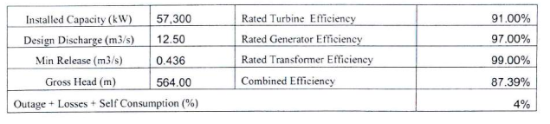

Table 10‑6: Considerations of data for energy estimation for 65 MW

| **Description** | **Value** | **Unit** |
| --- | --- | --- |
| Normal water level (Crest level at weir) | 2482 | masl |
| Turbine CL Level | 1853 | masl |
| Gross head | 629 | m |
| Turbine rated efficiency | 91% |  |
| Turbine efficiency for energy generation | 91% |  |
| Generator efficiency | 97% |  |
| Transformer efficiency | 99% |  |
| Overall efficiency | 87% |  |
| Rated net head, m | 607.17 | m |
| Number of Units | 3 |  |
| Design flow, m3/s | 12.5 | m3/s |
| Design flow, m3/s (Generation License) | 12.5 | m3/s |
| Per Unit Design flow, m3/s | 4.16 | m3/s |
| Downsrtream release | 0.436 | m3/s |
| Dry season outage + Self consumption | 4% |  |
| Wet season outage + Self consumption | 5% |  |
| Installed Capacity (PPA) | **57300** | KW |
| Installed Capacity | **65000** | KW |

As per the current PPA regulations of Nepal Electricity Authority (NEA), the energy to be generated during the Nepali months of 15th of Mangshir to 14th Jestha (i.e. Dec to May) has been estimated as dry energy and rest of the energy generation during the rest of the months has been considered as wet energy.

The summary of the energy estimation as per PPA signed previously in 2075 BS is presented in Table 10‑7. Also, the energy estimation for the upgraded scheme by adopting similar monthly flow and design discharge as that of PPA is presented in Table 10‑8.

Table 10‑7: Estimated energy in Nepali calendar month as per Power Purchase Agreement (PPA) for 57.3 MW

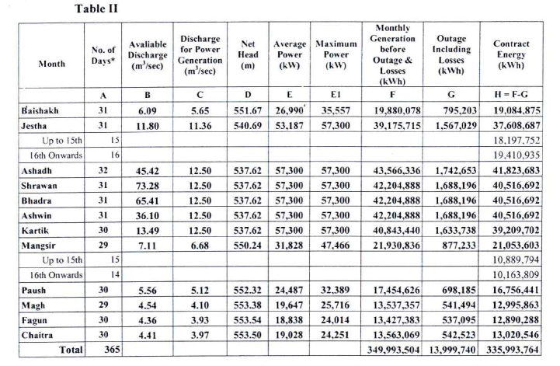

|  |  |  |
| --- | --- | --- |
| **Dry Season Energy, GWh** | **103.11** | **30.69%** |
| **Wet season Energy, GWh** | **232.88** | **69.31%** |
| **Total Annual Energy, GWh** | **335.99** | **100.00%** |

Table 10‑8 : Estimated energy in Nepali calendar month for the updgraded project capacity (65 MW)

|  |  |  |  |  |  |  |  |  |  |  |  |  |
| --- | --- | --- | --- | --- | --- | --- | --- | --- | --- | --- | --- | --- |
| **Month** | **Mean monthly Flow** | **D/S release** | **Available flow** | **Diverted flow for power generation** | **Total Head loss** | **Net Head** | **Average monthly power** | **Operating days** | **Monthly energy generation** | **Outage & self consumption** | **Generated Net energy for revenue** | |
| **Dry season energy** | **Wet season energy** |
| **(m3/s)** | **(m3/s)** | **(m3/s)** | **(m3/s)** | **(m)** | **(m)** | **(kW)** |  | **(KWh)** | **(KWh)** | **(KWh)** | **(KWh)** |
| Baisakh | 6.09 | 0.436 | 5.65 | 5.65 | 4.86 | 624.14 | **30389.7** | 31 | 22609957 | 1130498 | 21479459 |  |
| Jestha | 11.80 | 0.436 | 11.36 | 11.36 | 18.12 | 610.88 | **59782.7** | 31 | 44478354 | 2223918 |  |  |
| Jestha 1-15 |  |  |  |  |  |  |  | 16 |  |  | 21808741 |  |
| Jestha 16 onwards |  |  |  |  |  |  |  | 15 |  |  |  | 20445695 |
| Asar | 45.42 | 0.436 | 44.98 | 12.50 | 21.82 | 607.18 | **65000.0** | 32 | 49920000 | 2496000 |  | 47424000 |
| Shrawan | 73.28 | 0.436 | 72.84 | 12.50 | 21.82 | 607.18 | **65000.0** | 31 | 48360000 | 2418000 |  | 45942000 |
| Bhadra | 65.41 | 0.436 | 64.97 | 12.50 | 21.82 | 607.18 | **65000.0** | 31 | 48360000 | 2418000 |  | 45942000 |
| Ashoj | 36.10 | 0.436 | 35.66 | 12.50 | 21.82 | 607.18 | **65000.0** | 31 | 48360000 | 2418000 |  | 45942000 |
| Kartik | 13.49 | 0.436 | 13.05 | 12.50 | 21.82 | 607.18 | **65000.0** | 30 | 46800000 | 2340000 |  | 44460000 |
| Mangsir | 7.11 | 0.436 | 6.67 | 6.67 | 6.58 | 622.42 | **35773.5** | 29 | 24898368 | 1244918 |  |  |
| Mangsir 1-15 |  |  |  |  |  |  |  | 14 |  |  |  | 11418907 |
| Mangsir 16 onwards |  |  |  |  |  |  |  | 15 |  |  | 12234543 |  |
| Poush | 5.56 | 0.436 | 5.12 | 5.12 | 4.08 | 624.92 | **27575.4** | 30 | 19854300 | 794172 | 19060128 |  |
| Magh | 4.54 | 0.436 | 4.10 | 4.10 | 2.80 | 626.20 | **22131.5** | 29 | 15403557 | 616142 | 14787415 |  |
| Falgun | 4.36 | 0.436 | 3.92 | 3.92 | 2.60 | 626.40 | **21167.5** | 30 | 15240620 | 609625 | 14630995 |  |
| Chaitra | 4.41 | 0.436 | 3.97 | 3.97 | 2.65 | 626.35 | **21221.0** | 30 | 15279156 | 611166 | 14667989 |  |
| **Total** |  |  |  |  |  |  |  | **365** |  |  | **118669271** | **261574602** |
|  | | |  | **Energy Generated** | |  |  |  |  |  |  |  |
| **Dry Season Energy, GWh** | | | | **118.67** | **31.21%** |  |  |  |  |  |  |  |
| **Wet season Energy, GWh** | | | | **261.57** | **68.79%** |  |  |  |  |  |  |  |
| **Total Annual Energy, GWh** | | | | **380.24** | **100.00%** |  |  |  |  |  |  |  |







## Conclusion

As per the PPA signed between NEA and Hydro Village Pvt. Ltd. previously for the project capacity of 57.3 MW, the total dry and wet season energy generated is 103.11 GWh (30.69 %) and 232.88 GWh (69.31 %) per year respectively. Also, the total energy is 335.99 GWh.

In this UFSR, the energy generation has been calculated based on the design discharge of 12.5 m3/s as calculated before in Chapter 2. The considered design discharge and monthly flow is similar as that of PPA signed by NEA and Hydro Village Pvt. Ltd. The only aspect that is increased now is gross head. The installed capacity is increased to 65.00 MW due to the increment in gross head by 65m. The total energy is found to be 380.24 GWh per year. Out of the total energy, the dry energy is determined to be 118.67 GWh (31.21 %) whereas the wet season energy is 261.57 GWh (68.79%). This ensures that the proportion of dry to wet energy is maintained as 30:70.

# CONSTRUCTION PLANNING AND SCHEDULING

## Introduction

This section of the report describes the anticipated construction technology applied for various works and presents a work planning and implementation schedule for the execution of the project. A construction schedule involving major construction activities has been presented included in this chapter. Critical activities as well as milestone have been identified.

Accessibility to the project site, availability ofconstruction material, potential quarry sites and nearest markets, planned contract packages and their types for the implementation of the project has been for described in this chapter.

The average length of daylight in the project area is roughly 8 to 10 hours so that surface construction activities have been assumed to extend over the same period. A margin for time loss due to adverse weather or other unforeseen delaying conditions has been allowed in the adopted production rate. With regard to underground works, proper lighting and ventilation will be required.

The construction of the project will involve works fronts at 10 sites simultaneously i.e., one at Myagdi Headworks, one at Kunaban Headworks, one at settling basin area, seven to eight at waterway, work at surge shaft and work at powerhouse area. The details of construction activities are presented in the construction schedule.

## Accessibility

The project site can be accessed from Kathmandu following Tribhuvan Highway (Muglin), Prithivi Highway (Pokhara), Pokhara/Baglung highway (Baglung) and Maaldhunga-Beni Sadak till Myagdi district headquater - Beni. The road head from Kathmandu to Beni is blacktopped. From Beni, all weathered road leads till Darbang which is the nearest road head to the project site. As per the provided access road report, about 20 km road from Darbang to powerhouse site is under construction. The road passes along Lower Khara, Shivaratri Khola, Upper Khara, Khibang and Jugepani to reach the powerhouse site. A bailey bridge has also been proposed near Khibang. From the powerhouse site, approximately 8 km road has been designed to reach the headworks site.

As far as available the sand, aggregates, stones and boulders and clay materials shall be taken from the local resources. Further details of the availability of these construction materials in the project site have been described under **Chapter 4** [GEOLOGY AND GEOTECHNICAL STUDY] of this report. Considering the requirement of bulk quantity, cement and steel reinforcement will have to be purchased and carried from the nearest cities like Beni, Pokhara or even Heutada etc.

All hydro-mechanical and electromechanical materials and equipment will have to be imported either from India or other third countries and in both cases, therefore the possible alternatives and routes for different port of entry has been studied. Hence, available three alternative options of road transportation from port of entry to the project site have been provided in Table 11‑1.

Table 11‑1: Alternative routes to project site

|  |  |  |  |  |
| --- | --- | --- | --- | --- |
| **OPTION** | **FROM** | **TO** | **VIA** | **DISTANCE (km)** |
| Alternative I | Bhairahawa | Project Site | Butwal | 345.30 |
| Syangja |
| Pokhara |
| Baglung |
| Beni |
| Darbang |
|  |
| Alternative II | Birgunj | Project Site | Pathlaiya | 426.73 |
| Hetauda |
| Bharatpur |
| Muglin |
| Ambukhairini |
| Pokhara |
| Baglun |
| Beni |
| Darbang |
|  |
| Alternative III | Nepalgunj | Project Site | Kohalpur | 575.74 |
| Lamahi |
| Bhalunang |
| Chanauta |
| Gorusinge |
| Butwal |
| Syangja |
| Pokhara |
| Baglung |
| Beni |
| Darbang |
|  |

##### **Bhairahawa - Project Site**

Bhairahawa is shortest location for port of entry from India Boarder to the project site with total length of 345.30 km. This route passes from Bhairahawa via Siddhartha highway passing through Butwal, Synagja and Pokhara, from there the route pass through Bhupi Serchan highway through Baglung to Beni. The route upto this stretch is blacktopped. Total of 267.49 km stretch of this route is black topped the rest is gravel and earthen road.

##### **Birgunj – Project Site:**

Another viable option for port of entry from India can be Birgunj with total length of 426.73 km. This route passes from Birgunj via Tribhuvan highway passing through Pathlaiya and upto Hetauda. From Hetauda it passes through the Mahendra (East West) Highway up to Narayangadh. From Narayangad the route passes through Narayanghat Mulgin road and connects with the Prithivi Highway at Muglin. From Muglin the road passes to Ambukhaireni, Dumre, Damauli and to Pokhara via Prithivi Highway. From Pokhara the route pass through Bhupi Serchan highway through Baglung to Beni. The route upto this stretch is blacktopped. Total of 348.92 km stretch of this route is black topped the rest is gravel and earthen road.

##### **Nepalgunj - Project Site**

Nepalgunj is another possible location for port of entry from India Boarder to the project site however this the longest one among the ones discussed here with total length of 575.74 km. This route passess from Nepalgunj via Mahendra (East West) Highway through Kohalpur, Lamahi, Chanauta, and to Butwal. From there it via Siddhartha highway through Synagja to Pokhara and from there the route pass through Bhupi Serchan highway through Baglung to Beni. The route upto this stretch is blacktopped. Total of 497.93 km stretch of this route is black topped the rest is gravel and earthen road.

## Construction Activities

### Tendering, contract award and mobilization

The tendering and contract award for the civil work will take about 120 days and another 60 days for mobilization and temporary camp construction. It is recommended to precede the tendering of the electromechanical and hydro-mechanical contract packages in the same timeline of civil works contract package, so that the final layout details of the electromechanical components and loading patterns required for the final design of the powerhouse and switchyard civil works will be timely available from the EM contractor.

### Civil Works activities

#### River diversion during construction at Myagdi Khola

The construction works in the river, particularly the construction of weir, undersluice and intake structure require river diversion. Considering the huge discharge in the river during the monsoon (i.e., June – October) period, it is uneconomical and impracticable to divert the river throughout the year. Hence, the river diversion is designed for the estimated flood analyzed considering the flood data of November to May. This means that the cofferdam will be demolished during the monsoon thus by allowing the river flood to pass along the river and the construction will be carried out during November to May only. Depending on the work volume, the construction of the weir, undersluice and intake will require two years dry season. For this purpose, the flow in the river will be required to be diverted and protect the area by means of cofferdams along the river in two subsequent phases.

At first stage, it is proposed to divert the flow along the left bank of the Myagdi river and carryout the construction of the right part of the weir and corresponding portion of stilling basin, undersluice, intake and gravel trap and rightside flood wall. At second stage, coffer dam is shifted towards the left bank so that river flows from the undersluice portion and remaining left portion of weir will be constructed.

The deposits on the riverbank shall be removed as instructed by the Engineer to have enough space for construction activities. The deposit will be used for the river diversion work and for rip rap protection works. The construction of cofferdam will be taken up parallel with the removal of deposits. The construction of Coffer dam can be constructed with 1 number of Dozers (200 HP), 1 number of Hydraulic Excavators of 1.5 cum bucket capacity, 1 number of Vibratory Roller and sufficient number of 20/25 T Dumpers. The Coffer Dam is planned to be completed in one month.

### Weir, stilling basin, undersluice, intake and associated structures and right bank flood walls in Myagdi Khola

Considering the work volume, the construction of weir, undersluice and intake structure will require two stage of river diversion. In first stage, river flow shall be diverted along the left bank of the river and carryout the construction of the right part of the weir and corresponding portion of stilling basin, undersluice, intake and gravel trap. Remaining part of the weir shall be constructed during second stage of river diversion.

During the 1st Phase of river diversion more than 12,000 cum of earthwork with rock excavation is involved in these structures. By providing 1 Nos of compressor and a generator including sufficient drilling equipments such as handheld drill hammers and with 3 Nos of Hydraulic Excavators, out of which 2 with rock breaker and 1 with bucket of 1.5 m3 capacity and sufficient numbers of dumpers, daily progress of 300 m3 excavation is expected. Therefore, the excavation in this stage can be completed in about 1 and half months. Similarly, with more than 10,000 cum of earthwork with rock excavation is involved in 2nd phase of river diversion which can be completed with similar resources in 30 days. Adequate dewatering arrangements should be made during the excavation in foundation of headworks structures.

During the first stage of river diversion, the excavation work for the right portion of weir, stilling basin, undersluice and intake foundation will be completed in about six and half months. The excavation for foundation and cut-off wall will be done by rock breaker or with blasting. The excavation of foundation and cut-off wall up to the required level will be done and thereafter RCC works will follow in the excavated trench. The concreting at the foundation of these structures that are affected by the river flow shall be completed within 3 months prior to the start of monsoon. The superstructure works of the intake and gravel trap could be continued during monsoon after completing the foundation of these structures. However, the construction of superstructures of undersluice and right part of weir needs to be done during dry season. The left part of the weir shall be completed during the second year after 2nd stage river diversion works. The Hydro-Mechanical works for these structures will be executed in parallel to the civil works of these components. All civil and hydro mechanical works for these components will get completed in about 19 months after the start of work at headworks site.

During the planning, equipment and workforce has been considered in such a way that all the structures on the right bank that will be affected by the river flow will be completed in two seasons. After completing the First Phase works on the right bank, the river will be diverted through under sluice and the construction for Phase-II Weir works including left bank flood wall will be taken up.

### Connecting Canal

The construction of the connecting canal between Myagdi Headworks and Kunaban Headworks could be carried out throughout the year. The excavation work for connecting canal along right bank of the Myagdi Khola will take about 70 days including site clearance. After this, concreting work with placement of reinforcement bars will be carried out to construct rectangular box culvert which will take about 3 months.

#### River diversion during construction at Kunaban Khola

The construction works in the river, particularly the construction of weir, undersluice and intake structure require river diversion. Considering the huge discharge in the river during the monsoon (i.e., June – October) period, it is uneconomical and impracticable to divert the river throughout the year. Hence, the river diversion is designed for the estimated flood analyzed considering the flood data of November to May. This means that the cofferdam will be demolished during the monsoon thus by allowing the river flood to pass along the river and the construction will be carried out during November to May only. Depending on the work volume, the construction of the weir, undersluice and intake will require two years dry season. For this purpose, the flow in the river will be required to be diverted and protect the area by means of cofferdams along the river in two subsequent phases.

At first stage, it is proposed to divert the flow along the left bank of the Kunaban river and carryout the construction of the right part of the weir and corresponding portion of stilling basin, undersluice, intake and gravel trap and rightside flood wall. At second stage, coffer dam is shifted towards the left bank so that river flows from the undersluice portion and remaining left portion of weir and the left side flood wall will be constructed.

The deposits on the riverbank shall be removed as instructed by the Engineer to have enough space for construction activities. The deposit will be used for the river diversion work and for rip rap protection works. The construction of cofferdam will be taken up parallel with the removal of deposits. The construction of Coffer dam can be constructed with 1 number of Dozers (200 HP), 1 number of Hydraulic Excavators of 1.5 cum bucket capacity, 1 number of Vibratory Roller and sufficient number of 20/25 T Dumpers. The Coffer Dam is planned to be completed in one month.

### Weir, stilling basin, undersluice, intake and associated structures and right bank flood walls in Kunaban Khola

The construction of weir, undersluice and intake structure will require two stage of river diversion in Kunaban as well. In first stage, river flow shall be diverted along the left bank of the river and carryout the construction of the right part of the weir and corresponding portion of stilling basin, undersluice, intake and gravel trap. Remaining part of the weir and the left side flood wall shall be constructed during second stage of river diversion.

During the 1st Phase of river diversion more than 12,500 cum of earthwork with small amount of rock excavation is involved in these structures. By providing 1 Nos of compressor and a generator including sufficient drilling equipments such as handheld drill hammers and with 3 Nos of Hydraulic Excavators, out of which 1 with rock breaker and 2 with bucket of 1.5 m3 capacity and sufficient numbers of dumpers, daily progress of 500 m3 excavation is expected. Therefore, the excavation in this stage can be completed in about 30 days. Similarly, with more than 22,000 cum of earthwork with rock excavation is involved in 2nd phase of river diversion which can be completed with similar resources in 45 days. Adequate dewatering arrangements should be made during the excavation in foundation of headworks structures.

During the first stage of river diversion, the excavation work for the right portion of weir, stilling basin, undersluice and intake foundation will be completed in about six and half months. The excavation for foundation and cut-off wall can be done by hydraulic excavator with 1.5 m3 capacity bucket and a rock breaker. The excavation of foundation and cut-off wall up to the required level will be done and thereafter RCC works will follow in the excavated trench. The concreting at the foundation of these structures that are affected by the river flow shall be completed within 3 months prior to the start of monsoon. The superstructure works of the intake and gravel trap could be continued during monsoon after completing the foundation of these structures. However, the construction of superstructures of undersluice and right part of weir needs to be done during dry season. The left part of the weir shall be completed during the second year after 2nd stage river diversion works. The Hydro-Mechanical works for these structures will be executed in parallel to the civil works of these components. All civil and hydro mechanical works for these components will get completed in about 20 months after the start of work at headworks site.

During the planning, equipment and workforce has been considered in such a way that all the structures on the right bank that will be affected by the river flow will be completed in two seasons. After completing the First Phase works on the right bank, the river will be diverted through under sluice and the construction for Phase-II Weir works including left bank flood wall will be taken up.

### Settling basin and Approach Canal

The construction of the settling basin could be carried out independently throughout the year. Excavation and backfilling at this structure would be taken up with 2 Nos. of Hydraulic excavator of 1.5 cum bucket capacity and sufficient nos of 20/25 T Dumpers, daily progress of 600 m3 excavation is expected. Therefore, total earthwork of about 46,000 cum is planned to be completed in 2 and half months.

Adequate dewatering arrangements shall be made during the excavation at this work front. The concrete work will commence immediately after the completion of excavation work. Concreting of the structures will be taken by 1 nos. 60 m3 Batching plant and 2 Stationery 1 m3 Capacity Mixers. Placement of concrete is planned to be executed using wheelbarrows, concrete pumps and portable concrete vibrators. The construction of super structure concrete works at settling basin will be carried in parallel to hydro mechanical works coordinating with the hydro-mechanical contractor so that the embedded parts of the gates, stop log and trash racks could be placed on time following an appropriate manner. The erection of the gates will require about two months. All civil and hydro mechanical works for these components will get completed within 15 months after the start of work at these fronts.

#### Waterway

The construction of waterway consists of the construction of headrace tunnel, Surge Shaft, pressure shafts and tailrace.

### Headrace tunnel

D shaped 3.2 m(w) x 3.5 m (h) finished diameter 6170 m long headrace tunnel starts from inlet portal and meets at the surge shaft. There are two adits planned for construction purpose and one adit for the purpose of permanent access to the valve chamber.

The construction of headrace tunnel will be started from adits and outlet. Since in the inlet portal area, the construction activities of settling basin will be full fledge and construction of the Headrace tunnel can interfere with these activities, hence it is planned that after the construction of inlet portal and construction of about 30m (i.e., about 10m after the first bend) of the headrace tunnel the remaining portion of this stretch will be excavated through the Adit 1. During the peak of the construction there will be five working fronts in the headrace tunnel i.e., two fronts through Adit I, two fronts through Adit II and one front through outlet. Considering a conservative pull length of 2.5 m in some working fronts with difficult fronts while taking pull length of 4 m in some comfortable working fronts with two blast per day from five working faces, the excavation works of headrace tunnel will be completed within 27 months allocating 15% extra time for holidays and unpredictable conditions that may arise during the construction. Special attention in terms of resources is required at these work fronts for completion of work in time.

The tunnel will be excavated by conventional drill and blast method using mechanized equipment. The drilling for headrace tunnel is proposed to be carried out by using single-boom hydraulic drilling jumbo. In order to limit extra overbreaks, profile of tunnel will be marked after each cycle and periphery drilling will be carried out. The mucking operation will be carried out by using hag loader and tractors. Adequate number of dumpers will be provided to cater for lead involved for mucking.

The excavation of tunnel will be carried out in following operations:

**Survey and marking of profile**

Topographic survey shall be carried out to firm a close traverse between inlet portal and outlet portal to check and confirm the accuracy of survey control points. The headrace tunnel alignment and profile shall be marked in the ground along with the progress of excavation works.

**Drilling**

Drilling shall be done by using single-boom hydraulic drilling jumbo, which can theoretically drill up to 100m/hr. This progress can however be achieved under ideal conditions and continuous drilling operations. Since the drilling is to be carried out for large number of holes of limited depth, each time the location of booms will have to be changed which takes lot of time. As such, practically a progress of not more than 100m of drilling can be achieved in an hour. The spacing and pattern of the drill hole shall be finalized through successive numbers of drilling pattern design to limit or avoid the over-break and optimize the pull length.

**Charging and Blasting**

The holes drilled will be loaded by power-gel or equivalent. Non-electric detonators with millisecond delay are proposed to be used. Non-electric detonators will enable to carry out charging and drilling in simultaneous operations. After loading of explosive of the entire face is completed, the equipment and personnel shall be withdrawn and blasting shall be carried out.

**Defuming**

Adequate ventilation is essential during excavation of tunnel. The tunnel, during excavation, will be provided with one exhaust fan with a ventilation duct of 0.75m diameter. The ventilation system will not be required once the tunnel excavation has been completed.

**Scaling**

After excavation of the face, scaling of roof and sides will be carried out. All loose rock fragments shall be removed during scaling operation. Local drilling and blasting will be done, if required, to remove any undercut.

**Mucking**

In fair to good rock conditions, mucking operations shall be carried out immediately after scaling of face whereas in poor rock conditions primary rock support with rock bolt and a layer of shotcrete shall be provided first to avoid any loose rock from falling, and mucking shall be carried out thereafter.

**Rock Support Measures**

Safety Shotcreting shall be carried out upto excavated face after each blast. Whereas final shotcrete and rock bolting shall be provided about 3 pulls behind the excavated face. Both the operations, however, are to be carried out after each blast. The excavated tunnel will be supported by steel ribs in the reaches which are geologically weak and required from the design.

The final supports shall be applied after the completion of the excavation works.

**Tunnel Concrete Lining**

The concrete lining has been proposed in extremely poor stretch of the tunnel as required from the lining design.

**Contact Grouting**

Contact grouting in the tunnel is proposed to be carried out after concrete lining of tunnel. Contact grouting is provided to fill any gap between rock and concrete lining, especially at crown level, which has been left during concreting activity. For this purpose grout holes of 38 mm diameter will be drilled 600 mm inside the rock and grouting will be done at a low pressure of about 2 to 2.5 kg/cm2. The grouting will be carried out till refusal. Grout pumps will be utilized to carry out the grouting operations. The grouting operations will be finished two months after the concrete lining of tunnel is over.

**Consolidating Grouting**

Consolidation grouting shall be done at locations with poor ground conditions, as decided by the Engineer-in-Charge. The length of drill hole for consolidation grouting in general shall be 2.5 m deep in to the rock. Consolidation grouting would be carried out through these holes at a pressure ranging from 5 to 7 kg/cm2. The grouting in this case is also to be carried out till refusal or as determined by the site condition. Grouting shall be done using grout pumps.

**Cleaning of HRT**

After completion of all activities the tunnel will be thoroughly inspected for any foreign material left inside during construction. This will ensure that no damage is caused to the machines in case the undesirable objects find their way to powerhouse through the tunnel.

### Surge shaft

The construction of surge shaft will start immediately after the completion of the Aeration tunnel from top to bottom approach.

The construction of surge shaft involves following activities:

* Excavation and Support of Aeration Tunnel
* Shaft excavation and installation of ground support
* Concrete lining

The excavation operations of surge shaft shall be carried out from top to bottom with a pilot hole upto the bottom of the surge shaft for the purpose of ease of mucking. Concreting operations shall be done from bottom to top through the completed Aeration Tunnel. After each excavation, the rock should be provided a protective coat of shotcrete and rock bolting to prevent sliding of falling of loose blocks. The activity of protection of slopes should be carried out concurrently.

### Pressure shaft

The pressure shaft starts from the surge shaft and ends at branching point near the powerhouse. The total length of pressure shaft from surge shaft to the first branching point is about 1195.45m. There are three drop shafts having height of 196.38 m (first drop shaft), 246.95m (second drop shaft) and 98.02 m (third drop shaft). The drop shafts are connected by mild slope tunnel of length about 197.65 m and 260.35 m respectively. The length of mild slope penstock tunnel from bottom of third drop shaft to first bifurcation point is sbout 119.84. A valve chamber has been provisioned to accommodate the butterfly valve. This valve is operated when some repair and maintenance is required in the penstock pipe at downstream of this valve. Hence, this valve has been allocated near to the surge shaft as far as possible. An access tunel/adit has been provisioned to access to the valve chamber for the excavation of valve house.

Horizontal shaft will have the 3.4 m dia. D-shaped excavation section whereas the vertical drop shaft will be excavated in the circular section of 3.2 m excavation dia. Both the horizontal and vertical drop shaft will have steel lined finished diameter of 2.0 m. Thickness of the steel varies depending on the pressure head.

An adit has been provisioned near the powerhouse so as to assist in excavation and mucking without hampering the work front at powerhouse. Firstly, the excavation and support of the lowest horizontal tunnel will be carried out through this adit, later the vertical shaft which will dump muck through a pilot hole into this horizontal tunnel and this mucking shall also be carried out through this adit tunnel. The excavation of the upper horizontal shaft shall be carried out through the second portal and excavation of the vertical shaft 2 shall be carried out only after the supporting works inside this horizontal tunnel. The widening of the entry point of vertical shaft 2 for anchor block shall only be done after the saddle support and penstock pipe has been lain inside the horizontal shaft. Similarly, the vertical shaft 1 shall be excavated from top to bottom with mucking from the top itself.

### Powerhouse civil work

The main civil works in the powerhouse consists of excavation and concreting works. Hydraulic excavators will be used for excavation in the powerhouse area with small of rock excavation with blasting. It is estimated that it will take about 80 days for excavation upto the powerhouse machine foundation level. In addition, slope stabilizing measures will be conducted in parallel with the excavation work.

The concrete work will be carried out in two stages. The concrete works in wall, columns, slab, beams etc. and major part of the foundation will be carried out in first stage concreting. The minor concrete works around the draft tube, spiral casing etc will be carried out simultaneously with erection works. The erection of the units will follow one after other for efficient use of manpower and to save erection time. The size and position of columns, beams and roofs are designed such that there will be enough space for the installation and movement of the powerhouse crane. As soon as the finishing works completed, the erection of the auxiliary equipment will be started. Concreting work will be completed in about 10 months including some works of tailrace and switchyard.

### Tailrace culvert

The tailrace culvert is 2.4m wide by 2.0m wide concrete culvert with length of about 240m. The excavation work is to be carried out in conjunction with the powerhouse excavation and the concreting works shall be carried out in conjunction with the powerhouse.

The Civil works of the tailrace can be completed in 145 days.

### Switchyard

The outdoor switchyard will have surface area of 40 m x 20 m. The power cables connecting the generator to the stepup transformer in the switchyard will be accommodated in a cable trench.

Site preparation for the switchyard by leveling can be carried out independent of other works. The civil works for the switchyard will be completed in 80 days after the design of the electrical works is complete.

### Hydro-mechanical works

The hydro-mechanical works includes the design, supply and erection of the headrace pipe, penstock pipe, fine and coarse trashracks, gates and stoplogs etc. The fabrication and delivery of the pipe material and its fabrication as well as transportation upto the site will take about 300 days and it will be carried out simultaneously with the civil works of pressure shaft, mainly with concreting works after the completion of applying the rock support to the shaft tunnel. The design, material supply and fabrication of the gates will take about 300 days and erection of the gates will take about 90 days. The placing of the embedded parts of the gates and stop logs shall be carried out simultaneously with civil construction.

### Electromechanical equipment

The construction activities of electromechanical works will involve design and manufacturing of the major equipment and auxiliaries by the supplier itself at its factory. The supplier will be responsible for the erection, installation and commissioning at the project site. The design, fabrication and delivery of EM equipment will take about 400 days. After the necessary completion of civil foundation works, the erection of electromechanical equipment like turbine, generators, transformer and auxiliaries will commence. The erection of electromechanical equipment may take about 350 days.

### Transmission line

Transmission facilities can be viewed as a separate entity of the project. About 200 days have been allocated for the design, fabrication and commencement of delivery of transmission towers and conductors. And another 300 days have been allocated for the erection of the transmission line, construction of substation and interconnection facilities.

## Construction Schedule

The anticipated construction schedule for the project is shown in Figure 11‑1. The construction schedule shows that the power production can be started approximately 32 months after the commencement of the construction work. The construction time for the different activities has been set at a rate adjusted to the local conditions and to available information. The methods of construction described above have been used for planning and form a basis for the construction scheduling. It is assumed that the access road is constructed prior to the mobilization of the contractor while preparing this schedule.

Figure 11‑1: Construction Schedule for the project

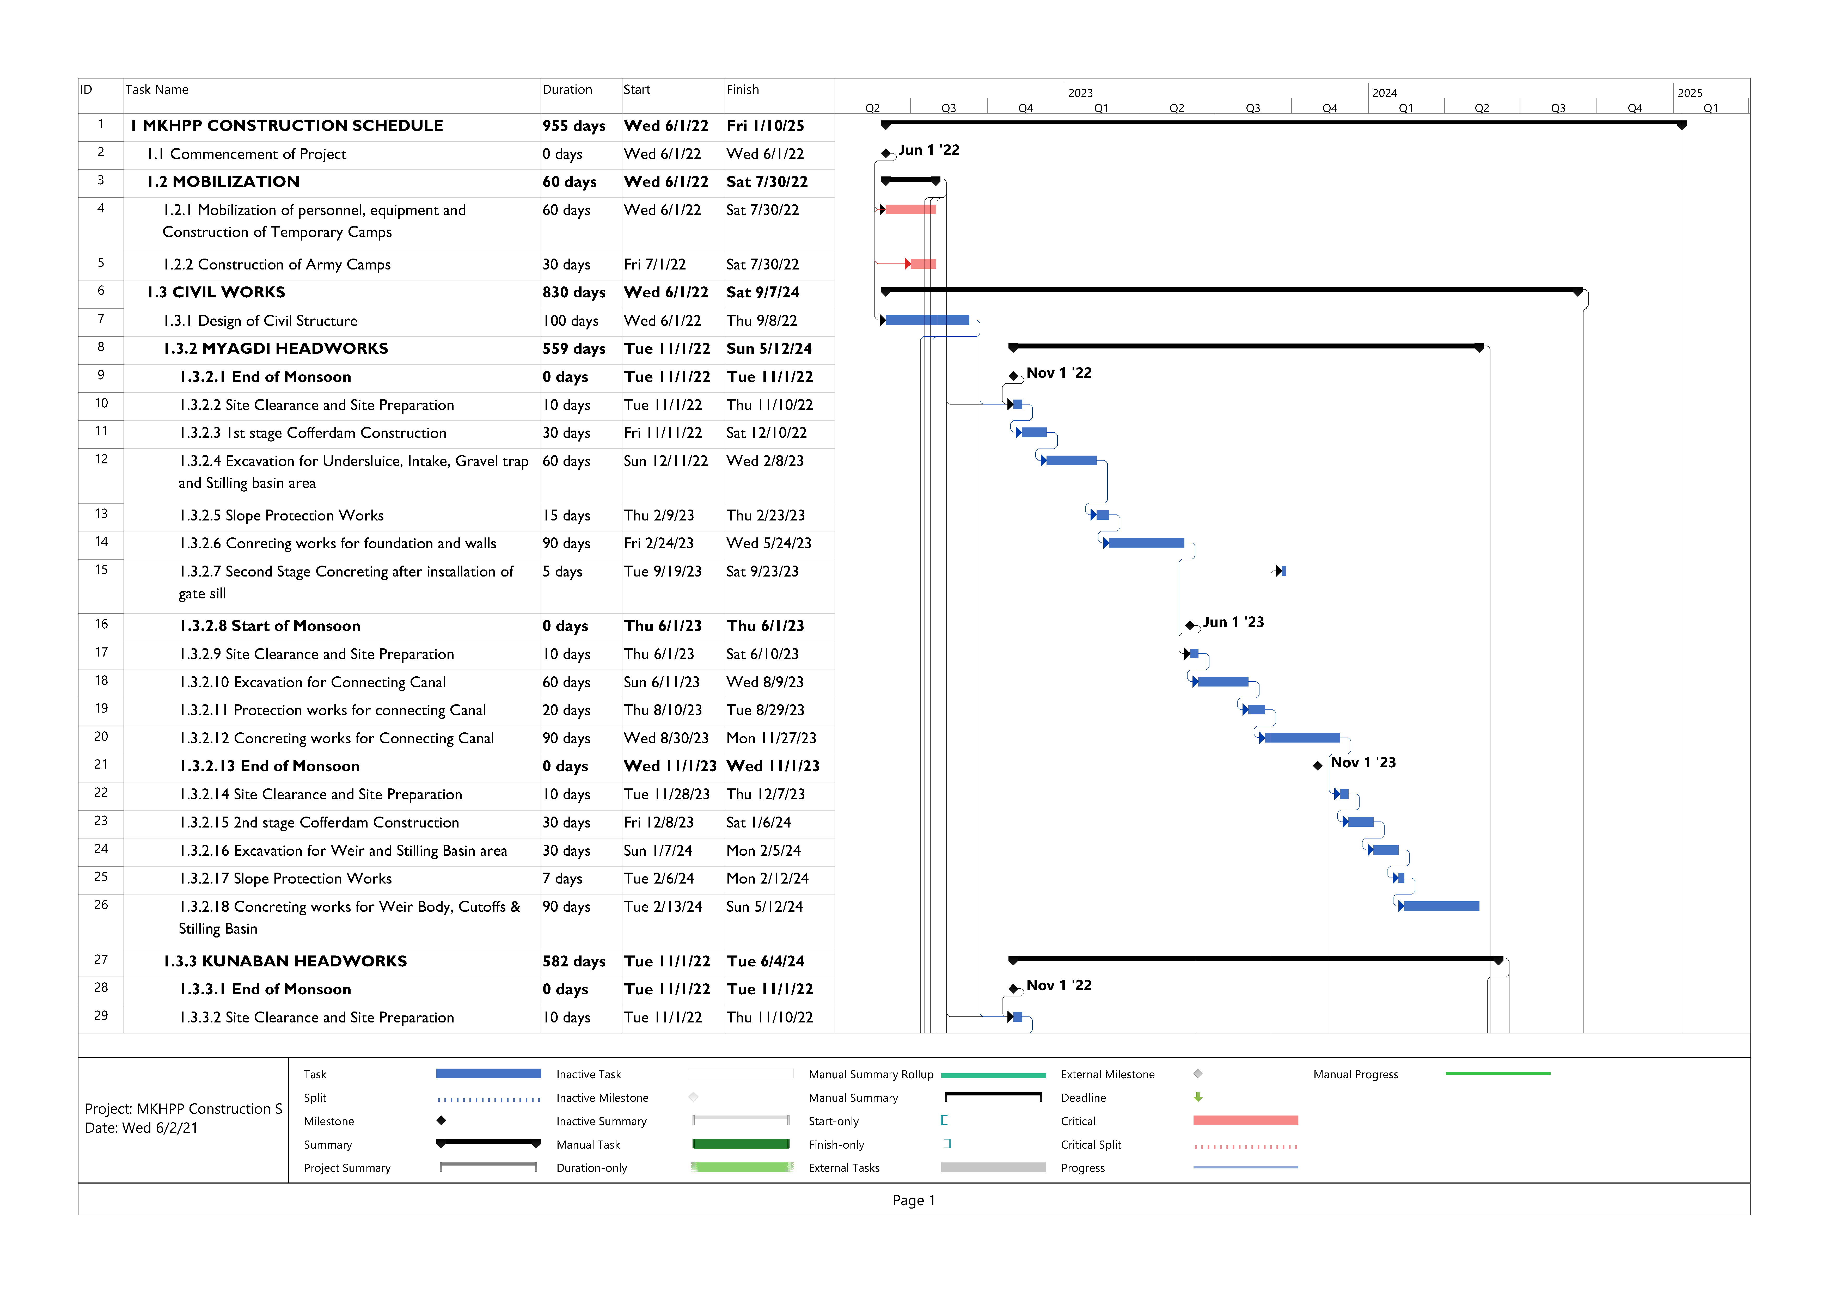

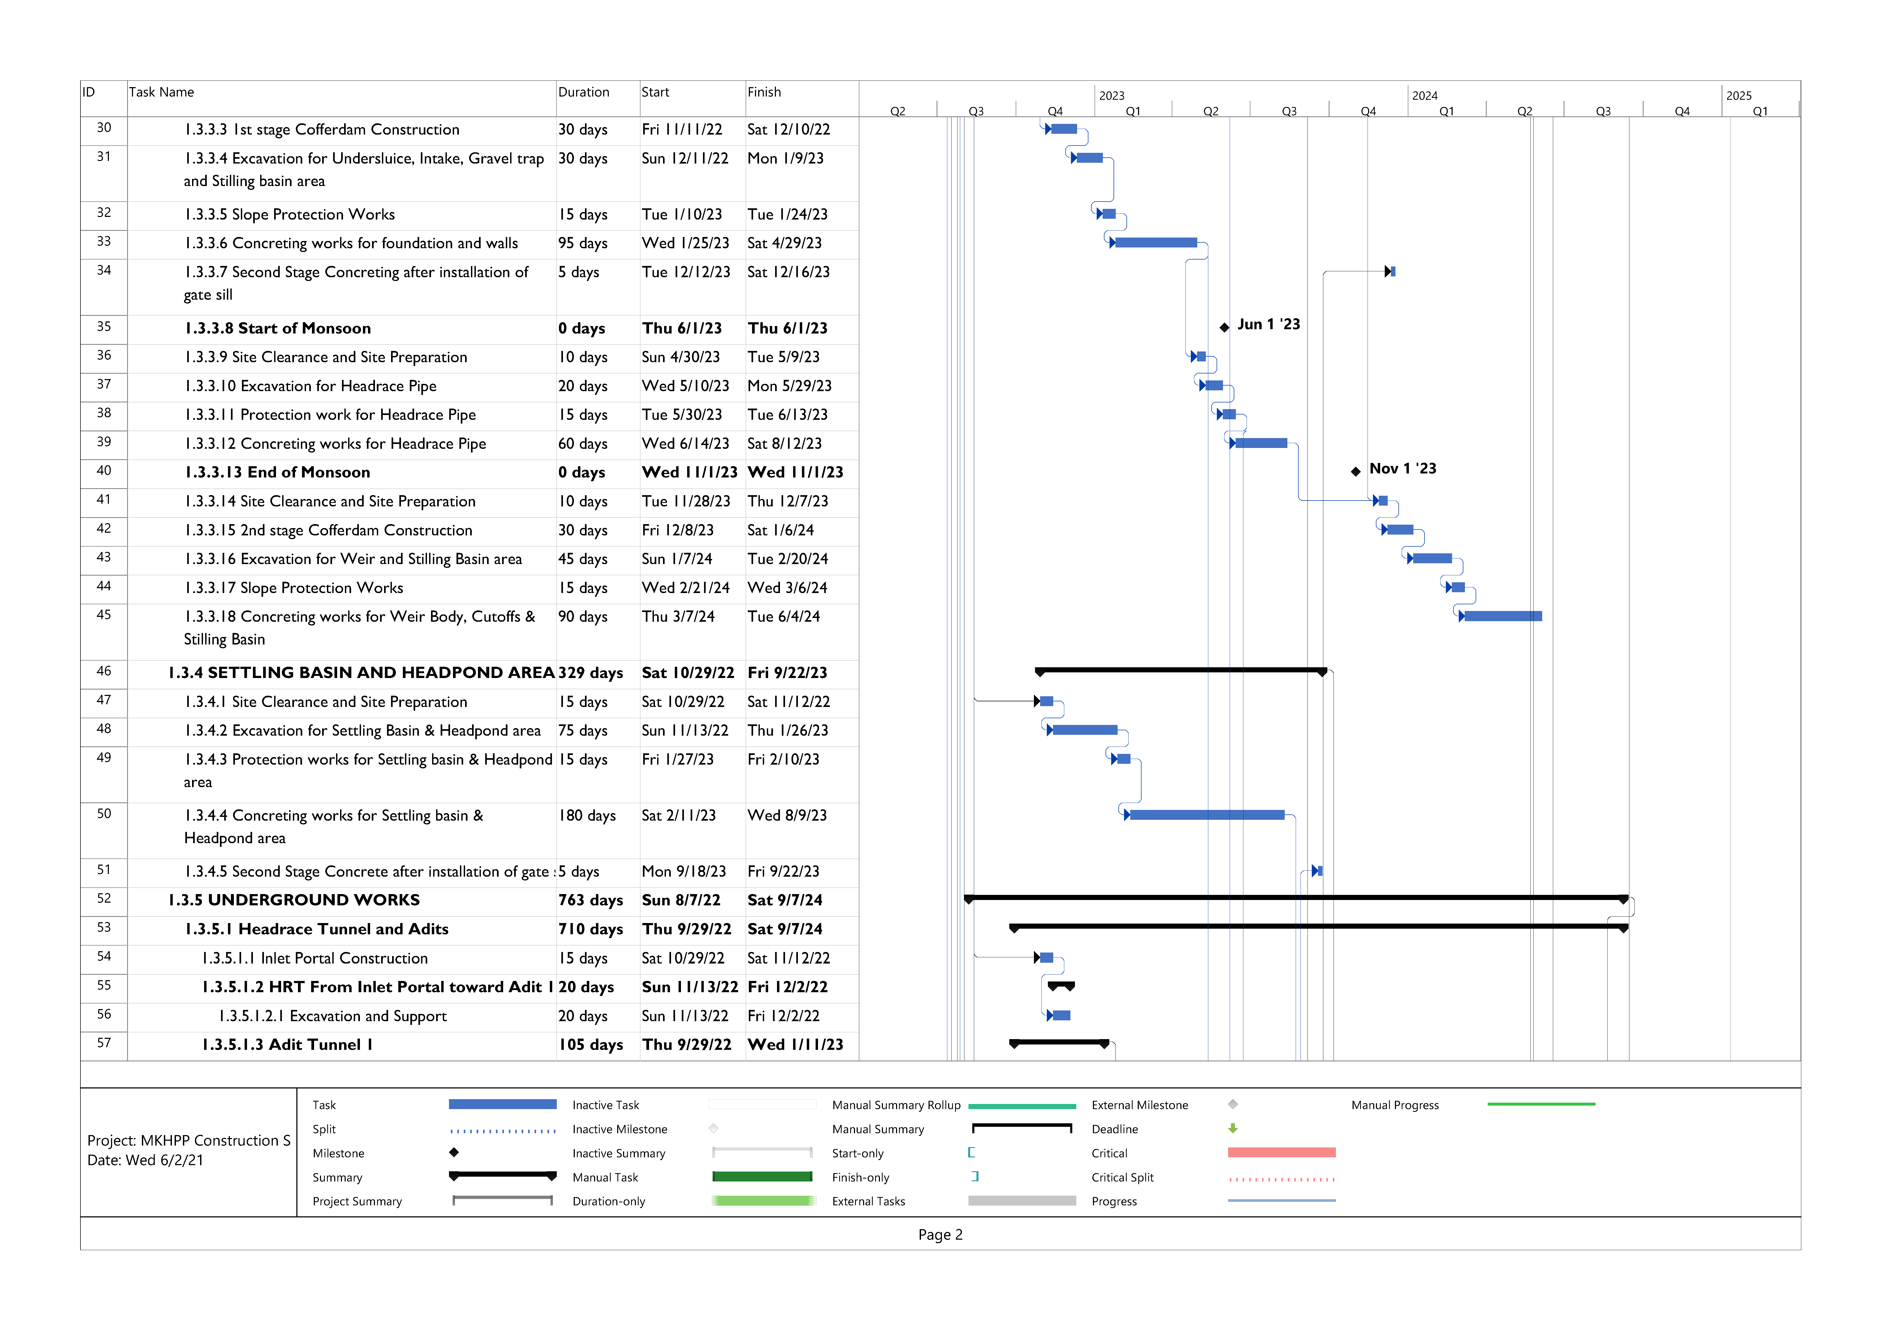

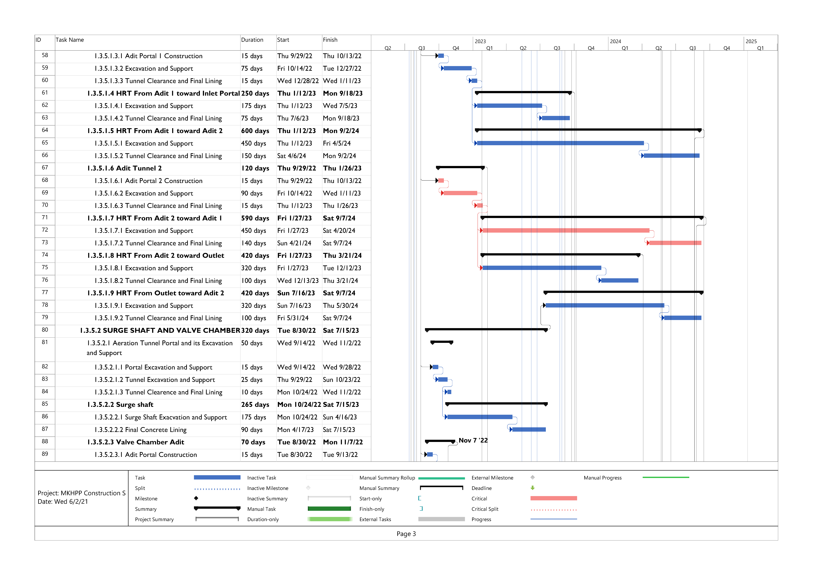

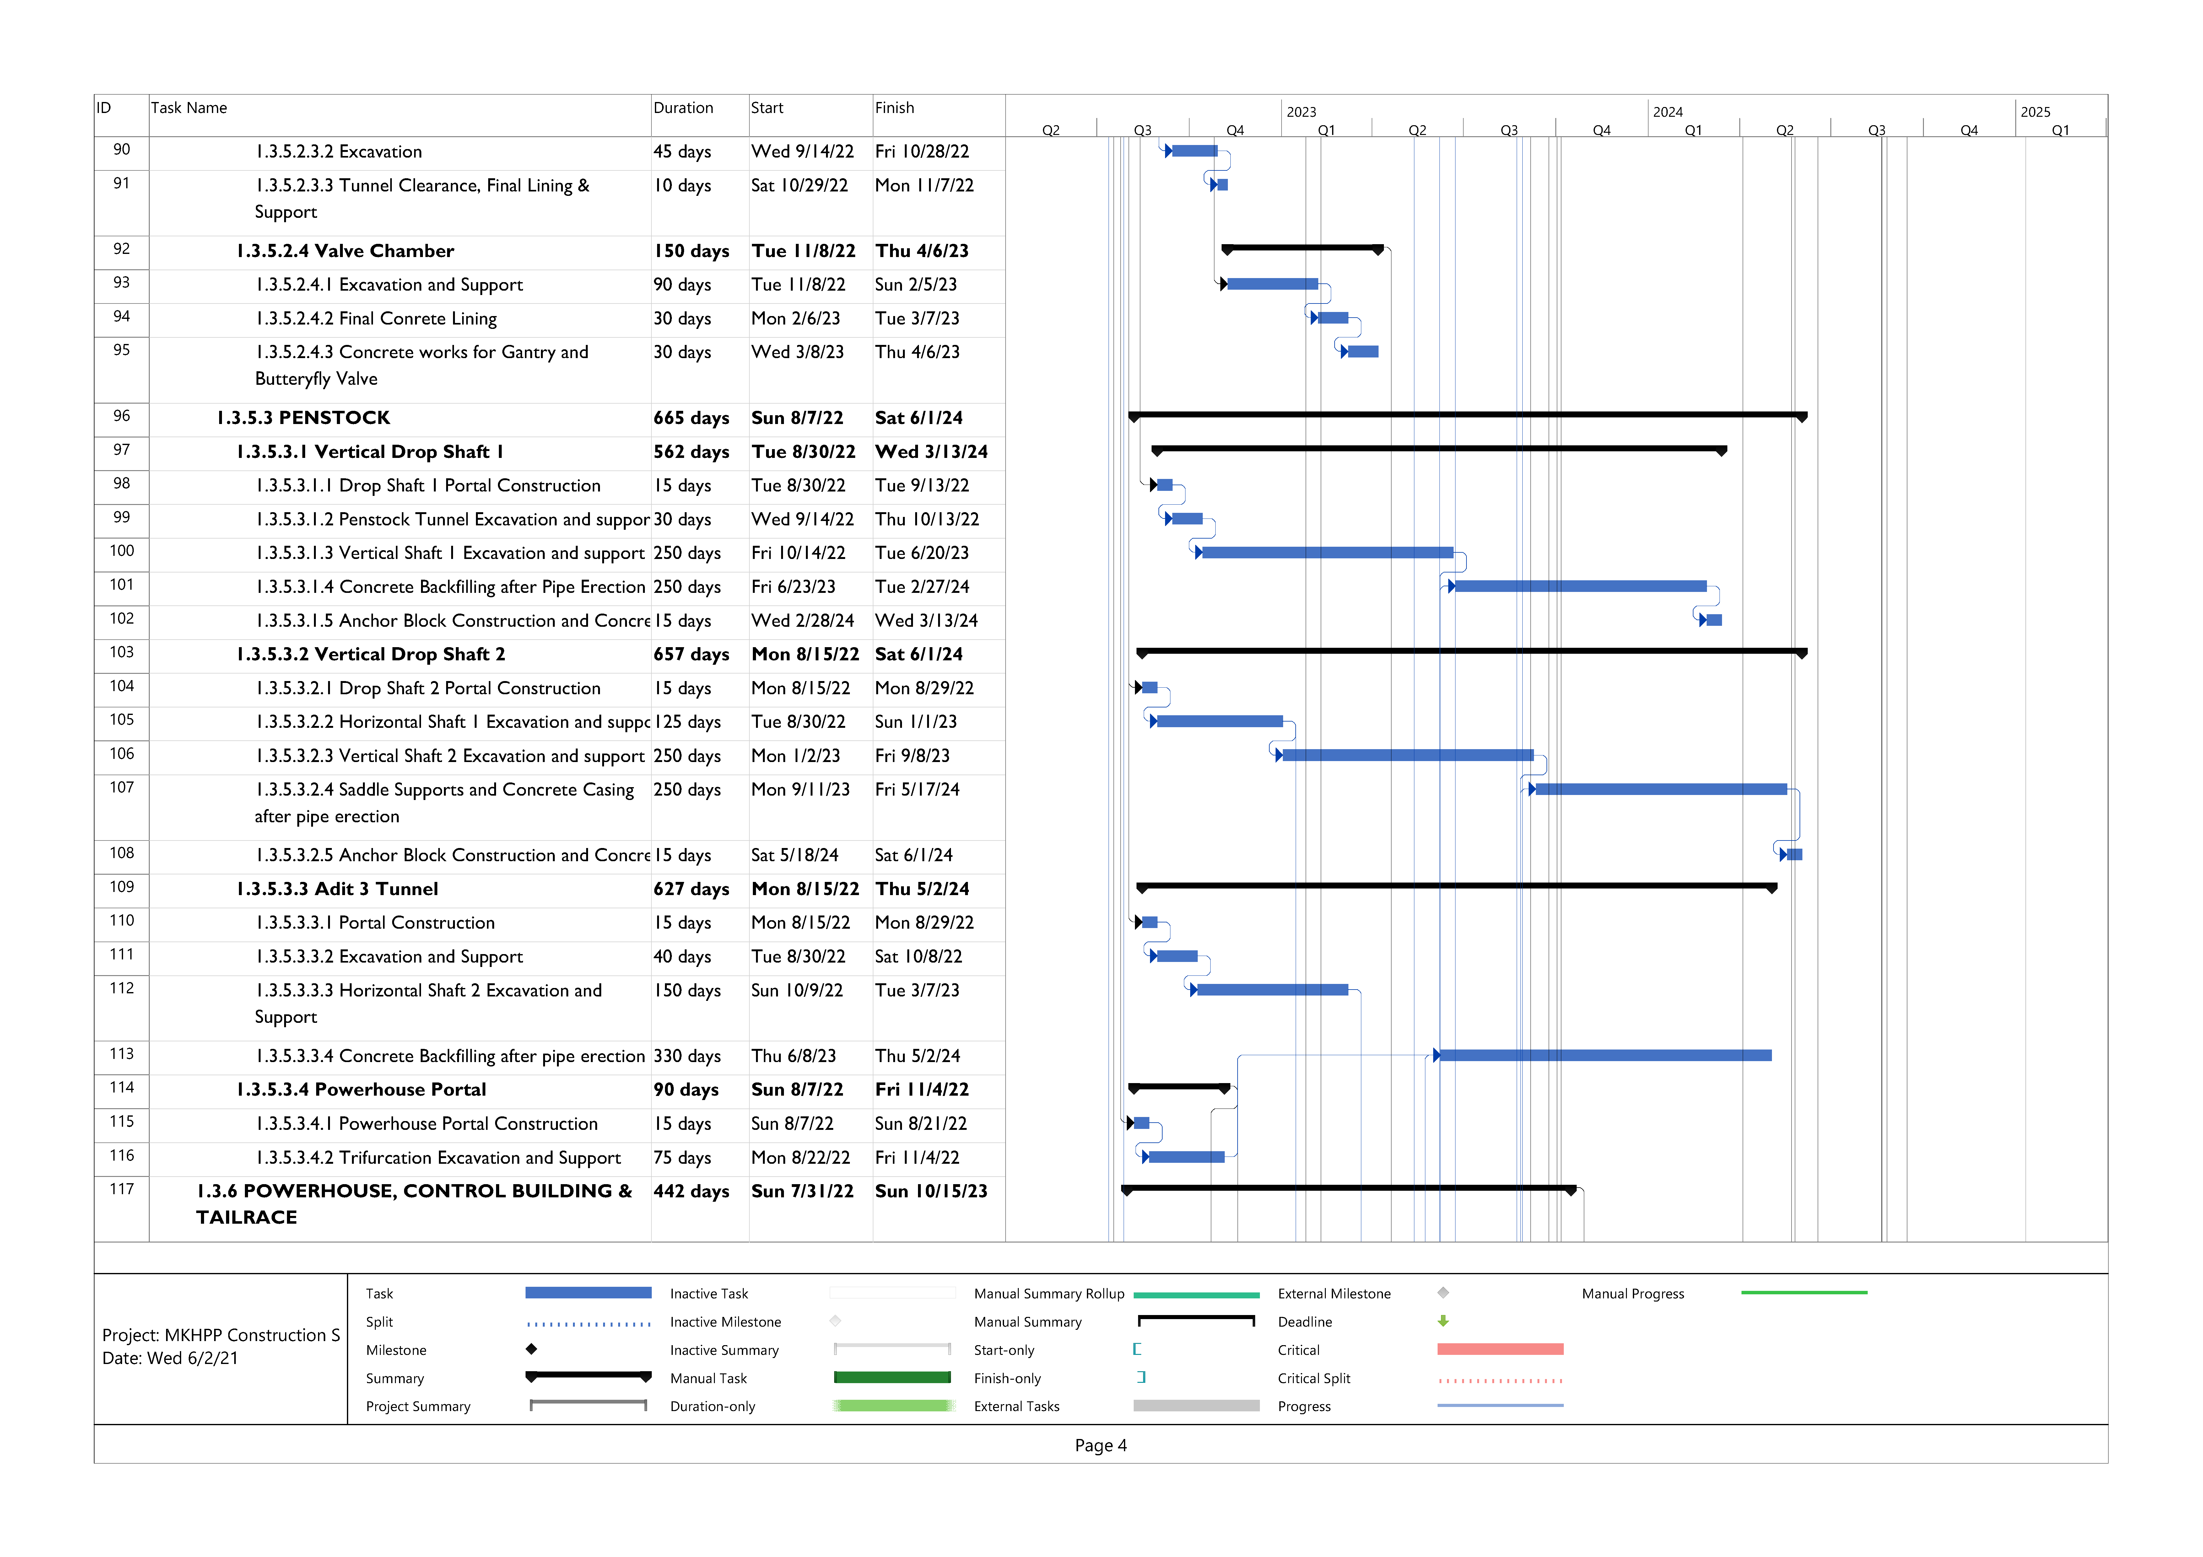

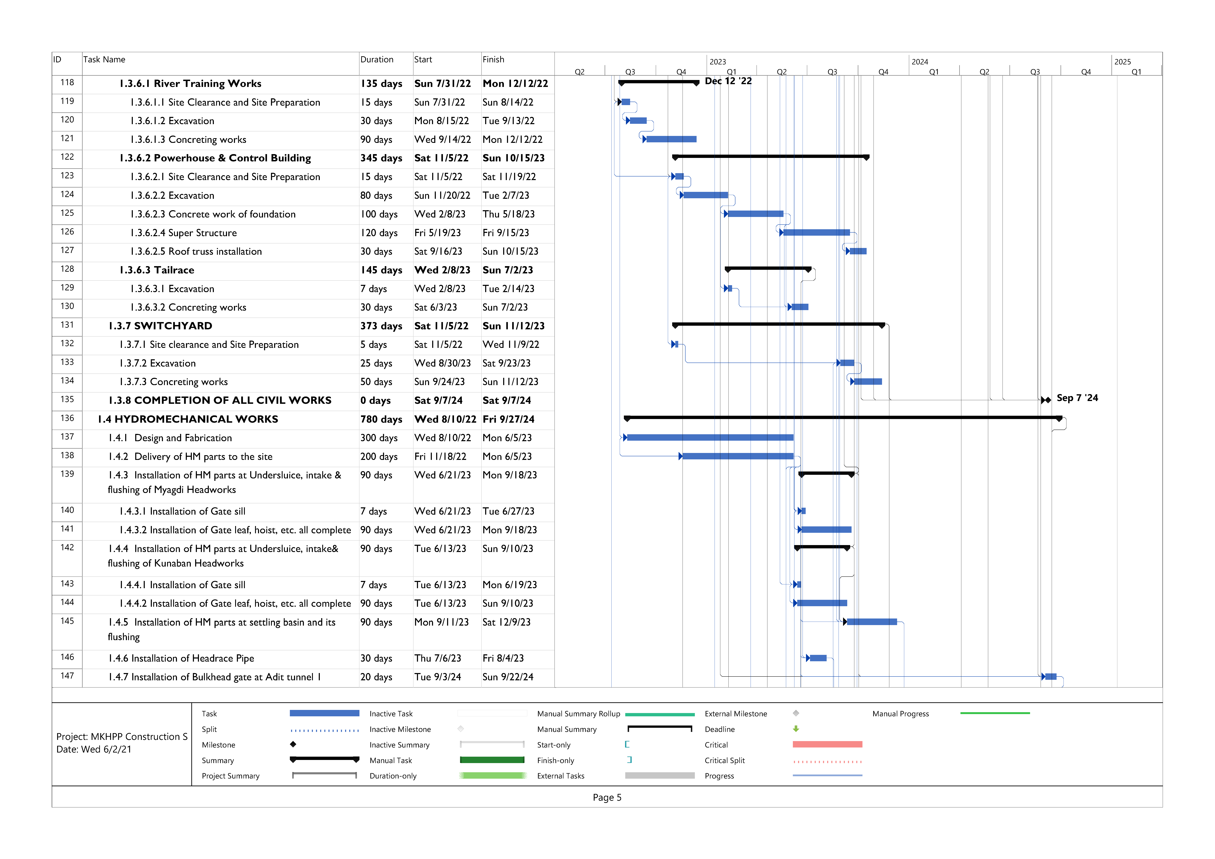

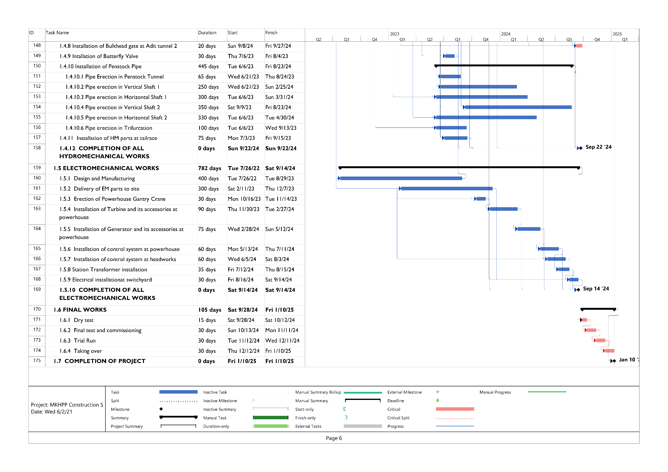

# PROJECT COST ESTIMATION

## General

This section of the report describes the methodology used for derivation of the project cost. The cost estimation report describes the methodology and assumptions used in the estimation of project cost. The costing of the project has been carried out based on the project quantities and corresponding unit rates. The methods of rate analysis, cost estimation methodology and assumptions made in the project cost estimation have been described in following sub-section.

## Rate Analysis

As far as available, the rates of component items of various activity items of works such as labor, materials, equipment etc. have been taken from District Rate of Myagdi District for fiscal year 2077/78. The transportation cost for these items have been added in the rate analysis. DoR norms have been used for transportation of materials to the project site. Norms prepared by different departments of GoN, such as DoR, DoLIDAR have been considered for the rate analysis. Some of the unit rates have been collected from different contractors where the norms are not applicable. Transportation Rate inside the Nepal has been considered as per Department of Road. Wherever possible, the current costs of equipment and material also have been taken from manufacturers for the purpose of cross-verification also from the projects under construction in the same region of the project.

The rates reflect quantity of material to be used for each unit item and the labour cost required for each unit of work. The charge rates of equipment and machinery as well as cost of construction power are included in the unit rates. Similarly, profit and overhead have been added as per standard practice. The rate analysis of various items of work are presented in Volume II – Annex C of this report.

## Cost estimation methodology

The cost of a project is primarily a function of type and quantity of work, the selected appropriate construction technology and schedule of construction. A detailed cost estimate has been prepared using analytical method whereby cost for labor, material and equipment required to complete each of various identified items of construction activities for project structure is considered. The analytical method is the generally accepted method of the international construction industry for projects of this nature. In this method, the work to be performed is broken down into various items of work and each item of work is then analyzed to determine material, manpower and equipment necessary for its execution. Knowledge of both construction and equipment required in various type of construction is essential for this method of cost estimating.

The project cost has been worked out in the heading given hereunder.

1. **Civil Works**

A1. Headworks (Myagdi Weir, Myagdi intake, Myagdi Undersluice, Myagdi Gravel Trap, Connecting Canal, Kunaban Weir, Kunaban intake, Kunaban Undersluice, Kunaban Gravel Trap, Approach canal and Flushing Culvert and Desanding basin/Headpond, Headrace pipe)

A2. Headrace Tunnel

A3. Adit Tunnels

A4. Aeration Tunnel

A5. Valve Control Tunnel

A6. Vertical Shafts

A7. Surge shaft

A8. Horizontal Shaft

A9. Penstock and its Supports

A10. Powerhouse, Tailrace & Switchyard (including protection works)

1. **Electro-Hydro-mechanical and Transmission Works**

B1. Electro-mechanical Works including Transformer and Interconnection Bay

B2. Hydro-mechanical Works (Penstock Pipes & steel lining, gates, trash racks)

B3. Transmission Line including land acquisition

1. **Infrastructures** **and** **Logistics**

C1. Access Road, Bridge and Repair/Maintenance

C2. Camp Facilities

C3. General Items

1. **EIA including mitigation and monitoring**
2. **Land acquisition, Compensation and Development Cost**
3. **Engineering Management and Supervision Cost**

F1. Owner's Engineering and Supervision

F2. Construction Design, Drawing and DPR

F3. Physical Modelling and Geotechnical Investigation

1. **Project Management Cost during Construction**

G.1 Vehicle Setup, maintenance and running cost

G.2 Office equipment, computer, printer, stationaries and running cost

G.3 Administrative and Management Cost

1. **Construction Power**
2. **Pre Project Development**
3. **Insurance During Construction**
4. **Loan Management Cost**
5. **Contingencies**

L1. Physical contingencies

L2. Price contingencies

1. **Custom Taxes**
2. **VAT**

## Description of Cost Items

### Unit rate for Civil Works

Major items of civil works include excavation of common soil, surface rock excavation, underground excavation, rock supports, backfilling, concreting, reinforcement work, form work, shotcrete etc.

Unit price of above-mentioned items has been calculated using the Myagdi District Rates for civil works 2077/2078 including the transportation cost for the materials. Reference of similar projects near to the same region has been also taken for the review of unit rates.

### Civil Works

The Civil Works heading includes all the civil works from the headworks site to the tailrace culvert and all other ancillary works. The total civil works has been further divided into two parts, surface and underground works. The surface work includes all the works in the headworks area till the headrace pipe and powerhouse with its ancillary works. Whereas the underground work includes all the works at HRT, surge shaft, underground penstock portions (vertical shaft and horizontal shaft), valve house, adit tunnels, aeration tunnels and portal works.

### Electromechanical Works

The cost of electromechanical (EM) equipment has been considered as US$ 210/kW in this study which is taken based on the rates provided by the potential bidders for the similar projects. This cost covers all the electro-mechanical works from main inlet valve to the outlet including the cost of operating system. Separate cost for Transformer bay (US$ 460,000) and Interconnection bay (US$ 400,000) has been considered. The total cost for the electro-mechanical components has been increased with reference to the submitted UFSR according to the current market value.

### Hydro-mechanical Works

The Hydro-mechanical Works includes all gates and stop logs, trash rack, steel penstock and steel lining works, valves, wear plates etc. Unit rates have been revised based on the current market prices of local and foreign Contractors and material used. Due to limitation of time, for all the project component the cost of HM is used same as before with additional cost of steel pipe added in the headrace section.

### Transmission Line

The cost of transmission line includes the cost of supplying and erecting the transmission line, compensation for land, connecting at sub-station etc. The cost has also been checked in reference to similar projects.

### Infrastructure Works and Logistics

This includes the cost of the construction of access roads, bridge construction and maintenance, permanent camp buildings, offices, temporary camps, water supply, septic facilities, communication, bunker set up and its operation.

#### Access Road, Bridge Construction and Maintenance

The cost allocated for access roads includes the cost for providing access road to various project components. Upgrading of existing road, new construction of road and maintenance during the construction, construction of bridge on the project access road have been considered under Access Road. As the topography is also challenging, a higher cost has been allocated in this study for access road construction.

#### Camp facilities

This heading includes cost for the construction of permanent camp buildings, offices, temporary camps in headworks, HRT adit and powerhouse areas. It also includes the cost for construction of camping facilities for the army personnel. Since, the camp area have not been studied in this study therefore, the same cost as considered in Summary of Project Cost in FSR, has been considered in this study.

#### General Items

As per this study, the general items include cost for bunker set up and its operation.

### EIA including mitigation and monitoring

Environmental mitigation and monitoring cost has been considered under this heading. Environmental cost consists of cost for necessary mitigation and monitoring of different environmental impacts created by the project development activities. Similarly, it also includes cost for the measures taken up to uplift the local community living condition. The cost from the approved EIA Report of the project has been considered in this study.

### Land Acquisition, Compensation and Development

Land acquisition/compensation and development cost includes the cost of acquiring the land permanently for the purpose of construction of the permanent structures of the project and renting or leasing during the construction for temporary camp and facilities. Similarly, it also includes the cost for compensating the properties like houses, for construction of the project structures. Since, there is no concrete basis for the estimation of the cost of land acquisition, the cost of land acquisition/compensation and development has been considered same as that considered in the FSR.

### Engineering Design and Supervision Cost

This heading includes cost for owner’s engineering and supervision, all the detail design works as well as construction supervision during construction of the project. It also includes Physical modelling and geotechnical investigation cost.

### Project Management Cost during Construction

An allowance has been made in the estimate to cover the developer’s operating costs during the detail design and construction phase. This heading includes the administrative and management costs (rental, salary etc.); office running costs; vehicle setup, maintenance and running costs; and overheads upto the completion of the project construction. This also includes the developers’ camp management, operation and security, health and safety cost at the site during the construction phase.

### Construction Power

It includes the cost for construction power and distribution works in the project area and maintenance of the transmission line for construction power and other miscellaneous works.

### Pre Project Development

This heading includes the licencing cost, administrative costs, taxes, office running costs and overheads during the preliminary study phase. This cost has already been spent on various activities (as per Client) and therefore included in this study as VAT inclusive cost. This cost has been considered same as that provided in FSR.

### Insurance during Construction

In this study, 0.75% of the Total Base Cost has been considered as insurance amount during construction. References to the similar projects has also been made to ascertain the insurance percentage. The insurance amount in the FSR is higher than that used in this study.

### Contingencies

#### Physical contingencies

It is the usual engineering practice to provide contingencies because there are lot of unseen works and uncertainties in hydropower projects. Different values of contingencies are adopted on their degree of uncertainties. Contingencies for surface civil works is taken as 10% of the total surface cost including access road and camp facilities, whereas 15% is adopted for underground civil works as the uncertainties are higher in underground works. The cost of further updating the drawings, cost of recommendations from this study and cost of uncertainties will be covered by the allocated contingencies. Similarly, contingencies of 4% in electro-mechanical equipment, 5% in hydro-mechanical works, 5% for transmission line and 5% for the ngineering design and supervision cost have been considered in this study.

The percentage used for various physical contingencies have been shown below:

Table 12‑1 Physical contingencies percentage

|  |  |  |
| --- | --- | --- |
| **S.N.** | **Description** | **Percentage** |
| 1. | Surface Civil Works | 10% |
| 2. | Underground Civil Works | 15% |
| 3. | Hydro-mechanical Works | 5% |
| 4. | Electro-mechanical Works | 4% |
| 5. | Transmission Line Works | 5% |
| 6. | Engineering Design and Supervision Cost | 5% |

#### Price contingencies

5% of the civil base cost and 3% of electro-mechanical, hydro-mechanical and transmission line base cost is allocated for price contingencies in this study because of the fact that the rate of materials are likely to change/escalate during the construction of the project.

The price contingency had to be calculated excluding VAT and custom tax. However, the VAT and custom tax has to be calculated for the contingency amount too.

### VAT and Taxes

In this study, it has been assumed that 13% VAT will be applicable for 100% of civil and 100% of engineering costs. Similarly, 5% of EM works, 50% of HM works and 100% of transmission line works has been considered as VAT complying. However, 1% custom tax is charged on VAT free items on import from outside the country. The EIA cost including mitigation and monitoring as well as Land acquisition/compensation and development cost are considered inclusive of VAT. Similarly, the Pre Project development cost are the developer cost for licensing, royalties etc. which has also been considered as VAT inclusive.

The EM, HM and TL works, 0%, 60% and 50% of the respective cost has been considered VAT complying. For remaining works 13% VAT has been considered.

Table 12‑2 VAT and Tax compliance percentage

| **S.N.** | **Description** | **Percentage** | |
| --- | --- | --- | --- |
| VAT Complying | Tax Complying |
| 1. | Electro-Mechanical Works | 5% | 95% |
| 2. | Hydro-Mechanical Works | 50% | 50% |
| 3. | Transmission Line Works | 100% | 0% |

## Project cost estimate

The summary of project cost estimate is given in Table 12‑3. The costs in Table 12‑3 are based on the above assumptions and various fees, contingencies as described in previous sections and unit rates derived for FY 77/78. The total project cost including VAT and all taxes but excluding IDC is estimated from this study has been found to be Rs. 11,060,503,981.83. The details of the project cost estimate are available in Annex C, Cost Estimate and Project Evaluation.

Table 12‑3: Summary of the project cost

| **Item No.** | **Detail** | **%** | **Cost in NRs** | **VAT Complying %** | **VAT Complying Amount (NRs)** | **% Allocation** |
| --- | --- | --- | --- | --- | --- | --- |
| **A** | **Civil Works** |  |  |  |  |  |
| A.1 | **Civil Surface Works** |  | 1,787,859,905 | 100% | 1,787,859,905 |  |
| A.2 | **Civil Underground Works** |  | 2,429,029,984 | 100% | 2,429,029,984 |  |
|  | ***Base Cost of Civil*** |  | ***4,216,889,889*** |  |  | 38.13% |
| **B** | **Electromechanical, Hydro-mechanical & Transmission Line** |  |  |  |  |  |
| B.1 | **Electro-mechanical Works including Accessories** |  | 1,794,336,880 | 5% | 89,716,844 |  |
| B.2 | **Hydro-mechanical Works** |  | 963,731,325 | 50% | 481,865,663 |  |
| B.3 | **Transmission Line** |  | 330,000,000 | 100% | 330,000,000 |  |
|  | ***Base Cost of EM,HM & TL*** |  | ***3,088,068,205*** |  |  | 27.92% |
|  |  |  |  |  |  |  |
|  | ***Total Base Cost (Total of A & B)*** |  | ***7,304,958,094*** |  |  | 66.05% |
| **C** | **Infrastructures** |  |  |  |  |  |
| C.1 | Access Road and Bridge |  | 428,100,000 | 100% | 428,100,000 |  |
| C.2 | Camp facilities, including bunker |  | 149,500,000 | 100% | 149,500,000 |  |
|  | ***Total Infrastructure Cost*** |  | ***577,600,000*** |  |  | 5.22% |
| **D** | **General Works** |  |  |  |  |  |
| D.1 | Land Acquisition |  | 150,000,000 | 0% | - |  |
| D.2 | Socio-environmental mitigation cost |  | 107,357,279 | 0% | - |  |
|  | ***Total of General Cost*** |  | ***257,357,279*** |  |  | 2.33% |
|  |  |  |  |  |  |  |
| **E** | **Other Costs** |  |  |  |  |  |
| E.1 | Engineering Management Cost (@2.5% of Total of A & B) | 2.5% | 410,000,000 | 100% | 410,000,000 | 3.71% |
| E.2 | Insurance During Construction (@ 0.75% of Total of A & B) | 0.75% | 54,787,186 | 100% | 54,787,186 | 0.50% |
| E.3 | Project management, Construction Power & Project Development |  | 485,000,000 | 100% | 485,000,000 | 4.38% |
|  | ***Total of Other Cost*** |  | ***949,787,186*** |  |  |  |
|  | **Total** |  | **9,089,702,559** |  |  | 82.18% |
|  |  |  |  |  |  |  |
|  | **TOTAL TAX AND VAT (Total of G & J)** |  | **822,776,603** |  |  | **7.44%** |
|  | **TOTAL CONTINGENCY (INCLUDING VAT & TAXES)** |  | **1,148,024,821** |  |  | **10.38%** |
|  | **TOTAL PROJECT COST** |  | **9,089,702,559** |  |  |  |
|  | **TOTAL PROJECT COST INCLUDING CONTINGENCY, NRs** |  | **10,237,727,379** |  |  |  |
|  | **TOTAL PROJECT COST INCLUDING CONTINGENCY VAT & TAX, NRs** |  | **11,060,503,982** |  |  | **100.00%** |







# FINANCIAL ANALYSES

## Introduction

Investing in a Hydropower project is similar to investment in any other business and hence the expected return is guided by the risk associated with it. Hence an investor should take into different factors that influence the cash flow to the project and the return to equity holders. Various factors such as tax rates, royalty, interest rate, and cost of capital are important parameters that affect the return to the project and investment.

Financial analysis of the Myagdi Khola Small Hydropower Project has been carried out to ascertain the financial viability of the scheme taking reference of Total Cost assessed and the total energy evaluated and taking into consideration of different legal provisions affecting hydropower development in Nepal. The technical feasibility of the scheme has been established thorough study carried out on the technical aspect.

Financial evaluation determines the monetary values of the cost and benefits in real term and is inclusive of taxes transfers, duties and escalation. The financial evaluation concerns with the developers of the project and its impact on their accounts. Hence, from the perspective of a private developer, financial evaluation is the most important aspect of the project to determine whether to finance it or not.

## Methodology

The conventional approach was followed for conducting the financial analysis. In this approach, costs and benefits were first estimated on a common basis. For a project to be technically feasible and financially viable, the benefits should be more than the costs. The methodology involves a number of assumptions based on prevailing values. These parameters are described in the subsequent sections.

Wherever possible, known information was collected either from the past experiences or from prevailing rules and regulations that are applied. Where financial parameters are not known they have been estimated by extrapolation from known data or reasonable assumptions have been made. These assumptions are, on the whole, considered to be realistic and standard for analysis of this nature.

The financial analysis consists of a cash flow during the project life, and it is evaluated for Net Present Value (NPV), a benefit/cost ratio and the internal rate of return (IRR) of the project.

A sensitivity analysis was carried out by varying some of the assumed parameters such as cost, flow in the river, interest rates etc. In financial analysis, project cost and benefits are compared using discounting measures of project worth. Generally, the three important economic indicators are used in the financial evaluation of the project and same indicators were used in the analysis.

### Net Present Value (NPV)

NPV is the present value of the incremental net benefit stream, i.e. the sum of the discounted cash flow of project benefits less sum of the discounted cash flow of the project costs. It indicates whether the project generates benefits in excess of those required by the discount rate or not. A project with a positive NPV is thus considered economic.

### Internal Rate of Return (IRR)

IRR is the discount rate which makes the NPV of the incremental net benefit stream equal to zero, i.e. the discount rate at which the discounted benefits equal the discounted costs. It indicates the economic profitability of the invested project. If IRR is less than the interest rate used in the analysis, the project is thought to be uneconomic as the discounted benefits do not outweigh the discounted costs.

### Benefit-Cost Ratio (BCR)

Benefit-Cost-Ratio is the ratio of the present value of the benefit stream to the present value of the cost stream. It indicates the extent to which the discounted stream of benefits exceeds the discounted stream of costs. A ratio greater than unity indicates benefits exceed costs whereas it is less than unity if the costs exceed benefits.

## Financial parameters

### Project cost

As described in Chapter 12, derived project capital cost includes all the construction costs, electromechanical equipment and installation costs, transmission line cost and infrastructure cost. The cost also includes environmental mitigation and monitoring cost, annual operation and maintenance cost and any other direct or indirect costs such as owner’s development cost including land acquisition etc. The cost also includes VAT and other applicable taxes.

### Interest rate

The loan amount will require some interest to be paid on the amount borrowed. The interest will be capitalized till the project starts producing revenue. Generally, the banks charge 8 to 10 % for such loans. In present case, an interest rate of 10.5 % has been considered.

### Discount rate

For any project, discount rate is of key variable in any economic evaluation of the project. It is necessary parameter for obtaining time value of money to compare future costs and benefits in terms of current currency value. However, it is not an interest rate. It reflects not the borrower’s cost of capital but rather the social cost of capital; that is the socio-economic returns which are foregone by using the funds for the project under consideration rather than elsewhere in the economy.

For this project, the reference discount rate or opportunity cost of capital selected is taken 10.55%.

### Debt equity ratio

As hydropower projects are highly capital intensive, funds have to be obtained from various donors or financial institutions like banks, credit organizations. It is also imperative that such a project could not be built solely on loans as the lender will require that the developer also put some funds. According to general trends, debt equity ratio of 75:25 has been assumed in this study.

### Energy rate

The unit rates in PPA has been considered in this review are shown below.

|  |  |
| --- | --- |
|  | **Unit rates** |
| Dry season energy | Rs. 8.40/kWh |
| Wet season energy | Rs. 4.80/kWh |

### Escalation

One of the major parameters for financial analyses is the energy tariff escalation. 3% escalation for 8 years from the Commercial Operation Date (COD) has been taken as per the PPA document; then after the rate will be constant throughout the project duration.

### Currency exchange rate

The currency exchange rate of is NRs. 120 per US dollar. This rate has been used as the “official” exchange rate in the conversion of all costs to and from the US dollars to the Nepalese currency (Rupees).

### Loan repayment period

It is assumed that the debt portion will have a grace period equal to the construction period and the repayment starts after the revenue generation starts. It will take 6 to 9 years for total repayment of the loan for small project and may extend to 15 to 20 years for larger projects. For the present project, loan repayment period has been taken as 12 years starting from the first year of repayment.

### Tax Rate

As stipulated in the Income Tax Act 2058, the applicable corporate tax rate for enterprises undertaking electricity generation is 20 %. However, the Government of Nepal has given a tax holiday of ten years from COD for hydropower projects. In addition, the corporate tax from 11th to 15th year will be 10%. Thereafter, it will be 20% from the 16th year.

### Royalties

Royalties have to be paid to the government for natural resource usage. As per Hydropower Development Policy, 2058, for the project of capacity ranging from 10 MW to 100 MW, such royalties are payable to the government at a rate of NRs. 150 for each installed Kilo-Watt of electricity per year plus 1.85% on the energy sold for a term of up to fifteen years from the date of generation of electricity for commercial purpose. After then, royalties will be at a rate of NRs. 1200 for each installed Kilo-Watt of electricity per year plus 10 % on the energy sold.

### Planning horizon

For financial analysis the expected life of the project has to be made so that over such period the cost and benefits can be forecasted. Replacement of electromechanical components is considered after 15 years of operation. The financial life of the project has been taken as the license period granted with a period of 30 years.

### Operation and maintenance cost

It has been assumed that 1.2% of the project cost will be required annually to meet operation and maintenance cost which includes repair and minor replacement costs during operation. This value has been adopted based on the experience of the hydropower projects in the country.

### Financing Charges

The financing charges have been considered 0.75%.

### Capital investment

The project is expected to be completed within 3 years after commencing the construction. For this reason, capital cost for the project will be disbursed during the project construction period as follows:

25% in Year 1,

35% in Year 2 and

40% in Year 3

The annual capital cost disbursement in each year has been divided into four instalments so as to get more accurate interest amount on loan investment.

### Depreciation

The depreciation rate of 3.33% per anum has been considered since the life of the project is 30 years.

### Other parameters

The Corporate overhead and insurance cost has been taken as 1% of the revenue and 0.7% of the project cost in the financial analysis. Similarly, inflation rate has been taken as the 4% per year.

## Project evaluation

### Financial analysis

For the financial analysis, the principal project benefits are revenues, which can be derived from the operation of the project. In the analysis, three important financial indicators: Benefit Cost (B/C) ratio and Internal Rate of Return (IRR) on Project cost and IRR on Equity. The considerations of the financial analysis as well as the financial analysis results have been presented in Table 13‑1. The financial analysis sheet has been included in Annex C of this report.

Table 13‑1 Considerations and results of the financial analysis

| **S. N.** | **Assumptions and Considerations** | **Value** |
| --- | --- | --- |
| 1. | Total cost of the project with VAT and taxes without IDC | NRs. 11,060,503,981.83 |
| 2. | Total annual energy | 380.24 GWh |
| 3. | Dry season Enery | 118.67 GWh |
| 4. | Wet season Energy | 261.57 GWh |
| 5. | Installed Capacity | 65 MW |
| 6. | Cost per MW | NRs. 170,161,599.72 |
| 7. | Dry energy rate | NRs. 8.40/kWh |
| 8. | Wet energy rate | NRs. 4.80/kWh |
| 9. | Equity/Debt ratio | 25:75 |
| 10. | Project life | 30 years from the day of operation |
| 11. | B/C ratio | 1.38 |
| 12. | IRR on Project | 14.57% |
| 13. | IRR of Equity | 16.95% |
| 14. | B/C ratio on Equity | 1.93 |



### Sensitivity analysis

Hydropower projects are subject to different risk factors such as cost overrun, interest risk fluctuation, etc. Sensitivity analysis of the project has been carried out to access the risk of cost overrun, interest rate fluctuation and energy deficit. The financial indicators IRR on Project and IRR on Equity have been calculated for cost overrun, interest rate fluctuation and energy deficit.

The sensitivity analysis has been studied and the summary of the sensitivity analysis is presented in Table 13‑2.

Table 13‑2 Result of sensitivity analysis for the project capacity 65 MW

|  |  |  |  |  |  |
| --- | --- | --- | --- | --- | --- |
| **Case No.** | **Details** | **Benefit-Cost Ratio** | **IRR on Project** | **Benefit-Cost Ratio** | **IRR on Equity** |
| **Base Case:** | **Interest Rate, I=13%, Cost Overrun=0%, Energy deficit=0%** | **1.38** | **14.57%** | **1.93** | **16.95%** |
| 1 | Interest Rate, I=15% Cost Overrun=0% | 1.37 | 14.44% | 1.83 | 16.15% |
| 2 | Interest Rate, I=13% Cost Overrun=10% | 1.23 | 12.85% | 1.47 | 13.60% |
| 3 | Interest Rate, I=13% Energy Defecit=10% | 1.21 | 12.64% | 1.42 | 13.19% |







## Conclusion

Financial analysis of the project has been carried out after having the energy estimate and the project cost as mentioned in their respective chapters above. For the Financial analysis, the project life has been taken as 30 years and debt equity ratio is taken as 75:25, interest rate of 13%. The tariff rates have been used as as NRs. 8.40 per kWh for the dry season energy i.e. for the months of Mangsir (14 days), Paush (Dec/Jan), Magh (Jan/Feb), Phalgun (Feb/March), Chaitra (March/April), Baishakh (April/May) and Jestha (15 days) and NRs. 4.80 for the rest of the months which is current rate provided by the NEA to the similar sized hydropower projects. The financial indicators, for the project capacity 65 MW, have been found as IRR on Project of 14.57%, IRR on Equity of 16.95% and B/C ratio of 1.38.

# CONCLUSION AND RECOMMENDATIONS

## Conclusion

The conclusions drawn from the hydrological, geological and geophysical studies, layout options, power and energy computation and project cost estimation has been summarized hereunder.

1. More than 90% of the catchment lies above 3000m, which is a favorable condition for higher degree of base flow throughout the year and less flood hazards.
2. The design discharge has been adopted to be 12.50 m3/s with the gross head of the project as 629.0m and the net head of the project as 607.18m.
3. The Myagdi Khola hydropower project is located between rocks of lesser Himalaya and Higher Himalaya separated by the Main central Thrust (MCT) which passes through the headrace tunnel at around chainage of 4400m. The MCT was active during the early phases of Himalayan orogeny but now is no longer active. From engineering point of view, the MCT is a thick zone of low to high grade metamorphic rocks without weak shear zones and hence this will not create any risks for construction of any structures.
4. The Myagdi valley upstream of the confluence headworks area is full of mass wasting events in past and still there are several active landslides. There might be a risk of damaging diversion weir and intake structures by landslide damming and landslide dammed outburst flood with debris flow in extreme mega event in future. Constant surveillance has to be ensured to identify such damming and removing the debris and necessary protection measures have to be taken to prevent rock fall / slope failures to prevent such events. The undersluice has been proposed at right bank of Myagdi Khola, parallel to the weir axis. The purpose of this is primarily to reduce the deposition of large amount of bed material in front of intake as the gates are operated to allow the bed material to safely pass downstream of the sluiceway gates during the monsoon period when there is excess discharge in the river.
5. Geologically, all the major structures of the project are found to be constructible but while taking proper care during the further study and construction phase of the project.
6. The project will have two number of headworks before the confluence of Myagdi and Kunaban River. Myagdi River has one headworks arrangement to divert the flow towards the Kunban headworks located at Kunaban River. It is expected that during the three months of the monsoon season the discharge from the Kunaban river is sufficient to operate the powerplant.
7. The Myagdi weir is proposed as a sloping glacis type concrete gravity weir with horizontal floor stilling basin. Considering the available space in this narrow river and considering the magnitude of flood the weir axis length of 14m excluding the sluiceway has been proposed. With this weir axis length, the head over the crest will be high which increase the level of intake operation platform; however, it will not have significant impact on cost as there is exposed bed rock on both the banks at weir axis in its upstream and downstream stretch which eliminates the need of upstream and downstream flood walls. The weir crest elevation has been fixed at the elevation of 2483 masl which is 5 m high weir above the upstream apron to prevent passing of the boulders into the intake. Due to the high concentration of boulders in the river it is recommended that both the upstream and downstream stretch of the weir be provided with boulder rip rap to prevent scouring of the river channel in vicinity of the structure.
8. Two number of undersluice with different opening are provided in the right bank of Myagdi river parallel to the weir considering the flood discharge in the river. One undersluice has opening of 2.5m width x 2.5m height whereas other has opening of 3.5 m width x 3.5m height.
9. The Myagdi river intake is proposed as a submerged orifice type side intake with two numbers of equal size of gate openings of 3.6 m wide and 2.5 high to draw the discharge of 11.5 m3/s including design discharge of 10m3/s and 15% additional discharge, required for flushing of gravel trap at the normal operation level.
10. Connecting canal will convey the total of 10 m3/s of discharge to the headworks of Kunaban at normal operating level at the intake. The canal will have size of 2.80m width x 2.10m height with total length of 462m. The canal will pass through partially in alluvial deposit and partially in rock cutting. As the uphill slope of the canal alignment consists of weathered rock and alluvial deposits, the approach canals have been designed as covered canal in some stretches whereas open canal in remaining stretches.
11. The Kunaban weir has been proposed as a boulder rip-rap weir. The boulder weir is chosen to ease the passage of boulders downstream of the weir as well as ease of construction than the other types of weir. Considering the available space and the magnitude of flood that the weir axis length of 20m excluding the sluiceway has been proposed. The weir crest elevation has been fixed to the elevation of 2482.00 masl which is 3.0 m high weir above the upstream apron. The undersluice has been proposed on the right bank of the river parallel to the weir with one sluiceway gate having opening size of 3.5m x 3.5m (W x H).
12. The Kunaban intake is proposed as a submerged orifice type side intake with two numbers of equal size of gate openings of 4.8 m wide and 2.0 high have been designed to draw the discharge of 15.64 m3/s including design discharge of 12.5 m3/s and 25% additional discharge, required for flushing of gravel trap and settling basin at the normal operation level. The flow velocity through the intake orifice at normal water level have been limited to 0.8 m/s. Top level of the intake gate has been fixed at 0.6 m below the weir crest level to prevent the entry of floating debris into the intake even during the normal operation level.
13. Settling basin with two bays with the dimension of 11m width, 85 m length and 9.94 m depth including hopper has been proposed. In consideration with high head plant and concentration of sediment at river, settling basin has been designed with 90% trap efficiency for the particle size of 0.15 mm from the Vetters’s theory.
14. Two options of settling basin location have been studied in this study, i.e. the Option I is just downstream of the intake on the right bank of the Kunaban river and the Option II is at about 400 m downstream of the intake near to the tunnel inlet portal. Huge excavation is required at Option II and also the there will be the risk of sediment depotion at approach culvert. Hence for now, Option I have been considered for the cost estimation and description of the project layout structures. However, it is recommended to carryout the drilling at both the settling basin locations for the assessment of necessary geotechnical information of the soil strata to make the final decision on settling basin location.
15. Considering the, high head of the project and eroding nature of sediment particles having dominant quartz content (i.e. about 50% quartz from the sample studied), mechanized flushing system is recommended.
16. The inlet portal is located about 500m downstream of the intake. During ERT study it was found that the proposed location has bed rock in about 5-10m below the ground level, however this needs to be confirmed with core drilling in the location.
17. The waterway of the project comprises of 6170m long inverted D-shaped headrace tunnel, Rock trap of dimension 28mx3.2mx2.2m (LengthxWidthxDepth below invert level) is also provided. 8m dia surge shaft with its top ventilated by means of Aeration tunnel of 45m length, 66.2 m long penstock tunnel, followed by three drop shafts of 196.38 m, 246.95 m and 98.02 m respectively connected by mild slope horizontal shafts of 197.65m, 260.35m, 119.84 m respectively. The mild slope tunnel after third drop shaft will convey water before finally branching off to three units. The right bank of Myagdi Khola has been selected for the waterway alignment based on the topography, space availability for the structures and based on geological conditions.
18. The headrace tunnel of 3.2m width x 3.5m height finished size has been proposed to convey the design discharge to the powerhouse. There will be two number of intermediate adits for construction. The headrace tunnel alignment is chosen such that the minimum side cover at the kholsi crossing is 150m since there are shear bands and weak zone which could lead to leakage from the tunnel if less side cover is provided. The HRT will pass through rock types of gneiss, quartzite and slate.
19. The Surge Shaft, Aeration tunnel and the outlet portal of the headrace tunnel lies in steep topography so its access should be properly studied during further study and detailed design of the project.
20. Two drop shafts followed by mild slope horizontal tunnel seems more practicable from safety consideration of the penstock pipe as surface pipe proposed during the previous study will have issues due to rock fall in such steep topography and difficulty during construction.
21. Since in the previous study the powerhouse was founded completely on the deposit material. It is structurally not desirable to rest the foundation of such a high head powerhouse on deposit material, hence, the powerhouse location has been shifted slightly upstream of the previous location on the right bank of Myagdi Khola with slope cutting of the exposed rock bed so as to provide the rock base for the foundation of the powerhouse. However, to finalize the exact location of the powerhouse the rock line must be finalized with drilling works at the proposed location.
22. There units of vertical axis pelton turbine has been proposed compared to two units in the previous study considering the ease of transportation and fluctuation of power generating discharge in the river.
23. It was found during the study that with the available flow and net head, the capacity of the project is found to be 65.0 MW.
24. The financial indicators for the project with 65.0 MW capacity are B/C ratio is 1.38, IRR on project 14.57%, IRR of Equity 16.95% and B/C ratio on Equity is 1.93.
25. The overall cost of the project with 65.0 MW capacity has been found to be NRs. 11,060,503,981.83 including VAT and all taxes but excluding interest during construction.
26. With above technical conclusions and financial indicators, the project is found viable from both technical and financial aspects.

## Recommendations

1. The project is recommended to implement as it has been found technically feasible and financially viable.
2. Flow measurement is the only way to verify the estimated hydrology, hence, it is strongly recommended to give the continuity to the flow measurement works at the intake sites of the project.
3. Further geotechnical investigations with core drilling and labrotary testing of samples are recommended to be carried out in further study phase of the project.
4. The design of the powerhouse carried out in this design is based on the preliminary calculations made using the IS code and the parameters taken from the similar sized project. Hence, the powerhouse design adopted during this study is not final and will have to be revised after getting the actual dimension and load parameters from the electro-mechanical supplier.

# REFERENCES

## Previous study documents

Updated Feasibility Study Report of Myagdi Khola Hydropower Project (MKHPP), June 2018, Technoquarry (P) Ltd

## Civil Design References

BS 6399:1984 Loading for Buildings

IS 875: 1987 Code of practice for design loads for buildings and structures

IS 1893:1984 Criteria for earthquake resistant design of structures, fourth revision

NBC105:1994 Design of buildings in Nepal

EM 1110-2-2100 Stability analysis of concrete structures

BS 8110:1985 Structural Use of Concrete

BS 8007:1987 Design of Reinforced Concrete Structures for Retaining Aqueous Liquids

BS 4466:1987 Specification for Bending Dimension and Scheduling of Reinforcement for Concrete

EM 1110-2-2000 Standard practice for concrete for civil works structures

EM 1110-2-2104 Strength design for reinforced concrete hydraulic structures

EM 1110-2-2105 Design of hydraulic steel structures

EM 1110-2-3001 Planning and design of hydroelectric power plant structures

IS 2062:1999 Steel for General Structural Purposes - Specification

IS 456:2000 Code of Practice for Plain and Reinforced Concrete

IS 800:1984 Code of Practice for General Construction in Steel

IS 1786:2008 High strength deformed steel bars and wires for concrete Reinforcement

## Mechanical

DIN 19704 Hydraulic steel structures. Criteria for design and calculation

EM 1110-2-4205 Hydroelectric power plants mechanical design

IS 800:1984 Code of practice for general construction in steel

IS 875:1987 Code of practice for design loads for buildings and structures

IS 2062:1999 Steel for General Structural Purposes - Specification

IS 4622:2003 Recommendations for structural design of fixed wheel gates

IS: 6938:1989 Design of rope drum and chain hoists for hydraulic gates

IS 11388 Recommendations for design of trash racks for intakes

## Electro Mechanical

IS 12800 (Part 1): 1993 Guidelines for selection of turbines, preliminary dimensioning and layout of surface hydro-electric power houses

IS 13118: 1991 Specification for high voltage alternating current circuit breaker

IS-2026, IEC-60076 Power transformers

IS-325, IEC-34 Three phase induction motors

IS-2705, IEC-185, IEC 60044 Current transformers

IS-3156, IEC-186, IEC 60044 Potential transformers

IS-3070, IEC-60099 Lightning arrestors for AC system

IS-2516, IEC 62271-100 Circuit breakers for AC system

IEC 9921, IEC 129, IEC 1818 Isolators & earthing switches for voltage above 1 kV AC system

IS 3231, IS 722, IEC 521, BS 3T Electrical relays for power system protection

IEC 62056 Communication protocol

IS 13010, IS 722, IEC 521, BS 3T Energy meter

IEC 171, IS 2165 Insulation coordination

IEC 71 Electrical clearances

IS 398, IEC 1089, BS 215 ACSR bare conductor

IEC 60287, IEC 60853, IEC 60949 Current rating for XLPE cable system

IEEE 80 AC substation grounding

IS 1646, IS 3034 Fire safety of electrical equipment

IS 3043 Code of Practice in earthing

IEC 61850 Substation automation

IEC 60598 Luminaries

IEC 60694, 62271 High voltage switchgear & control-gear equipment

IEC 60947, 60439 Low voltage switchgear & control-gear

IEC 60255 Electrical Relays

IEC 60909 Short-circuit current in 3-phase AC system

IEC 60826 Overhead transmission lines

IEC 60364 Electrical installation of buildings

## Other References

* Buried Pipe Design, A. P. Moser and Steven Folkman 2008, McGraw-Hill Companies
* Civil Engineering Formulas, Tyler G. Hicks, P.E. 2010, McGraw-Hill Companies
* Design Criteria for Concrete Arch and Gravity Dams, United States Department of the Interior Bureau of Reclamation
* Design of Small Dams, United States Department of the Interior Bureau of Reclamation
* EM 1110-2-2200, Gravity Dam Design, U.S. Army Corps of Engineers
* EM 1110-2-2702, Design Of Spillway Tainter Gates, U.S. Army Corps of Engineers
* EM 1110-2-2901, Tunnels and Shafts in Rock, U.S. Army Corps of Engineers
* Foundation engineering handbook design and construction with the 2006 international building code, Robert W. Day. 2006, The McGraw-Hill Companies, Inc.
* Guide to the design of thrust blocks for buried pressure pipelines, CIRIA, Report 128
* Guidelines for Design of Intakes for Hydroelectric Plants, 1995, American Society of Civil Engineers
* Hydraulic gates and valves in free surface flow and submerged outlets, Jack Lewin 1995, Thomas Telford
* Reinforced Concrete Design, W. H. Mosley and J. H. Bungey, 1990, Macmillan
* Roark’s Formulas for Stress and Strain, Warren C. Young and Richard G. Budynas 2002, McGraw-Hill Companies
* Sediment control at intakes: a design guide, [Avery, P.](http://www.irc.nl/docsearch/results/?name=86484), 1989, Bedford, UK: [BHRA Fluid Engineering](http://www.irc.nl/docsearch/results/?publ=99264).
* Standard Method of Detailing Structural Concrete A manual for best practice 2006, The Institution of Structural Engineers
* Steel Penstocks, 1993, American Society of Civil Engineers
* Stress Analysis of Wye Branches, United States Department of the Interior Bureau of Reclamation
* The Foundation Engineering Handbook, Manjriker Gunaratne 2006, Taylor & Francis
* Welded Steel Penstocks, United States Department of the Interior Bureau of Reclamation
* Irrigation Engineering and Hydraulic Structures , Santosh Kumar Garg

## Geological Study references

Bordet P (1961) Recherches Géologiques dans L’Himalaya du Népal,Région du Makalu, Expéditions Françaises a l’Himalaya 1954–1955. Edition du Centre National de la Recherche Scientifique (C.N. R. S.), 275 pp (with geological maps and plates)

Dhital, M. R, 2015. Geology of Nepal Himalaya, Regional prospective of classic colloided orogen

Grimstad E. and Barton N., 1993, Updating of the Q-System for NMT Int. Symp. On ‘Sprayed Concrete’. Norway, Norwegian Concrete Association.

G.S. Thapa, 1970, Unpublished report, Department of Mines and Geology

Hagen T (1969) Report on the geological survey of Nepal. Volume 1: Preliminary reconnaissance. Denkschiiften der Schweizerischen Naturforschenden Gesellschaft, Band LXXXVI/1, 185 pp (with ageological map)

NGI Q systm handbook, 2012, Using the Q system, Rockmass classification and support design

Stöcklin J., and Bhattarai, K. D., 1977, Geology of Kathmandu area and Central Mahabharat Range, Nepal Himalaya, HMG Nepal/UNDP Report. 64 p. with maps, unpublished.